|  |  |
| --- | --- |
|  | **MINISTRY OF EDUCATION AND TRAINING** |

**FPT UNIVERSITY**

Capstone Project Document

Anki Pan

|  |  |  |
| --- | --- | --- |
| **AKP Team** | | |
| **Project team** | Bui Hong Nhung | SE02082 |
| Vu Hong Thai | SE02654 |
| Le Thanh Binh | SE02917 |
| Nguyen Duc Huy Hoang | SE02651 |
| Pham Trong Nghia | SE02781 |
| Ngo Thi Mai | SE02218 |
| **Supervisor** | Mr. Tran Binh Duong | |
| **Project code** | AKP | |

**Ha Noi 14th Jul, 2015**

**Acknowledge**

*We specially thank to Mr. Tran Binh Duong, our supervisor, for his support through out this project. His instruction and motivation has been lessons for us not only about technique, but also about how to work as a team in a real project.*

*We also thank to our families and friends. Their encouragement has helped us to overcome many pressure to complete our product.*

TABLE OF CONTENTS

I. INTRODUCTION 1

1. PROJECT INFORMATION 1

2. PROJECT TEAM 1

3. INITIAL IDEAL 2

3.1. Background 2

3.2. Existing Products 3

3.2.1. Google translate 3

3.2.2. CamDictionary 6

3.2.3. JDict 9

3.2. Our Proposal 11

II. PROJECT MANAGEMENT PLAN 13

1. PROJECT OVERVIEW 13

1.1. Project description 13

1.2. Scope 13

1.3. Standard Objectives 13

1.4. Milestones and Deliverables 14

1.4.1. Milestones 14

1.4.2. Deliverables 15

2. PROJECT ORGANIZATION 17

2.1 Software Process Model 17

2.2 Project Lifecycle 17

2.3 Roles and Responsibilities 18

3. TOOLS AND INFRASTRUCTURES 19

3.1. Hardware 19

3.2. Software 20

4. SCHEDULES 21

4.1. Detail Schedules 21

5. COMMUNICATION MANAGEMENT 25

5.1. Stakeholders and Contacts 25

5.2. Communication Management Approach 26

5.3. Communication Requirements 26

5.4. Communication Method and Technologies 26

5.5 Communication Matrix 27

6. RISK MANAGEMENT[ 29

6.1. Risk Management Approach 29

6.2. Risk Identification 29

6.3. Risk Qualification and Prioritization 29

6.4. Risk Monitoring 29

6.5. Risk Register 30

6.5.1. Risk description 30

6.5.2. Probability – Impact matrix 31

6.5.3. Risk response plan & Risk status 32

7. QUALITY MANAGEMENT 34

7.1. Quality Management Overview 34

7.1.1. Organization, Responsibilities, and Interfaces 34

7.1.2. Tools, Environment, and Interfaces 34

7.2. Quality Planning 34

7.2.1. Define Project Quality 34

7.2.2. Measure Project Quality 35

7.3. Quality Assurance 36

7.3.1. Analyze Project Quality 36

7.3.2. Improve Project Quality 37

7.4. Quality Control 37

7.5. Action Plan 38

III. SOFTWARE REQUIREMENT SPECIFICATION 40

1. INTRODUCTION 40

1.1 Purpose 40

1.2. Scope 40

1.3. Overview 40

2. OVERALL DESCRIPTION 40

2.1. Scope of work 40

2.2. Assumptions 41

3. FUNCTIONAL REQUIREMENTS 42

3.1. Android application 42

3.1.1. User Case Diagram 42

3.1.2. Functions 43

3.2. Server 76

3.2.1 User case diagram 76

3.2.2. Functions 77

4. NON – FUNCTIONAL REQUIREMENTS 102

4.1. Usability 102

4.2. Availability 102

4.3. Performance 102

4.4. Interface 102

4.4.1. User interface 102

4.4.2. Hardware interface 102

4.4.3. Software interface 102

4.5. Security 102

IV. SOFTWARE DETAIL DESIGN 103

1. ARCHITECTURE DESIGN 103

1.1. Introduction 103

1.1.1. Purpose 103

1.1.2. Scope 103

1.1.3. Overview 103

1.2. Description of Architecture Design 104

1.3. Architecture Goals & Contraints 104

1.3.1. Technical Platform 105

1.3.2. Communication 105

1.3.3. Security 105

1.3.4. Persistence 105

1.3.5. Reliability/Availability 105

1.3.6. Performance 105

1.4. User Case View 105

1.5. Deployment View 107

1.6. Implementation View 108

1.7. Detail Design of Application 108

1.7.1. Overview 108

1.7.2. Design 109

1.8. Detail design of Server 162

1.8.1. Overview 162

8.1.2. Detail design 163

1.9. AKP image processing library 187

1.9.1. Purpose 187

1.9.2. Tesseract’ shortcoming 188

1.9.3. Tesseract’s recognition of Japanese 190

1.9.4. AKP Image Processing Library 191

1.9.5. AKP image processing library’s limitation 201

1.10. Size And Performance 201

1.11. Quality 201

1.11.1. Scalability: 201

1.11.2. Reliability / Availability: 201

1.11.3. Portability: 201

1.11.4. Security: 201

2. DATABASE DESIGN 202

2.1. Introduction 202

2.1.1. Purpose 202

2.1.2. Overview 202

2.2. Database 203

2.2.1. Application database 203

2.2.2. Server database 206

2.3. Code Design 208

2.3.1. Japanese_dict.content 208

2.3.2. Kanji.content 208

2.3.3. User.password 208

3. INTERFACE DESIGN 209

3.1. Introduction 209

3.2. Interface Design of Application 209

3.2.1. Structure and Layout 209

3.2.2. Screen Description 211

3.3. Interface Design of Server 221

3.3.1. Structure and layout 221

3.3.2. Page content description 223

V. EVALUATION 235

1. TEST PLAN 235

1.1. Introduction 235

1.1.1. Purpose 235

1.1.2. Background information 235

1.1.3. Scope of testing 236

1.1.4. Constraints 237

1.1.5. Risk List 237

1.1.6. Training Needs 237

1.2. Requirement For Test 238

1.2.1. Test items 238

1.2.2. Acceptance test criteria 239

1.3. Test strategy 239

1.3.1. Test type 239

1.3.2 Test stages 241

1.4. Resource 242

1.4.1 Human resource 242

1.4.2 Environment 243

1.5. Test Milestones 243

1.6. Deliverables 244

2. TEST REPORT 245

2.1. Integration test 245

2.2. System test 245

3. CHECK LIST 246

VI. IMPLEMENTATION 248

1. DEVELOPMENT 248

2. PROGRESS REPORT 248

VII. INSTALLATION GUIDE AND USER MANUAL 251

1. INSTALLATION GUIDE 251

1.1. English Version 251

1.1.1. Prerequisites 251

1.1.2. Installation procedures 251

1.1.3. Uninstall procedures 251

1.2. Japanese Version 251

1.1.1. 前提条件 251

1.1.2. インストール手順 251

1.1.3. アンインストール手順 252

2. USER MANUAL 252

2.1. Select a screen 252

2.2. Scan document 253

2.3. Select text on scanned document 253

2.4. Search word in Japanese dictionary 254

2.5. Search kanji in Kanji dictionary 255

2.6. View history 256

2.7. View all favorite words 256

2.8. Clear history 257

2.10. Select Dictionary package 258

2.11. Delete Dictionary package 259

2.12. Download Dictionary package 259

VII. CONCLUSION 261

1. LESSONS LEARN 261

2. FUTURE WORK 261

APPENDICES 262

1. SURVEY SUMMARY 262

2. MEETING MINUTES 264

3. CONFIGURATION MANAGEMENT 267

3.1. CI Identification and Naming Convention 267

3.2. Version Numbering Rules[6] 269

3.3. Directory Structure 270

4. CODING CONVENTION 271

4.1. Coding Convention 271

4.2. Comment Convention 272

REFERENCES: 273

**ACRONYMS & ABBREVIATIONS**

| Abbreviations | Description | Note |
| --- | --- | --- |
| AKP | Anki Pan |  |
| CI | Configuration Items |  |
| OCR | Optical Character Recognition |  |
| MM | Meeting Minute |  |
| PM | Project Manager |  |
| PMP | Project Management Plan |  |
| SDD | Software Detail Design |  |
| SRS | Software Requirement Specification |  |
| SUM | Software User Manual |  |
| W# | Week# |  |
| WR | Weekly Report |  |
| SAD | Software Architecture Design |  |
| FRS | Functional Requirement Specification |  |
| QA | Quality Assurance |  |
| PM | Project Manager |  |
| SRS | Software Requirement Specification |  |
| TM | Team Member |  |
| De | Designer |  |
| DB | Database |  |
| .db | SQLite Database file extension |  |
| .ico | Icon file extension |  |
| PK | Primary Key |  |
| FK | Foreign Key |  |

# I. INTRODUCTION

# **1. PROJECT INFORMATION**

* **Project name:** Anki Pan
* **Project code:** AKP
* **Project type:** Android application
* **Project category:** New development
* **Business domain:** Education
* **Project manager:** Bui Hong Nhung
* **Time line:** May 4th 2015 to August 15th 2015

# **2. PROJECT TEAM**

* **Supervisor**

|  |  |  |
| --- | --- | --- |
| **Name** | **Email** | **Title** |
| **Tran Binh Duong** | duongtb@fpt.edu.vn | Supervisor |

* **Team member**

|  |  |  |  |
| --- | --- | --- | --- |
| **Name** | **Student Roll** | **Email** | **Role** |
| **Bui Hong Nhung** | SE02082 | NhungbhSE02082@fpt.edu.vn | Leader |
| **Vu Hong Thai** | SE02654 | thaivhSE02654@fpt.edu.vn | Member |
| **Le Thanh Binh** | SE02917 | binhltSE02917@fpt.edu.vn | Member |
| **Nguyen Duc Huy Hoang** | SE02651 | HoangndhSE02651@fpt.edu.vn | Member |
| **Pham Trong Nghia** | SE02781 | NghiaptSE02781@fpt.edu.vn | Member |
| **Ngo Thi Mai** | SE02218 | MaintSE02218@fpt.edu.vn | Member |

# **3. INITIAL IDEAL**

## **3.1. Background**

Japan is one of the most advanced countries in the world. In addition, Japanese culture is spreading very quickly to other countries through manga, anime,... Therefore, more and more people study Japanese. A research of JPF (Japan Foundation for Culture Exchange) shows that until 2012, there are 3,985,669 people studying Japanese, 63,805 Japanese teachers and 16,046 Japanese educational institutions. Those numbers are still constantly growing bigger and bigger.

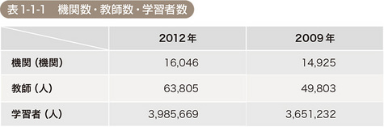

(機関：Organization 教師：Teacher 学習者：Student)

*Figure 1: JPF research in 2013*

Most of people who study Japanese find it difficult to read Japanese document. Japanese includes a lot of Chinese-like characters called Kanji. Without knowing how to read the Kanji, it will be difficult to type those Kanji to search for their meaning.

We conducted a research among students who are studying Japanese. Those students often read books, comic, newspapers written in Japanese (see Chart 1). The result shows that 88.2% out of 78 students doing the survey find it difficult to read Japanese document (see Chart 2).

Chart 1

Chart 2

Chart 2

Almost of the students want an application that can scan Japanese in documents. More than 60% of them need help in translate the document, and search for the meaning of words.

*(See AK_SurveySummary in Appendix for detail about this survey)*

## 3.2. Existing Products

### 3.2.1. Google translate[2]

Google translate is considered as the best application in language processing. It provides user a completed services including character recognition, speech to text and translate.

**Functions:**

* Scan printed document and detect characters of many language, include Japanese
* Allow user to import image to detect characters
* Translate to many other language
* Convert speech to text and translate
* Save translated words and documents
* Bookmark words / documents
* Copy words / documents
* Turn on flash to take image

**Some screenshots of Google translate:**

Main screen

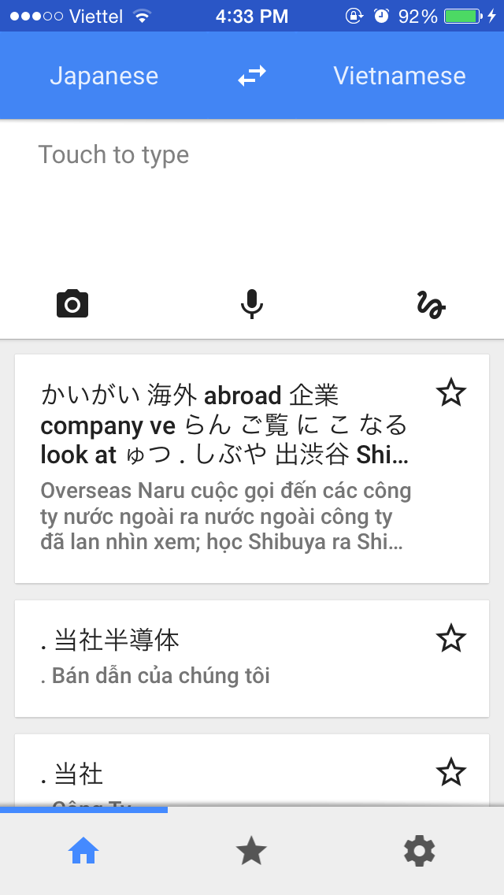

Scan and recognize text:

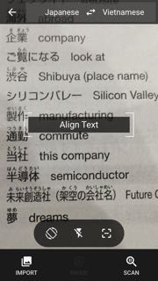 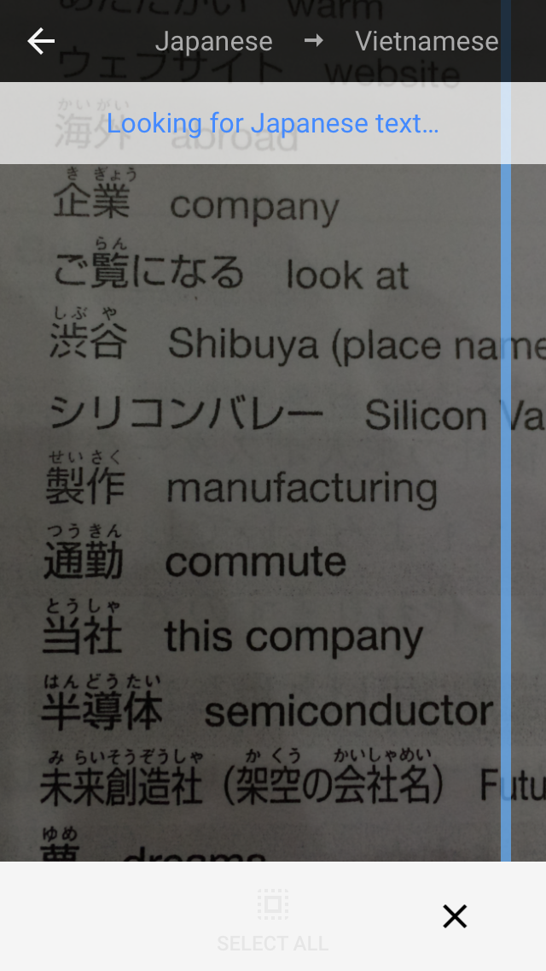 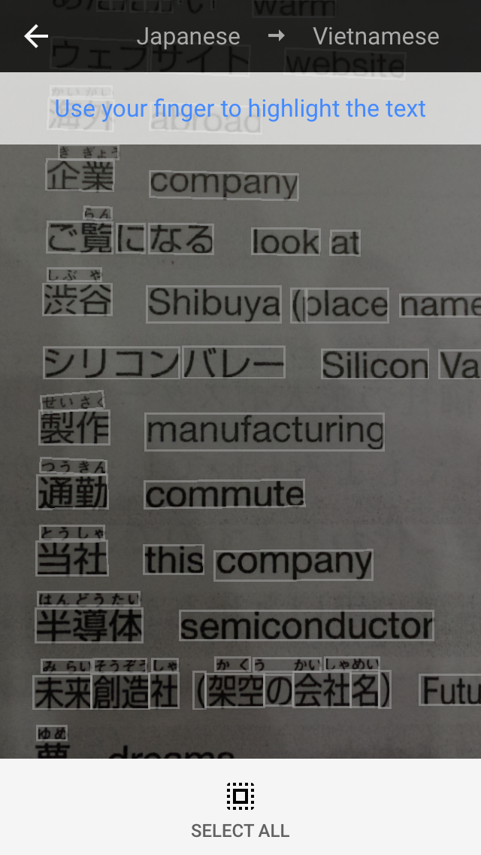

Translate to other languages:

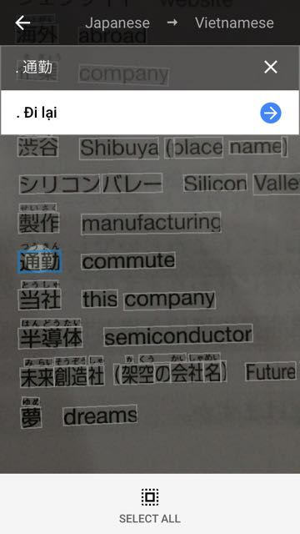 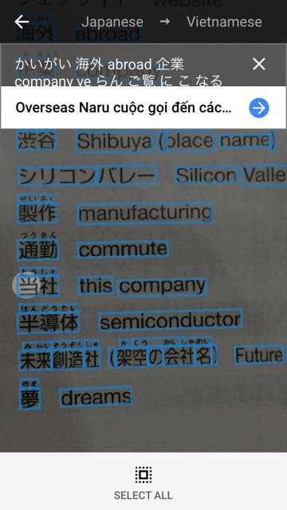 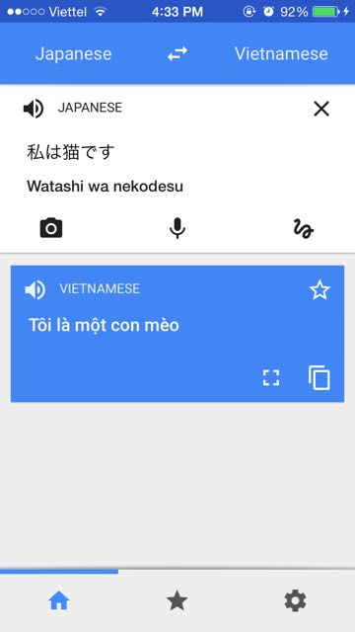

Speech to text

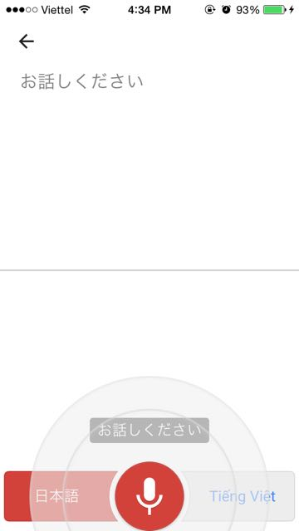 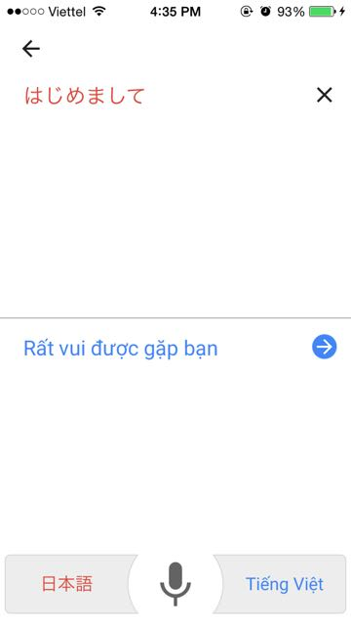

Save to history and bookmark

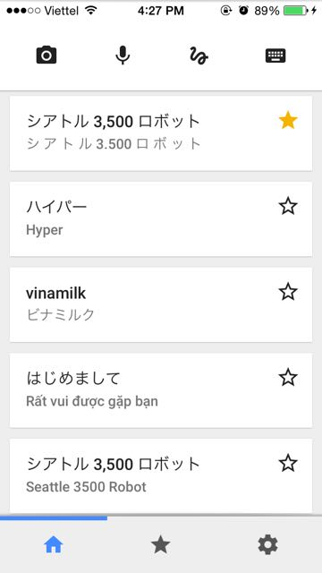 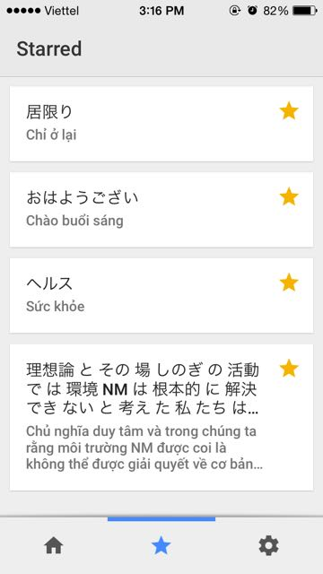

**Pros:**

* Interface design is simple and easy to use
* Document scanning is fast
* Character recognition is in high correction rate
* Recognize many language
* Translate from / to many language

**Cons:**

* Require Internet access for character recognition and translation

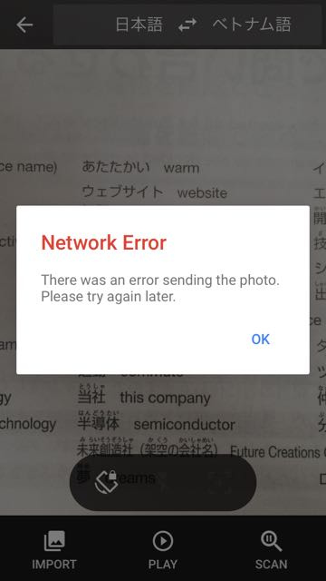 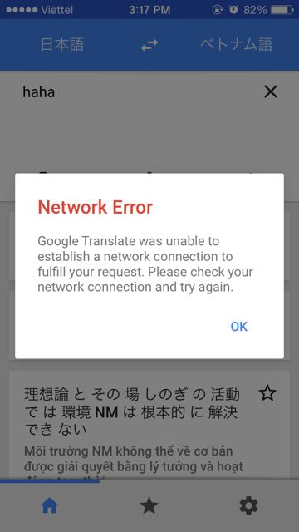

* Translation may return wrong meaning of words
* Does not provide other information about words (word-class, examples,...). Only the meaning of words may not satisfies people who study Japanese and want to understand the words deeply.

### 3.2.2. CamDictionary[3]

CamDictionary is another good application in character recognition

**Functions:**

* Scan and recognize printed characters of many languages in three ways:

+ User touch somewhere in the screen to show application the area to scan

+ User move the application eye to the text area that they want to scan

+ User capture to document, and then choose a part of the document to scan

* Allow user to import image to detect characters
* Turn on flash to take image
* Translate from / to many other languages
* Save translated words to History or My Vocabulary
* Download dictionary and search words in dictionary
* Send words and words’ meaning through message or email

**Some screenshots of CamDictionary:**

Scan and recognize text:

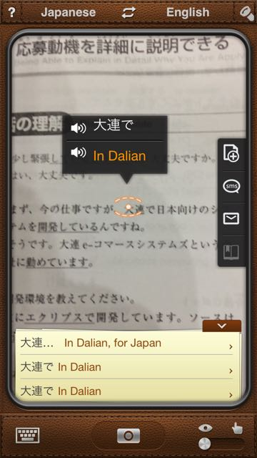 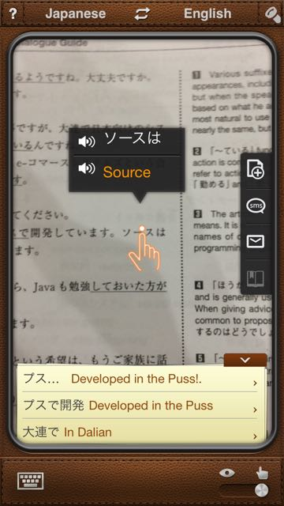 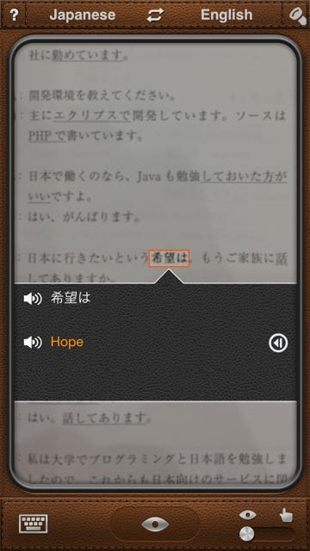

Translate:

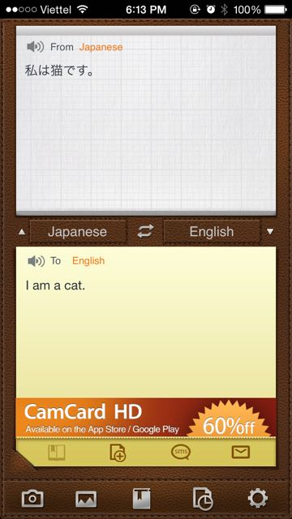

Save to history or my vocabulary

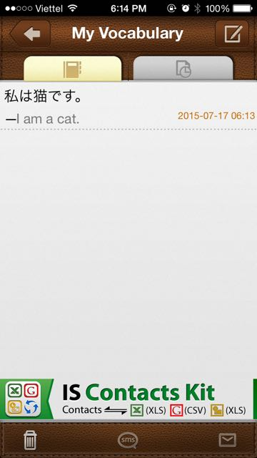 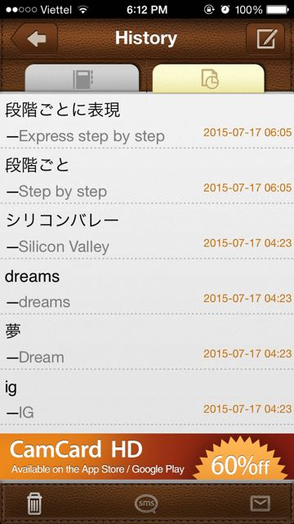

Download dictionary:

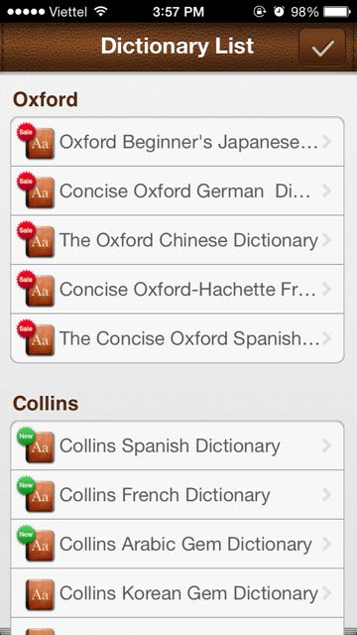 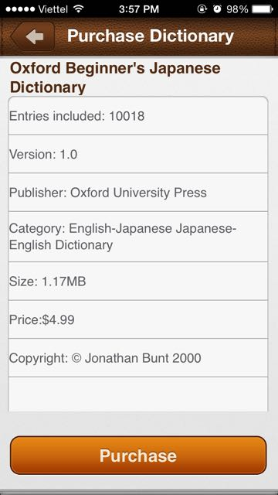

Send through email or message:

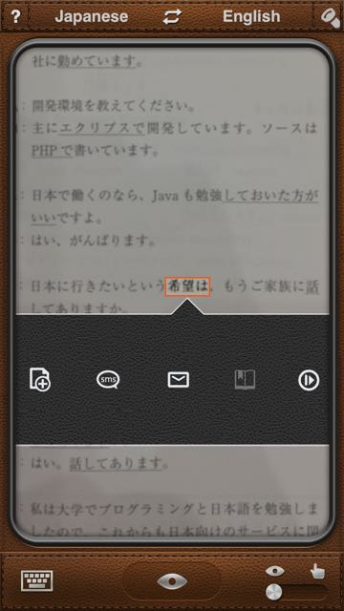 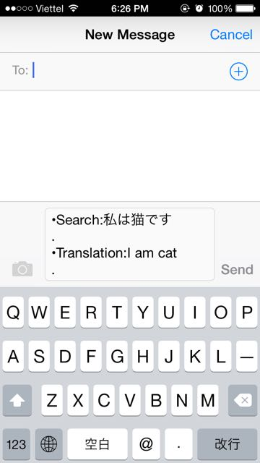

**Pros:**

* The application is interactive. User can choose to scan document in 3 ways. The design for scanning screen is interesting.
* Text scan and character recognition is highly correct.
* The scanning function works offline
* User can purchase dictionary to search words, which give a more correct meaning and other information like word-class, example,...

**Cons:**

* Require Internet access for translation
* User has to pay for the dictionaries

### 3.2.3. JDict[4]

Jdict is one of the most popular Japanese – Vietnamese dictionary application

**Functions:**

* Look up words in Japanese – Vietnamese dictionary, Vietnamese – Japanese dictionary and Kanji dictionary
* Save words to history
* Bookmark words

**Some screenshots of JDict**

Search words in dictionary

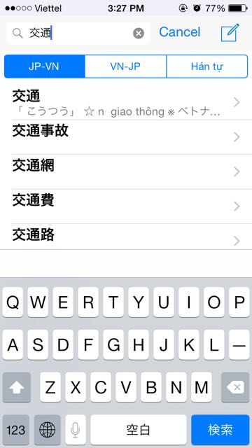 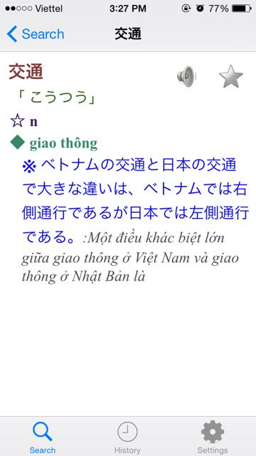

Save to history and bookmark

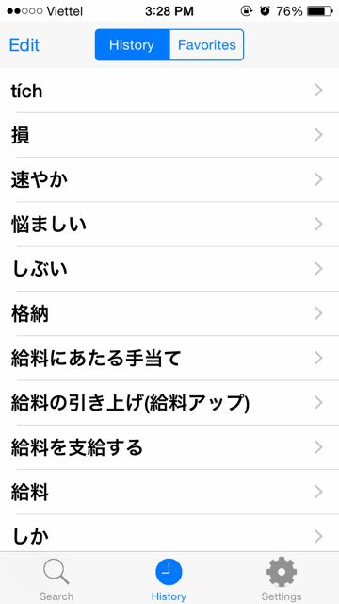 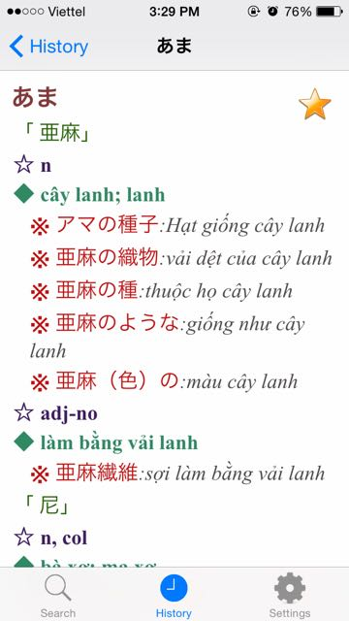

**Pros:**

* Simple and easy-to-understand interface design
* Give detail meanings, examples, word-class, pronunciation of words
* Can search for about 700.000 Japanese words, and almost Kanji
* Explain words’ meaning in Vietnamese, which is helpful for Vietnamese people.

**Cons:**

* User has to input words to search for the meaning. If they do not know how to read Kanji, they can not type the Kanji to search. It will take time to draw the Kanji from keyboard.

## 3.2. Our Proposal

We will develop a single application that support people who studying Japanese everything they need for reading printed Japanese document. The application will have the below main functions:

* Scan text in Japanese document
* Recognize Japanese characters
* Allow user to download free dictionaries
* Search for meaning of words, Kanji in dictionary
* Save words to history for user’s later review
* Add words to favorite list

The application will be interactive, easy to use and work offline.



*Figure 2: Doraemon's copying toast*

We name the application Anki Pan, which means copying toast in English. Anki Pan is a Doraemon’s gadget which allows user to memorize any contents ‘printed’ on it. To use the copying toast, one should press one side of the toast on a book page. The text on the book then will be printed on the toast. Eating the toast later, eater can remember everything that has been printed on the toast. Just like how to use the copying toast, user using our application will take their phone above the book page and press the capture button. The book page with text on it then will be saved (printed) to the application. The application will extract text from the book page so that user can require application to translate or to look up meaning of words. By doing this, user can understand the content of the book, remember words and their meaning, just like swallowing the content of book by eating a toast.

Our application in compare to Google Translate, CamDictionary and JDict:

|  |  |  |  |  |
| --- | --- | --- | --- | --- |
| **Function** | **Google Translate** | **CamDictionary** | **JDict** | **Anki Pan** |
| Scan and recognize text | Many language | Many language | ✖ | Japanese only |
| Translate | ✔ | ✔ | ✖ | ✖ |
| Search words in dictionary | ✖ | ✔ | ✔ | ✔ |
| Free Dictionary | ✖ | ✖ | ✔ | ✔ |
| Save words to history | ✔ | ✔ | ✔ | ✔ |
| Bookmark words | ✔ | ✔ | ✔ | ✔ |
| Work offline | ✖ | ✖ | ✔ | ✔ |

# II. PROJECT MANAGEMENT PLAN

# 1. PROJECT OVERVIEW

## 1.1. Project description

In this project, we will develop an Android application that support Japanese learner in reading Japanese book. User can use this application to scan Japanese in a book page and look up for the meaning of each words. This will save user’s time for searching words in the book that they do not understand, because they do not have to type every single words. The Application will be design so that user have to do least but receive best result. Beside, we will also develop a business service for admins to manage dictionary database.

## 1.2. Scope

This project covers all processes, from planning, requirement specification, design, development, to testing.

Project team will develop an Android Application for user to scan Japanese document and search words’ meaning, and a server to manage dictionary database and provide dictionary download service for the Application.

* **Functional requirements:**

The Application allows user to scan text in Japanese documents and search for words’ meaning in dictionaries. All searched words will be saved to history. User can also add a word to their favorite list. Application provides dictionary packages for user to download and use for searching word.

The server is developed for Admins and  Roots Admins of Anki pan system. Admin / Root Admin can login, logout, manage their profile, manage dictionary packages (upload, edit, delete). Root Admin can add / edit / delete Admins’ accounts.

* **Non-functional requirements:**

The Application must be design for user’s convenience. It should require no internet access to run, except for downloading dictionary package. Interface design should be good looking and easy to understand. Time delay for image processing and text recognition must be optimized.

## 1.3. Standard Objectives

* This project must be finished no later than 15/08/2015
* The final Application covers 100% of requirements
* The 6 team members give best effort to complete the project

## 1.4. Milestones and Deliverables

### 1.4.1. Milestones

|  |  |  |  |
| --- | --- | --- | --- |
| **No.** | **Task** | **Start date** | **End date** |
| 1 | Approve Project’s initial idea | 11/05/2015 | 11/05/2015 |
| 2 | Create and submit Report 1: Introduction | 18/05/2015 | 22/05/2015 |
| 3 | Create and submit Report 2: Project Management Plan ver1.0 | 28/05/2015 | 1/06/2015 |
| 4 | Create and submit Report 3: Software Requirement Specification ver1.0 | 2/06/2015 | 5/06/2015 |
| 5 | Design interface ver1.0 | 3/06/2015 | 5/06/2015 |
| 6 | Create Report 4: Software Architecture design ver1.0 | 5/06/2015 | 5/06/2015 |
| 7 | Create and submit Test plan ver1.0 | 8/06/2015 | 10/06/2015 |
| 8 | Evaluate Increment 1 | 12/06/2015 | 12/06/2015 |
| 9 | Design database ver1.0 | 17/06/2015 | 22/06/2015 |
| 10 | Report result of testing Tesseract library | 23/06/2015 | 23/06/2015 |
| 11 | Complete Scan screen | 9/07/2015 | 9/07/2015 |
| 12 | Evaluate Increment 2 | 13/07/2015 | 13/07/2015 |
| 13 | Complete server | 22/07/2015 | 22/07/2015 |
| 14 | Create & execute & report ST of server | 20/07/2015 | 24/07/2015 |
| 15 | Complete Dictionary screen | 23/07/2015 | 23/07/2015 |
| 16 | Complete Result screen | 23/07/2015 | 23/07/2015 |
| 17 | Complete image processing library | 29/07/2015 | 29/07/2015 |
| 18 | Complete History screen | 30/07/2015 | 30/07/2015 |
| 19 | Complete Setting screen | 31/07/2015 | 31/07/2015 |
| 20 | Create & execute & report IT | 30/07/2015 | 2/08/2015 |
| 21 | Evaluate Increment 3 | 3/08/2015 | 3/08/2015 |
| 22 | Create and submit Report 6: User manual | 5/08/2015 | 6/08/2015 |
| 23 | Execute & report ST of Application | 5/08/2015 | 7/08/2015 |
| 24 | Submit final report of Testing | 7/08/2015 | 7/08/2015 |
| 25 | Submit final report | 14/08/2015 | 14/08/2015 |

### 1.4.2. Deliverables

|  |  |  |  |  |  |
| --- | --- | --- | --- | --- | --- |
| **No.** | **Deliverables** | **Format** | **Delivery date** | **Verified by** | **Deliver Medium** |
| * **Initial** | | | | | |
| 1 | Introduction ver1.0 | .pdf | 22/05/2015 | Supervisor | Email |
|  | MM_15052015 | .pdf | 15/06/2015 | Supervisor | Email |
|  | MM_22052015 | .pdf | 22/05/2015 | Supervisor | Email |
|  | WR_W1_22052015 | .pdf | 22/05/2015 | Supervisor | Email |
| * **Increment 1** | | | | | |
|  | Communication matrix ver1.0 | .xls | 1/06/2015 | Supervisor | Email |
|  | Risk register ver1.0 | .xls | 1/06/2015 | Supervisor | Email |
|  | Work schedule | .mpp | 1/06/2015 | Supervisor | Email |
|  | Project management plan ver1.0 | .pdf | 1/06/2015 | Supervisor | Email |
|  | Software requirement specification ver1.0 | .pdf | 5/06/2015 | Supervisor | Email |
|  | Component design | .asta | 5/06/2015 | Supervisor | Email |
|  | Test plan ver1.0 | .pdf | 11/06/2015 | Supervisor | Email |
|  | MM_01062015 | .pdf | 1/06/2015 | Supervisor | Email |
|  | MM_12062015 | .pdf | 12/06/2015 | Supervisor | Email |
|  | WR_W3_29052015 |  | 29/05/2015 | Supervisor | Email |
|  | WR_W4_05062015 |  | 05/06/2015 | Supervisor | Email |
|  | WR_W5_12062015 |  | 12/06/2015 | Supervisor | Email |
| * **Increment2** | | | | | |
|  | Design of database | .jpg | 22/06/2015 | Supervisor | Email |
|  | Result of testing Tesseract | .xls | 23/06/2015 | Supervisor | Email |
|  | MM_15062015 | .pdf | 15/06/2015 | Supervisor | Email |
|  | MM_29062015 | .pdf | 29/06/2015 | Supervisor | Email |
|  | WR_W6_19062015 |  | 19/06/2015 | Supervisor | Email |
|  | WR_W7_27062015 |  | 27/06/2015 | Supervisor | Email |
|  | WR_W8_12072015 |  | 12/07/2015 | Supervisor | Email |
| * **Increment 3** | | | | | |
|  | Software requirement specification ver2.10 | .pdf | 14/07/2015 | Supervisor | Email |
|  | Work schedule ver2.0 | .mpp | 14/07/2015 | Supervisor | Email |
|  | Project management plan ver2.0 | .pdf | 14/07/2015 | Supervisor | Email |
|  | Introduction ver2.0 | .pdf | 16/07/2015 | Supervisor | Email |
|  | Screen design ver1.0 | .pdf | 29/07/2015 | Supervisor | Email |
|  | MM_20072015 | .pdf | 20/07/2015 | Supervisor | Email |
|  | MM_28072015 | .pdf | 28/07/2015 | Supervisor | Email |
|  | WR_W10_19072015 | .pdf | 19/07/2015 | Supervisor | Email |
|  | WR_W11_26072015 | .pdf | 26/07/2015 | Supervisor | Email |
|  | WR_W12_02082015 | .pdf | 02/08/2015 | Supervisor | Email |
| * **Increment 4** | | | | | |
|  | User manual ver1.0 | .pdf | 6/08/2015 | Supervisor | Email |
|  | Database design ver1.1 | .pdf | 6/08/2015 | Supervisor | Email |
|  | Software detail design ver2.0 | .pdf | 7/08/2015 | Supervisor | Email |
|  | Final report of Testing | .xls | 7/08/2015 | Supervisor | Email |
|  | Final report | .pdf | 13/07/2015 | Supervisor | Email |
| hard copy | 14/07/2017 | FPT University | Direct |
|  | WR_W13_09082015 | .pdf | 09/08/2015 | Supervisor | Email |
|  | WR_W14_16082015 | .pdf | 16/08/2015 | Supervisor | Email |

# 2. PROJECT ORGANIZATION

## 2.1 Software Process Model

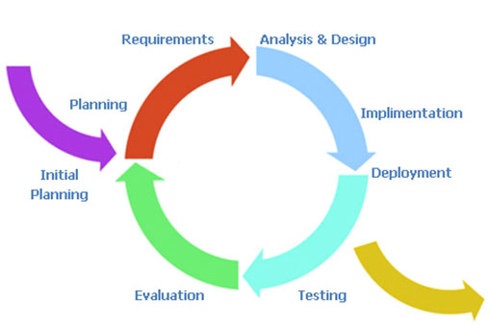

*Figure 3: Incremental and Iterative Model*

In this project, we apply Incremental and Iterative model as development process model.

## 2.2 Project Lifecycle

This project is divided into 6 phases: Initiation, Increment 1, Increment 2, Increment 3, Increment 4, Closing. Each Increment goes through planning, requirement specification, analysis and design, development, testing and evaluation. In each Incremental we bases on result of the previous Increment to plan and specify requirement and develop additional function for the system. Project manager monitors and controls the progress of project team through out the project.

## 2.3 Roles and Responsibilities

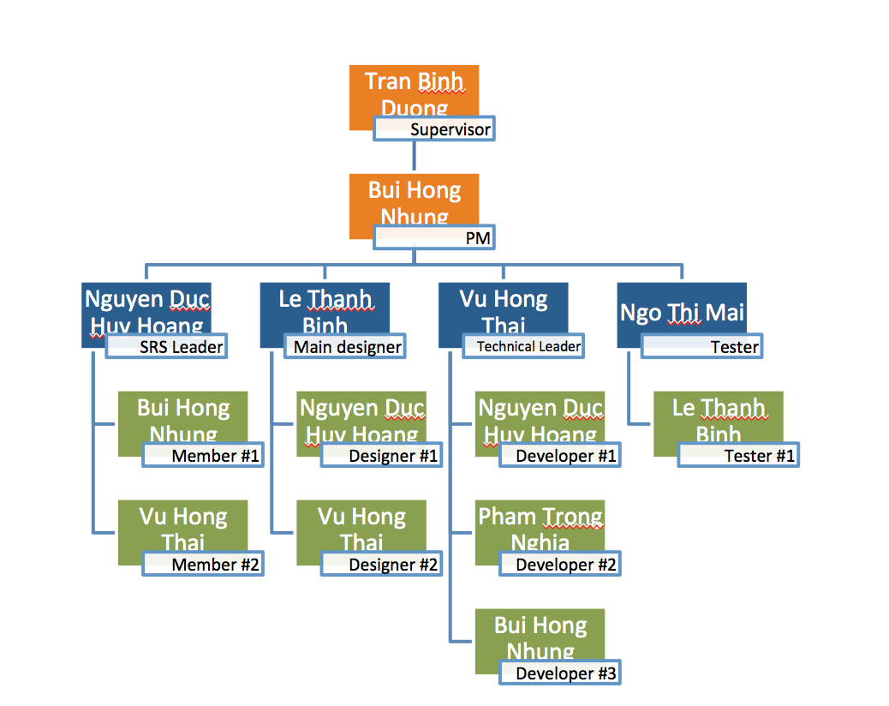

*Figure 4: Organization structure*

|  |  |  |
| --- | --- | --- |
| **Role** | **Full name** | **Responsibility** |
| Instructor | Tran Binh Duong | * Give instruction for project team * Verify deliverables * Supervise project team’s status |
| PM | Bui Hong Nhung | Have overal responsibility of the project   * Create project plan * Assign task to team members * Tracking team member’s work * Report work status to the instructor |
| * Requirement analysis team | | |
| SRS leader | Nguyen Duc Huy Hoang | Complete SRS document and submit to PM |
| Member #1 | Bui Hong Nhung | Create user case diagram |
| Member #2 | Vu Hong Thai | Specify non-functional requirent |
| * Design team | | |
| Main designer | Le Thanh Binh | Design interface for Application and server |
| Designer #1 | Vu Hong Thai | Support in design for Application |
| Designer #2 | Nguyen Duc Huy Hoang | Support in design for server |
| * Development team | | |
| Technical leader | Vu Hong Thai | * Train other member of Android development * Create coding convention * Decide technique and tools to be used * Develop android Application * Create SDD |
| Developer #1 | Nguyen Duc Huy Hoang | * Code server |
| Developer #2 | Pham Trong Nghia | * Design database * Code for database related functions of android Application |
| Developer #3 | Bui Hong Nhung | * Develop image processing library |
| * Test team | | |
| Test leader | Ngo Thi Mai | * Create test plan * Create test cases * Execute text cases * Report test result |
| Tester #1 | Le Thanh Binh | * Create test cases * Execute test case |

# 3. TOOLS AND INFRASTRUCTURES

## 3.1. Hardware

* Personal computer for coding and testing with minimum configuration of 2GB RAM, 80GB of hard disk, Intel core 2 Duo
* Smart phone run on Android operating system
* Internet network connection

## 3.2. Software

|  |  |  |
| --- | --- | --- |
| **Category** | **Software name** | **Version** |
| Operating system | Microsoft Windows 7 | Professional |
| Office tools | Microsoft Word | 2010 |
| Microsoft Excel | 2010 |
| Microsoft Power point | 2010 |
| Management tool | Microsoft Project | 2010 |
| Trello |  |
| Google Driver |  |
| Design tool | Astah | 6.8.0 |
| [www.draw.io](http://www.draw.io) |  |
| Adobe Photoshop | CS6 |
| Development tool | Eclipse |  |
| Database tool | SQLite manager | 0.8.1 |
| MySQL |  |
| Source code management tool | Github.com |  |

# 4. SCHEDULES

## 4.1. Detail Schedules



*Figure 5: Schedule for Pre-initiate and Initiate phase*



*Figure 6: Schedule for Increment 1*



*Figure 7: Schedule for Increment 2*



*Figure 8: Schedule for Increment 3*



*Figure 9: Schedule for Increment 4 and Closing phase*

# 5. COMMUNICATION MANAGEMENT

## 5.1. Stakeholders and Contacts

|  |  |  |  |
| --- | --- | --- | --- |
| **Name** | **Title** | **Role** | **Contacts** |
| Tran Binh Duong | Mr. | Supervisor | [duongtb@fpt.edu.vn](mailto:duongtb@fpt.edu.vn)  (84) 936-168-165 |
| Bui Hong Nhung | Mrs. | PM | [Nhungbhse02082@fpt.edu.vn](mailto:Nhungbhse02082@fpt.edu.vn)  (84) 166-7762-099 |
| Vu Hong Thai | Mr. | Technical Leader | [Thaivhse02654@fpt.edu.vn](mailto:Thaivhse02654@fpt.edu.vn)  (84) 169-820-4900 |
| Le Thanh Binh | Mr. | Main Designer | [Binhlnse02917@fpt.edu.vn](mailto:Binhlnse02917@fpt.edu.vn)  (84) 914-465-993 |
| Nguyen Duc Huy Hoang | Mr. | Developer | [Hoangndhse02651@fpt.edu.vn](mailto:Hoangndhse02651@fpt.edu.vn)  (84) 965-957-811 |
| Pham Trong Nghia | Mr. | Developer | [Nghiaptse02781@fpt.edu.vn](mailto:Nghiaptse02781@fpt.edu.vn)  (84) 982-822-412 |
| Ngo Thi Mai | Mrs. | Test Leader | [Maintse02218@fpt.edu.vn](mailto:Maintse02218@fpt.edu.vn)  (84) 966-656-692 |

## 5.2. Communication Management Approach

Project team communicate frequently to ensure the progress of each member’s work. Project manager report to the Supervisor frequently and honestly so that the Supervisor can track the team’s work and give support/advice as need.

All request for change or proposal of new ideal must be discussed in team. If project team agree to change, project team must then discuss with the Supervisor. Once the change is approved, project manager will update the plan and to project team and Supervisor.

The communications requirements are documented in the Communications Matrix of this document. The Communications matrix will be used as guide for what/when/how/who/whom to communicate through out the project.

## 5.3. Communication Requirements

The project manager will communicate with the Supervisor in order to determine his preferred frequency and time of communication.

As all project team members still take part in classes while doing project, project manager should communicate to understand their schedule, and therefore specify appropriate communication plan for the team.

## 5.4. Communication Method and Technologies

* Create a Facebook private group for team member to discuss and share informal information and activity. This would be a place for member to communicate freely, and therefore would help in strengthen relationship between members.
* Use Google docs to share documents
* Public weekly reports of team members in Google docs to keep them writing report. This will help project manager in tracking work of team members, and also help team member understand progress of the others.
* Update Work schedule before weekly meeting with Supervisor

## 5.5 Communication Matrix

|  |  |  |  |  |  |  |  |
| --- | --- | --- | --- | --- | --- | --- | --- |
| **Communication Type** | **Objective** | **Medium** | **Frequency** | **Audience** | **Owner** | **Deliverable** | **Format** |
| Kickoff Meeting | Discuss and agree on project objective, and scope | * Face to face | Once (At the start of the project) | * Instructor * Project Team | Project Manager | * Meeting Minutes | * Soft copies on Microsoft Word |
| Project Team Meeting | Review status of the project. Discuss solutions for any raised issues. Assign tasks for team members | * Face to face * Email * Conversation (Skype) | 3 times per week, base on personal schedule. | * Project Team | Project Manager | - Project schedule   * Assigned tasks | * Soft copies on Microsoft Word * Assigned tasks on Trello |
| Project Plan Meeting | Discuss and planning project process | * Face to face * Email * Conversation (Skype) | As needed | * Project Team | Project Manager | * Meeting Minutes * Project Management Plan | * Soft copies on Microsoft Word * WBS on Microsoft Project |
| Architecture Design Meeting | Review prototype  Discuss, contribute and review System Architecture Design | * Face to face * Email | As needed | * Project Team | Technical Leader | * Meeting Minutes * System Architecture Design Document | * Soft copies on Microsoft Word * System Architecture Design on Astah |
| GUI Design Meeting | Discuss, contribute and review GUI Design | * Face to face * Email | As needed | * Project Team | Technical Leader | * Meeting Minutes * GUI Design * Document | * Soft copies on Microsoft Word * GUI Design on Photoshop |
| Database Design Meeting | Discuss, contribute and review Database Design | * Face to face | As needed | * Project Team | Technical Leader | * Meeting Minutes * Database Design | * Soft copies on Microsoft Word |
| Test Plan Meeting | Discuss, and review Test Plan | * Face to face | As needed | * Project Team | Technical Leader | * Meeting Minutes * Test Plan | * Soft copies on Microsoft Word |
| Bug Report | Report found bugs to team members and assign fix tasks | * Face to face * Email | As needed | * Project Team | Test Leader | * Bug Report | * Soft copies on Microsoft Excel |
| Personal Weekly Report | Report task status (what is done, what will be done next week, any issue) of personal work | * Email * Google driver | Every Friday | * Project team | Project Manager | * Personal Weekly Report | * Soft copies on Microsoft Excel |
| Project team weekly report | Report task status (what is done, what will be done next week, any issue) | * Email | Every Saturday | * Instructor | Project manager | * Weekly report | * Soft copies on Microsoft word |
| Meeting with Instructor | Report project status of team’s work to instructor  Get advices for project from instructor | * Face to face * Email | Every Monday | * Instructor * Project Team | Project Manager | * Meeting Minutes * Team Weekly Report | * Soft copies on Microsoft Word |
| Unexpected Issue | Find a solution for any unexpected raised issues. | * Face to face * Conversation (Skype) * Facebook private group | As needed | * Instructor * Project Team | Project Manager | * Meeting Minutes | * Soft copies on Microsoft Word |

# 6. RISK MANAGEMENT[5]

## 6.1. Risk Management Approach

The approach to manage risks for this project is the process by which project team identifies and ranks the various risks. The most likely and high impact risks will be added to the risk register and will be delivered to all team members, to ensure that every member perceive of these potential risks. Project manager must pay attention to all items in risk register during project and take appropriate action when a risk triggered. Upon the completion of the project, project manager will analyze each risk as well as the management process. Base on this analysis, project manager will identify any improvements that can be make to risk management process, and capture these improvements as a part of lessons learned.

## 6.2. Risk Identification

Risk identification will be conducted in the first project team meeting. The method used by project team to identify risk will be brainstorming. Every team member raise their idea about any risk that might happen. PM will note down team member’s idea. There must be no judgment or bias during brainstorming. When there is no other idea, project team will review all risks that have been note down. Risks that is almost unlikely to happen will be erased. Risks with high impact or most likely to happen will be kept. There should be no more than 10 risks to be kept.

Besides, project team will review other capstone project in order to determine the most common risks and the strategies used to mitigate those risks.

## 6.3. Risk Qualification and Prioritization

In order to determine the severity of the risked identified by the project team, a probability and impact factor will be assigned to each risk. PM then will prioritize risks base on their probability and impact. Finally, PM will create a probability –impact matrix.

## 6.4. Risk Monitoring

Risk monitoring will be a continuous process through out the project. Avoidance plan should be taken carefully from start of the project. In case a risk is about to happen, PM will apply contingency plan to prevent risk. If risk is already happen, PM apply fall back plan to minimize impact.

## 6.5. Risk Register

### 6.5.1. Risk description

|  |  |  |  |  |  |  |  |
| --- | --- | --- | --- | --- | --- | --- | --- |
| **No.** | **Risk Name** | **Description** | **Category** | **Route cause** | **Probability** | **Impact** | **Trigger** |
| R1 | Lack of skills and ability for a specified work | Team members are unable to complete work because they do not know how to do | Human | Team members have not studied or experienced similar work | Medium | High | Team members take a lot of time to do their task / Team member informed that they can not do the task |
| R2 | Team member conflict | Team member disagree with each others and refuse to work | Human | Unclear requirement specification. Team members do not unify on solutions when problem occurs. | Medium | High | When somebody does not work because of disagreement |
| R3 | Requirement changes | The scope may change, unplanned requirements may get added | Requirement | Request from Supervisor or team member for new function, or to change requirement | Medium | High | When Supervisor or team member request to change requirement |
| R4 | User reject the product | Unfriendly GUI Large for downloading Application is not suitable with market trend | Requirement | Lack of graphic design skill Does not optimize code | Medium | High | User complaint about the application |
| R5 | Team member distraction | Team members do not pay enough time for the project | Human | Team members are busy with studying while doing project | Medium | High | Team members does not spend time for work and tasks are not completed on time |
| R6 | Schedule flaws | Time for one task may too long or too short Trouble may occurs during process that makes task longer than expected | Estimates | The project is planned assuming that all will take the most optimistic path possible Poor plan analysis Poor tem member assessment | High | Medium | Somebody have much time to free and some did not finish their task on time |
| R7 | Unrealistic expectation | Project team expects more than what they can do | Requirement | Team members' abilities are overestimated | Low | High | When nobody known how to reach the goal |
| R8 | Lack of Supervisor support | Supervisor may have not enough time to support project team | Human | Communicate with Supervisor inefficiently Supervisor is busy personal business, and support many team at the same of time | Low | Medium | It takes 2 day or more for mail response. Meeting with Supervisor is hard to arranged. |

### 6.5.2. Probability – Impact matrix

|  |  |  |  |  |
| --- | --- | --- | --- | --- |
| **Probability** | **High** |  | R6 |  |
| **Medium** |  |  | R1, R2, R3, R4, R5 |
| **Low** |  | R8 | R7 |
|  | **Low** | **Medium** | **High** |
|  |  | **Impact** | | |

### 6.5.3. Risk response plan & Risk status

|  |  |  |  |  |  |
| --- | --- | --- | --- | --- | --- |
| **No.** | **Risk name** | **Risk response** | | | **Status** |
| **Avoidance plan** | **Contingency plan** | **Fall back plan** |
| R1 | Lack of skills and ability for a specified work | Do well at training phase. PM should understand ability of each team member and assign right work for right person. | Assign more team members to support or to do the task. | Ask for support of external interfaces. | Activated / Solved |
| R2 | Team member conflict | Clear requirement. Pay attention on team building activities. | Negotiate to deal with conflict. | Report to Supervisor | Not yes active |
| R3 | Requirement changes | Specify software requirement between Supervisor and project team before start of development. Give special consideration in requirements. | Discuss with Supervisor to decide if project teams can follow old requirement. | Change requirement. Develop for new required functions. | Activated/ Solved |
| R4 | User reject the product | Conduct a market survey Follow coding construction | Listen to users' complaint and find solution | Change requirement | Not yes active |
| R5 | Team member distraction | Understand team members' schedule and assign suitable tasks and set appropriate deadlines. Require team member to set high priority for the project. | Arrange team work frequently. Sketch deadline for the assigned tasks. | Assign task to other member. | Activated / Solved |
| R6 | Schedule flaws | Get to known team member skill Use Microsoft Project tool Add slack time for importance task | Member who has free time involve in and support to finish task If there are some task that has more time than usual, member who take responsibilities should help each other | Create new time schedule | Activated / Solved |
| R7 | Unrealistic expectation | Understand members' ability. Set appropriate goal and all team member should agree on common goal | Remove unnecessary functions, and focus on key functions | Change project | Activated / Solved |
| R8 | Lack of Supervisor support | Define a meeting schedule with Supervisor Use communication medium effectively | Reference from other source. | Ask for support of other interfaces. | Not yes active |

# 7. QUALITY MANAGEMENT

## 7.1. Quality Management Overview

### 7.1.1. Organization, Responsibilities, and Interfaces

|  |  |  |
| --- | --- | --- |
| **Name** | **Role** | **Responsibilities** |
| Tran Binh Duong | Supervisor | * Helps define product quality expectations. * Determines final acceptance of product’s quality. |
| Bui Hong Nhung | PM | * Create quality plan * Facilitate resolution of quality issues, escalating as needed |
| Ngo Thi Mai | Test leader | Provide test and test management |
| Team members:   * Vu Hong Thai * Pham Trong Nghia * Nguyen Duc Huy Hoang * Bui Hong Nhung | Developer | * Provide feedback on quality plan, help determine metrics and criteria for this project * Be a part of quality reviews and provide feedback on deliverables |

### 7.1.2. Tools, Environment, and Interfaces

|  |  |
| --- | --- |
| **Tool** | **Description** |
| **Cause-and-effect diagram** | Used to find the root cause problem when their is a complaint about quality problem. |
| **Flowchart** | Used to illustrate a solution model for a problem. |
| **Control chart** | Used to detect logical error of functions. Apply Seven Run Rule. |

## 7.2. Quality Planning

### 7.2.1. Define Project Quality

* ***System output***:

+ A server to manage dictionary package and provide download service for the application

+ An Android application supports end-users in scanning Japanese document and searching for words’ meaning.

* ***Functionality***:

+ Server allow admin / root admin to login, upload / edit / delete dictionary package. It also provide service to download dictionary package.

+ Android application has main functions: scans and recognize Japanese characters, translates, searches words in dictionary, and downloads dictionary packages from server.

* ***Performance***:

+ Time delay for image processing is less than 10s

+ Other functions of server perform well while dictionary package is downloading to the application

* ***Reliability***:

+ The application is available 24/7

+ Server can handle a least 1000 clients concurrently

+ The accuracy of Japanese detection is at least 80%

* ***Maintainability***:

+Android application is easily to be updated without any crashes. Source code is readability, complies with coding convention.

+ System has to be design to be easy to extend.

* ***Security***

+ Information of admins / root admins on server is secured

### 7.2.2. Measure Project Quality

|  |  |
| --- | --- |
| **Metric** | **Goal** |
| Accurate | - The accuracy of text line detection is at least 80%  - The accuracy of text recognition is a least equal Tesseract accuracy for image with out pre-processed. |
| Response of mobile application | Time delay for image processing <= 10s |
| Bugs/Lines of Code | UT: 8 – 9 bugs / KLOC  ST: 2 – 4 bugs / KLOC  *( based on Fsoft norms)* |
| Maximum deep of loops | <= 4 |
| Android Program Size | <= 100 MB |
| Algorithm complexity | <= O(n^2) |
| Android version support | Support Android version 4.4.2 Kitkat to 5.0.1 Lollipop |
| Android screen support | Multiscreen  Must be tested on 320x480, 768x1024, 768x1336, 1080x1920 screens |
| Website support browser | Support Chrome version 41.0.xxx, Firefox version 36.0 or later. |

## 7.3. Quality Assurance

### 7.3.1. Analyze Project Quality

|  |  |  |  |
| --- | --- | --- | --- |
| **Milestone** | **Deliverables** | **Goal** | **Review and Approved** |
| 5/06/2015 | Interface design ver1.0 | * Good looking & easy-to-use * Cover all functions specified in SRS | HoangNDH  MaiNT |
| 5/06/2015 | Software architecture design ver1.0 | Design to be easy to extend | Supervisor |
| 23/06/2015 | Result of testing Tesseract library | * Tested with Hiragana, Furigana, Kanji * Tested by single word and sentence * Tested with different text size | ThaiVH  Supervisor |
| 22/07/2015 | Server | * Reveal API for use. * Information of admins / root admins on server is secured | MaiNT  ThaiVH |
| 23/07/2015 | Dictionary screen | Time delay for searching a word <= 1s | MaiNT |
| 23/07/2015 | Result screen | The accuracy of text recognition is a least equal Tesseract accuracy for image with out pre-processed. | MaiNT |
| 29/07/2015 | Image processing library | * The accuracy of text line detection is at least 80% for image with text only * Text line extraction is <= 10s | ThaiVH  MaiNT |
| 2/08/2015 | Integration test report | 30 – 34 test cases / KLOC  2 – 4 bugs / KLOC | NhungBH |
| 7/08/2015 | System test report | 30 – 34 test cases / KLOC  2 – 4 bugs / KLOC | NhungBH |

### 7.3.2. Improve Project Quality

|  |  |
| --- | --- |
| **Issue** | **Action** |
| Difficult to track project’s progress | * Weekly report, team work 3 days / week * Using Trello to track team members’ work |
| Maintainability | * Specify coding conventions document * Concentrate on architecture design |
| Low quality code | * Unit Test * Peer review, peer coding among developers * Using Open Source and Framework: OpenCV, Tesseract, Spring framework |
| Hard to gain 80% accuracy of text line extraction | Early study algorithms and combines some algorithms together to get higher precision |
| Reward and discipline | * Teambuilding to increase communication ability between project’s members * Have punishment rules when:   + Submit terrible code (which causes to re-coding more than 10%)  + Miss deadline |
| Acceptance of users | Do survey to discovery what features user want from this projects. Do it before design progress. |

## 7.4. Quality Control

|  |  |  |  |
| --- | --- | --- | --- |
| **Deliverables** | **Goal** | **Quality control activity** | **Frequency /**  **Interval** |
| Interface design | * Good looking & easy-to-use * Cover all functions specified in SRS | Designer has to:   * Ask for advice of some other designer * Take comment from friends on completed work * Have approve from SRS leader | Each time design a new screen |
| Software architecture design | Design to be easy to extend | Have review and judgment from Supervisor | On completion |
| Result of testing Tesseract library | * Tested with Hiragana, Furigana, Kanji * Tested by single word and sentence * Tested with different text size | Have approve from Test leader and Technical leader | On completion |
| Server | * Reveal API for use * Information of admins / root admins on server is secured | Testers execute security test | On completion |
| Dictionary screen | Time delay for searching a word <= 1s | PM requires developer to report to technical leader about method to be used | Report before and after coding |
| Result screen | The accuracy of text recognition is a least equal Tesseract accuracy for image with out pre-processed. | Technical leader , test leader review and evaluate image processing algorithm | Every new version of image processing library |
| Image processing library | * The accuracy of text line detection is at least 80% for image with text only * Text line extraction is <= 5s | Technical leader , test leader review and evaluate image processing algorithm | Every new version of image processing library |
| Integration test report | 30 – 34 test cases / KLOC  2 – 4 bugs / KLOC | PM requires testers to report on work | Weekly |
| System test report | 30 – 34 test cases / KLOC  2 – 4 bugs / KLOC | PM requires testers to report on work | Weekly |

## 7.5. Action Plan

|  |  |  |  |  |
| --- | --- | --- | --- | --- |
| **What** | **Who** | **When** | **How** | **Output** |
| Define coding convention | NhungBH | 28/05/2015 | Read standard coding convention of Oracle  Extract and modify to reuse it | Coding Convention  *(10.1 in this document)* |
| Training Trello | All team | 13/05/2015 | ThaiVH guides team members how to use Trello |  |
| Market research | NhungBH  NghiaPT  MaiNT | 18/05/2015 to 22/05/2015 | Do survey to find out what functions users need | Survey summary |
| Traning OpenCV | NhungBH  ThaiVH  HoangND | 13/05/2015 to 21/05/2015 | * Read OpenCV documents * Find out how to set up and complete ‘Hello World’ tutorial. * Try some core class and functions for image processing. | * OpenCV Training Report * HelloWorld Source Code Example |
| Research for image processing algorithms | NhungBH | 8/06/2015  to  8/07/2015 | * Research many algorithms includes:   + Detect contours  + Remove noise  + Convert image to threshold   * Actively discover and evaluate each algorithm and decide what to use * Get Advice from Supervisor and Experts | Report on image processing library (steps, algorithm) |
| Training Unit Test | ThaiVH  NhungBH  HoangND  NghiaPT | 13/05/2015 | Training how to create and perform Unit Test | Training Report |

# III. SOFTWARE REQUIREMENT SPECIFICATION

# 1. INTRODUCTION

## 1.1 Purpose

This document provides developers, testers, QAs a complete and comprehensive description of both the functional requirement and non-functional requirements of the Anki Pan System. Developers base on this document to develop the system, and testers base on this to assure the quality of the output system. Project manager base on this document to create schedule and assign task to team members.

## 1.2. Scope

This document define all functional and non functional requirements for Anki Pan system.

## 1.3. Overview

Section 2 of this document provides overall information of the project, while excluding the specific requirements. Instead, it provides the background for those requirements, which are defined in Section 3

Section 3 describes all the requirements in detail, including functional requirements and non-functional requirements. Each function is described based on the following format:

* Use Case: the detailed description of all use cases
* Screen: The mockup/prototype of the screen which describes the workflow of the Use Case

# 2. OVERALL DESCRIPTION

## 2.1. Scope of work

Project team will develop an Android Application for user to scan Japanese document and search words’ meaning, and a server to manage dictionary database and provide dictionary download service for the Application.

The Application includes below main functions:

* Capture image
* Detect Japanese characters in image captured by users
* Select text in captured image
* Search for meaning of Japanese words and Kanji in dictionaries
* Download dictionary: allow user to download dictionary package, each  package include a Japanese dictionary and a Kanji dictionary.
* Save words to history
* Bookmark words

The diagram below shows the flow of interact between user and application from capturing document to search word in dictionary.

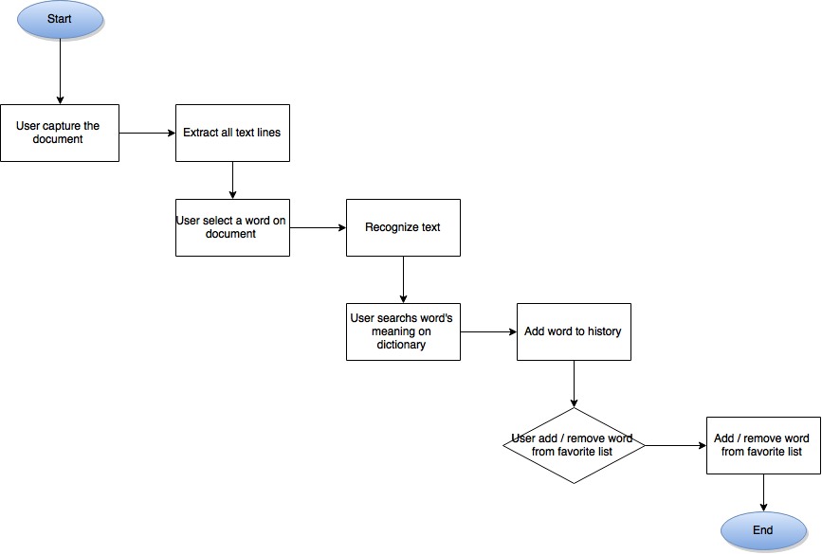

*Figure 10: Flow of scan image and searching word*

The server is developed for admins of the system, with below main functions:

* Login as admin or root admin
* Logout
* Manage user’ profile (add, delete, edit information)
* Upload dictionary packages, each package includes 2 kind of dictionaries: Japanese dictionary and Kanji dictionary
* Manage dictionary packages (edit, delete)

Project team use open source for Japanese recognition. Dictionary database will be download from Internet.

## 2.2. Assumptions

N/A

# 3. FUNCTIONAL REQUIREMENTS

## 3.1. Android application

### 3.1.1. User Case Diagram

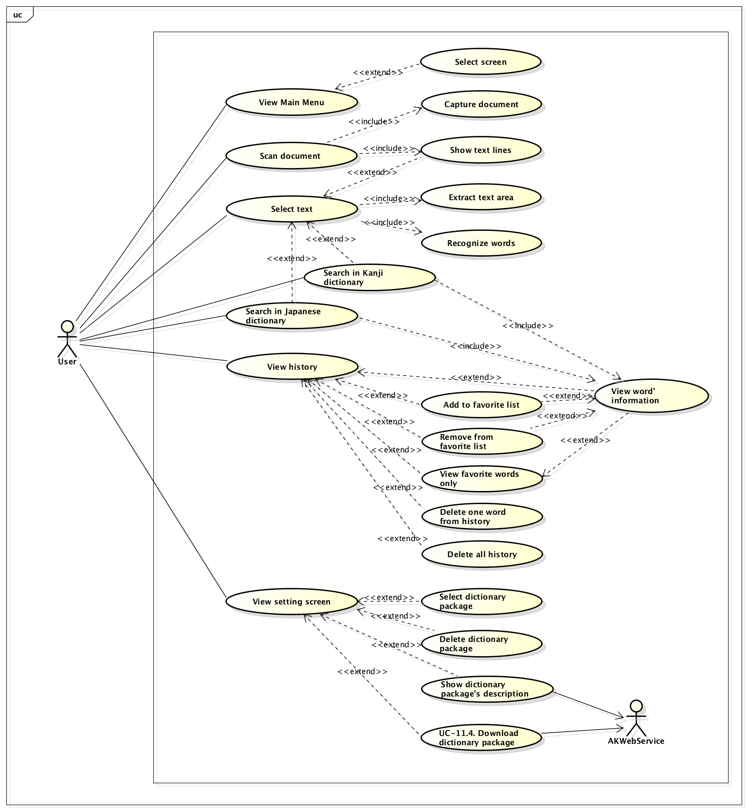

*Figure 11: User case diagram of Application*

### 3.1.2. Functions

#### 3.1.2.1. Main menu

##### **3.1.2.1.1. User cases**

###### *UC – 1. View Main Menu*

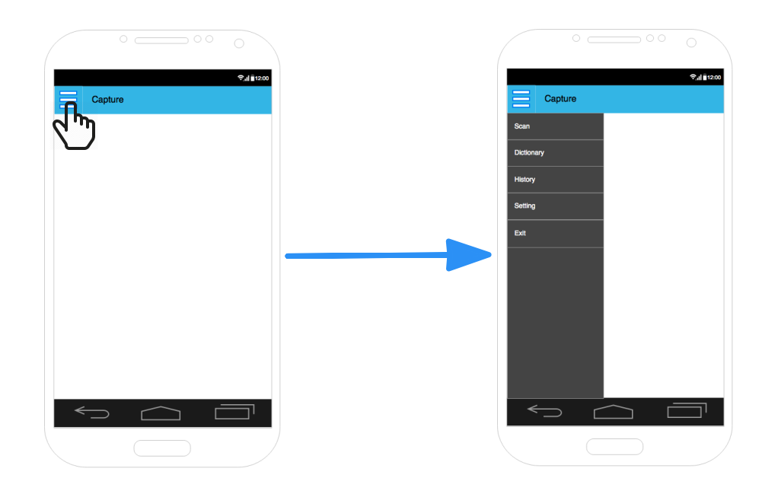

*Figure 12: Screens of UC - 1*

|  |  |  |
| --- | --- | --- |
| Use Case ID | | UC-01 |
| Use Name | | View main menu |
| Actor | | User |
| Description | | User views list of Screens in Anki Pan application |
| Precondition | | N/A |
| Trigger | | N/A |
| Post-Condition | | View list of Screens in Anki Pan application |
| Main flow | | |
| Step | Actor | Action |
| 1 | User | Tap the Menu icon on the top left corner of the screen |
| 2 | System | Show list of Screens include:   1. Scan 2. Dictionary 3. History 4. Setting 5. Exit   Each item go with its own icon |
| Alternative flow | | |
| Exceptions | | N/A |

###### *UC – 1.1 Select screen*

|  |  |  |
| --- | --- | --- |
| Use Case ID | | UC - 1.1 |
| Use Name | | Select screen |
| Actor | | User |
| Description | | User selects a screen |
| Precondition | | N/A |
| Trigger | | N/A |
| Post-Condition | | View screen that user selected |
| Main flow | | |
| Step | Actor | Action |
| 1 | User | Tap on the entry of the screen in the Menu list that he want to open |
| 2 | System | If user tap on Scan, direct to scan screen  If user tap on Dictionary, direct to tab Result of Dictionary screen  If user tap on History, direct to tab Favorite of History screen, and show all history  If user tap on Setting, direct to tab Dictionary Setting of Setting screen |
| Alternative flow | | |
| Exceptions | | N/A |

##### **3.1.2.1.2. Screen description**

| Field Name | Description | Mandatory | Read only | Control type | Data Type | Length |
| --- | --- | --- | --- | --- | --- | --- |
| Header | Include Main menu icon and the title of the application, as describe below. | - | - |  | - | - |
| Title bar | Show application name: Anki Pan | - | - | Label | - | - |
| Menu button | The main menu button, tapping on this button will extend the menu list from the left of the screen, tapping on it again will hide the menu list | - | - | Button | - | - |
| Menu items list | The list of the main menu | - | - | List | - | - |

#### 3.1.2.2. Scan

##### **3.1.2.2.1. User cases**

###### *UC – 2. Scan document*

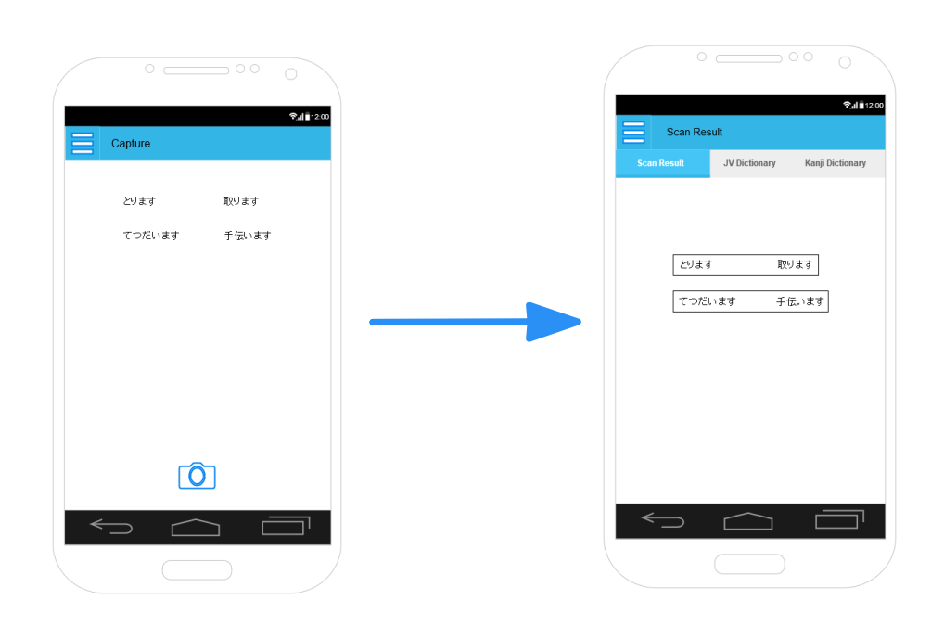

*Figure 13: Screens of UC - 2*

|  |  |  |  |
| --- | --- | --- | --- |
| Use Case ID | | | UC - 2 |
| Use Name | | | Scan document |
| Actor | | | User |
| Description | | | User scans a Japanese document |
| Precondition | | | User select Scan screen in UC – 1.1 |
| Trigger | | | N/A |
| Post-Condition | | | View document with all text lines have been surrounded by rectangles |
| Main flow | | | |
| Step | Actor | | Action |
| 1 | System | | Show scan screen with a line in the middle and Camera button |
| 2 | User | | User bases on the line shown on the screen to adjust he smart phone so that the document is not so skew  User presses the Camera button |
| 3 | System | | Direct to Result tab of the Dictionary screen  Show the document with all text lines have been surrounded in rectangles |
| Alternative flow | | | |
| Precondition | | |  |
| 1 | | User | In step 2 of main flow, user taps the Menu icon and selects another screen |
| 2 | | System | Direct to the screen that user selected  If user selects Dictionary screen and he had scan a document before this, view the Result tab with the last status |
| Exceptions | | | N/A |

##### **3.1.2.2.2. Screen description**

Description of Scan screen:

| Field Name | Description | Mandatory | Read only | Control type | Data Type | Length |
| --- | --- | --- | --- | --- | --- | --- |
| Header | Include Menu icon and the title of the application | - | - |  | - | - |
| Camera button | When tapping on this button, the system will capture image and perform image processing | - | - | Button | - | - |
| Tab bar | The tab bar of the dictionary feature, contain 3 items: Scan Result, JV Dictionary, Kanji Dictionary | - | - | Button | - | - |

#### 3.1.2.3 Dictionary

##### **3.1.2.3.1 User cases**

###### *UC – 3 Select text*

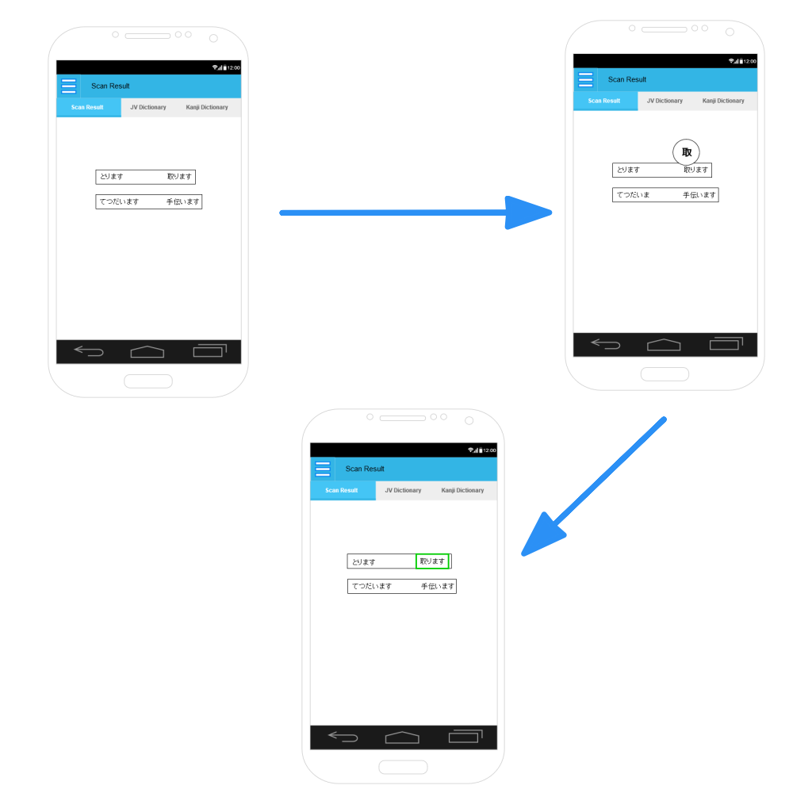

*Figure 14: Screens of UC – 3*

|  |  |  |  |
| --- | --- | --- | --- |
| Use Case ID | | | UC – 3 |
| Use Name | | | Select text |
| Actor | | | User |
| Description | | | User selects text on scanned image |
| Precondition | | | UC – 2 |
| Trigger | | | N/A |
| Post-Condition | | | Selected text area is surrounded by a rectange and selected text is written on the text bar on top of screen |
| Main flow | | | |
| Step | Actor | | Action |
| 1 | User | | Tab finger on the first point of the text area that he want to select and move the finger until the last point of the text area. |
| 2 | System | | View a Manifier with the zoomed out image of the area that user’s finger is on while his finger is moving on the screen so that user can see the text clear in case the text on the document is small. |
| 3 | System | | When user lifted up his finger, extract the exact text area that user want to choose. User may missed some strokes of the first or last characters in the selected area. System check to extract the area that include all characters that user may intended to choose. |
| 4 | System | | Surround the exact text area by a rectangle |
| 5 | System | | Recognize text in the exact selected area and write to the text field in top of the screen. |
| Alternative flow | | | |
| Precondition | | | UC-02 |
| 1 | | User | Just makes one tap on the screen |
| 2 | | System | Do nothing. Keep the screen on current status |
| Exceptions | | | N/A |

###### *UC – 4 Search in Japanese dictionary*

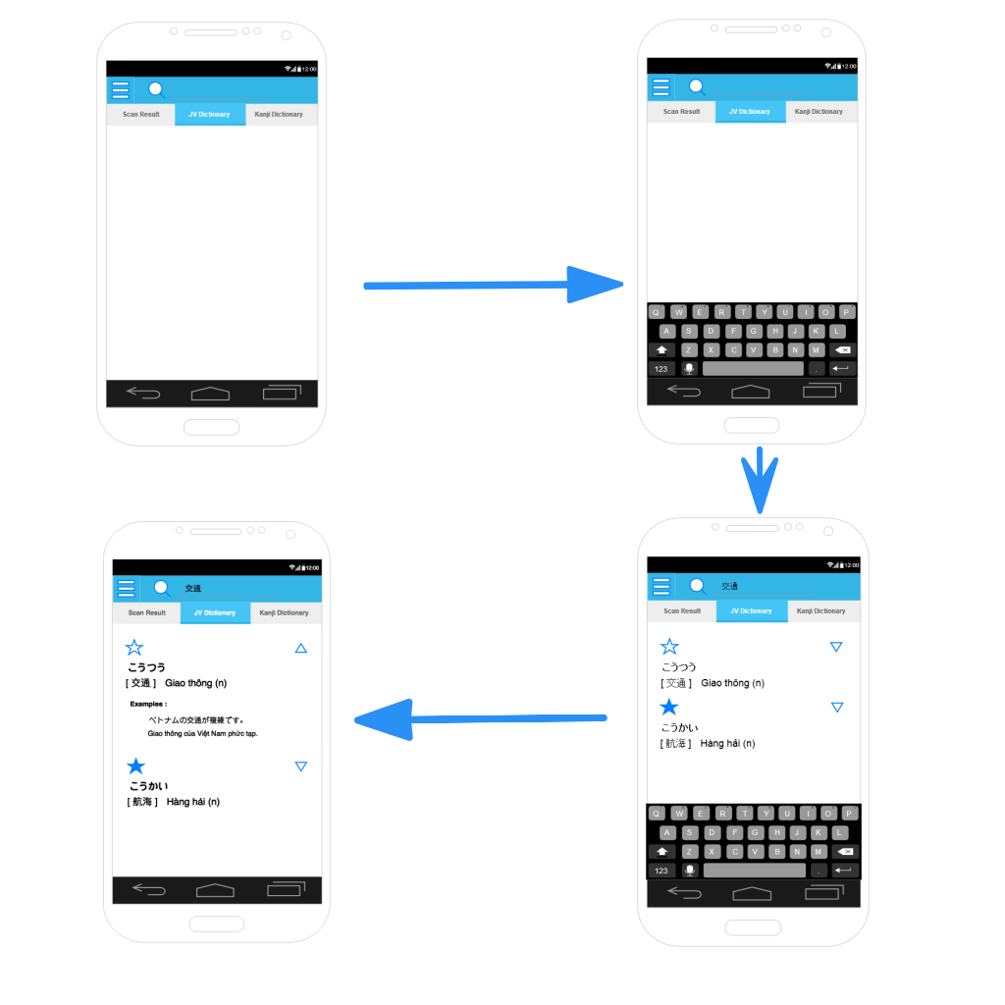

*Figure 15: Screens of UC – 4’ main flow*

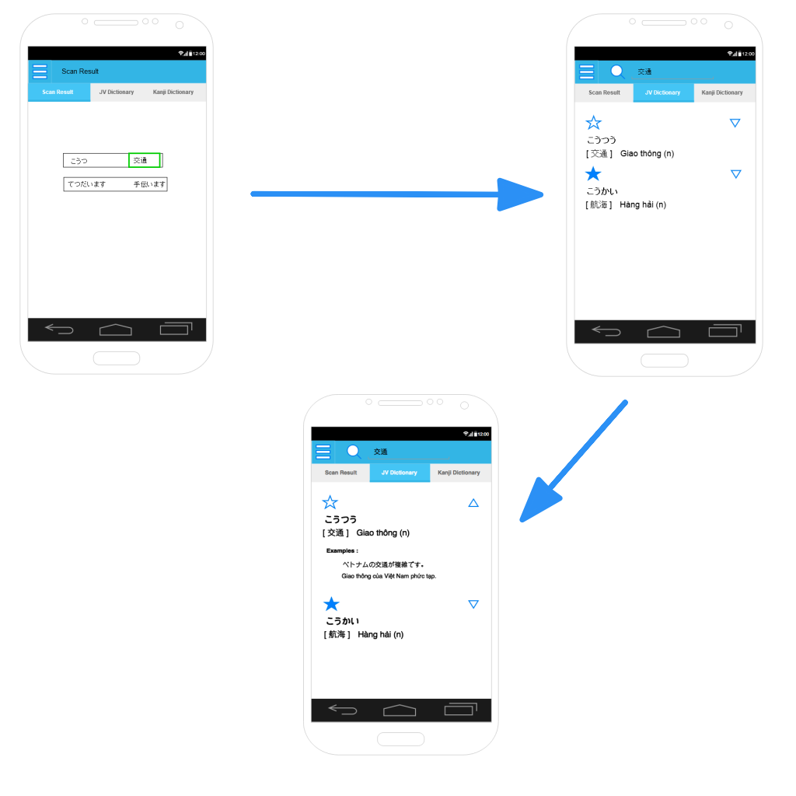

*Figure 16: Screens of UC - 4' alternative flow 1*

|  |  |  |  |
| --- | --- | --- | --- |
| Use Case ID | | | UC – 4 |
| Use Name | | | Search in Japanese dictionary |
| Actor | | | User |
| Description | | | User searchs for word’s meaning in Japanese dictionary |
| Precondition | | | System is in dictionary screen |
| Trigger | | | N/A |
| Post-Condition | | | Show information of the word  Save the searched word, if it is available in the dictionary, to History |
| Main flow | | | |
| Step | Actor | | Action |
| 1 | User | | Tap to open tab Japanese dictionary |
| 2 | User | | Tap on the magnifier icon in the right of the text field on top of the screen |
| 3 | System | | Show keyboard |
| 4 | User | | Type the word his want to search, then press Search key |
| 5 | System | | Search the word in text field in Japanese dictionary   * If the word are Hiragana / Katakana / Kanji: Search all the words which have the first part matchs the searching word. For example: search for 交通 will return * If the word are Romaji: Search all the words which’s Hiragana writting have the first part matchs the searching word. For example: search for Aki will return 空き（あき）、あきあきました、秋風（あきかぜ） |
| 6 | System | | Show a list of output words in form of extendable list view, each entry includes a Star icon, word, its reading, the first meaning and word class. |
| 7 | User | | Tap on the Extend Icon of a entry |
| 8 | System | | Extend the entry and view full information of the word (word, star icon, Hiragana writting, meaning, example...)  Save the word in this entry to History |
| Alternative flow 1 | | | |
| Precondition | | | System is Dictionary screen |
| 1 | User | | User selects text in scanned document as in UC – 3 |
| 2 | System | | Write the recognized text in user selected area to the text field in the top of Dictionary screen |
| 3 | User | | Tap the tab Japanese dictionary |
| 4 | System | | View Japanese dicitonary tab. |
| 5 | System | | Follow steps 5 to 8 in main flow |
| Alternative flow 2 | | | |
| Precondition | | | User has typed a word and searched in Kanji dictionary tab |
| 1 | | User | Tap the tab Japanese dictionary |
| 2 | | System | Follow step 5 to 8 of the main flow |
| Alternative flow 3 | | | |
| Precondition | | |  |
| 1 | | User | After step 8 of the main flow, user tap the Extend icon of the extending entry |
| 2 | | System | Change the entry to the short form with Star icon, word and a brief information |
| Exceptions | | | In step 6 of main flow, if there is no word found, display message “There is no result!” |

###### *UC – 4.1 Add to favorite list (Japanese dictionary screen)*

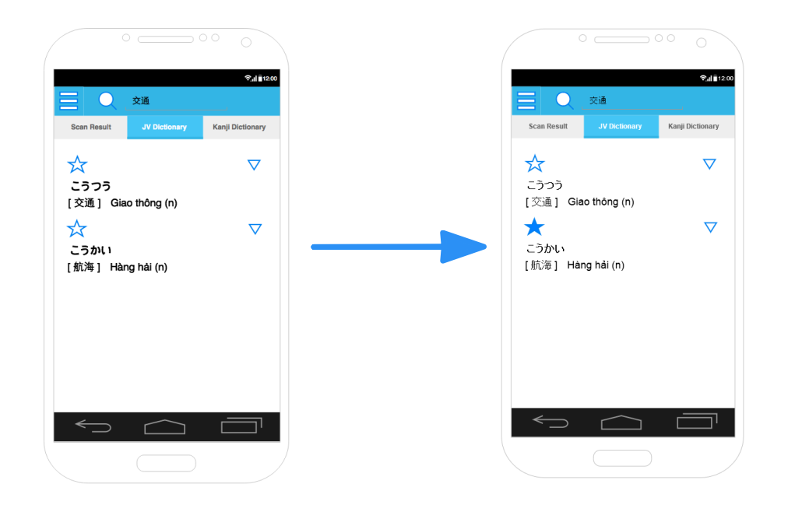

*Figure 17: Screens of UC - 4.1*

|  |  |  |  |
| --- | --- | --- | --- |
| Use Case ID | | | UC – 4.1 |
| Use Name | | | Add to favorite list |
| Actor | | | User |
| Description | | | User add a word in Japanese dictionary to favorite list |
| Precondition | | | System is in tab Japanese dictionary  User has searched a word in Japanese dictionary, and System is showing a list of words, as in steps 6 of main flow of UC - 5 |
| Trigger | | | N/A |
| Post-Condition | | | The word is added to favorite list |
| Main flow | | | |
| Step | Actor | | Action |
| 1 | User | | Tap on the grey start icon in the entry of the word that he want to add to favorite list |
| 2 | System | | Change the star to yellow  Add the word in the entry to favorite list in database |
| Alternative flow 1 | | | |
| Precondition | | | System is Japanese tab  User has expanded a entry, as in steps 8 of main flow of UC - 5 |
| 1 | | User | Tap on the grey star icon of the expanding entry |
| 2 | | User | Change the star to yellow  Add the word in the entry to favorite list |
| Exceptions | | |  |

###### *UC – 4.2 Remove from favorite list (Japanese dictionary screen)*

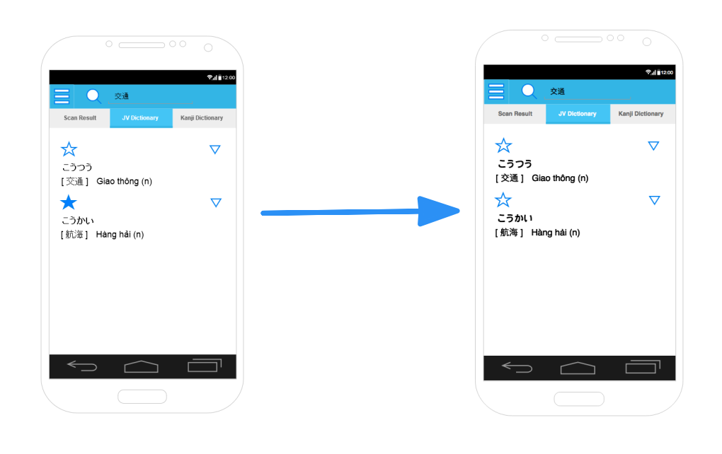

*Figure18: Screens of UC - 4.2*

|  |  |  |  |
| --- | --- | --- | --- |
| Use Case ID | | | UC – 4.2 |
| Use Name | | | Remove from favorite list |
| Actor | | | User |
| Description | | | User removes a word in Japanese dictionary form favorite list |
| Precondition | | | System is in tab Japanese dictionary  User has searched a word in Japanese dictionary, and System is showing a list of words, as in steps 6 of main flow of UC - 5 |
| Trigger | | | N/A |
| Post-Condition | | | The word is removed from favorite list |
| Main flow | | | |
| Step | Actor | | Action |
| 1 | User | | Tap on the yellow start icon in the entry of the word that he want to add to favorite list |
| 2 | System | | Change the star to grey  Remove the word in the entry from favorite list |
| Alternative flow 1 | | | |
| Precondition | | | System is Japanese tab  User has expanded a entry, as in steps 8 of main flow of UC - 5 |
| 1 | | User | Tap on the yellow star icon of the expanding entry |
| 2 | | User | Change the star to grey  Add the word in the entry to favorite list in database |
| Exceptions | | |  |

###### *UC – 5 Search in Kanji dictionary*

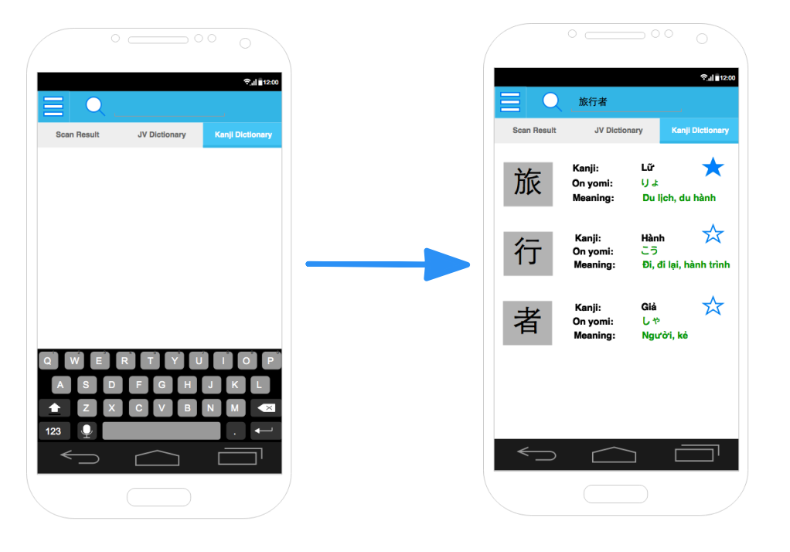

*Figure 19: Screens of UC - 5' main flow*

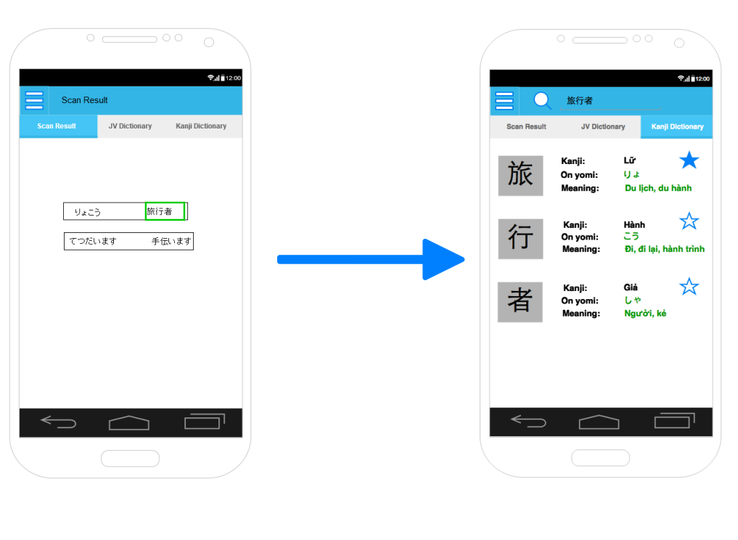

*Figure 20: Screens of UC - 5' alternative flow 1*

|  |  |  |
| --- | --- | --- |
| Use Case ID | | UC – 5 |
| Use Name | | Search in Kanji dictionary |
| Actor | | User |
| Description | | User searches for Kanji information in Kanji dictionary |
| Precondition | | System is in Dictionary screen |
| Trigger | | N/A |
| Post-Condition | | Show information of all Kanji in user’s input  Save the searched Kanji, if it is available in the dictionary, to History. |
| Main flow | | |
| Step | Actor | Action |
| 1 | User | Tap to open tab Kanji dictionary |
| 2 | User | Tap on the magnifier icon in the right of the text field on top of the screen |
| 3 | System | Show keyboard |
| 4 | User | Type the word his want to search, then press Search key |
| 5 | System | If the text in the text field is Japanese characters, extract all Kanji from the text. For example: Extract Kanji from 秋は涼しい return 2 Kanji 秋、涼. Search for these Kanji in Kanji dictionary  If the text in the text field is not Japanese, search all the Kanji that have other reading the same as the text. |
| 6 | System | Show a list of found Kanji. With each Kanji, show Kanji, On yomi, Kun yomi, meaning, other reading (if the Kanji has) and Star icon  Save all Kanji to History |
| Alternative flow 1 | | |
| Precondition | | Dictionary screen |
| 1 | User | Select text in scanned document as in UC – 3 |
| 2 | System | Write the recognized text in user selected area to the text field in the top of Dictionary screen |
| 3 | User | Tap the tab Kanji dictionary |
| 4 | System | View tab Kanji dicitonary |
| 3 | System | Follow steps 5 to 6 in main flow |
| Alternative flow 2 | | |
| Precondition | | User has typed and searched a word in Japanese dictionary |
| 1 | User | Tap the tab Kanji dictionary |
| 2 | System | Follow step 5 to 6 of the main flow |
| Exceptions | | In step 6 of main flow, if there is no word found, display message “There is no result!” |

###### *UC – 5.1 Add to favorite list (Kanji dictionary screen)*

|  |  |  |
| --- | --- | --- |
| Use Case ID | | UC – 5.1 |
| Use Name | | Add to favorite list |
| Actor | | User |
| Description | | User adds a word in Japanese dictionary to favorite list |
| Precondition | | System is in tab Kanji dictionary  User has searched Kanji dictionary, and System is showing a list of words, as in steps 6 of main flow of UC - 6 |
| Trigger | | N/A |
| Post-Condition | | The word is added to favorite list |
| Main flow | | |
| Step | Actor | Action |
| 1 | User | Tap on the grey start icon in the entry of the word that he want to add to favorite list |
| 2 | System | Change the star to yellow  Add the word in the entry to favorite list in database |
| Exceptions | |  |

###### *UC – 6.2 Remove from favorite list (Kanji dictionary screen)*

|  |  |  |
| --- | --- | --- |
| Use Case ID | | UC – 5.2 |
| Use Name | | Remove from favorite list |
| Actor | | User |
| Description | | User removes a Kanji from favorite list |
| Precondition | | System is in tab Kanji dictionary  User has searched in Kanji dictionary, and System is showing a list of words, as in steps 6 of main flow of UC - 6 |
| Trigger | | N/A |
| Post-Condition | | The word is added to favorite list |
| Main flow | | |
| Step | Actor | Action |
| 1 | User | Tap on the yellow start icon in the entry of the word that he want to add to favorite list |
| 2 | System | Change the star to grey  Remove the word in the entry from favorite list |
| Exceptions | |  |

##### **3.1.2.3.2. Screen description**

Description of Result tab

| Field Name | Description | Mandatory | Read only | Control type | Data Type | Length |
| --- | --- | --- | --- | --- | --- | --- |
| Header | Include the Menu icon and the title Anki Pan | - | - |  | - | - |
| Document area | Show the document that user captured. Text lines in the document are surrounded by white rectangles. | - | - | Image | - | - |
| Magnifier | Zoom in the area that user’s finger is on when he is selecting text. | - | - |  | - | - |

Description of Japanese tab

| Field Name | Description | Mandatory | Read only | Control type | Data Type | Length |
| --- | --- | --- | --- | --- | --- | --- |
| Header | Include the Menu icon and the title Anki Pan | - | - |  | - | - |
| Input text are | Text area for user to input words | N | N | Text | Text | - |
| Word lists | Show a list of words that match user’s input | - | - | Extendable list | - | - |
| Star icon | User taps on Star icon to add / remove words from favorite list | - | - | Image icon | - | - |
| Extend icon | User taps on Extend icon to view full information of words (word type, example, meaning,...). Tap again to back to short form. | - | - | Image icon | - | - |

Description of Kanji tab

| Field Name | Description | Mandatory | Read only | Control type | Data Type | Length |
| --- | --- | --- | --- | --- | --- | --- |
| Header | Include the Menu icon and the title Anki Pan | - | - |  | - | - |
| Input text are | Text area for user to input words | N | N | Text | Text | - |
| Word lists | Show a list of Kanji in user’s input. Each Kanji is show with the Kanji in big size, On yomi, Kun yomi and the meaning of the Kanji, and other way of reading if any. | - | - | List | - | - |
| Star icon | User taps on Star icon to add / remove words from favorite list | - | - | Image icon | - | - |

#### 3.1.2.4 History

##### **3.1.2.4.1. User cases**

###### *UC – 6 View History*

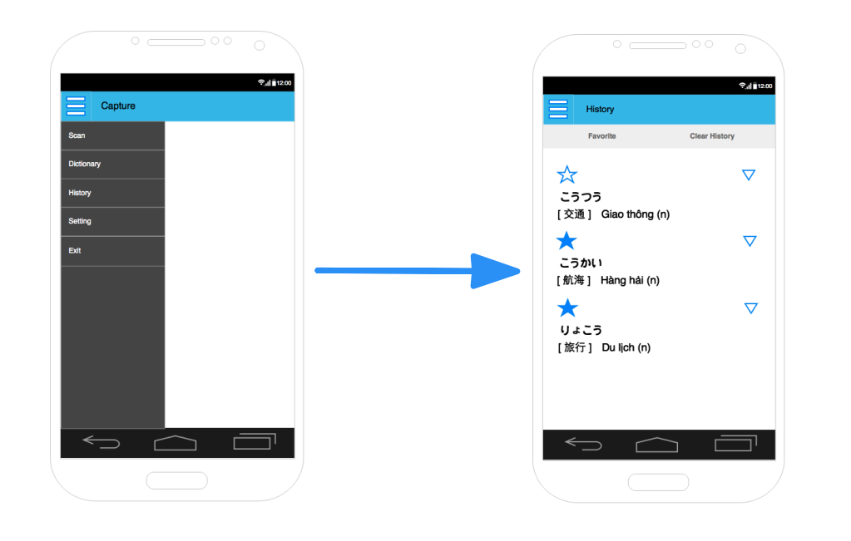

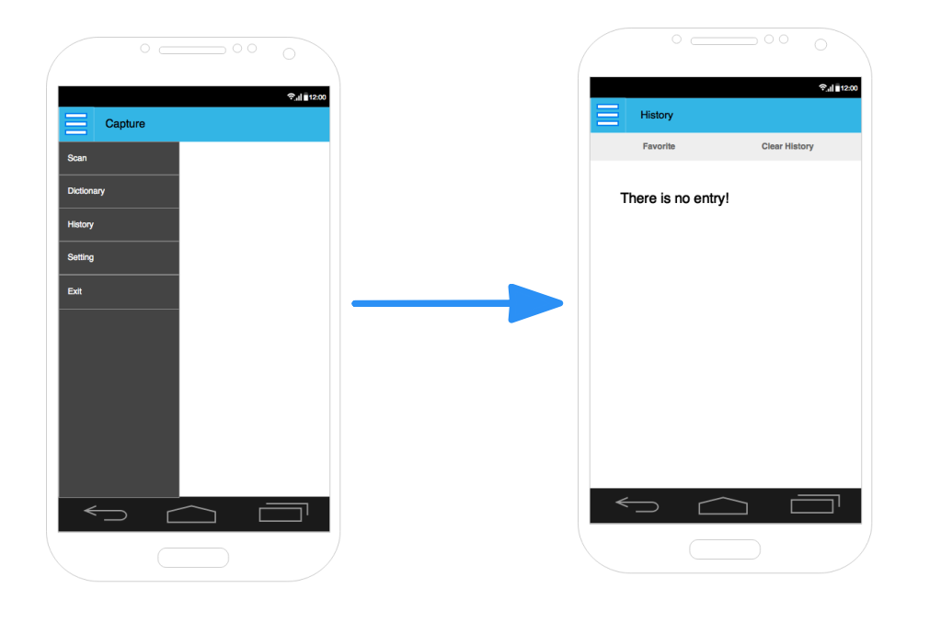

*Figure 21: Screens of UC – 6*

|  |  |  |  |
| --- | --- | --- | --- |
| Use Case ID | | | UC - 6 |
| Use Name | | | View history |
| Actor | | | User |
| Description | | | User view all words that he has searched |
| Precondition | | | N/A |
| Trigger | | | N/A |
| Post-Condition | | | All words in history are shown on screen |
| Main flow | | | |
| Step | Actor | | Action |
| 1 | User | | Tap on the Menu icon in the top left of the screen |
| 2 | System | | Show the screen list |
| 3 | User | | Tap on entry History |
| 4 | System | | Show History screen with all words user has search, in form of extendable list view.   * In the entry of Japanese word: show Star icon, the word, its reading, the first meaning and word class (as in step 6 of UC – 5. Search in Japanese dictionary) * In the entry of Kanji: show Star icon and the Kanji   If there is no word in History, show message “There is no word in History” |
| Alternative flow 1 | | | |
| Exceptions | | N/A | |

###### *UC – 6.1 View word’s information (History screen)*

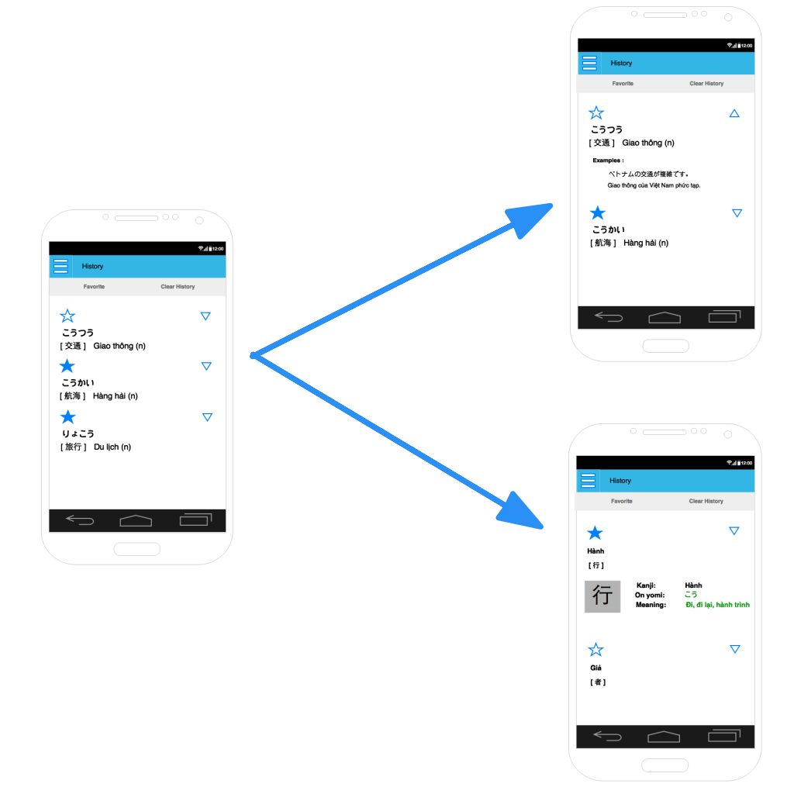

*Figure 22: Screens of UC - 6.1*

|  |  |  |  |
| --- | --- | --- | --- |
| Use Case ID | | | UC – 6.1 |
| Use Name | | | View word’s information |
| Actor | | | User |
| Description | | | User looks for information of a word in history |
| Precondition | | | System is in History screen |
| Trigger | | | N/A |
| Post-Condition | | | Information of the word is shown on screen |
| Main flow | | | |
| Step | Actor | | Action |
| 1 | User | | Tap on the Extend icon on the right of the entry of the word that he want to see detail information |
| 2 | System | | Extend the entry and view detail information of the word   * If the word in the entry is from Japanese dictionary, then search in Japanese dictionary, and show all its information (Star icon, word, Hiragana / Kanji writing, meaning, word class, example...) as show in step 8 of UC – 5. Search in Japanese dictionary * If the word in the entry is from Kanji dictionary, then search in Kanji dictionary and show Kanji, On yomi, Kun yomi, other reading (if it has), meaning, as show in step 6 of UC – 6. Search in Kanji dictionary |
| Alternative flow 1 | | | |
| Precondition | |  | |
| 1 | User | Tap on the Extend icon of the entry again | |
| 2 | System | Show short form of the entry   * if the word in the entry is Japanese word: show Star icon, word, its reading, the first meaning and word class. * if the word in the entry is Kanji: show Star icon and the Kanji | |
| Exceptions | | N/A | |

###### *UC – 6.2 Add to favorite list ( History screen)*

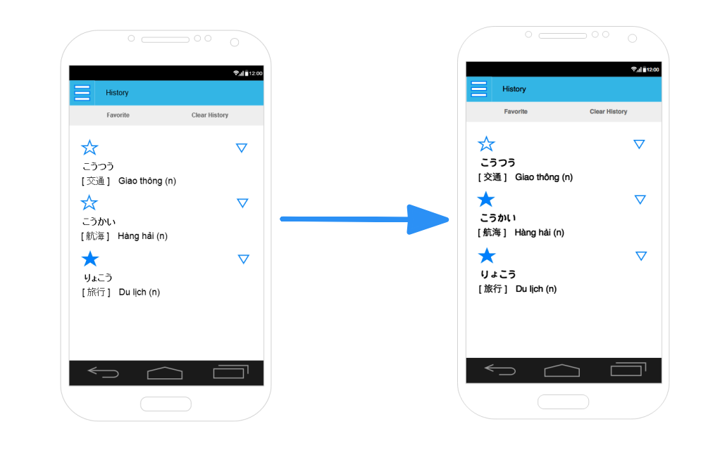

*Figure 23: Screens of UC - 6.2*

|  |  |  |  |
| --- | --- | --- | --- |
| Use Case ID | | | UC – 6.2 |
| Use Name | | | Add to favorite list |
| Actor | | | User |
| Description | | | User adds a word favorite list |
| Precondition | | | System is in History screen |
| Trigger | | | N/A |
| Post-Condition | | | The word is added to favorite list |
| Main flow | | | |
| Step | Actor | | Action |
| 1 | User | | Tap on the grey start icon in the entry of the word that he want to add to favorite list |
| 2 | System | | Change the star to yellow  Add the word in the entry to favorite list in database |
| Alternative flow 1 | | | |
| Precondition | | | System is in History screen |
| 1 | | User | Tap on the Extend icon on the right of a entry |
| 2 | | System | Expand the entry and show detail information of the word in the entry, as in step 2 of UC – 7.1 |
| 3 | | User | Tap on grey star icon in the entry |
| 4 | | System | Change the star to yellow  Add the word in the entry to favorite list |
| Exceptions | | |  |

###### *UC – 6.3 Remove from favorite list (History screen)*

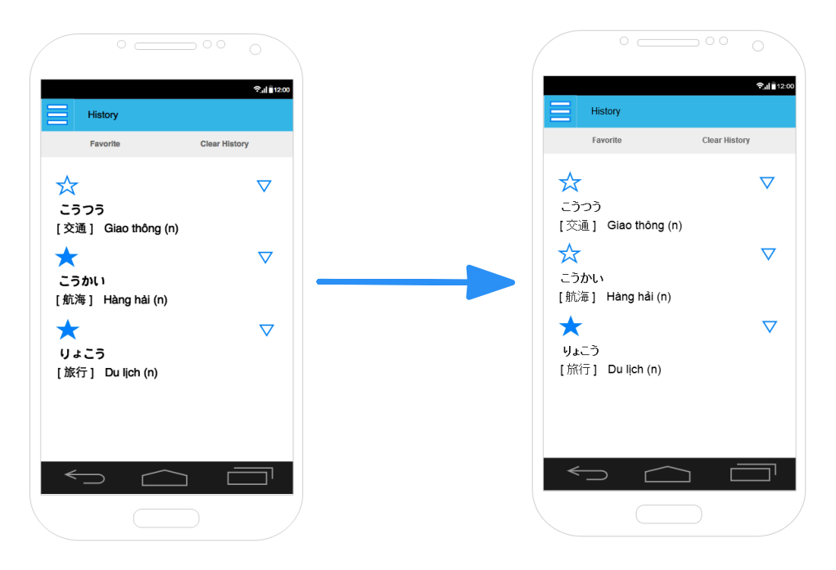

*Figure 24: Screens of UC - 6.3*

|  |  |  |  |
| --- | --- | --- | --- |
| Use Case ID | | | UC – 6.3 |
| Use Name | | | Remove form favorite list |
| Actor | | | User |
| Description | | | User removes a word form favorite list |
| Precondition | | | System is in History or Favorite screen |
| Trigger | | | N/A |
| Post-Condition | | | The word is removed from favorite list |
| Main flow | | | |
| Step | Actor | | Action |
| 1 | User | | Tap on the yellow start icon in the entry of the word that he want to remove from favorite list |
| 2 | System | | Change the star to grey  Remove the word in the entry from favorite list in database |
| Alternative flow 1 | | | |
| Precondition | | | System is in History or Favorite screen |
| 1 | | User | Tap on the Extend icon on the right of a entry |
| 2 | | System | Expand the entry and show detail information of the word in the entry, as in step 2 of UC – 7.1 |
| 3 | | User | Tap on yellow star icon in the entry |
| 4 | | System | Change the star to grey  Remove the word in the entry from favorite list in database |
| Exceptions | | |  |

###### *UC – 6.4 View favorite words only*

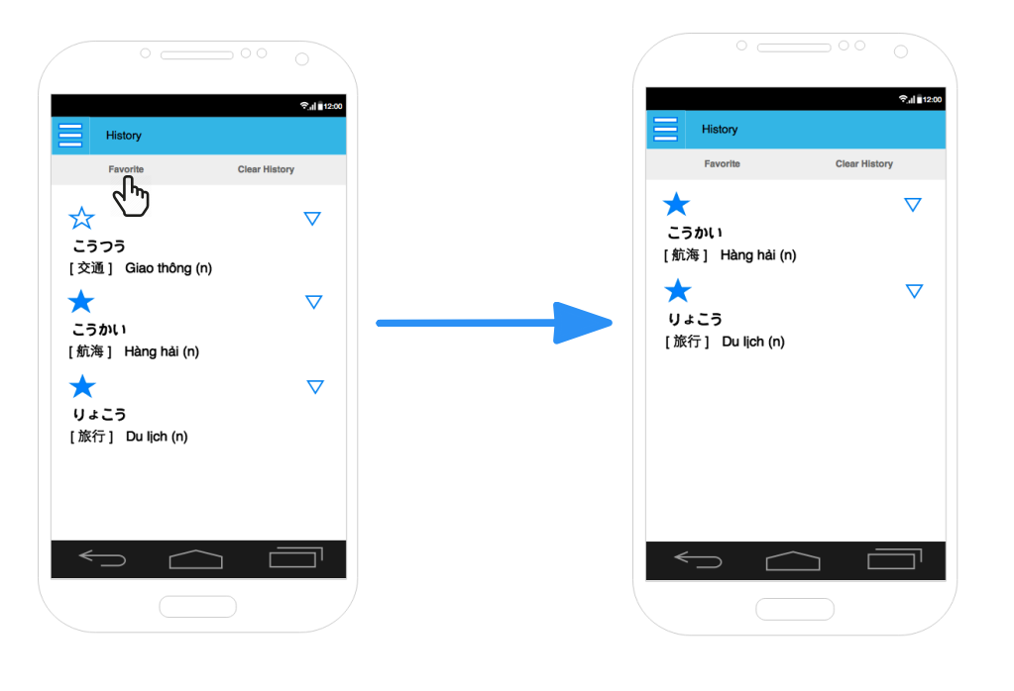

*Figure 25: Screens of UC - 6.4*

|  |  |  |  |  |
| --- | --- | --- | --- | --- |
| Use Case ID | | | | UC – 6.4 |
| Use Name | | | | View favorite words only |
| Actor | | | | User |
| Description | | | | View all word that user put to favorite list |
| Precondition | | | | System is in History screen |
| Trigger | | | | N/A |
| Post-Condition | | | | View all word in favorite list |
| Main flow | | | | |
| Step | | Actor | | Action |
| 1 | | User | | Tap on the Favorite button |
| 2 | | System | | Show all words in favorite list. The words are shown in form of extendable list view.   * In the entry of Japanese word: show Star icon, the word, its reading, the first meaning and word class (as in step 6 of UC – 5. Search in Japanese dictionary) * In the entry of Kanji: show Star icon and the Kanji |
| Alternative flow 1 | | | | |
| Precondition | | | |  |
| 1 | System | | | If there is no word in Favorite list, show message “There is no word in Favorite list” |
| Alternative flow 2 | | | | |
| Precondition | | |  | |
| 1 | User | | After step 2 of the main flow, user tap the Favorite button again | |
| 2 | System | | Back to History screen with all favorite and not favorite words in the History | |
| Exceptions | | | | N/A |

###### *UC – 6.5 Delete a word from history*

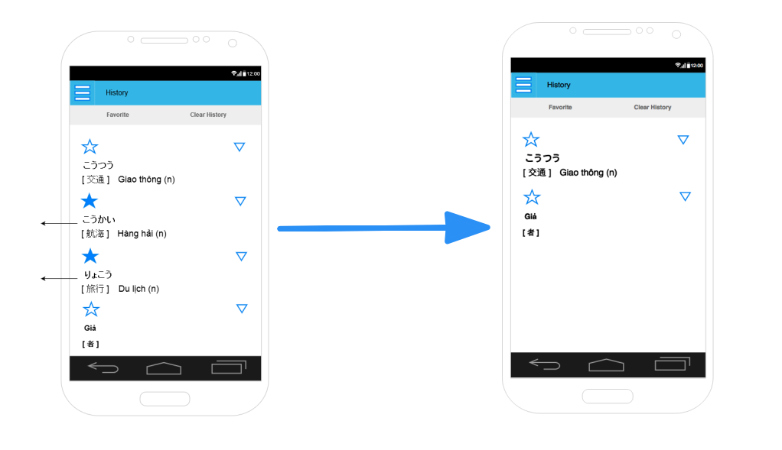

*Figure 26: Screens of UC - 6.5*

|  |  |  |  |
| --- | --- | --- | --- |
| Use Case ID | | | UC – 6.5 |
| Use Name | | | Delete 1 word from History |
| Actor | | | User |
| Description | | | User deletes one word from History |
| Precondition | | | System is in History screen |
| Trigger | | | N/A |
| Post-Condition | | | The deleted word is delete from History table of database |
| Main flow | | | |
| Step | Actor | | Action |
| 1 | User | | Tap on one entry in the History and swap it to the left |
| 2 | System | | Show confirm message form “Do you want to delete the word?”, with 2 button “Yes”, “No” |
| 3 | User | | Press “Yes” button |
| 4 | System | | Remove entry with the word from screen  Delete the word in History table of database |
| Alternative flow | | | |
| Precondition | | |  |
| 1 | | User | In step 3 of main flow, user press “No” button |
| 2 | | System | Close confirm message form |
| Exceptions | | | N/A |

###### *UC – 6.6 Delete all history*

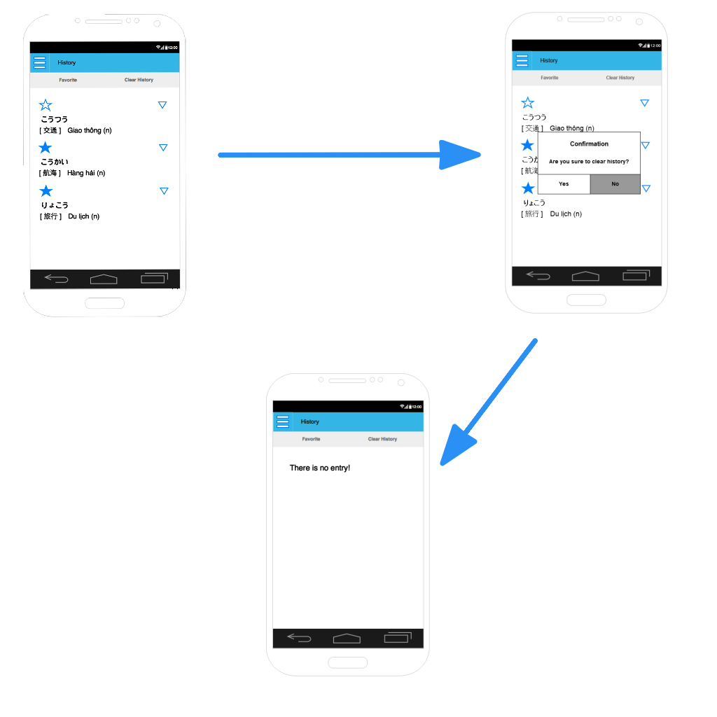

*Figure 27: Screens of UC - 6.6*

|  |  |  |  |
| --- | --- | --- | --- |
| Use Case ID | | | UC – 6.6 |
| Use Name | | | Delete all History |
| Actor | | | User |
| Description | | | User deletes all words from History |
| Precondition | | | System is in History screen |
| Trigger | | | N/A |
| Post-Condition | | | All words are deleted from History table of database |
| Main flow | | | |
| Step | Actor | | Action |
| 1 | User | | Tap on Clear history button |
| 2 | System | | Show confirm message form “Do you want to delete all history?”, with 2 button “Yes”, “No” |
| 3 | User | | Press “Yes” button |
| 4 | System | | Show message “There is no word in history”  Delete all words in History table in database |
| Alternative flow | | | |
| Precondition | | |  |
| 1 | | User | In step 3 of main flow, user press “No” button |
| 2 | | System | Close confirm message form |
| Exceptions | | | N/A |

##### **3.1.2.4.2 Screen description**

| Field Name | Description | Mandatory | Read only | Control type | Data Type | Length |
| --- | --- | --- | --- | --- | --- | --- |
| Header | The title bar of the application | - | - |  | - | - |
| Favorite button | The favorite button of each word or kanji entry. Tapping on this will add or remove the favorite state | - | - | Button | - | - |
| Word (Kana) | The word entries from searching query, always written in Hiragana or Katakana, there may be some entries have the same value | Y | Y | Label | Text | 10 |
| Word (Kanji) | The word entries above written in Kanji, no entries have the same value. | N | Y | Label | Text | 7 |
| Meaning | The meaning of the word entry. Also contain word type (noun, verb, adjective,…) | Y | Y | Label | Text | 30 |
| Extend button | The extend button for each word. Tapping on this will expand or collapse the content of the words to displays examples. The button direction is reserved after each time user tap on it. | - | - | Button | - | - |
| Example | The example area of each word entry. Example contains a Japanese sentence following by a Vietnamese sentence translated from the above one. | Y | Y | Label | Text | 200 |
| Confirmation box | The dialog box appears when user choose to clear history entry(ies) | - | - | Dialog box | - | - |

#### 3.1.2.5 Setting

##### **3.1.2.5.1. User cases**

###### *UC – 7: View Setting screen*

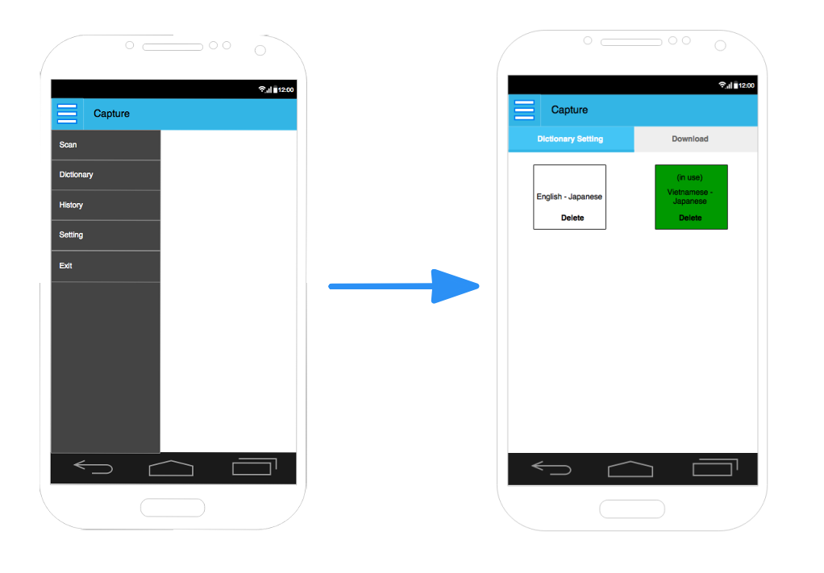

*Figure 28: Screens of UC - 7*

|  |  |  |
| --- | --- | --- |
| Use Case ID | | UC – 7 |
| Use Name | | View Setting screen |
| Actor | | User |
| Description | | User views setting scrren |
| Precondition | |  |
| Trigger | | N/A |
| Post-Condition | | Setting screen is shown |
| Main flow | | |
| Step | Actor | Action |
| 1 | User | Tap on Menu icon in top left of the screen |
| 2 | User | Tap on Setting item |
| 3 | System | Open tab Dictionary setting of Setting screen  In tab Dictionary setting, list all dictionary packages that user has downloaded. The dictionary package is choosen to use for searching word’ information in Dictionary screen is marked. |
| Exceptions | | N/A |

###### *UC – 7.1 Select a dictionary package*

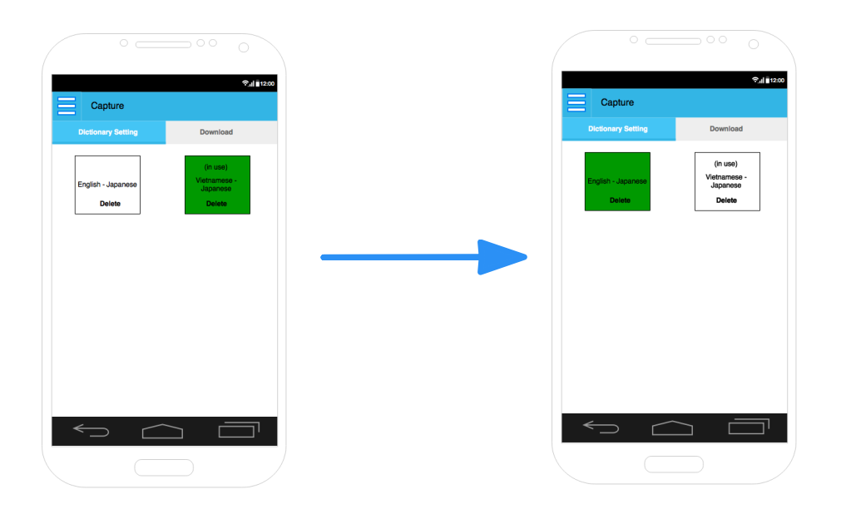

*Figure 29: Screen of UC - 7.1*

|  |  |  |
| --- | --- | --- |
| Use Case ID | | UC – 7.1 |
| Use Name | | Select a dictionary package |
| Actor | | User |
| Description | | User select a dictionary package to use in Dictionary screen |
| Precondition | | System is in Setting screen |
| Trigger | | N/A |
| Post-Condition | | The selected dictionary package is used in Dictionary screen |
| Main flow | | |
| Step | Actor | Action |
| 1 | User | If system is not in tab Dictionary Setting, tap on tab Dictionary Setting |
| 2 | System | Show tab Dictionary Setting with all dictionary package that user has download, and the dictionaray package which is in used is marked. |
| 3 | User | Tab on the dictionary package that he want to use in Dictionary screen |
| 4 | System | Mark the selected dictionary package  Change the dictionary package use for Dictionary screen to selected one. |
| Exceptions | | N/A |

###### *UC – 7.2 Delete a dictionary package*

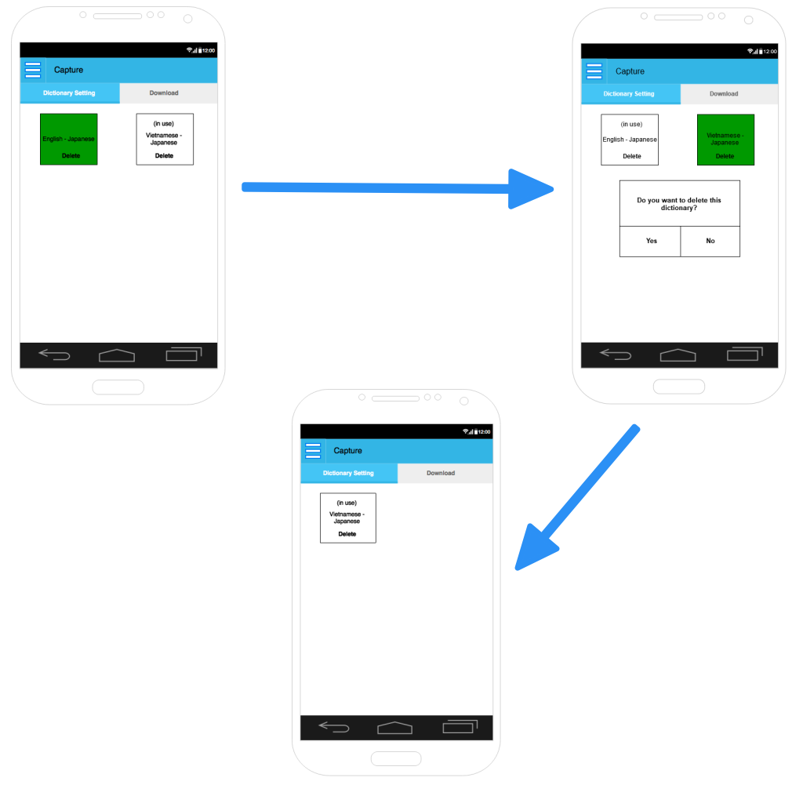

*Figure 30: Screens of UC - 7.2’ main flow*

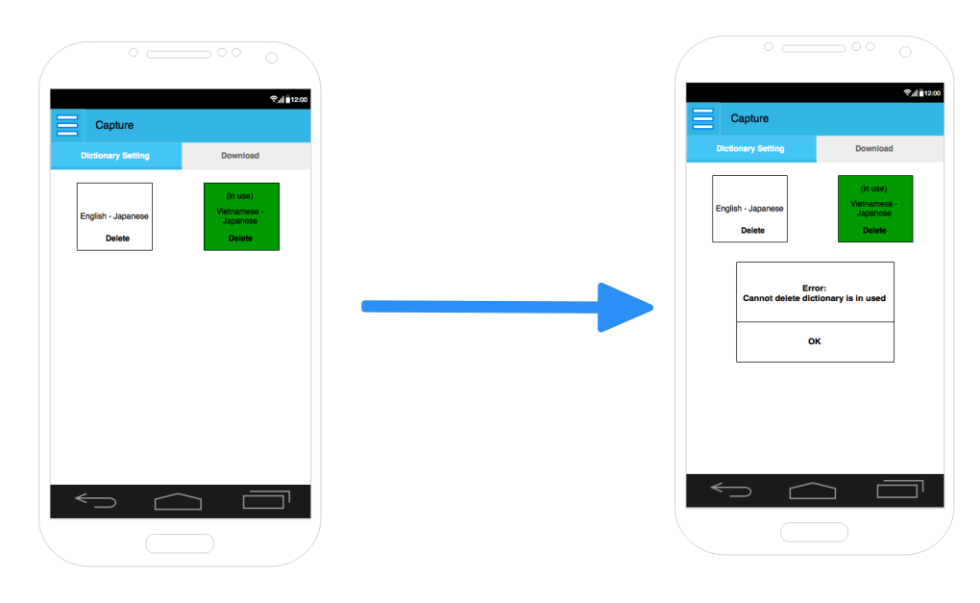

*Figure 31: Screens of UC - 7.2' alternative flow*

|  |  |  |  |
| --- | --- | --- | --- |
| Use Case ID | | | UC – 7.2 |
| Use Name | | | Delete a dictionary package |
| Actor | | | User |
| Description | | | User delete a dictionary package that he has downloaded |
| Precondition | | | System is in tab Dictionary setting of Setting screen |
| Trigger | | | N/A |
| Post-Condition | | | The deleted dictionary package is removed from database |
| Main flow | | | |
| Step | Actor | | Action |
| 1 | User | | Tap on Delete button of the dictionary package that he wants to delete |
| 2 | System | | Show confirm message form: “Do you want to delete [Dictionary package’s name] dictionary package?” with 2 button “Yes” and “Cancel” |
| 3 | User | | Tap on Yes button |
| 4 | System | | Remove the dictionary package from screen  Delete the dictionary package from database |
| Alternative flow 1 | | | |
| Precondition | | |  |
| 1 | | User | In step 3 of the main flow, user tap on “Cancel” button |
| 2 | | System | Close confirm form |
| Alternative flow 2 | | | |
| Precondition | | | System is in Dictionary setting of Setting screen |
| 1 | | User | In step 1 of the main flow, user tap on Delete button of the dictionary package that is using for Dictionary screen |
| 2 | | System | Show warning message form “This dictionary package is in use!” with OK button |
| 3 | | User | Tap on Ok button |
| 4 | | System | Close warning form |
| Exceptions | | | N/A |

###### *UC – 7.3 View dictionary package’s description*

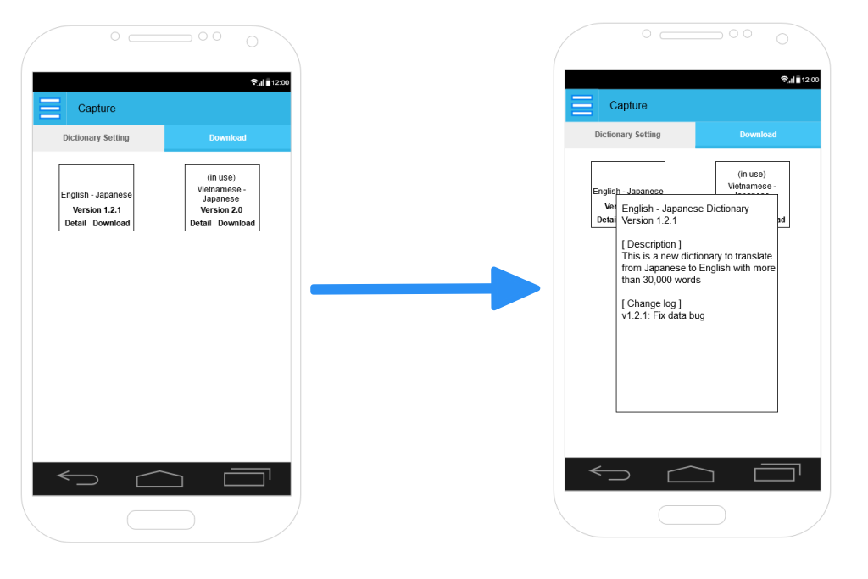

*Figure 32: Screens of UC - 7.3*

|  |  |  |
| --- | --- | --- |
| Use Case ID | | UC – 8.3 |
| Use Name | | View dictionary package’s description |
| Actor | | User |
| Description | | User views description of a dictionary package |
| Precondition | | System is in Setting screen |
| Trigger | | N/A |
| Post-Condition | | The selected describtion of the dictionary package is shown on screen |
| Main flow | | |
| Step | Actor | Action |
| 1 | User | If system is not in tab Download, tap on tab Download |
| 2 | System | Send request to AKServer to get information of all Dictionary package available  Show tab Download with all dictionary packages available on server and has not been downloaded |
| 3 | User | Tap Detail button of a package that he wants to view detail description |
| 4 | System | Pop out a form with description of the package, with OK button |
| 5 | User | Tap on OK button |
| 6 | System | Close the form |
| Exceptions | | N/A |

###### *UC – 7.4 Download a dictionary package*

|  |  |  |  |
| --- | --- | --- | --- |
| Use Case ID | | | UC – 8.4 |
| Use Name | | | Download a dictionary package |
| Actor | | | User |
| Description | | | User downloads a new dictionary package |
| Precondition | | | System is in tab Download of Setting screen |
| Trigger | | | N/A |
| Post-Condition | | | The dictionary package is saved in the application |
| Main flow | | | |
| Step | Actor | | Action |
| 1 | User | | Tap on Download button of the dictionary package that he wants to download |
| 2 | System | | Show confirm message form: “Do you want to download [Dictionary package’s name] dictionary package?” with 2 button “Yes” and “Cancel” |
| 3 | User | | Tap on Yes button |
| 4 | System | | Request to AKServer to get the dictionary package  Show status bar while downloading the dictionary package |
| 5 | System | | Close the status bar when download is completed |
| Alternative flow 1 | | | |
| Precondition | | |  |
| 1 | | User | In step 3 of the main flow, user tap on “Cancel” button |
| 2 | | System | Close confirm form |
| Exceptions | | | If application is not connecting to the internet, show message form “Please connect to the internet to download this dictionary package” |

##### **3.1.2.5.2. Screen description**

| Field Name | Description | Mandatory | Read only | Control type | Data Type | Length |
| --- | --- | --- | --- | --- | --- | --- |
| Title bar | The title bar of the application | - | - | Label | - | - |
| Menu bar | The tab bar of the dictionary feature, contain 2 tab buttons: Setting Dictionary Downlaod | - | - | Button | - | - |
| Dictionary item | A dictionary item, contains its name, current version, tapping on this item will set the dictionary to “in use” state | - | - | Component | - | - |
| Delete button | The delete button of each dictionary item in setting tab | - | - | Button | - | - |
| Error dialog | The dialog that show error when user tries to delete a dictionary that are currently “in use” | - | - | Dialog box | - | - |
| Detail button | The detail button of each dictionary item in download tab | - | - | Button | - | - |
| Detail box | The box containing all description about the selected dictionary | - | - | Box | Text | 500 |
| Download/Update button | The download button of each dictionary. Will change to update button if the dictionary is already exist in user’s device | - | - | Button | - | - |
| Confirmation box | The dialog box appears when user choose to delete dictionary | - | - | Dialog box | - | - |

## 3.2. Server

### 3.2.1 User case diagram

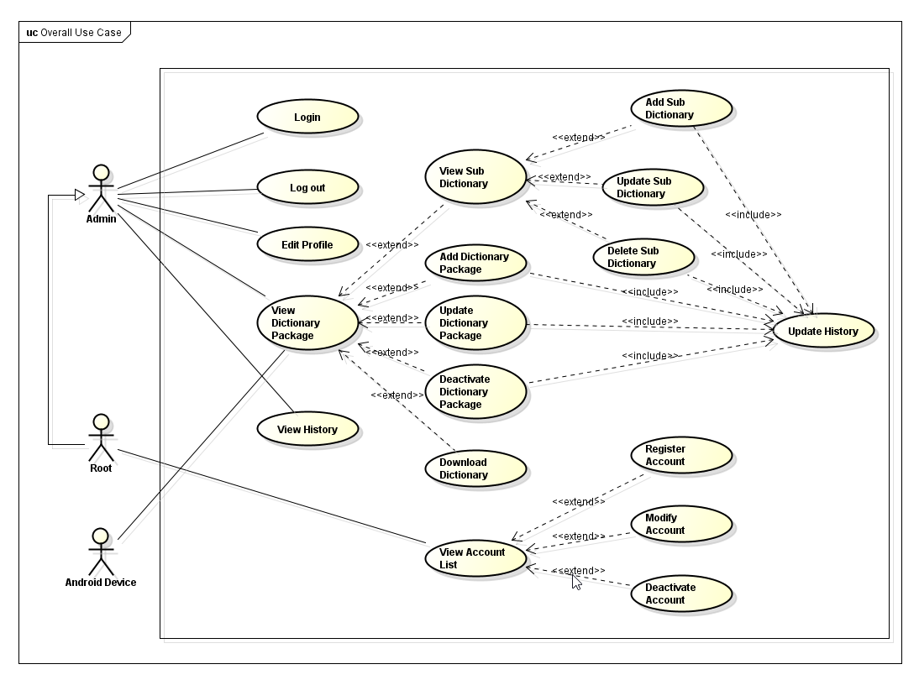

*Figure 33: User case diagram for server*

### 3.2.2. Functions

#### 3.2.2.1 Login

##### **3.2.2.1.1 User cases**

###### *UC – 8. Login*

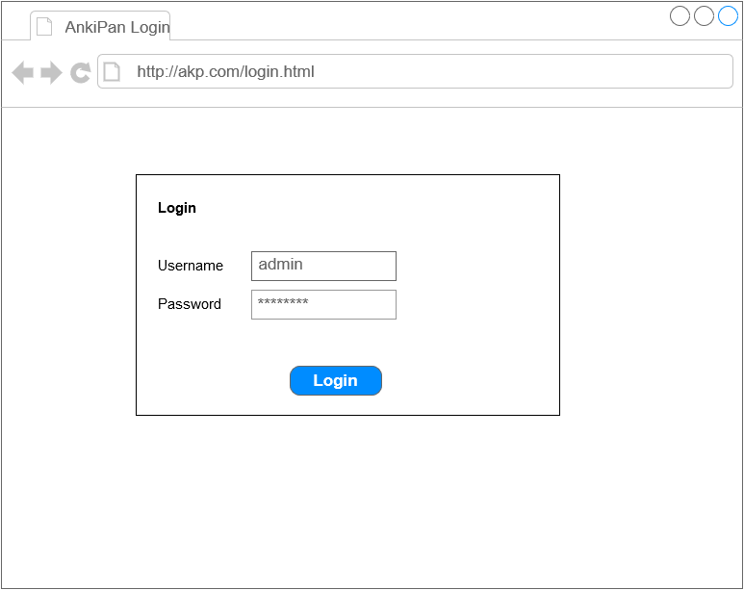

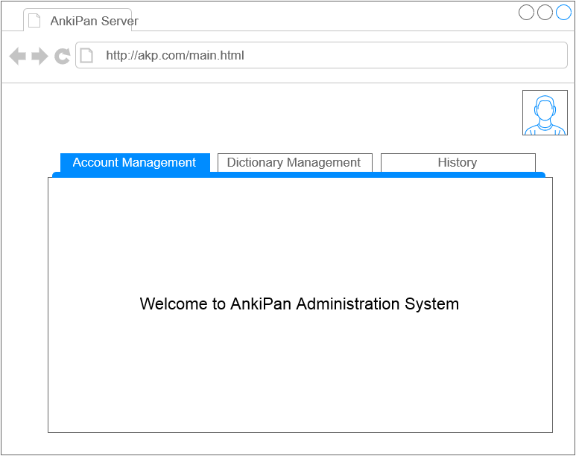

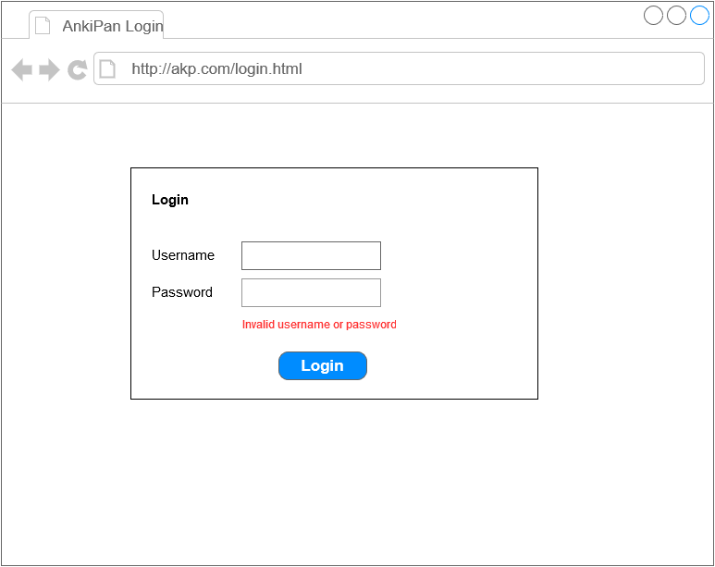

*Figure 34: Screens of UC - 8*

|  |  |  |  |
| --- | --- | --- | --- |
| Use Case ID | | | UC – 8 |
| Use Name | | | Login |
| Actor | | | Admin |
| Description | | | Admin login into AnkiPan Server |
| Precondition | | | Internet connection |
| Trigger | | | N/A |
| Post-Condition | | | The admin’s session is stored |
| Main flow | | | |
| Step | Actor | | Action |
| 1 | Admin | | Type Ankipan’s URL into the address box of the browser, then press “Enter” or use “Go” button |
| 2 | System | | Display the index page, which allows admin to login |
| 3 | Admin | | Enter his/her username and password, click “Login” button |
| 4 | System | | Validate input information, then grant access to AnkiPan Server |
| Alternative flow 1 | | | |
| Precondition | | | In step 3, admin entered incorrect information |
| 1 | | User | Entered incorrect information |
| 2 | | System | Validated information, then display the login page again with error message “Incorrect username and password” |
| Exceptions | | | N/A |

##### **3.2.2.1.2. Screen description**

| Screen | Field Name | Description | Mandatory | Read only | Control type | Data Type | Length |
| --- | --- | --- | --- | --- | --- | --- | --- |
| Login page | Username | The username field of the login form.  Default value: none. | Y | N | Text field | Text | 20 |
| Password | The password field of the login form, mask every character user typed in with asterisk (*).  Default value: none | Y | N | Password field | Text | 20 |
| Login button | The button for logining into the system | - | - | Button | - | - |
| Main page | Navigation bar | The main navigation bar of the entire system, containing 3 item: Account list (only for root admin), Dictionary list, History list | - | - | Navigation bar | - | - |
| Welcome text | The welcome text display in the content pane after user login into the system  Default value: “Welcome to AnkiPan Administration System” | Y | Y | Text | Text | 50 |
| Avatar | The profile picture of the current user | - | - | Picture | - | - |
| Login fail page | Error message | The error message when user enter incorrect username or password then login | Y | Y | Text | Text | 30 |

#### 3.2.2.2 Log out

##### **3.2.2.2.1 User cases**

###### *UC – 9.2. Log out*

|  |  |  |  |
| --- | --- | --- | --- |
| Use Case ID | | | UC – 9.2 |
| Use Name | | | Log out |
| Actor | | | Admin |
| Description | | | Admin log out from AnkiPan Server |
| Precondition | | | Internet connection |
| Trigger | | | N/A |
| Post-Condition | | | The admin’s session is ended |
| Main flow | | | |
| Step | Actor | | Action |
| 1 | Admin | | Click “Log out” link on the upper right of the browser screen |
| 2 | System | | Ended admin’s session, then redirect admin to the index page |
| Alternative flow 1 | | | |
| Precondition | | |  |
|  | |  | N/A |
| Exceptions | | | N/A |

#### 3.2.2.3 Manage profile

##### **3.2.2.3.1 User cases**

###### *UC – 10.1 Edit Profile*

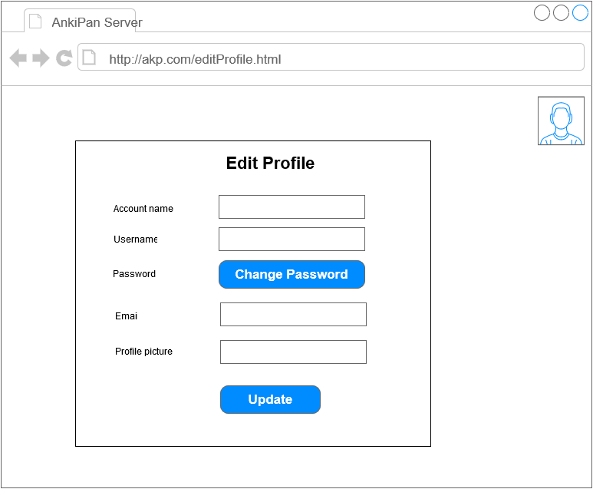

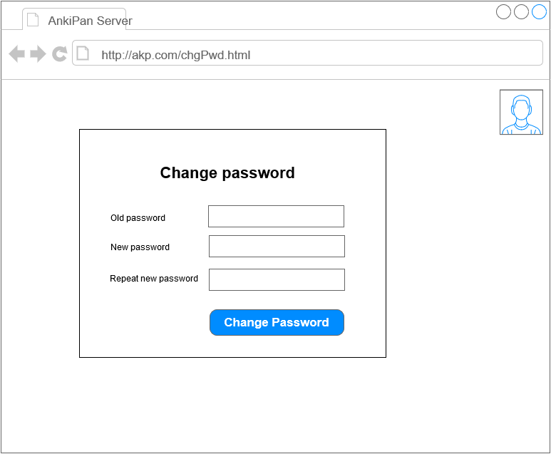

|  |  |  |  |
| --- | --- | --- | --- |
| Use Case ID | | | UC – 10.1 |
| Use Name | | | Edit Profile |
| Actor | | | Admin |
| Description | | | Admin edit owned profile |
| Precondition | | | Internet connection |
| Trigger | | | N/A |
| Post-Condition | | | The admin’s session is ended |
| Main flow | | | |
| Step | Actor | | Action |
| 1 | Admin | | Click “Welcome” link or the admin’s logo on the upper right of the browser screen |
| 2 | System | | Load admin’s information, then display the edit profile form, with user information entered. |
| 3 | Admin | | Edit information, and click Update |
| 4 | System | | Update admin’s new information into the database, then redirect to the main screen |
| Alternative flow 1 | | | |
| Precondition | | | At step 3 of the main flow, user leave any field blank |
| 1 | | Admin | Leave any field blank |
| 2 | | System | Surround the field with red lines, notify admin to enter that field |
| Exceptions | | | N/A |

###### *UC 10.2 – View Account List*

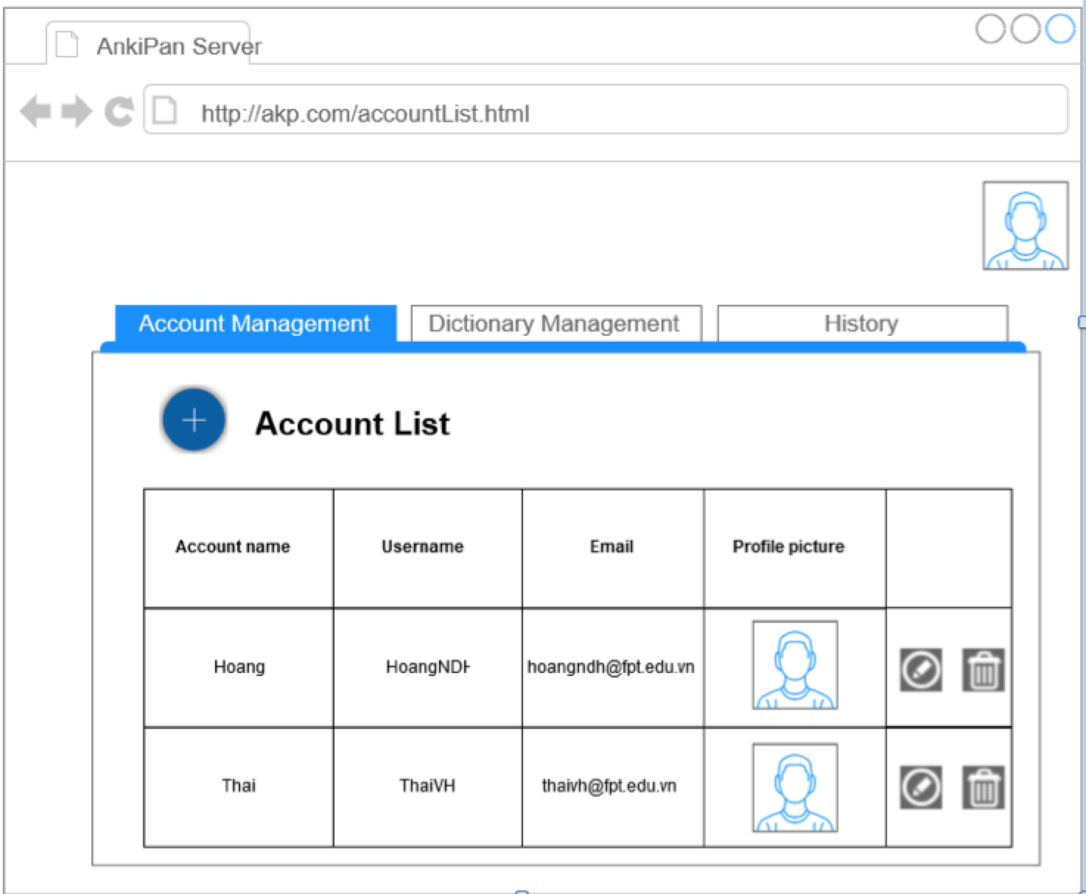

|  |  |  |  |
| --- | --- | --- | --- |
| Use Case ID | | | UC – 10.2 |
| Use Name | | | View Account List |
| Actor | | | Root Admin |
| Description | | | Root Admin view other admin’s account list |
| Precondition | | | Internet Connection |
| Trigger | | | N/A |
| Post-Condition | | | N/A |
| Main flow | | | |
| Step | Actor | | Action |
| 1 | Admin | | Click on “Account List” link on taskbar |
| 2 | System | | Get the admin’s account list |
| 4 | System | | Display the account list on the screen |
| Alternative flow 1 | | | |
| Precondition | | |  |
| 1 | | User | Admin try to access the account list link |
| 2 | | System | Block admin and redirect to main page |
| Exceptions | | | N/A |

###### *UC 10.3 – Register account*

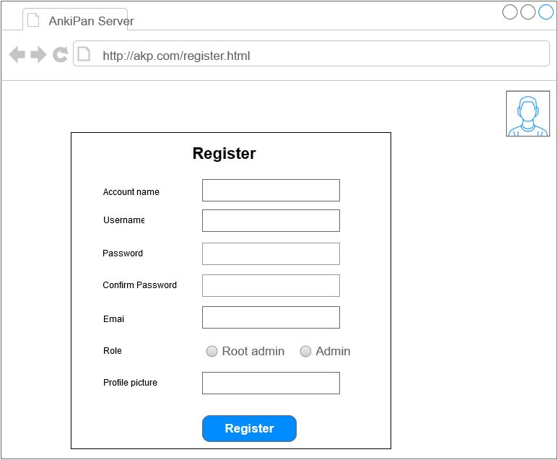

|  |  |  |  |
| --- | --- | --- | --- |
| Use Case ID | | | UC – 10.3 |
| Use Name | | | Register account |
| Actor | | | Root admin |
| Description | | | Root admin create new account for other admin access |
| Precondition | | | Internet Connection |
| Trigger | | | N/A |
| Post-Condition | | | New account is created and added into the database |
| Main flow | | | |
| Step | Actor | | Action |
| 1 | Root admin | | Click “Create new account” link on the tab bar |
| 2 | System | | Display the add new account form |
| 3 | Root admin | | Enter new admin’s information into fields, then click “Register” |
| 4 | System | | Validate input |
| 5 | System | | Add new account into the database, then return to account list page |
| Alternative flow 1 | | | |
| Precondition | | |  |
| 1 | | Root admin | In step 3 of the main flow, root admin leaves any field blank |
| 2 | | System | Surround the empty field with red lines, require root admin to fill that field |
| Alternative flow 2 | | | |
| Precondition | | |  |
| 1 | | Root admin | In step 3 of the main flow, root admin fill incorrect email, then click “Register” |
| 2 | | System | Show error message “Invalid email address” |
| 3 | | Root admin | Tap on Ok button |
| 4 | | System | Close error message |
| Exceptions | | | N/A |

###### *UC 10.4 – Modify account*

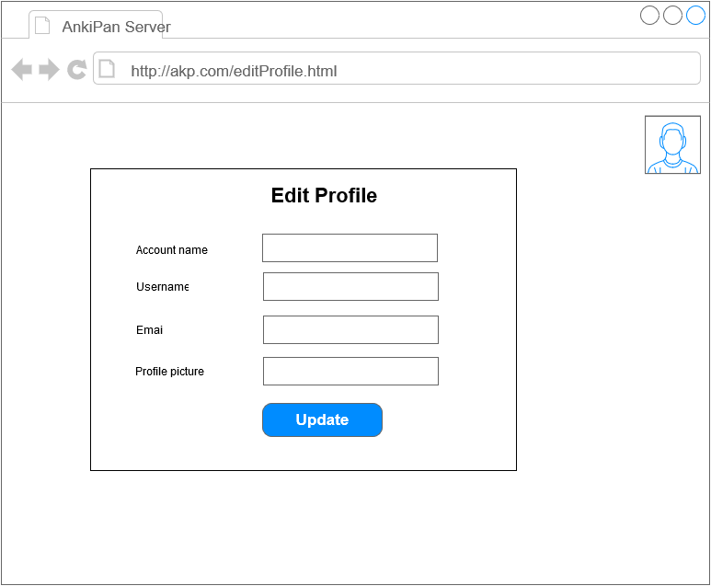

|  |  |  |  |
| --- | --- | --- | --- |
| Use Case ID | | | UC – 10.4 |
| Use Name | | | Modify account |
| Actor | | | Root admin |
| Description | | | Root admin modify other admin account |
| Precondition | | | Internet Connection  Root admin is at account list page |
| Trigger | | | N/A |
| Post-Condition | | | Admin’s account is modified and save into the database |
| Main flow | | | |
| Step | Actor | | Action |
| 1 | Root admin | | On the account list page, click the pen button at the right of admin account |
| 2 | System | | Display the update account page |
| 3 | Root admin | | Enter admin’s new information into fields, then click “Update” |
| 4 | System | | Validate input |
| 5 | System | | Update new account into the database, then return to account list page |
| Alternative flow 1 | | | |
| Precondition | | |  |
| 1 | | Root admin | In step 3 of the main flow, root admin leaves any field blank |
| 2 | | System | Surround the empty field with red lines, require root admin to fill that field |
| Alternative flow 2 | | | |
| Precondition | | |  |
| 1 | | Root admin | In step 3 of the main flow, root admin fill incorrect email, then click “Update” |
| 2 | | System | Show error message “Invalid email address” |
| 3 | | Root admin | Tap on Ok button |
| 4 | | System | Close error message |
| Exceptions | | | N/A |

###### *UC 10.5 – Deactivate account*

|  |  |  |  |
| --- | --- | --- | --- |
| Use Case ID | | | UC – 10.5 |
| Use Name | | | Deactivate account |
| Actor | | | Root admin |
| Description | | | Root admin deactivate other admin’s account, preventing him/her from accessing the system |
| Precondition | | | Internet Connection  Root admin is at account list page |
| Trigger | | | N/A |
| Post-Condition | | | Admin’s account is deactivated and cannot be used to access the system again. |
| Main flow | | | |
| Step | Actor | | Action |
| 1 | Root admin | | On the account list page, click the trash bin icon at the right of the admin’s account information |
| 2 | System | | Deactivate the account, then display the list again, with that account removed |
| Alternative flow 1 | | | |
| Precondition | | |  |
|  | |  | N/A |
| Exceptions | | | N/A |

##### **3.2.2.3.2 Screen description**

| Screen | Field Name | Description | Mandatory | Read only | Control type | Data Type | Length |
| --- | --- | --- | --- | --- | --- | --- | --- |
| Account List page | Account table | The table containing account information about admin (including root admin) | - | - | Table | - | - |
| Account name column | The account name column of the list of admins | - | - | Table header | - | - |
| Username column | The username column of the list of admins | - | - | Table header | - | - |
| Email column | The email column of the list of admins | - | - | Table header | - | - |
| Role column | The role column of the list of admins | - | - | Table header | - | - |
| Profile picture column | The profile picture column of the list of admins | - | - | Table header | - | - |
| Edit profile page | Account name | The account name of the current admin, this field is fixed  Default value: current admin’s account name | Y | Y | Text field | Text | 30 |
| Username | The account name of the current admin  Default value: current admin’s username | Y | N | Text field | Text | 30 |
| Password button | The change password button | - | - | Button | - | - |
| Email | The emai of the current admin  Default value: current admin’s email | Y | N | Text field | Text | 50 |
| Profile Picture | The profile picture of the current admin  Default value: none | - | - | File | - | - |
| Change password page | Old password | The old password of the current user, mask all character with asterisk (*)  Default value: none  Constant: more than 6 characters, no space | Y | N | Password field | Text | 30 |
| New password | The new password of the current user, mask all character with asterisk (*)  Default value: none | Y | N | Password field | Text | 30 |
| Repeat new password | The old password of the current user, mask all character with asterisk (*)  Default value: none | Y | N | Password field | Text | 30 |
| Register Page | Account name | The account name of the new admin  Default value: none | Y | N | Text field | Text | 30 |
| Username | The username of the new admin  Default value: none | Y | N | Text field | Text | 30 |
| Password | The password of the new admin, mask all field with asterisk (*)  Default value: none | Y | N | Password field | Text | 30 |
| Confirm password | The password confirmation of the new admin, mask all field with asterisk (*)  Default value: none | Y | N | Password field | Text | 30 |
| Email | The email of the new admin  Default value: none  Constant: contain @ and domain name | Y | N | Text field | Text | 30 |
| Role | The role of the new admin, containing 2 items which root admin will choose 1: admin and root admin | - | - | Radio box | - | - |
| Profile Picture | The profile picture of the new admin | - | - | File | - | - |
| Register button | The register button of the register form | - | - | Button | - | - |

#### 3.2.2.4 Manage dictionary packages

##### **3.2.2.4.1 User cases**

###### *UC 11.1 - View Dictionary Package*

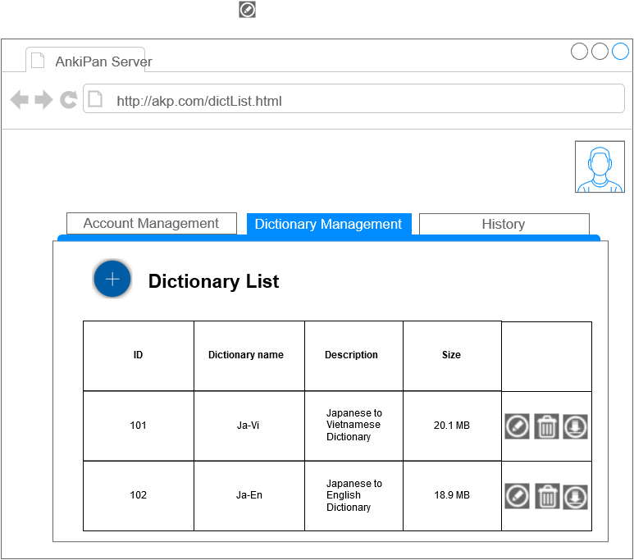

|  |  |  |  |
| --- | --- | --- | --- |
| Use Case ID | | | UC – 11.1 |
| Use Name | | | View Dictionary Package |
| Actor | | | Admin |
| Description | | | Admin view dictionary package list |
| Precondition | | | Internet Connection |
| Trigger | | | N/A |
| Post-Condition | | | N/A |
| Main flow | | | |
| Step | Actor | | Action |
| 1 | Admin | | Click on “Dictionary Package List” link on taskbar |
| 2 | System | | Get the dictionary package list |
| 4 | System | | Display the dictionary package list on the screen |
| Alternative flow 1 | | | |
| Precondition | | |  |
|  | |  | N/A |
| Exceptions | | | N/A |

###### *UC 11.2 – Add Dictionary Package*

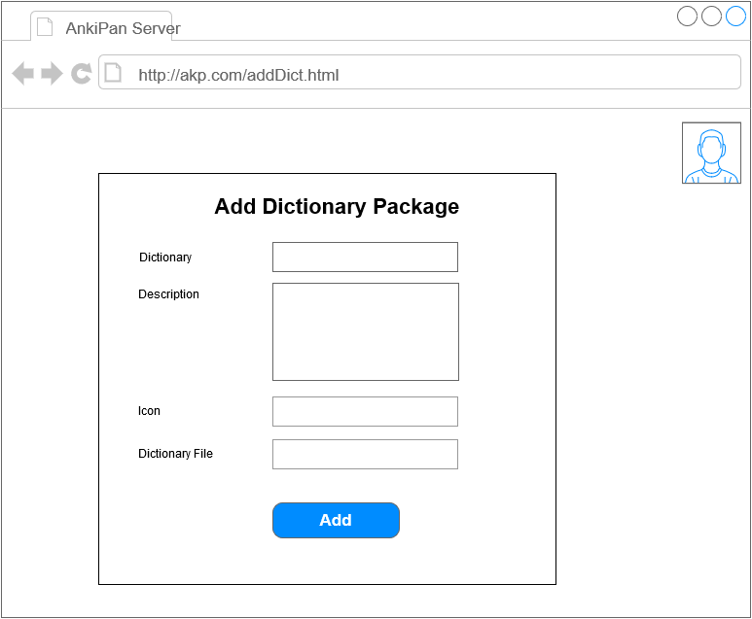

|  |  |  |  |
| --- | --- | --- | --- |
| Use Case ID | | | UC – 11.2 |
| Use Name | | | Add Dictionary Package |
| Actor | | | Admin |
| Description | | | Admin add new dictionary package |
| Precondition | | | Internet Connection  Admin is at the dictionary package list |
| Trigger | | | N/A |
| Post-Condition | | | New dictionary package is created and added into the database |
| Main flow | | | |
| Step | Actor | | Action |
| 1 | Admin | | On the dictionary package list, click the + button |
| 2 | System | | Display the add new dictionary form |
| 3 | Admin | | Enter new dictionary package’s information into fields, then click “Add” |
| 4 | System | | Validate input |
| 5 | System | | Add new dictionary package into the database, then return to dictionary package list page |
| Alternative flow 1 | | | |
| Precondition | | |  |
| 1 | | Admin | In step 3 of the main flow, admin leaves any field blank |
| 2 | | System | Surround the empty field with red lines, require admin to fill that field |
| Exceptions | | | N/A |

###### *UC 11.3 – Update Dictionary Package*

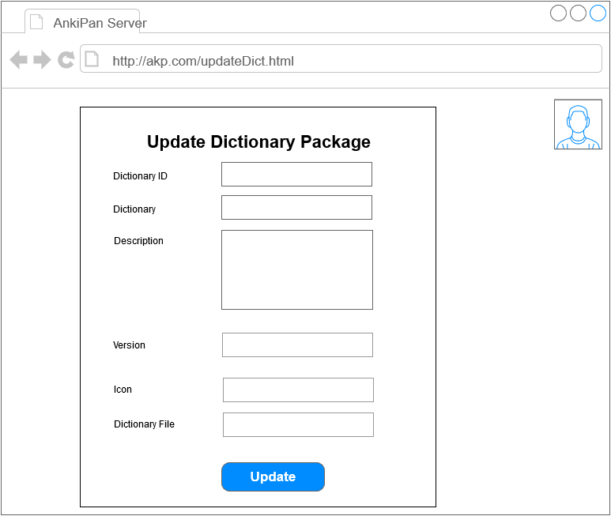

|  |  |  |  |
| --- | --- | --- | --- |
| Use Case ID | | | UC – 11.3 |
| Use Name | | | Update Dictionary Package |
| Actor | | | Admin |
| Description | | | Admin update the dictionary package |
| Precondition | | | Internet Connection  Admin is at dictionary package list page |
| Trigger | | | N/A |
| Post-Condition | | | Dictionary package is updated and save into the database |
| Main flow | | | |
| Step | Actor | | Action |
| 1 | Admin | | On the dictionary package list page, click the pen icon at the right of the dictionary package |
| 2 | System | | Display the update dictionary package page |
| 3 | Admin | | Enter new dictionary package’s information into fields, then click “Update” |
| 4 | System | | Validate input |
| 5 | System | | Update new dictionary package’s information into the database, then return to dictionary package list page |
| Alternative flow 1 | | | |
| Precondition | | |  |
| 1 | | Admin | In step 3 of the main flow, Admin leaves any field blank |
| 2 | | System | Surround the empty field with red lines, require admin to fill that field |
| Exceptions | | | N/A |

###### *UC 11.4 – Deactivate Dictionary Package*

|  |  |  |  |
| --- | --- | --- | --- |
| Use Case ID | | | UC – 11.4 |
| Use Name | | | Deactivate Dictionary Package |
| Actor | | | Admin |
| Description | | | Admin deactivate the dictionary package |
| Precondition | | | Internet Connection  Admin is at dictionary package list page |
| Trigger | | | N/A |
| Post-Condition | | | Dictionary Package is deactivated and any device cannot get its information |
| Main flow | | | |
| Step | Actor | | Action |
| 1 | Admin | | On the dictionary package list page, click the trash bin icon at the right of the dictionary package information |
| 2 | System | | Deactivate the dictionary package, then display the dictionary package list again, with that dictionary package removed |
| Alternative flow 1 | | | |
| Precondition | | |  |
|  | |  | N/A |
| Exceptions | | | N/A |

**3.2.2.4.2 Screen description**

| Screen | Field Name | Description | Mandatory | Read only | Control type | Data Type | Length |
| --- | --- | --- | --- | --- | --- | --- | --- |
| Dictionary List page | Dictionary table | The table containing dictionary information | - | - | Table | - | - |
| ID column | The ID column of the list of dictionary package | - | - | Table header | - | - |
| Dictionary name column | The name column of the list of dictionary package | - | - | Table header | - | - |
| Description column | The description column of the list of dictionary package | - | - | Table header | - | - |
| Size | The size column of the list of dictionary package | - | - | Table header | - | - |
| Toolbox colum | The toolbox column of the list of dictionary package, containing button related to the dictionary of the same row | - | - | Table header | - | - |
| Add dictionary page | Dictionary name | The name of the new dictionary  Default value: none | Y | Y | Text field | Text | 30 |
| Description | The desciprion of the new dictionary  Default value: none | Y | N | Text  area | Text | 250 |
| Icon | The icon of the new dictionary | - | - | File | - | - |
| Dictionary file | The file of the new dictionary | - | - | File | - | - |
| Add button | The add dictionary form’s button | - | - | Button | - | - |
| Update dictionary page | Dictionary ID | The ID of the current dictionary, this field is fixed  Default value: current dictionary’s ID | Y | Y | Text field | Text | 5 |
| Dictionary name | The name of the current dictionary  Default value: current dictionary’s name | Y | N | Text field | Text | 30 |
| Description | The desciprion of the current dictionary  Default value: current dictionary’s description | Y | N | Text  area | Text | 250 |
| Version | The version of the current dictionary  Default value: current dictionary’s version | Y | N | Text field | Text | 10 |
| Icon | The icon of the new dictionary | - | - | File | - | - |
| Dictionary file | The file of the new dictionary | - | - | File | - | - |
| Update button | The add dictionary form’s button | - | - | Button | - | - |

###### *UC 11.5 – View Sub Dictionary*

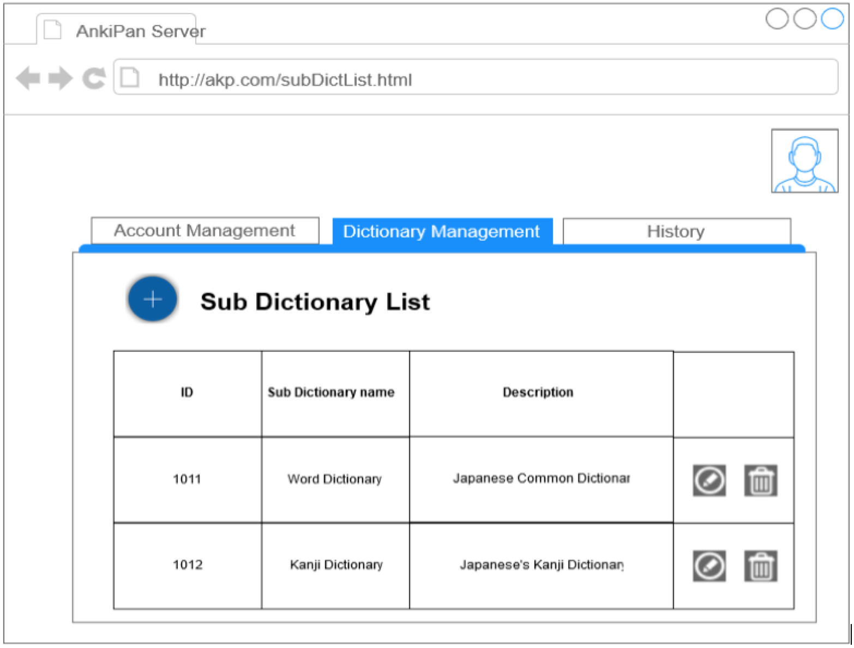

|  |  |  |  |
| --- | --- | --- | --- |
| Use Case ID | | | UC – 11.5 |
| Use Name | | | View Sub Dictionary |
| Actor | | | Admin |
| Description | | | Admin view sub dictionary list |
| Precondition | | | Internet Connection  Admin is at dictionary package list page |
| Trigger | | | N/A |
| Post-Condition | | | N/A |
| Main flow | | | |
| Step | Actor | | Action |
| 1 | Admin | | On the dictionary package list page, click on the dictionary package |
| 2 | System | | Get the sub dictionary list |
| 4 | System | | Display the sub dictionary list on the screen |
| Alternative flow 1 | | | |
| Precondition | | |  |
|  | |  | N/A |
| Exceptions | | | N/A |

###### *UC 11.6 – Add Sub Dictionary*

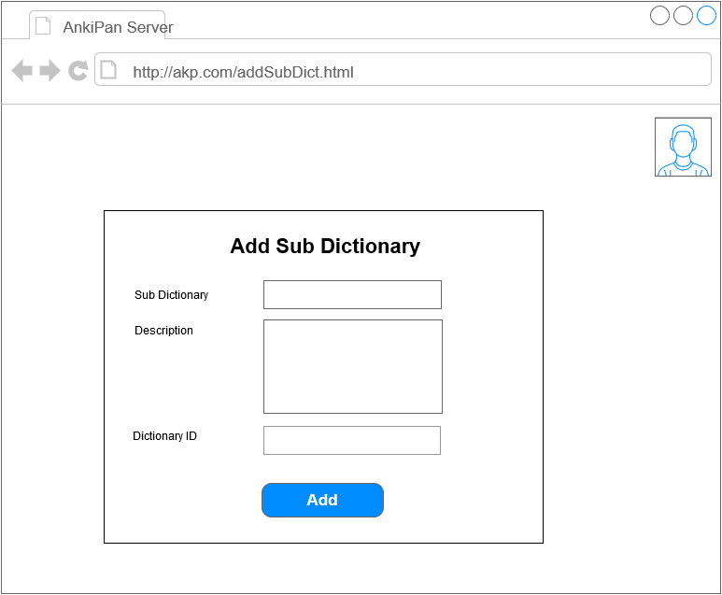

|  |  |  |  |
| --- | --- | --- | --- |
| Use Case ID | | | UC – 11.6 |
| Use Name | | | Add Sub Dictionary |
| Actor | | | Admin |
| Description | | | Admin add new sub dictionary |
| Precondition | | | Internet Connection  Admin is at the sub dictionary list |
| Trigger | | | N/A |
| Post-Condition | | | New sub dictionary is created and added into the database |
| Main flow | | | |
| Step | Actor | | Action |
| 1 | Admin | | On the sub dictionary list, click the + button |
| 2 | System | | Display the add new sub dictionary form |
| 3 | Admin | | Enter new sub dictionary’s information into fields, then click “Add” |
| 4 | System | | Validate input |
| 5 | System | | Add new sub dictionary into the database, then return to sub dictionary list page |
| Alternative flow 1 | | | |
| Precondition | | |  |
| 1 | | Admin | In step 3 of the main flow, admin leaves any field blank |
| 2 | | System | Surround the empty field with red lines, require admin to fill that field |
| Exceptions | | | N/A |

###### *UC 11.7 – Update Sub Dictionary*

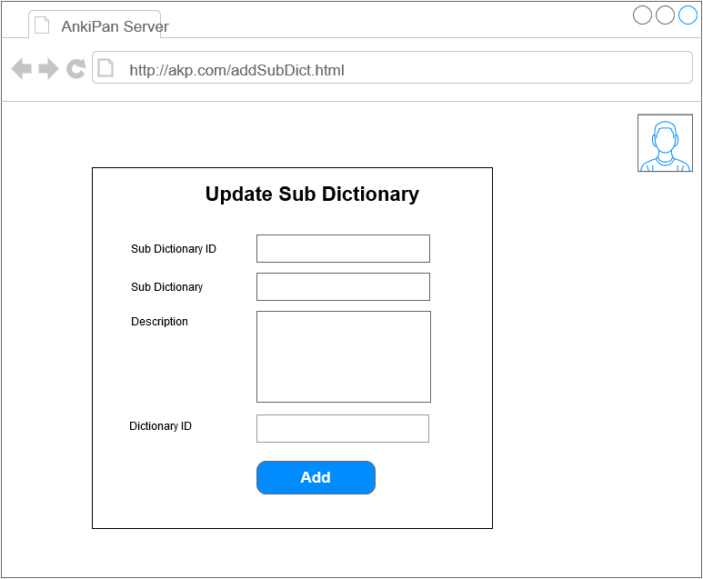

|  |  |  |  |
| --- | --- | --- | --- |
| Use Case ID | | | UC – 11.7 |
| Use Name | | | Update Sub Dictionary |
| Actor | | | Admin |
| Description | | | Admin update the sub dictionary |
| Precondition | | | Internet Connection  Admin is at sub dictionary list page |
| Trigger | | | N/A |
| Post-Condition | | | Sub dictionary is updated and save into the database |
| Main flow | | | |
| Step | Actor | | Action |
| 1 | Admin | | On the account list page, click the pen icon at the right of the sub dictionary |
| 2 | System | | Display the update sub dictionary page |
| 3 | Admin | | Enter new sub dictionary’s information into fields, then click “Update” |
| 4 | System | | Validate input |
| 5 | System | | Update new sub dictionary’s information into the database, then return to sub dictionary list page |
| Alternative flow 1 | | | |
| Precondition | | |  |
| 1 | | Admin | In step 3 of the main flow, Admin leaves any field blank |
| 2 | | System | Surround the empty field with red lines, require admin to fill that field |
| Exceptions | | | N/A |

###### *UC 11.8 – Delete Sub Dictionary*

|  |  |  |  |
| --- | --- | --- | --- |
| Use Case ID | | | UC – 11.8 |
| Use Name | | | Delete Sub Dictionary |
| Actor | | | Admin |
| Description | | | Admin delete the sub dictionary |
| Precondition | | | Internet Connection  Admin is at sub dictionary list page |
| Trigger | | | N/A |
| Post-Condition | | | Sub Dictionary is deleted from the database |
| Main flow | | | |
| Step | Actor | | Action |
| 1 | Admin | | On the sub dictionary list page, click the trash bin icon at the right of the sub dictionary information |
| 2 | System | | Delete the sub dictionary, then re-display the sub dictionary package list |
| Alternative flow 1 | | | |
| Precondition | | |  |
|  | |  | N/A |
| Exceptions | | | N/A |

###### *UC 11.9 – Download Dictionary*

|  |  |  |  |
| --- | --- | --- | --- |
| Use Case ID | | | UC – 11.9 |
| Use Name | | | Download Dictionary |
| Actor | | | Admin, Android Device |
| Description | | | Admin and any Android Device perform downloading the dictionary |
| Precondition | | | Internet Connection |
| Trigger | | | N/A |
| Post-Condition | | | Dictionary is downloaded to the user’s device |
| Main flow | | | |
| Step | Actor | | Action |
| 1 | Admin | | On the dictionary package list, click the download icon at the right of the dictionary package’s information |
| 2 | System | | Get the dictionary data |
| 3 | System | | Transfer the dictionary data to user device |
| Alternative flow 1 | | | |
| Precondition | | |  |
| 1 | | Android Device | At the step 1 of the main flow, Android device request an URL with dictionary package ID to the system |
| 2 | | System | Get the dictionary data |
| 3 | | System | Transfer the dictionary data to user device |
| Exceptions | | | N/A |

##### **3.2.2.4.2 Screen description**

| Screen | Field Name | Description | Mandatory | Read only | Control type | Data Type | Length |
| --- | --- | --- | --- | --- | --- | --- | --- |
| Sub Dictionary List page | Sub Dictionary table | The table containing sub dictionary information | - | - | Table | - | - |
| ID column | The ID column of the list of sub dictionary | - | - | Table header | - | - |
| Sub Dictionary name column | The name column of the list of sub dictionary | - | - | Table header | - | - |
| Description column | The description column of the list of sub dictionary | - | - | Table header | - | - |
| Version | The version column of the list of sub dictionary | - | - | Table header | - | - |
| Toolbox colum | The toolbox column of the list of sub dictionary, containing button related to the dictionary of the same row | - | - | Table header | - | - |
| Add sub dictionary page | Sub Dictionary name | The name of the new sub dictionary  Default value: none | Y | Y | Text field | Text | 30 |
| Description | The descriprion of the new sub dictionary  Default value: none | Y | N | Text  area | Text | 250 |
| Dictionary ID | The ID of the dictionary package, this field is fixed  Default value: the dictionary package’s ID | Y | Y | Text field | Text | 30 |
| Add button | The add sub dictionary form’s button | - | - | Button | - | - |
| Update dictionary page | Sub Dictionary ID | The ID of the current sub dictionary, this field is fixed  Default value: current sub dictionary’s ID | Y | Y | Text field | Text | 5 |
| Sub Dictionary name | The name of the current sub dictionary  Default value: current sub dictionary’s name | Y | N | Text field | Text | 30 |
| Description | The desciprion of the current sub dictionary  Default value: current sub dictionary’s description | Y | N | Text  area | Text | 250 |
| Version | The version of the current sub dictionary  Default value: current sub dictionary’s version | Y | N | Text field | Text | 10 |
| Dictionary ID | The ID of the dictionary package, this field is fixed  Default value: the dictionary package’s ID | Y | Y | Text field | Text | 30 |
| Update button | The add sub dictionary form’s button | - | - | Button | - | - |

#### 3.2.2.5 History Logging

##### **3.2.2.5.1 User cases**

###### *UC 12.1 – View History List*

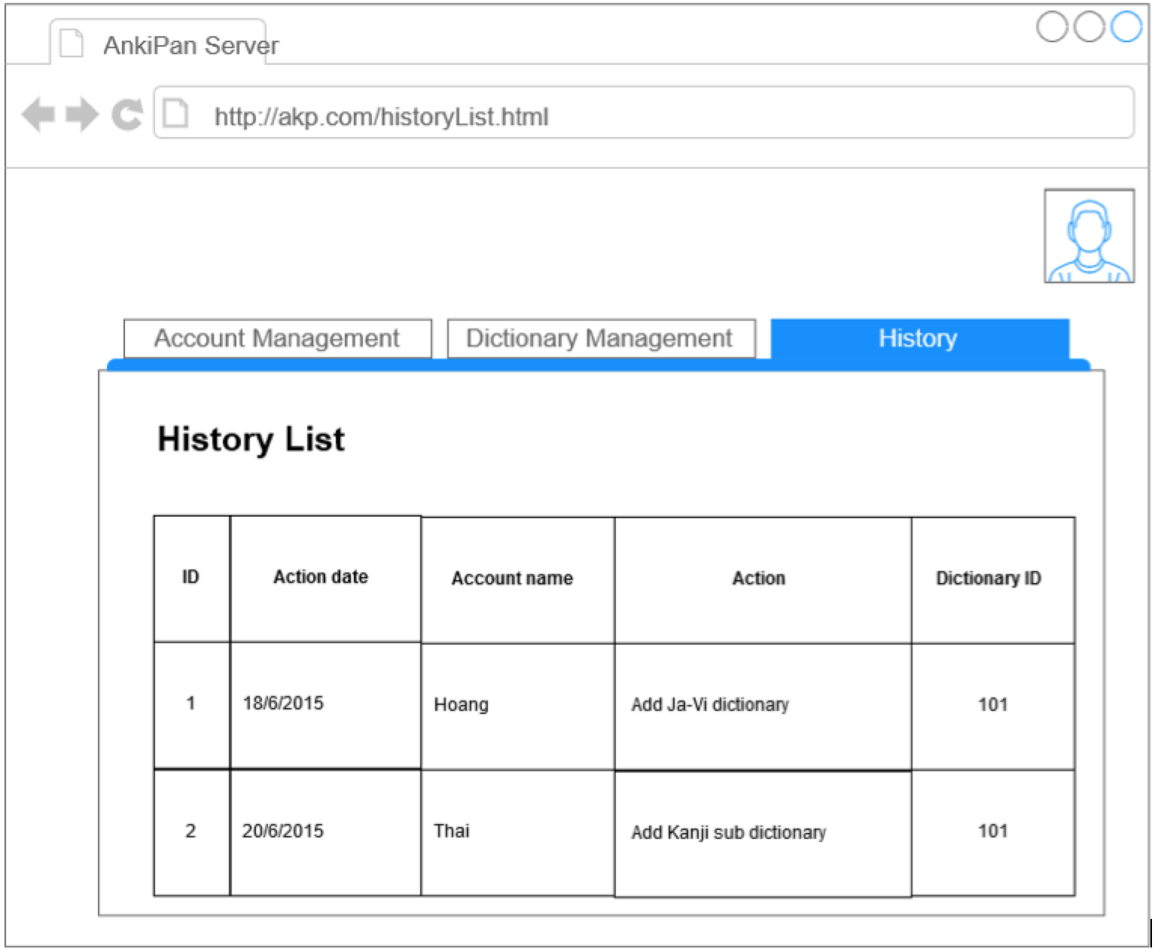

|  |  |  |  |
| --- | --- | --- | --- |
| Use Case ID | | | UC – 11.5 |
| Use Name | | | View History List |
| Actor | | | Admin |
| Description | | | Admin view history list |
| Precondition | | | Internet Connection |
| Trigger | | | N/A |
| Post-Condition | | | N/A |
| Main flow | | | |
| Step | Actor | | Action |
| 1 | Admin | | Click the History List link on the tab bar |
| 2 | System | | Get the history list |
| 4 | System | | Display the history list on the screen |
| Alternative flow 1 | | | |
| Precondition | | |  |
|  | |  | N/A |
| Exceptions | | | N/A |

###### *UC 12.2 – Update History*

|  |  |  |  |
| --- | --- | --- | --- |
| Use Case ID | | | UC – 12.2 |
| Use Name | | | Update History |
| Actor | | | System |
| Description | | | System log history into the database |
| Precondition | | | N/A |
| Trigger | | | UC – 11.2, 11.3, 11.4, 11.6, 11.7, 11.8 |
| Post-Condition | | | New history entry is generated and added into the database |
| Main flow | | | |
| Step | Actor | | Action |
| 1 | Admin | | Complete any use case in Trigger |
| 2 | System | | Generated new history entry |
| 5 | System | | Add new history entry into the database |
| Alternative flow 1 | | | |
| Precondition | | |  |
|  | |  | N/A |
| Exceptions | | | N/A |

##### **3.2.2.5.2 Screen description**

| Screen | Field Name | Description | Mandatory | Read only | Control type | Data Type | Length |
| --- | --- | --- | --- | --- | --- | --- | --- |
| History List page | History table | The table containing history information | - | - | Table | - | - |
| ID column | The ID column of the list of history entries | - | - | Table header | - | - |
| Action date column | The action date column | - | - | Table header | - | - |
| Account name column | The account name of admins who created the entry | - | - | Table header | - | - |
| Action | The action of the admins | - | - | Table header | - | - |
| Dictionary ID | The ID of dictionary package that has been made change | - | - | Table header | - | - |

# 4. NON – FUNCTIONAL REQUIREMENTS

## 4.1. Usability

* User interface should be clear and easy to user
* User need no more than 10 minutes to learn how to use the application
* User need no more than 10 minutes to learn how to use the server

## 4.2. Availability

* Available time of the application: >= 95%
* Available time of the server: >= 95%

## 4.3. Performance

* Time for image processing: less than 10s
* Time for searching a word in dictionary: less than 3s

## 4.4. Interface

### 4.4.1. User interface

* User interface will be designed base on flat design
* User interface for application must be simple and clear.

### 4.4.2. Hardware interface

* The application can run on smart phone that installs Android version 4.2 or higher

### 4.4.3. Software interface

* Tesseract open ORC library for Japanese recognition
* OpenCV library for image processing

## 4.5. Security

* Secure user accounts on server

# IV. SOFTWARE DETAIL DESIGN

# 1. ARCHITECTURE DESIGN

## 1.1. Introduction

### 1.1.1. Purpose

The Software Architecture Document (SAD) provides a comprehensive architectural overview of the Ankipan application 1.0 offered by Ankipan team. It present a number of different architectural views to depict different aspects of the system. It is intended to capture and convey the significant architectural decisions which have been made on the system.

### 1.1.2. Scope

The Scope of this SAD is to depict the architecture design of the Ankipan application create by Ankipan team.

### 1.1.3. Overview

In order to provide an overview of this document, the SAD contains the following subsection:

1. Section 2: describes the use of each view in 4+1 views
2. Section 3: describe the architecture constrains if the system
3. Section 4: describe the functional requirements with its flow and notice.
4. Section 5: describe the most important use-case realization, and architecture of each function
5. Section 6: describe the dynamic aspect of the system, explain the system process and how they communicate
6. Section 7: describe how the system deployed, the topology of software component of the physical layer, as well as the connection between these components
7. Section 8: describe the layers and subsystems of the application
8. Section 9: describe the layers and subsystems of the server
9. Section 10: describe the Image processing lib
10. Section 11: describe any significant persistent element
11. Section 12: describe any non-functional requirement as known as performance and constraints
12. Section 13: describe any aspects related to the quality of service (QoS) attribute

## 1.2. Description of Architecture Design

This document depicts the architecture using the views defined in the “4+1” model [KRU41] as below:

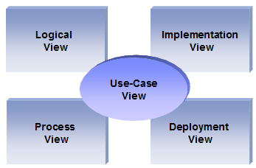

*Figure 35: View Model 4 + 1*

**Use case view**

**Audience:** all the stack holder of the system

**Area:** describes the set of the scenarios and/ or use cases that represent some significant, central functionality of the system.

**Related Artifacts:** Use-Case Model

**Logical view**

**Audience:** Designer

**Area:** Function Requirements: describes the design’s object model. Also describes the most important use-case realizations

**Related Artifacts:** Class diagram, Sequence diagram, Communication diagram

**Implementation view**

**Audience:** Programmers

**Area:** Software components: describes the layers and subsystem of the application

**Related Artifacts:** Component diagram, package diagram

**Deployment view**

**Audience:** Manager

**Area:** Topology: describes the mapping of the software onto the hardware and shows the system’s distributed aspects.

**Related Artifacts:** Deployment diagram

**Process view**

**Audience:** Integrators

**Area:** non-functional requirements: describes the designer’s concurrency and synchronization aspects

**Related Artifacts:** Activity diagram

## 1.3. Architecture Goals & Constraints

This section describe the software requirements and objectives that have show significant impact in the architecture

### 1.3.1. Technical Platform

This application will be deployed as an Android standalone application.

The AnkiPan Web Application will be deployed onto a JEE 7 Platform (Apache Tomcat 8.0.9, as it is already the application server use for internal application)

### 1.3.2. Communication

AnkiPan application will send a String to Google API to translate text and, gets data’s information from our own server.

### 1.3.3. Security

The system must be secure because of user’s information store in our own web server. The system must be secured, especially user data

### 1.3.4. Persistence

Data in web server will be stored by relational database.

But data in application, specifically dictionary data will be stored with no relation, because of performance.

Login using username and password

### 1.3.5. Reliability/Availability

Because this application is a standalone app, so we have no trouble with Android application’s Availability

The availability is the key requirement, as it is required to perform downloading action from any Android device.

Targeting availability is 14/7: 14 hours a day, 7 days a week

Time left (10 hours) is reserved for any maintain activities

### 1.3.6. Performance

Any process related to password must take about 1-2 seconds to get response from server (for security reason)

## 1.4. User Case View

This section list all use cases of AKP system.



Figure 36: Overall application Use Case

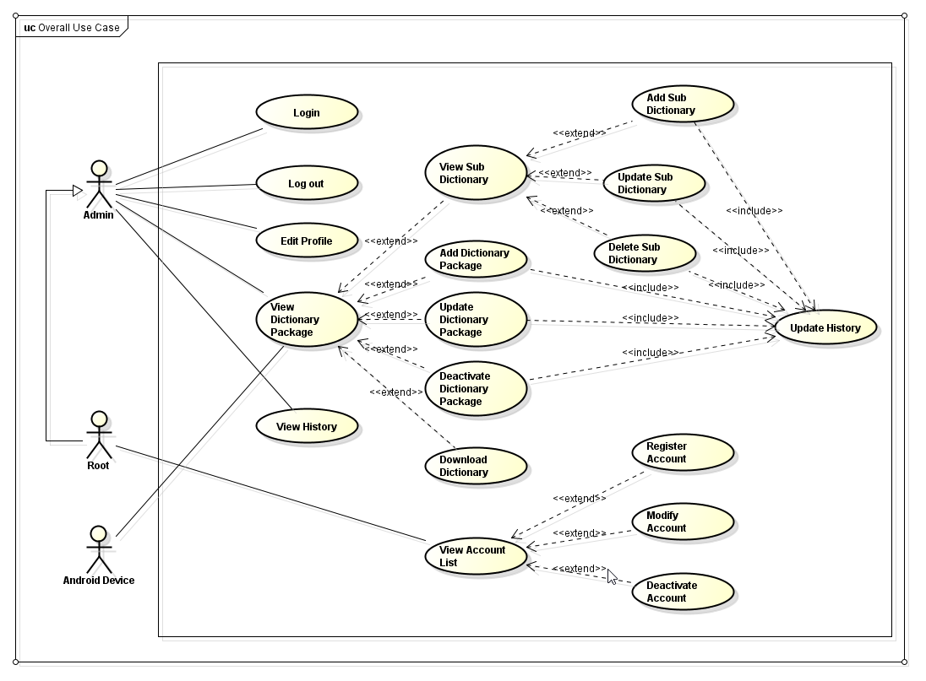

Figure 37: Overall webserver Use Case

## 1.5. Deployment View

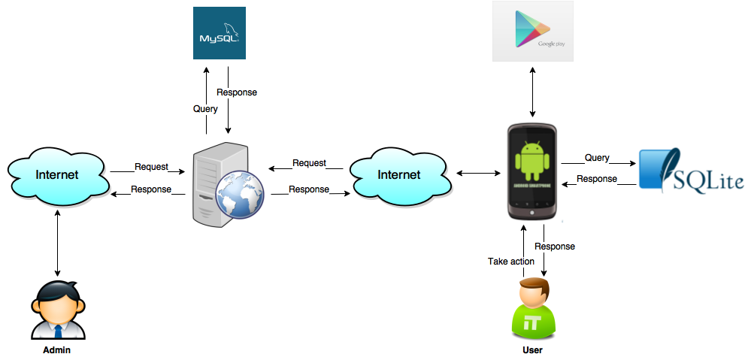

Figure 38: Overview of Anki Pan system

AKP system includes Anki Pan application, server and 2 main kinds of user: admin and user.

User uses Anki Pan application. Anki Pan application queries data from SQLite database to response user’s request in need. New version of Anki Pan application will be uploaded to Google play store for user to download and update the application.

Admins of Anki Pan system upload dictionary packages to MySQL database on server. User can download dictionary packages from server to application.

## 1.6. Implementation View

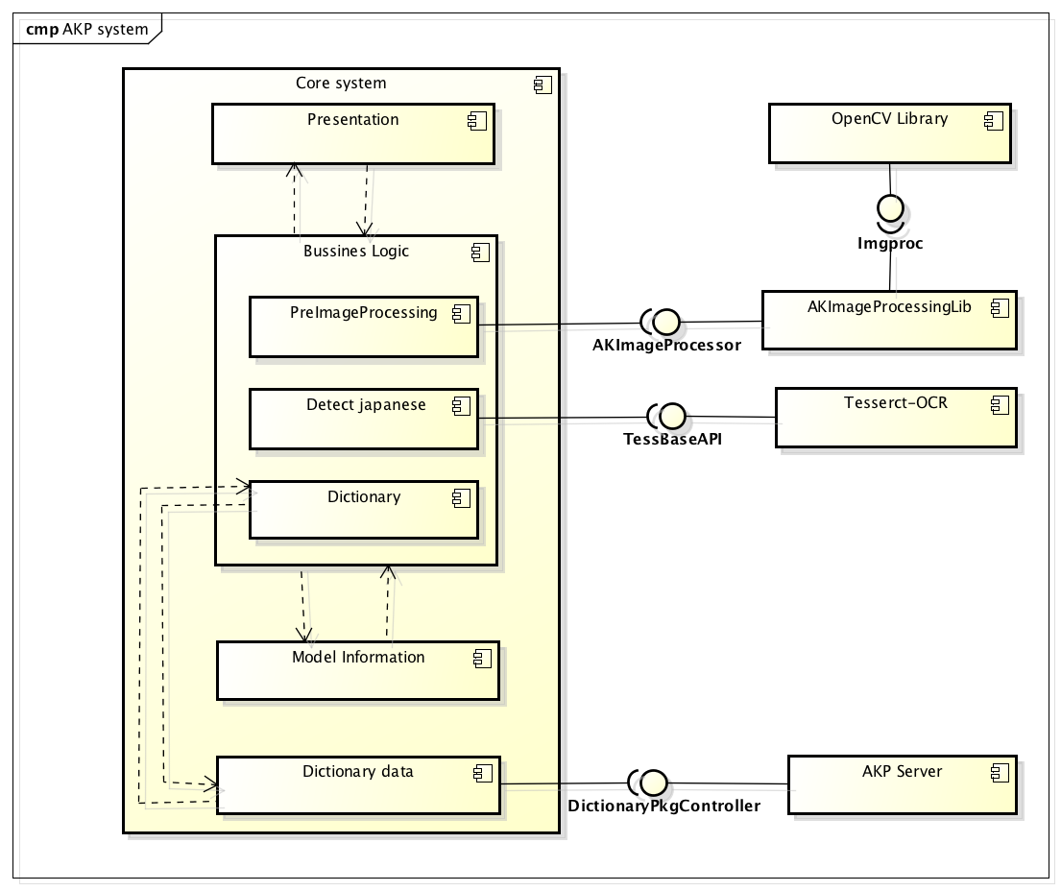

Figure 39: Component Diagram

The system includes a core system to implement required functions on application and a server to upload dictionary packages. Development team will also develop a library to process image, using OpenCV library. Tesseract open source OCR will be used to recognize text.

## 1.7. Detail Design of Application

### 1.7.1. Overview

This application base on MVC model and using Android Studio IDE to program.

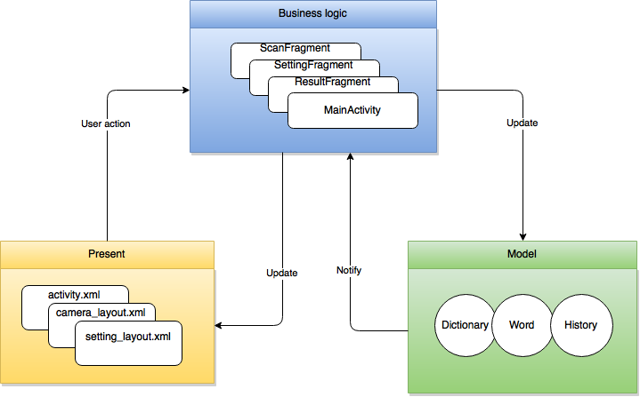

Figure 40: Overview of application architecture

### 1.7.2. Design

#### 1.7.2.1. View Main Menu

##### **1.7.2.1.1. Use Case specification**

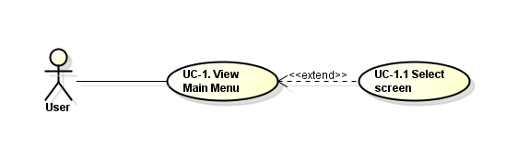

Figure 41: MVC model

* **Description:** User can be view all application’s menu by tapping Menu button on the left top of display screen.

##### **1.7.2.1.2. Logical view**

##### **Class diagram**

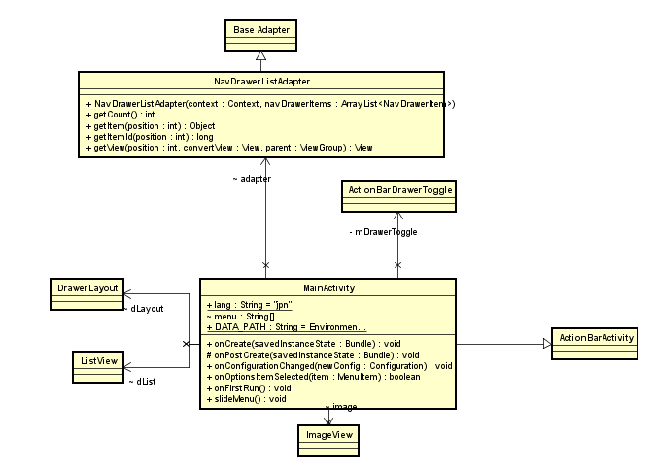

Figure 42: View Main Menu Classes Diagram

##### **Class Specification:**

1. **MainActivity class:**
2. *Attributes:*

|  |  |  |  |
| --- | --- | --- | --- |
| No | Name | Type | Description |
| 1 | lang | Static final String | This variable contain Tesseract’s train data file extension |
| 2 | menu | String[] | This variable contain all of view screen’s name |
| 3 | DATA_PATH | Static final String | Contain application’s folder destination in external memory of smartphone |

1. *Methods*

OnCreate:

|  |  |  |  |  |
| --- | --- | --- | --- | --- |
| Purpose | Create an activity when at its first call | | | |
| Return | Type | | | Description |
| void | | |  |
| Parameters | No | Name | Type | Description |
| 1 | savedInstanceState | Bundle | Contain bundle that transfer from calling method |

OnPostCreate:

|  |  |  |  |  |
| --- | --- | --- | --- | --- |
| Purpose | Called when activity start-up is complete (after onStart() and onRestoreInstanceState(Bundle) have been called). Applications will generally not implement this method; it is intended for system classes to do final initialization after application code has run. | | | |
| Return | Type | | | Description |
| void | | |  |
| Parameters | No | Name | Type | Description |
| 1 | savedInstanceState | Bundle | If the activity is being re-initialized after previously being shut down then this Bundle contains the data it most recently supplied in onSaveInstanceState(Bundle) |

onOptionsItemSelected:

|  |  |  |  |  |
| --- | --- | --- | --- | --- |
| Purpose | Called by the system when the device configuration changes while your activity is running. Note that this will only be called if you have selected configurations you would like to handle with the configChanges attribute in your manifest. If any configuration change occurs that is not selected to be reported by that attribute, then instead of reporting it the system will stop and restart the activity (to have it launched with the new configuration). | | | |
| Return | Type | | | Description |
| boolean | | | Return false to allow normal menu processing to proceed, true to consume it here. |
| Parameters | No | Name | Type | Description |
| 1 | item | MenuItem | The menu item that was selected. |

onConfigurationChange:

|  |  |  |  |  |
| --- | --- | --- | --- | --- |
| Purpose | Called whenever an item in your options menu is selected. The default implementation simply returns false to have the normal processing happen (calling the item's Runnable or sending a message to its Handler as appropriate). You can use this method for any items for which you would like to do processing without those other facilities. | | | |
| Return | Type | | | Description |
| void | | |  |
| Parameters | No | Name | Type | Description |
| 1 | newConfig | Configuration | The new device configuration. |

onFirstRun:

|  |  |  |  |  |
| --- | --- | --- | --- | --- |
| Purpose | Called on the first time running of application | | | |
| Return | Type | | | Description |
| void | | | Its create the first screen will display when application opened |
| Parameters | No | Name | Type | Description |
|  |  |  |  |

slideMenu:

|  |  |  |  |  |
| --- | --- | --- | --- | --- |
| Purpose | Called when application open | | | |
| Return | Type | | | Description |
| void | | | Initiate variable and content of variable |
| Parameters | No | Name | Type | Description |
|  |  |  |  |

1. **NavDrawerListAdapter:**
2. *Methods*

getCount:

|  |  |  |  |  |
| --- | --- | --- | --- | --- |
| Purpose | How many items are in the data set represented by this Adapter | | | |
| Return | Type | | | Description |
| int | | | Count of items |
| Parameters | No | Name | Type | Description |
|  |  |  |  |

getItem:

|  |  |  |  |  |
| --- | --- | --- | --- | --- |
| Purpose | Get the data item associated with the specified position in the data set | | | |
| Return | Type | | | Description |
| Object | | | The data at the specified position |
| Parameters | No | Name | Type | Description |
| 1 | position | int | Position of the item whose data we want within the adapter's data set |

getView

|  |  |  |  |  |
| --- | --- | --- | --- | --- |
| Purpose | Get a View that displays the data at the specified position in the data set. You can either create a View manually or inflate it from an XML layout file. When the View is inflated, the parent View (GridView, ListView...) will apply default layout parameters unless you use inflate(int, android.view.ViewGroup, boolean) to specify a root view and to prevent attachment to the root. | | | |
| Return | Type | | | Description |
| View | | | A View corresponding to the data at the specified position |
| Parameters | No | Name | Type | Description |
| 1 | position | int | The position of the item within the adapter's data set of the item whose view we want |
|  | 2 | convertView | View | The old view to reuse, if possible. Note: You should check that this view is non-null and of an appropriate type before using. If it is not possible to convert this view to display the correct data, this method can create a new view |
|  | 3 | parent | ViewGroup | The parent that this view will eventually be attached to |

##### **Sequence Diagram:**

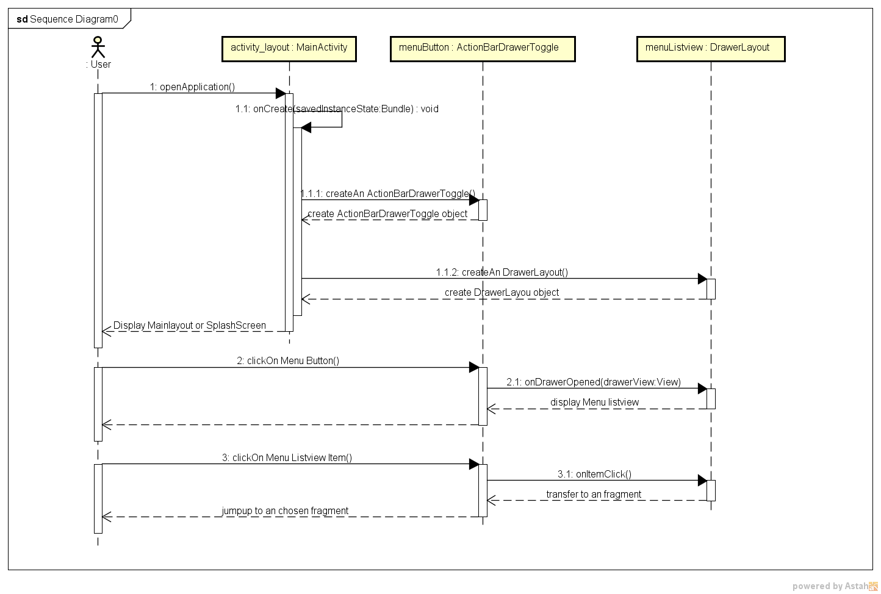

Figure 43: View Main Menu Sequence Diagram

#### 1.7.2.1.3. Activity Diagram

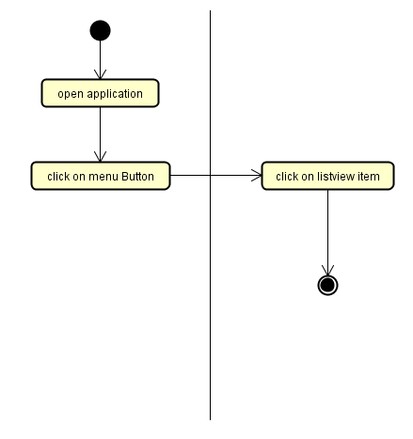

Figure 44: View Main Menu Activity Diagram

#### 1.7.2.2. Scan Document

#### 1.7.2.2.1. Use Case specification

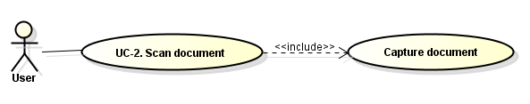

Figure 45: Scan Document Use Case

* **Description:** User can scan document by capture an image.

#### 1.7.2.2.2. Logical view

* **Class Diagram:**

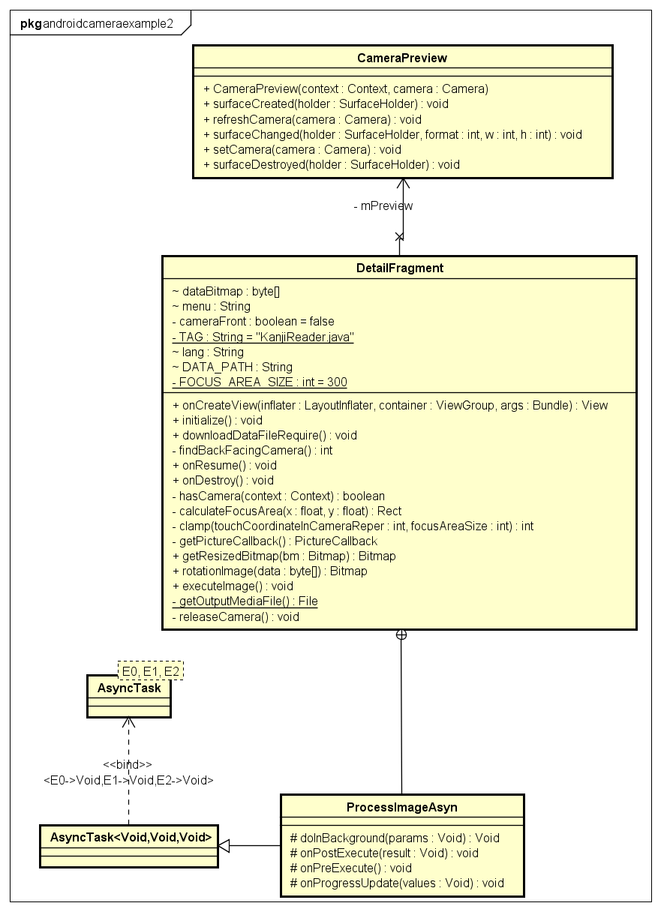

Figure 46: Scan Document Class Diagram

* **Class Specification:**

1. **DetailFragment class:**
2. *Attributes:*

|  |  |  |  |
| --- | --- | --- | --- |
| No | Name | Type | Description |
| 1 | Bitmap | Data[] | This variable contain image information’s datas |
| 2 | TAG | String | This variable contain an TAG name |
| 3 | DATA_PATH | String | Contain application’s folder destination in external memory of smartphone |
| 4 | Lang | String | This variable contain all of view screen’s name |
| 5 | FOCUS_AREA_SIZE | int | Contain area size to focus in display |

1. *Methods*

downloadDataFileRequire:

|  |  |  |  |  |
| --- | --- | --- | --- | --- |
| Purpose | Check if lang.train data file exits if is not, download and initial it from internet | | | |
| Return | Type | | | Description |
| void | | |  |
| Parameters | No | Name | Type | Description |
|  |  |  |  |

findBackFacingCamera:

|  |  |  |  |  |
| --- | --- | --- | --- | --- |
| Purpose | Check if device has an back Camera | | | |
| Return | Type | | | Description |
| int | | | If device has no camera return -1. If it has, return camera’s id |
| Parameters | No | Name | Type | Description |
|  |  |  |  |

onResume:

|  |  |  |  |  |
| --- | --- | --- | --- | --- |
| Purpose | Reopen Camera | | | |
| Return | Type | | | Description |
| void | | |  |
| Parameters | No | Name | Type | Description |
|  |  |  |  |

onDestroy:

|  |  |  |  |  |
| --- | --- | --- | --- | --- |
| Purpose | Release Camera | | | |
| Return | Type | | | Description |
| void | | |  |
| Parameters | No | Name | Type | Description |
|  |  |  |  |

hasCamera:

|  |  |  |  |  |
| --- | --- | --- | --- | --- |
| Purpose | Check if Camera is exits or not (call in **findBackFacingCamera** method) | | | |
| Return | Type | | | Description |
| boolean | | | If device has an camera return true, and false if it is not |
| Parameters | No | Name | Type | Description |
| 1 | context | Context | Application’s context |

calculateFocusArea:

|  |  |  |  |  |
| --- | --- | --- | --- | --- |
| Purpose | Calculate an focus area in display screen | | | |
| Return | Type | | | Description |
| Rect | | | Position of x, y and width, height of focus rectangular |
| Parameters | No | Name | Type | Description |
| 1 | x | float | Position of touch point |
| 2 | y | float | Position of touch point |

getResizedBitmap:

|  |  |  |  |  |
| --- | --- | --- | --- | --- |
| Purpose | Calculate and resize an image to fit display | | | |
| Return | Type | | | Description |
| Bitmap | | |  |
| Parameters | No | Name | Type | Description |
| 1 | bitmap | Bitmap | An original bitmap image |

rotationImage:

|  |  |  |  |  |
| --- | --- | --- | --- | --- |
| Purpose | Rotate image to portrait mode | | | |
| Return | Type | | | Description |
| Bitmap | | | Image after rotation |
| Parameters | No | Name | Type | Description |
| 1 | data | byte[] | byte[] data after capture |

executeImage:

|  |  |  |  |  |
| --- | --- | --- | --- | --- |
| Purpose | Scan and get text lines | | | |
| Return | Type | | | Description |
| void | | |  |
| Parameters | No | Name | Type | Description |
|  |  |  |  |

releaseCamera:

|  |  |  |  |  |
| --- | --- | --- | --- | --- |
| Purpose | Release camera after capture or change activity | | | |
| Return | Type | | | Description |
| void | | |  |
| Parameters | No | Name | Type | Description |
|  |  |  |  |

1. **Camera Preview:**
2. *Methods:*

surfaceCreated:

|  |  |  |  |  |
| --- | --- | --- | --- | --- |
| Purpose | This is called immediately after the surface is first created. Implementations of this should start up whatever rendering code they desire. Note that only one thread can ever draw into a Surface, so you should not draw into the Surface here if your normal rendering will be in another thread. | | | |
| Return | Type | | | Description |
| void | | |  |
| Parameters | No | Name | Type | Description |
| 1 | holder | SurfaceHolder | The SurfaceHolder whose surface is being created. |

refreshCamera:

|  |  |  |  |  |
| --- | --- | --- | --- | --- |
| Purpose | Stop and reopen camera | | | |
| Return | Type | | | Description |
| void | | |  |
| Parameters | No | Name | Type | Description |
| 1 | camera | Camera | Object camera need to refresh |

surfaceChanged:

|  |  |  |  |  |
| --- | --- | --- | --- | --- |
| Purpose | This is called immediately after any structural changes (format or size) have been made to the surface. You should at this point update the imagery in the surface. This method is always called at least once, after surfaceCreated(SurfaceHolder). | | | |
| Return | Type | | | Description |
| void | | |  |
| Parameters | No | Name | Type | Description |
| 1 | holder | SurfaceHolder | The SurfaceHolder whose surface has changed. |
| 2 | format | int | The new PixelFormat of the surface. |
| 3 | width | int | The new width of the surface. |
| 4 | height | int | The new height of the surface. |

surfaceDestroyed:

|  |  |  |  |  |
| --- | --- | --- | --- | --- |
| Purpose | This is called immediately before a surface is being destroyed. After returning from this call, you should no longer try to access this surface. If you have a rendering thread that directly accesses the surface, you must ensure that thread is no longer touching the Surface before returning from this function. | | | |
| Return | Type | | | Description |
| void | | |  |
| Parameters | No | Name | Type | Description |
| 1 | holder | SurfaceHolder | The SurfaceHolder whose surface is being destroyed. |

1. **ProcessImageAsyn class:**
2. *Methods:*

doInBackground:

|  |  |  |  |  |
| --- | --- | --- | --- | --- |
| Purpose | Override this method to perform a computation on a background thread. The specified parameters are the parameters passed to execute(Params...) by the caller of this task. This method can call publishProgress(Progress...) to publish updates on the UI thread. | | | |
| Return | Type | | | Description |
| void | | | A result, defined by the subclass of this task. |
| Parameters | No | Name | Type | Description |
| 1 | params | Void | The parameters of the task. |

onPostExecute:

|  |  |  |  |  |
| --- | --- | --- | --- | --- |
| Purpose | Runs on the UI thread after doInBackground(Params...). The specified result is the value returned by doInBackground(Params...). This method won't be invoked if the task was cancelled. | | | |
| Return | Type | | | Description |
| void | | |  |
| Parameters | No | Name | Type | Description |
| 1 | result | Result | The result of the operation computed by doInBackground(Params...). |

onPreExecute:

|  |  |  |  |  |
| --- | --- | --- | --- | --- |
| Purpose | Runs on the UI thread before doInBackground(Params...). | | | |
| Return | Type | | | Description |
| void | | |  |
| Parameters | No | Name | Type | Description |
|  |  |  |  |

onProgressUpdate:

|  |  |  |  |  |
| --- | --- | --- | --- | --- |
| Purpose | Runs on the UI thread after publishProgress(Progress...) is invoked. The specified values are the values passed to publishProgress(Progress...). | | | |
| Return | Type | | | Description |
| void | | |  |
| Parameters | No | Name | Type | Description |
| 1 | value | Void | The values indicating progress. |

* **Sequence diagram**

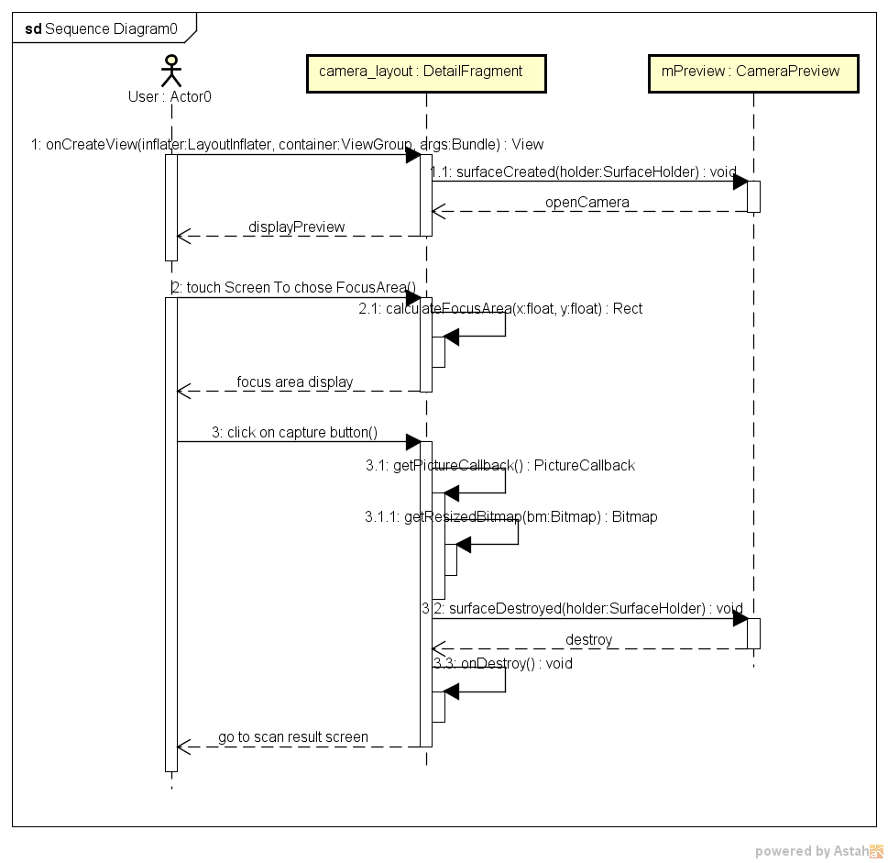

Figure 47: Scan Document Sequence Diagram

#### 1.7.2.2.3. Activity Diagram:

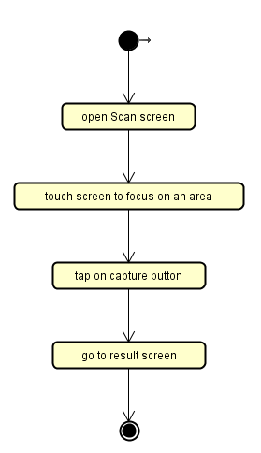

Figure 48: Scan Document Activity Diagram

#### 1.7.2.3. Select text

#### 1.7.2.3.1. Use Case specification

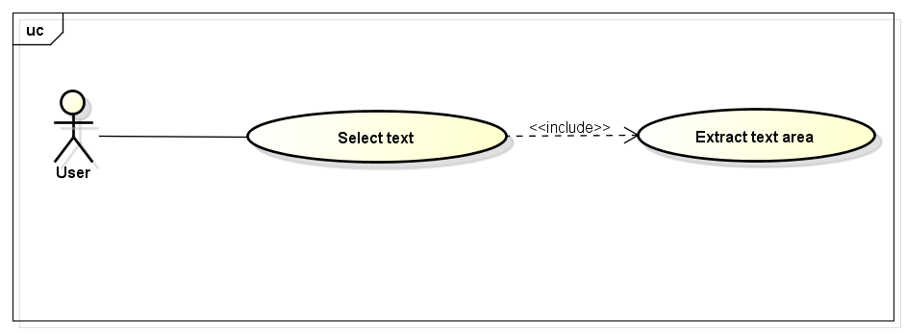

Description: After capture image by camera, user can chose text area by touch to start-area-point to end-area-point. Then, the chosen area will be high light and recognize text from this area.

**1.7.2.3.2. Logical View**

* **Class diagram**

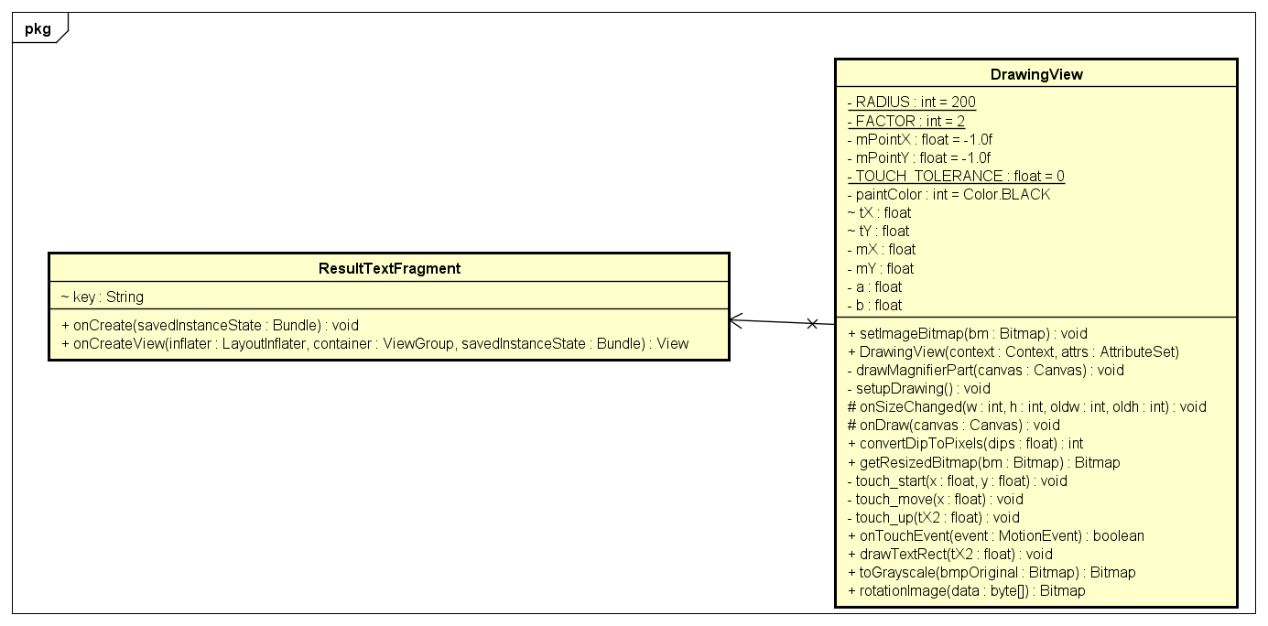

*Figure 49: Class diagram of user case Select text*

* **Class specification**

1. **Drawing view**
2. *Attribute*

|  |  |  |  |
| --- | --- | --- | --- |
| No | Name | Type | Description |
| 1 | paintColor | int | Color value that defined in class Color in Android |
| 2 | tX | float | Current x position that user pointing in |
| 3 | tY | float | Current y position that user pointing in |
| 4 | mX | float | X position that use in |
| 5 | mY | float |  |
| 6 | a | float | X start point |
| 7 | b | float | Y start point |

1. *Methods*

setImageBitmap

|  |  |  |  |  |
| --- | --- | --- | --- | --- |
| Purpose | Called when init view, this method set src for view in layout xml | | | |
| Return | Type | | | Description |
| void | | |  |
| Parameters | No | Name | Type | Description |
| 1 | bm | Bitmap | This parameter refer an Bitmap variable |

drawMagnifierPart

|  |  |  |  |  |
| --- | --- | --- | --- | --- |
| Purpose | Called when user touch in View, that will create an magnifier to scale touch area | | | |
| Return | Type | | | Description |
| void | | |  |
| Parameters | No | Name | Type | Description |
| 1 | canvas | Canvas | This parameter refer an Canvas variable that will be scale on |

setupDrawing

|  |  |  |  |  |
| --- | --- | --- | --- | --- |
| Purpose | This method call when init some variable use to draw on canvas object that set image to | | | |
| Return | Type | | | Description |
| void | | |  |
| Parameters | No | Name | Type | Description |
|  |  |  |  |

onDraw

|  |  |  |  |  |
| --- | --- | --- | --- | --- |
| Purpose | This method override from super method, call when user have any action to View | | | |
| Return | Type | | | Description |
| void | | |  |
| Parameters | No | Name | Type | Description |
| 1 | canvas | Canvas | Refer an Canvas object |

touch_start

|  |  |  |  |  |
| --- | --- | --- | --- | --- |
| Purpose | This method call when user start to touch on View | | | |
| Return | Type | | | Description |
| void | | |  |
| Parameters | No | Name | Type | Description |
| 1 | x | float | Refer an x position of touch point |
| 2 | y | float | Refer an y position of touch point |

touch_move

|  |  |  |  |  |
| --- | --- | --- | --- | --- |
| Purpose | This method call when user start to move finger on View | | | |
| Return | Type | | | Description |
| void | | |  |
| Parameters | No | Name | Type | Description |
| 1 | x | float | Refer an x position of touch point |
| 2 | y | float | Refer an y position of touch point |

touch_up

|  |  |  |  |  |
| --- | --- | --- | --- | --- |
| Purpose | This method call when user end of touch | | | |
| Return | Type | | | Description |
| void | | |  |
| Parameters | No | Name | Type | Description |
| 1 | x | float | Refer an x position of touch point |
| 2 | y | float | Refer an y position of touch point |

drawTextRect

|  |  |  |  |  |
| --- | --- | --- | --- | --- |
| Purpose | This method call after user finish action on View, after that, this method start to run and execute information which is collect from these step above | | | |
| Return | Type | | | Description |
| void | | |  |
| Parameters | No | Name | Type | Description |
| 1 | tX2 | float | Refer an x position of the last touch point |

**1.7.2.3.1. Sequence diagram**

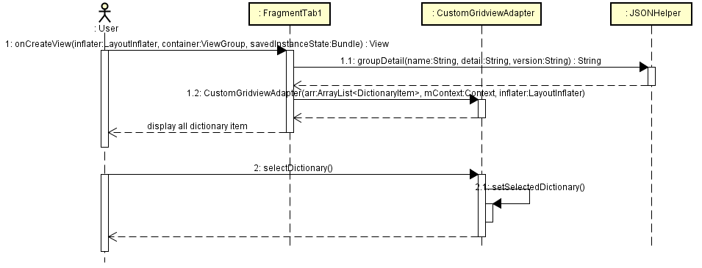

*Figure 50: Sequence diagram of user case Select text*

**1.7.2.3.4. Activity diagram**

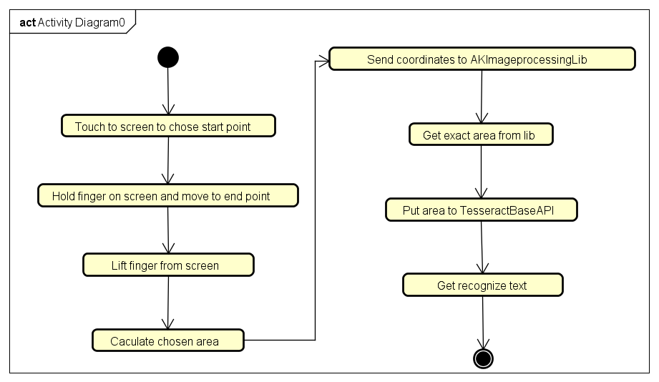

*Figure 51: Activity diagram of user case Select text*

#### 1.7.2.4. Search in Kanji Dictionary

#### 1.7.2.4.1. Use Case specification

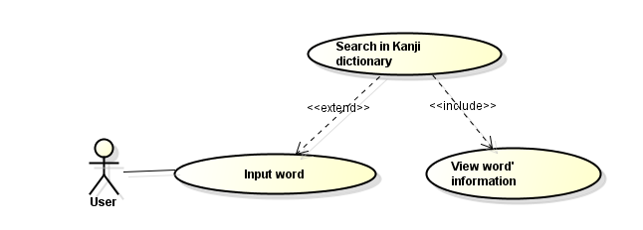

Figure 52: Search Kanji Dictionary Use Case

* **Description:** After input text or scan text in the previous step, user can search word meaning that already existed in database by click on search button on keyboard.

#### 1.7.2.4.2. Logical View

* **Class Diagram:**

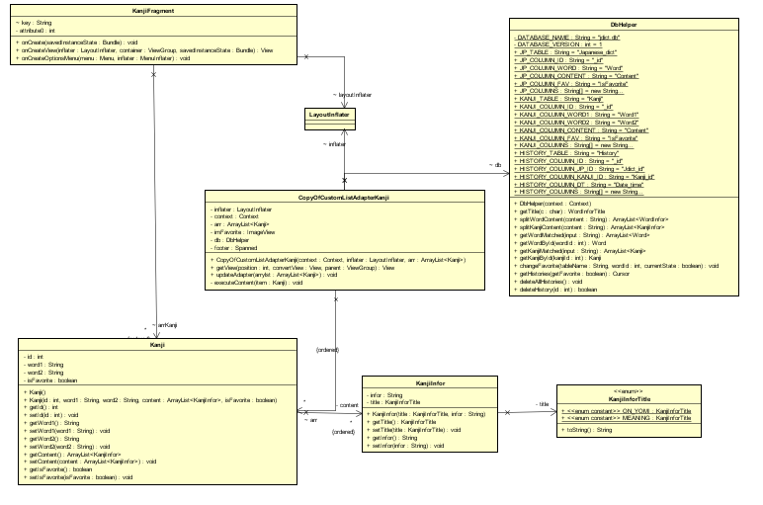

Figure 53: Search Kanji Dictionary Class Diagram

* **Class Specification:**

1. **KanjiInfor:**
2. *Attribute:*

|  |  |  |  |
| --- | --- | --- | --- |
| No | Name | Type | Description |
| 1 | Infor | String | This variable contain kanji word’s information |
| 2 | Title | KanjiInforTitle | This variable contain kanji word’s title (like Onyomi and meaning) |

1. *Method:*

getTitle:

|  |  |  |  |  |
| --- | --- | --- | --- | --- |
| Purpose | Called when want to get title of kanji word | | | |
| Return | Type | | | Description |
| KanjiInforTitle | | |  |
| Parameters | No | Name | Type | Description |
|  |  |  |  |

setTitle:

|  |  |  |  |  |
| --- | --- | --- | --- | --- |
| Purpose | Called when want to set title of kanji word | | | |
| Return | Type | | | Description |
| void | | |  |
| Parameters | No | Name | Type | Description |
| 1 | title | KanjiInforTitle |  |

getInfor:

|  |  |  |  |  |
| --- | --- | --- | --- | --- |
| Purpose | Called when want to get information of kanji word | | | |
| Return | Type | | | Description |
| String | | |  |
| Parameters | No | Name | Type | Description |
|  |  |  |  |

setInfor:

|  |  |  |  |  |
| --- | --- | --- | --- | --- |
| Purpose | Called when want to set information of kanji word | | | |
| Return | Type | | | Description |
| Void | | |  |
| Parameters | No | Name | Type | Description |
| 1 | infor | String |  |

1. **Kanji class:**
2. *Attribute:*

|  |  |  |  |
| --- | --- | --- | --- |
| No | Name | Type | Description |
| 1 | Id | int | This variable contain id of kanji word in database |
| 2 | word1 | String | This variable contain kanji word’s in Japanese |
| 3 | word2 | String | This variable contain kanji word’s in other language |
| 4 | isFavorite | boolean | If this kanji word is mark to favorite or not |
| 5 | Content | ArrayList<KanjiInfor> | Contain content of word (like meaning, onyomi) |

1. *Methods*

Kanji:

|  |  |  |  |  |
| --- | --- | --- | --- | --- |
| Purpose | Constructor create an Kanji object | | | |
| Return | Type | | | Description |
| Kanji | | |  |
| Parameters | No | Name | Type | Description |
| 1 | id | Int |  |
| 2 | word1 | String |  |
| 3 | word2 | String |  |
| 4 | isFavorite | boolean |  |
| 5 | content | ArrayList<KanjiInfor> |  |

1. **CopyOfCustomListAdapterKanji Class:**
2. *Attributes:*

|  |  |  |  |
| --- | --- | --- | --- |
| No | Name | Type | Description |
| 1 | Inflater | LayoutInflater | This variable LayoutInflater of Activity |
| 2 | Context | Context | This variable contain context of application |
| 3 | Arr | ArrayList<Kanji> | This variable contain arraylist of kanji object |
| 4 | imFavorite | ImageView | Point to imageview in xml layout that display this kanji is favorite or not |
| 5 | Db | DbHelper | Point to database connector already open |
| 6 | Footer | Spanned | Footer of kanji word |

1. *Methods*

getView:

|  |  |  |  |  |
| --- | --- | --- | --- | --- |
| Purpose | Call when create an adapter and fill the list view | | | |
| Return | Type | | | Description |
| View | | | Return a view of listview item |
| Parameters | No | Name | Type | Description |
| 1 | position | int |  |
| 2 | convertView | View |  |
| 3 | parent | ViewGroup |  |

updateAdapter:

|  |  |  |  |  |
| --- | --- | --- | --- | --- |
| Purpose | Called when adapter change and new listview have to fill | | | |
| Return | Type | | | Description |
| void | | |  |
| Parameters | No | Name | Type | Description |
| 1 | arrylst | ArrayList<Kanji> | New arraylist have to fill in adapter |

executeContent:

|  |  |  |  |  |
| --- | --- | --- | --- | --- |
| Purpose | Method change Kanji’s word con tent from String to Html | | | |
| Return | Type | | | Description |
| void | | | Change content of kanji word from enum to Html form with more color and symbol like interface design |
| Parameters | No | Name | Type | Description |
| 1 | item | Kanji |  |

#### 1.7.2.4.3. Sequence Diagram:

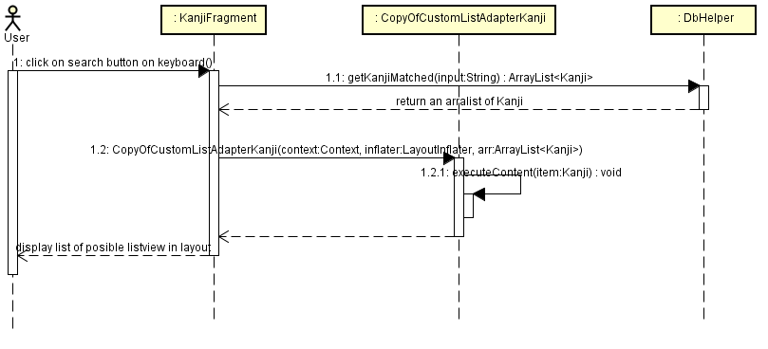

Figure 54: Search Kanji Dictionary Sequence Diagram

#### 1.7.2.4.4. Activity Diagram

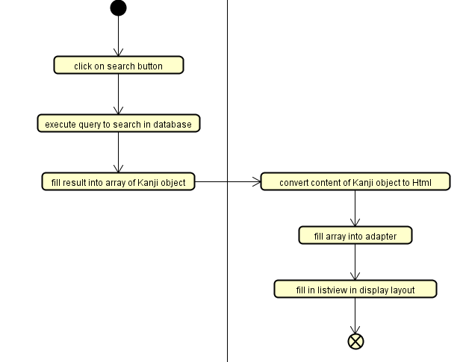

Figure 55: Search Kanji Dictionary Activity Diagram

#### 1.7.2.5. Search in Japanese Dictionary

#### 1.7.2.5.1. Use Case Specification

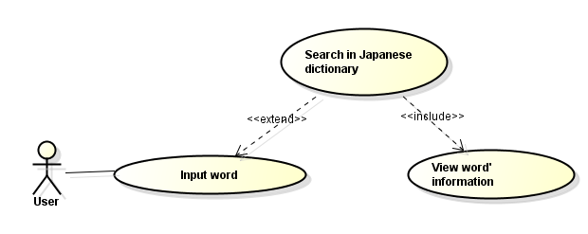

Figure 56: Search Japanese Dictionary Use Case

#### 1.7.2.5.2. Logical View

* **Class Diagram:**

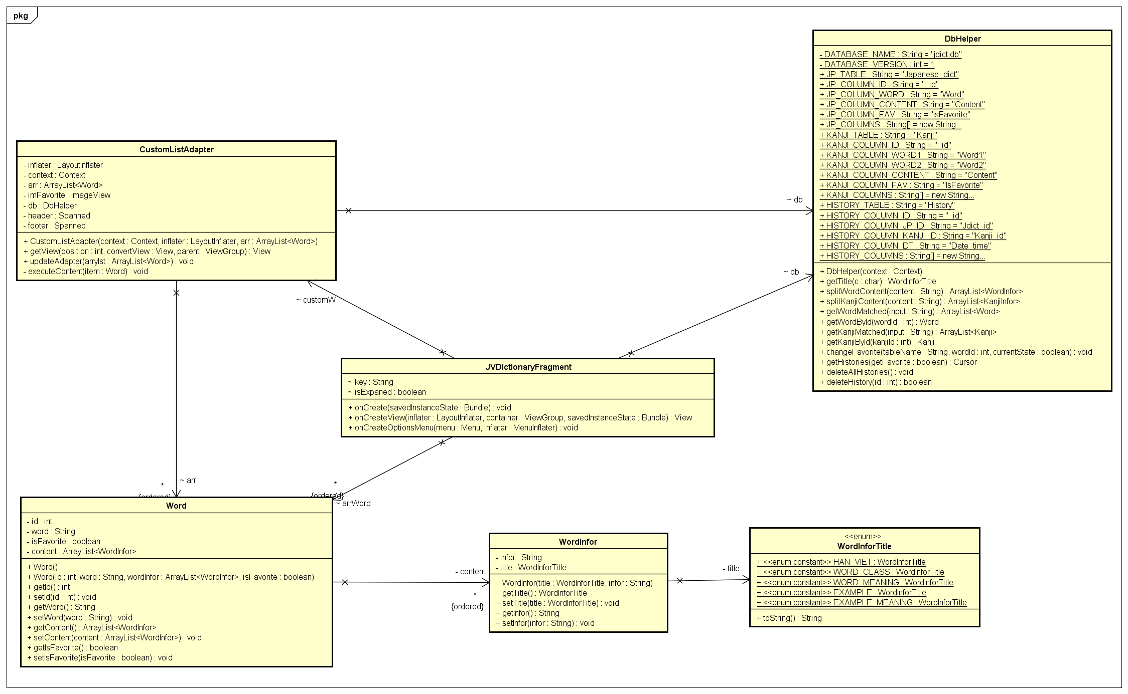

Figure 57: Search Japanese Dictionary Class Diagram

* **Class Specification:**

1. **WordInfor Class:**
2. *Attribute:*

|  |  |  |  |
| --- | --- | --- | --- |
| No | Name | Type | Description |
| 1 | Infor | String | This variable contain kanji word’s information |
| 2 | Title | WordInforTitle | This variable contain word’s title (like example and meaning) |

1. *Method:*

getTitle:

|  |  |  |  |  |
| --- | --- | --- | --- | --- |
| Purpose | Called when want to get title of word | | | |
| Return | Type | | | Description |
| WordInforTitle | | | Return an ENUM type variable |
| Parameters | No | Name | Type | Description |
|  |  |  |  |

#### 1.7.2.5.3. Sequence Diagram:

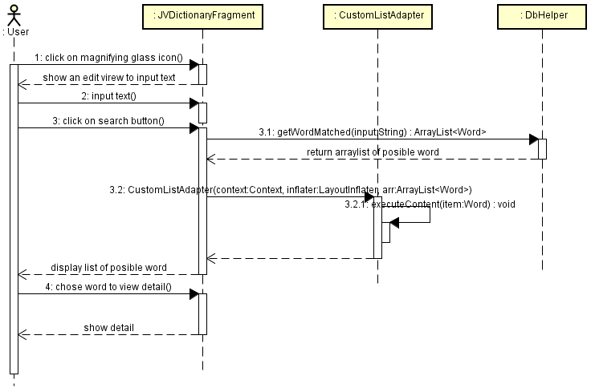

Figure 58: Seach Japanese Dictionary Sequence Diagram

#### 1.7.2.5.4. Activity Diagram

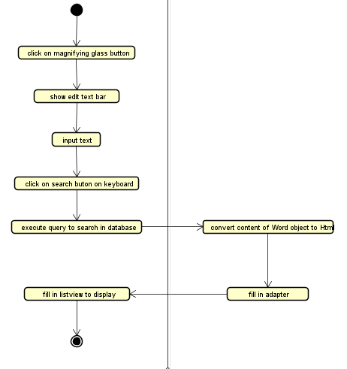

Figure 59: Search Japanese Dictionary Activity Diagram

#### 1.7.2.6. Select Dictionary Package

#### 1.7.2.6.1. Use Case Specification

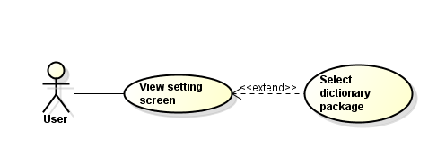

Figure 27 - Select Dictionary Package Use Case

* **Description:** User can select what dictionary package that search in.

#### 1.7.2.6.2. Logical View

* **Class Diagram:**

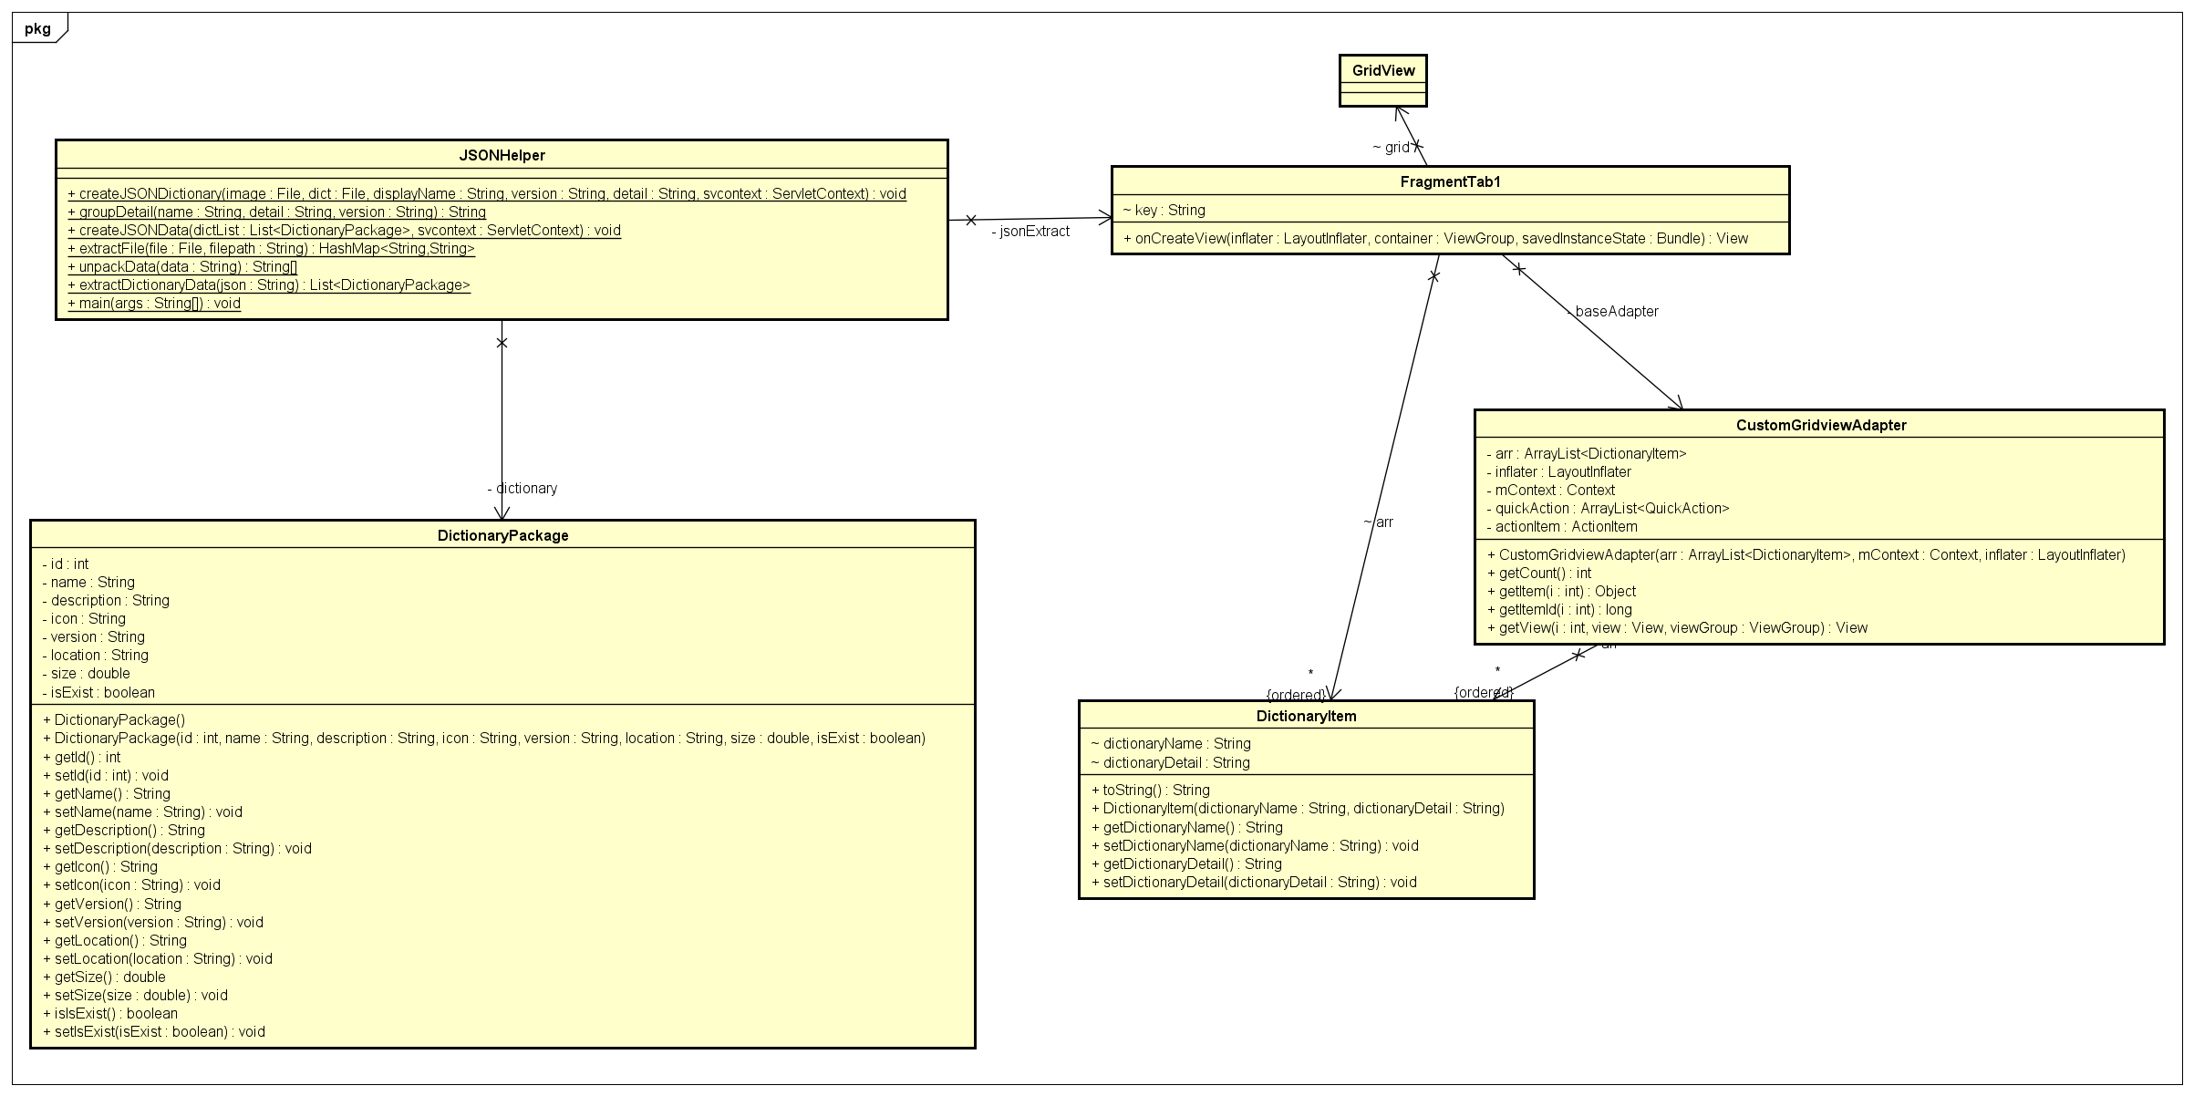

Figure 60: Select Dictionary Package Class Diagram

* **Class Specification:**

1. **CustomGridviewAdapter:**
2. *Attributes:*

|  |  |  |  |
| --- | --- | --- | --- |
| No | Name | Type | Description |
| 1 | arr | ArrayList<DictionaryItem> |  |
| 2 | inflater | LayoutInflater |  |
| 3 | mContext | Context |  |
| 4 | quickAction | ArrayList<QuickAction> | Contain list of quickaction object that add to grid view item tooltips |
| 5 | actionItem | ActionItem | Specific tooltips item |

1. *Methods*

getView:

|  |  |  |  |  |
| --- | --- | --- | --- | --- |
| Purpose | Call when create an adapter and fill the list view | | | |
| Return | Type | | | Description |
| View | | | In this method, we create an view that contain information of a dictionary item and it’s detail tooltips |
| Parameters | No | Name | Type | Description |
| 1 | i | int | Contain index of item |
| 2 | view | View | View of item |
| 3 | viewGroup | ViewGroup |  |

1. **JSONHelper:**
2. *Method:*

extractFile:

|  |  |  |  |  |
| --- | --- | --- | --- | --- |
| Purpose | Extract a json extension file into db extension file and hash map data. | | | |
| Return | Type | | | Description |
| HashMap<String,String> | | | Return information about dictionary data |
| Parameters | No | Name | Type | Description |
| 1 | file | File | The json extension file that hold dictionary information |
| 2 | filepath | String | The filepath that will transfer the db extension file into |

extractDictionaryData

|  |  |  |  |  |
| --- | --- | --- | --- | --- |
| Purpose | Extract a json string into a list of dictionary package data | | | |
| Return | Type | | | Description |
| List<DictionaryPackage> | | | Return a list of dictionary package data |
| Parameters | No | Name | Type | Description |
| 1 | json | String | The json string that hold the information of a list of dictionary package |

#### 1.7.2.6.3. Sequence Diagram:



Figure 61: Select Dictionary Package Sequence Diagram

#### 1.7.2.6.4. Activity Diagram

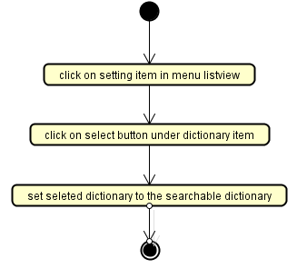

Figure 62: Select Dictionary package Activity Diagram

#### 1.7.2.7. Delete Dictionary Package

#### 1.7.2.7.1. Use Case Specification

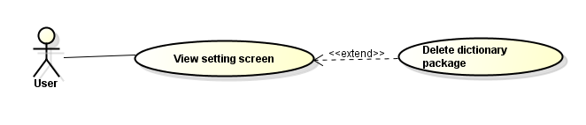

Figure 32 - Delete Dictionary package Use Case

* **Description:** After download a Dictionary package, user can delete these dictionary from external memory.

#### 1.7.2.7.2. Logical View

* **Class Diagram:**

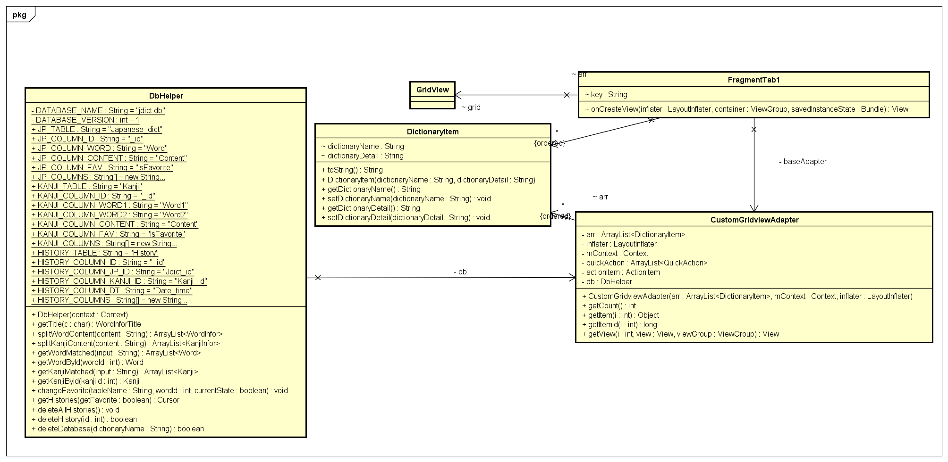

*Figure 63: Class diagram for Delete dictionary package user case*

* **Class Specification:**

1. **DBhelper:**
2. *Method:*

deleteDatabase:

|  |  |  |  |  |
| --- | --- | --- | --- | --- |
| Purpose | Call when user want to delete a dictionary package | | | |
| Return | Type | | | Description |
| boolean | | | Return true if success, false if its fail |
| Parameters | No | Name | Type | Description |
| 1 | dictionaryName | String | Name of dictionary package |

#### 1.7.2.7.3. Sequence Diagram:

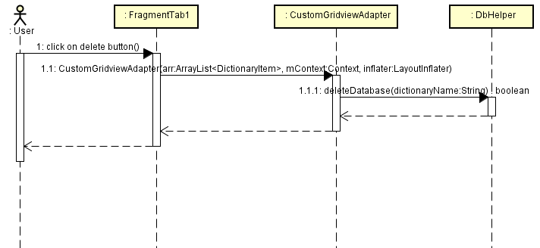

*Figure 64: Sequence diagram of deleting dictionary package*

#### 1.7.2.7.4. Activity Diagram

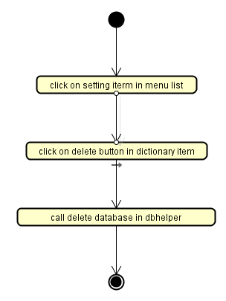

*Figure 65: Activity diagram of deleting dictionary package*

#### 1.7.2.8. Show dictionary package's description

#### 1.7.2.8.1. Use Case Specification

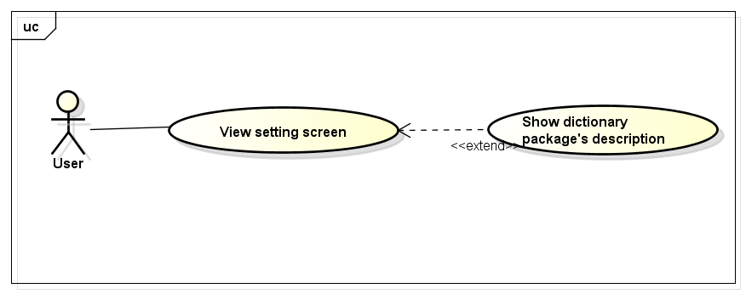

* **Description:** User can see detail information of dictionary package from tooltips that display in setting screen.

#### 1.7.2.8.2. Logical View

* **Class Diagram:**

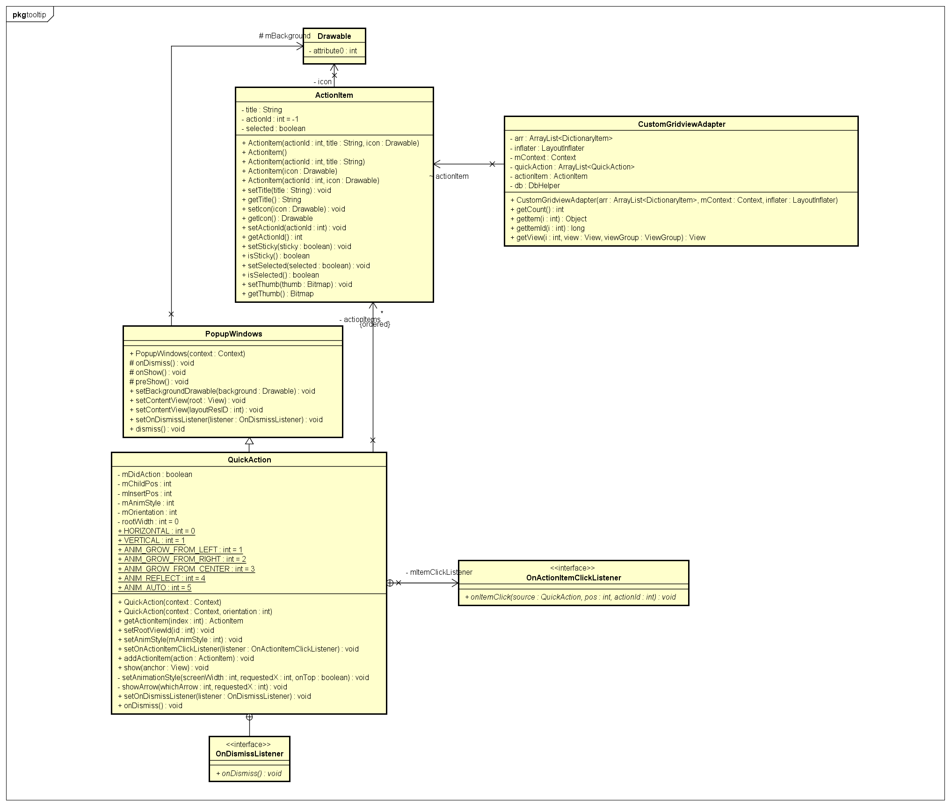

*Figure 66: Class diagram of user case Show dictionary package’s describtion*

* **Class Specification:**

1. **ActionItem class:**
2. *Attribute:*

|  |  |  |  |
| --- | --- | --- | --- |
| No | Name | Type | Description |
| 1 | title | String | Title of the button on tooltips |
| 2 | actionId | int |  |
| 3 | selected | boolean | This tooltips is open or not |

1. **QuickAction class:**

###### *Attribute:*

|  |  |  |  |
| --- | --- | --- | --- |
| No | Name | Type | Description |
| 1 | mDidAction | boolean | The tootips is showing or not |
| 2 | mChildPos | int | Position of child view |
| 3 | mInsertPos | int | Count the number of chikd view added |
| 4 | mAnimStyle | int | Animation style pass over |
| 5 | mOrientation | int | Orientation pass over (HORIZONTAL, or VERTICAL) |
| 6 | rootWidth | int |  |
| 7 | HORIZONTAL | int |  |
| 8 | VERTICAL | int |  |
| 9 | ANIM_GROW_FROM_LEFT | int |  |
| 10 | ANIM_GROW_FROM_RIGHT | int |  |
| 11 | ANIM_GROW_FROM_CENTER | int |  |
| 12 | ANIM_REFLECT | int |  |
| 13 | ANIM_AUTO | int |  |

###### *Method:*

getActionItem:

|  |  |  |  |  |
| --- | --- | --- | --- | --- |
| Purpose | Return list of action item | | | |
| Return | Type | | | Description |
| List<ActionItem> actionItems | | |  |
| Parameters | No | Name | Type | Description |
|  |  |  |  |

setOnActionItemClickListener:

|  |  |  |  |  |
| --- | --- | --- | --- | --- |
| Purpose | Set action for clicking action | | | |
| Return | Type | | | Description |
| void | | |  |
| Parameters | No | Name | Type | Description |
| 1 | action | Action Item |  |

addActionItem:

|  |  |  |  |  |
| --- | --- | --- | --- | --- |
| Purpose | Add an action Item | | | |
| Return | Type | | | Description |
| void | | |  |
| Parameters | No | Name | Type | Description |
| 1 | action | Action Item |  |

show:

|  |  |  |  |  |
| --- | --- | --- | --- | --- |
| Purpose | Show tooltips | | | |
| Return | Type | | | Description |
| void | | |  |
| Parameters | No | Name | Type | Description |
| 1 | anchor | View | View that user click on |

setAnimationStyle:

|  |  |  |  |  |
| --- | --- | --- | --- | --- |
| Purpose | Show tooltips | | | |
| Return | Type | | | Description |
| void | | |  |
| Parameters | No | Name | Type | Description |
| 1 | screenWidth | int | Display screen width |
| 2 | requestedX | int | X position of view |
| 3 | onTop | boolean |  |

showArrow:

|  |  |  |  |  |
| --- | --- | --- | --- | --- |
| Purpose | Show arrow point to clicked view | | | |
| Return | Type | | | Description |
| void | | |  |
| Parameters | No | Name | Type | Description |
| 1 | whichArrow | int | Type of arrow |
| 2 | requestedX | int | X position of view |

onDismiss:

|  |  |  |  |  |
| --- | --- | --- | --- | --- |
| Purpose | Dismiss tootips | | | |
| Return | Type | | | Description |
| void | | |  |
| Parameters | No | Name | Type | Description |
|  |  |  |  |

#### 1.7.2.8.3. Sequence Diagram:

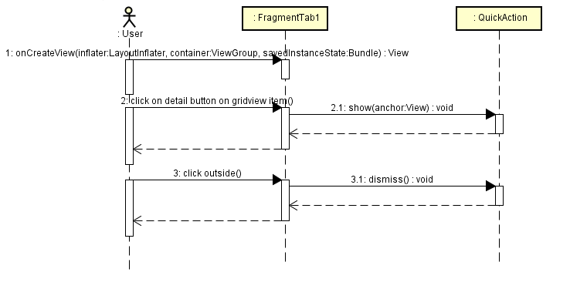

*Figure 67: Sequence diagram of user case View dictionary package's description*

#### 1.7.2.8.4. Activity Diagram

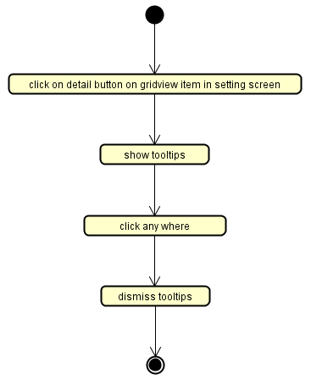

*Figure 68: Activity diagra of user case View dictionary package's description*

#### 1.7.2.9. View History

#### 1.7.2.9.1. Use Case Diagram:

* **Description:** View user’s searching history.

#### 1.7.2.9.2. Logical view

* **Class diagram**

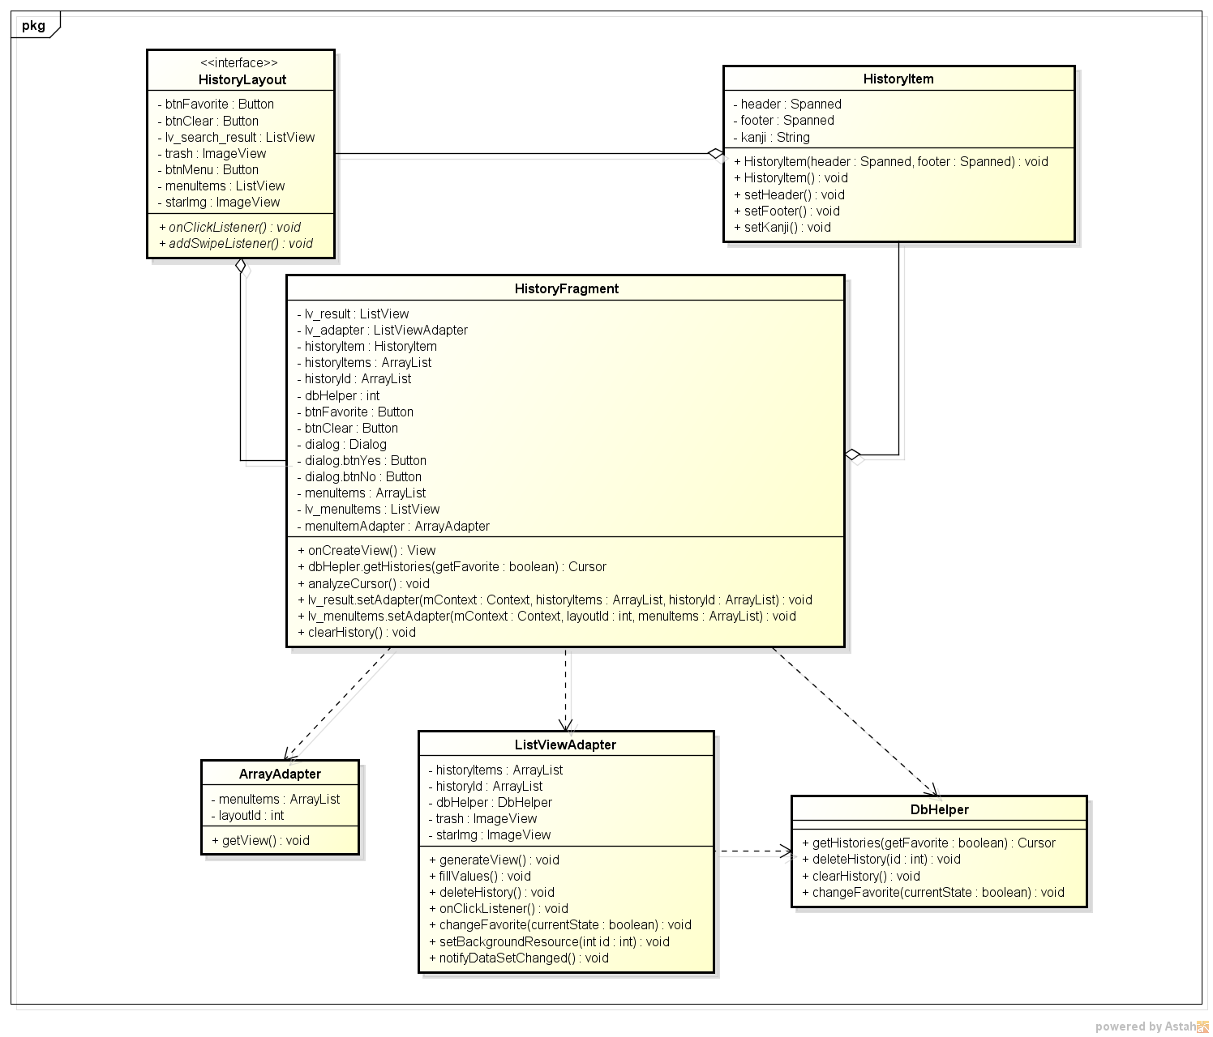

*Figure 69: Class diagram of User case View history*

* **Class specification:**

1. **HistoryFragment class**

###### *Attribute:*

|  |  |  |  |
| --- | --- | --- | --- |
| No | Name | Type | Description |
| 1 | lv_result | ListView | display all history items |
| 2 | lv_adapter | ListView adapter | bind data to every item of ListView (lv_result) |
| 3 | historyItem | History Item | store information (header, footer) to display in each ListView item |
| 4 | historyItems | ArrayList | list of historyItems |
| 5 | historyId | ArrayList | store the id of each history item. |
| 6 | dbHelper | DbHelper | used for accessing database |

###### *Method:*

lv_result.setAdapter

|  |  |  |  |  |
| --- | --- | --- | --- | --- |
| Purpose | Create actor’s account after actor logins into system. | | | |
| Return | Type | | | Description |
| void | | |  |
| Parameters | No | Name | Type | Description |
| 1 | mContext | Context | the activity context |
| 2 | historyItems | ArrayList | list of HistoryItem objects to display on layout |
| 3 | historyId | ArrayList | list of history items id |

analyzeCursor

|  |  |  |  |  |
| --- | --- | --- | --- | --- |
| Purpose | analyze the Cursor information to add to listview | | | |
| Return | Type | | | Description |
| void | | |  |
| Parameters | No | Name | Type | Description |
|  |  |  |  |

1. **HistoryItem class**

###### *Attribute:*

|  |  |  |  |
| --- | --- | --- | --- |
| No | Name | Type | Description |
| 1 | header | Spanned | store data of header TextView in the layout |
| 2 | footer | Spanned | store data of footer TextView in the layout |

###### *Method*

HistoryItem

|  |  |  |  |  |
| --- | --- | --- | --- | --- |
| Purpose | Create a HistoryItem object | | | |
| Return | Type | | | Description |
| void | | | this is a constructor to create a HistoryItem object with null attribute |
| Parameters | No | Name | Type | Description |
|  |  |  |  |

setHeader

|  |  |  |  |  |
| --- | --- | --- | --- | --- |
| Purpose | assign value for header attribute | | | |
| Return | Type | | | Description |
| void | | | Assign value for header attribute |
| Parameters | No | Name | Type | Description |
| 1 | header | Spanned | The header attribute of HistoryItem object |

setFooter

|  |  |  |  |  |
| --- | --- | --- | --- | --- |
| Purpose | assign value for footer attribute | | | |
| Return | Type | | | Description |
| void | | | assign value for footer attribute |
| Parameters | No | Name | Type | Description |
| 1 | footer | Spanned | the footer attribute of HistoryItem object |

1. **DbHelper class**

###### *Method:*

getHistories

|  |  |  |  |  |
| --- | --- | --- | --- | --- |
| Purpose | get all history items | | | |
| Return | Type | | | Description |
| void | | | get all history items |
| Parameters | No | Name | Type | Description |
| 1 | getFavorite | boolean | false: get all items  true: get items that are favorite |

1. **ListViewAdapter class**

###### *Attribute:*

|  |  |  |  |
| --- | --- | --- | --- |
| No | Name | Type | Description |
| **1** | historyItems | ArrayList | list of historyItem. Each element will be bind to one lisview item |
| **2** | historyId | ArrayList | list of history item id (id in the database) |
| **3** | dbHelper | Dbelper | access database |

###### *Method:*

fillValues

|  |  |  |  |  |
| --- | --- | --- | --- | --- |
| Purpose | fill values into listview item | | | |
| Return | Type | | | Description |
| void | | |  |
| Parameters | No | Name | Type | Description |
| 1 | id | Int | the id of the listview item |
|  | 2 | view | View | the listview item |

#### 1.7.2.9.3. Sequence diagram

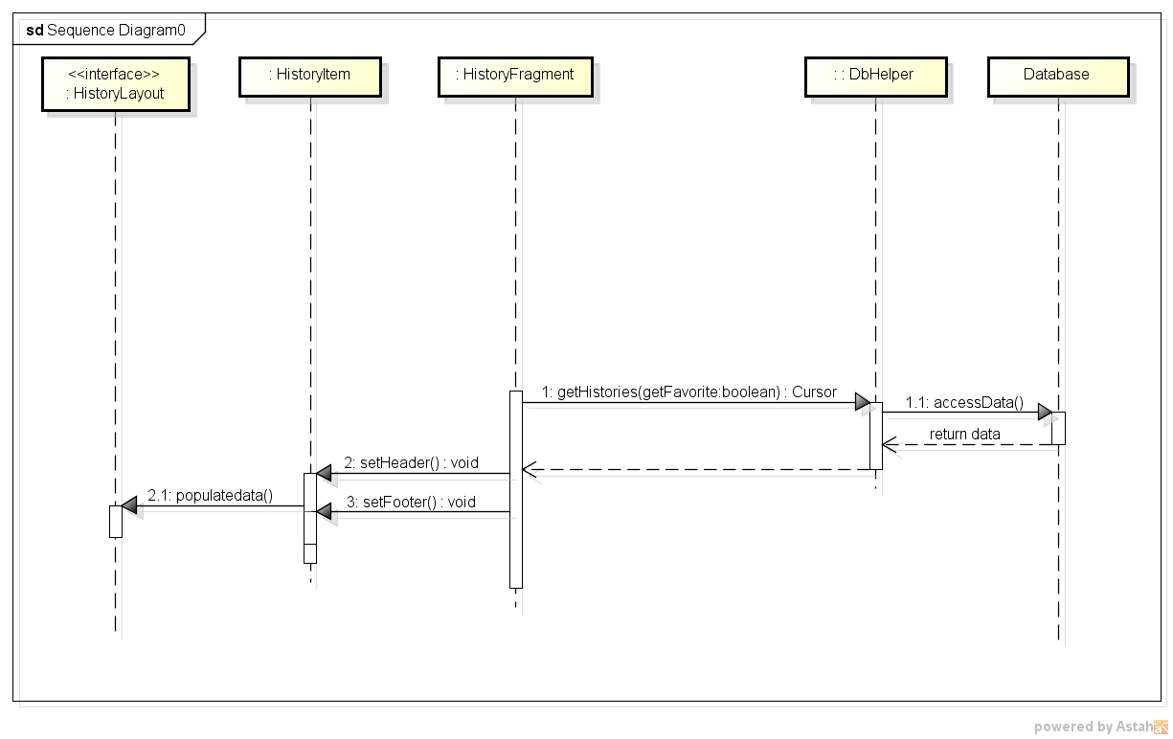

*Figure 70: Sequence diagram of user case View history*

**1.7.2.9.4. Activity diagram**

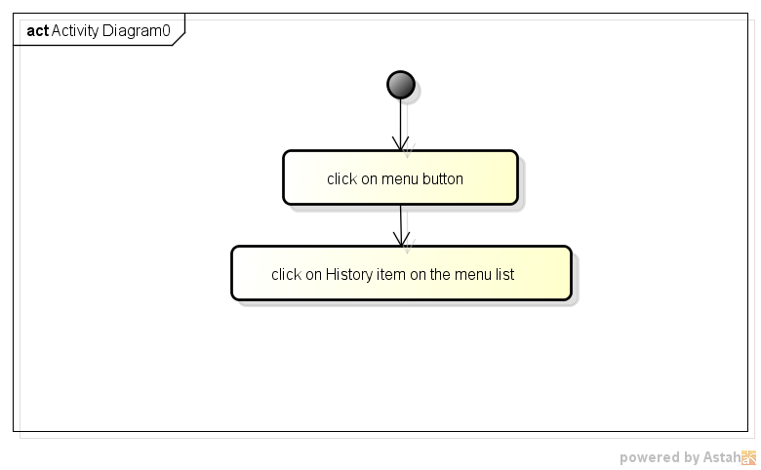

*Figure 71: Activity diagram of UC view history*

#### 1.7.2.10. View favorite words only

**1.7.2.10.1. User case**

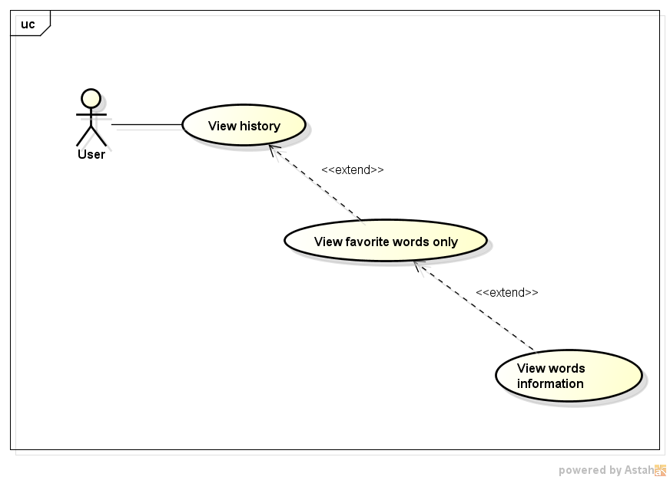

*Figure 72: User case View farorite words*

#### 1.7.2.10.1. Logical view

* **Class diagram**



*Figure 73: Class diagram for user case View favorite*

* **Class specification:**

1. **HistoryFragment class**

###### *Attribute:*

|  |  |  |  |
| --- | --- | --- | --- |
| No | Name | Type | Description |
| 1 | lv_result | ListView | display all history items |
| 2 | btnFavorite | Button | click to filter favorite words  click again do disable filter |
| 3 | lv_adapter | ListView Adapter | bind data to every item of ListView (lv_result) |
| 4 | historyItem | History Item | store information (header, footer) to display in each ListView item |
| 5 | historyItems | ArrayList | list of historyItems |
| 6 | historyId | ArrayList | store the id of each history item |
| 7 | dbHelper | DbHelper | used for accessing database |

###### *Method:*

btnFavorite.setOnClickListener

|  |  |  |  |  |
| --- | --- | --- | --- | --- |
| Purpose | filter by favorite words | | | |
| Return | Type | | | Description |
| void | | |  |
| Parameters | No | Name | Type | Description |
| 1 | View.OnClickListener | OnClickListener | the OnClickListener, executes events inside it when the view is clicked |

lv_result.setAdapter

|  |  |  |  |  |
| --- | --- | --- | --- | --- |
| Purpose | Create actor’s account after actor logins into system. | | | |
| Return | Type | | | Description |
| void | | |  |
| Parameters | No | Name | Type | Description |
| 1 | mContext | Context | the activity context |
| 2 | historyItems | ArrayList | list of HistoryItem objects to display on layout |

analyzeCursor

|  |  |  |  |  |
| --- | --- | --- | --- | --- |
| Purpose | analyze the Cursor information to add to listview | | | |
| Return | Type | | | Description |
| void | | |  |
| Parameters | No | Name | Type | Description |
|  |  |  |  |

1. **HistoryItem class**

###### *Attribute:*

|  |  |  |  |
| --- | --- | --- | --- |
| No | Name | Type | Description |
| **1** | header | Spanned | store data of header TextView in the layout |
| **2** | footer | Spanned | store data of footer TextView in the layout |

###### *Method:*

HistoryItem

|  |  |  |  |  |
| --- | --- | --- | --- | --- |
| Purpose | Create a HistoryItem object | | | |
| Return | Type | | | Description |
| void | | |  |
| Parameters | No | Name | Type | Description |
|  |  |  |  |

setHeader

|  |  |  |  |  |
| --- | --- | --- | --- | --- |
| Purpose | assign value for header attribute | | | |
| Return | Type | | | Description |
| void | | | assign value for header attribute |
| Parameters | No | Name | Type | Description |
| 1 | header | Spanned | the header attribute of HistoryItem object |

setFooter

|  |  |  |  |  |
| --- | --- | --- | --- | --- |
| Purpose | assign value for footer attribute | | | |
| Return | Type | | | Description |
| void | | | assign value for footer attribute |
| Parameters | No | Name | Type | Description |
| 1 | footer | Spanned | The footer attribute of HistoryItem object |

1. **DbHelper class**

###### *Method:*

getHistories

|  |  |  |  |  |
| --- | --- | --- | --- | --- |
| Purpose | get all history items | | | |
| Return | Type | | | Description |
|  | | |  |
| Parameters | No | Name | Type | Description |
| 1 | getFavorite | boolean | false: get all items  true: get items that are favorite |

1. **ListViewAdapter class**

###### *Attribute:*

|  |  |  |  |
| --- | --- | --- | --- |
| No | Name | Type | Description |
| **1** | historyItems | ArrayList | list of historyItem. Each element will be bind to one lisview item |
| **2** | historyId | ArrayList | list of history item id (id in the database) |
| **3** | dbHelper | Dbelper | access database |

1. *Method:*

fillValues

|  |  |  |  |  |
| --- | --- | --- | --- | --- |
| Purpose | fill values into listview item | | | |
| Return | Type | | | Description |
| void | | |  |
| Parameters | No | Name | Type | Description |
| 1 | id | int | The id of the listview item |
| 2 | view | View | The listview item |

#### 1.7.2.10.2. Sequence diagram

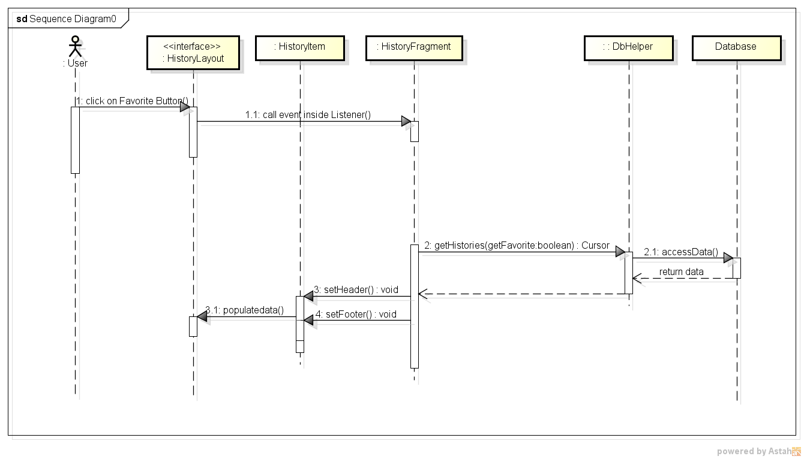

*Figure 74: Sequence diagram of user case View favorite*

**1.7.2.10.4. Activity diagram**

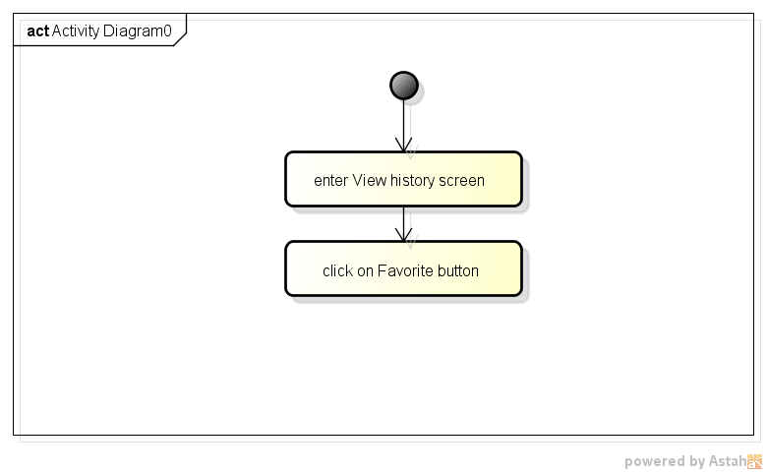

*Figure 75: Activity diagram of user case View favorite words*

#### 1.7.2.11. Add to favorite list/ Remove from favorite list

**1.7.2.11.1. User case diagram**

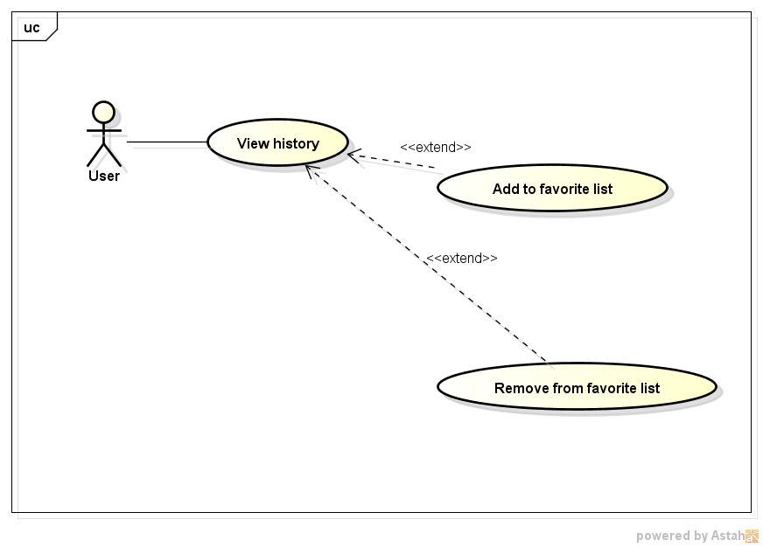

*Figure 76: User case Add / remove from favorite list*

##### **1.7.2.11.2. Logical view**

* **Class diagram:**



*Figure 77: Class diagram of user case Add / Remove from favorite*

* **Class specification:**

1. **ListViewAdapter class**

###### *Attribute:*

|  |  |  |  |
| --- | --- | --- | --- |
| No | Name | Type | Description |
| 1 | historyId | ArrayList | store the id of each history item. |
| 2 | starImg | ImageView | click to change favorite state |

###### *Method:*

setBackgroundResource

|  |  |  |  |  |
| --- | --- | --- | --- | --- |
| Purpose | change the star image that suits the favorite state | | | |
| Return | Type | | | Description |
| void | | |  |
| Parameters | No | Name | Type | Description |
| 1 | id | int | The resource id of the image |

1. **DbHelper class**

###### *Method:*

changeFavorite

|  |  |  |  |  |
| --- | --- | --- | --- | --- |
| Purpose | change the favorite state | | | |
| Return | Type | | | Description |
| void | | |  |
| Parameters | No | Name | Type | Description |
| 1 | tableName | String | the table that contains the word/kanji |
| 2 | id | int | the word/kanji ID |
| 3 | currentState | boolean | the current favorite state of that word/kanji |

#### 1.7.2.11.3. Sequence diagram:

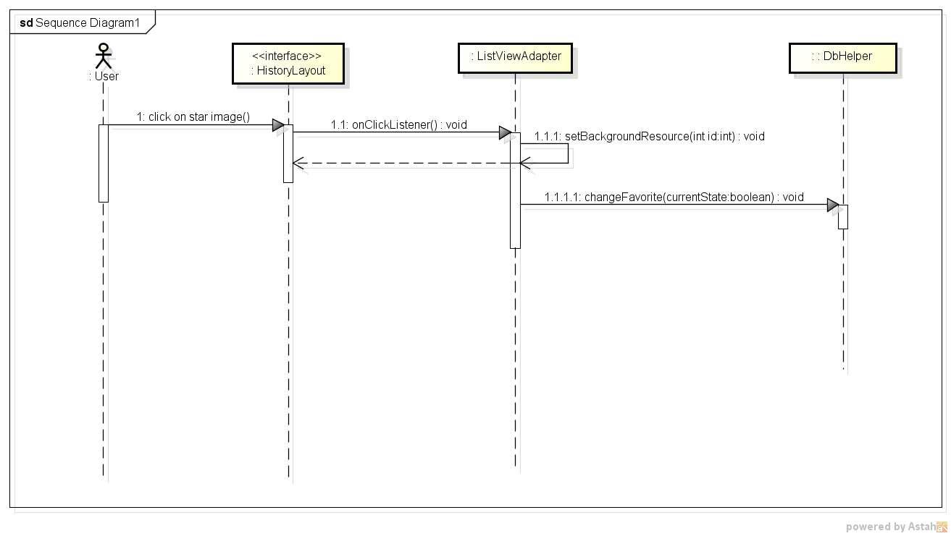

*Figure 78: Sequence diagram of user case Add / Remove from favorite*

**1.7.2.11.4. Activity diagram**

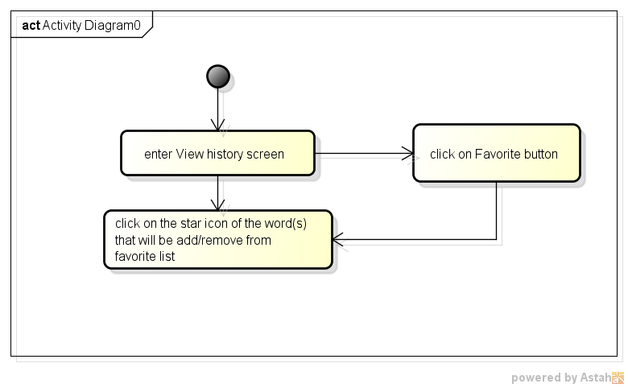

*Figure 79: Activity diagram of user case Add / remove from favorite list*

#### 1.7.2.12. Delete one word from history

**1.7.2.12.1. User case**

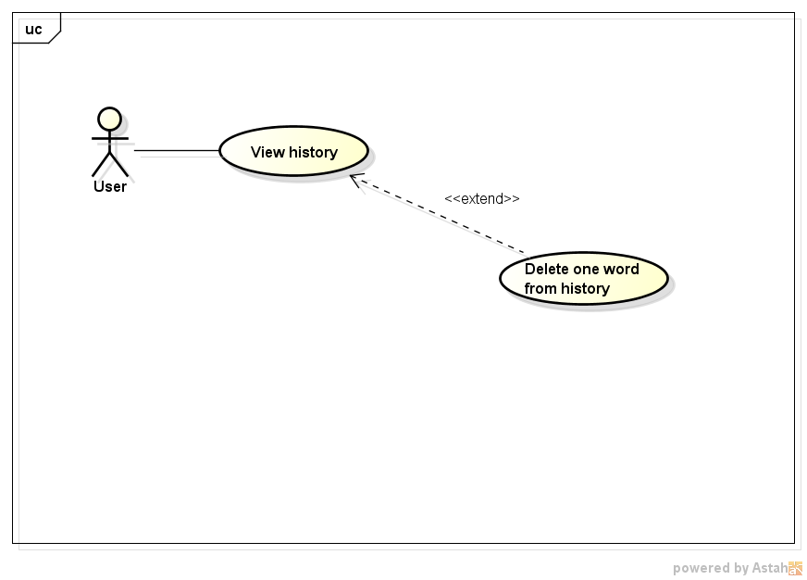

*Figure 80: User case Delete word from histor*

#### 1.7.2.12.2. Logical view

* **Class diagram:**



*Figure 81: Class diagram of user case Delete a word from history*

* **Class specification:**

1. **ListViewAdapter class**

###### *Method*

historyItems.remove

|  |  |  |  |  |
| --- | --- | --- | --- | --- |
| Purpose | remove an item from historyItems ArrayList | | | |
| Return | Type | | | Description |
| void | | |  |
| Parameters | No | Name | Type | Description |
| 1 | position | int | The position of the item in the array list |

historyId.remove

|  |  |  |  |  |
| --- | --- | --- | --- | --- |
| Purpose | remove an item from historyId ArrayList | | | |
| Return | Type | | | Description |
| void | | |  |
| Parameters | No | Name | Type | Description |
| 1 | position | int | The position of the item in the array list |

1. **DbHelper class**

###### *Method*

deleteHistory

|  |  |  |  |  |
| --- | --- | --- | --- | --- |
| Purpose | remove a history record from history table | | | |
| Return | Type | | | Description |
| void | | |  |
| Parameters | No | Name | Type | Description |
| 1 | id | int | The id of history record |

#### 1.7.2.12.2. Sequence diagram:

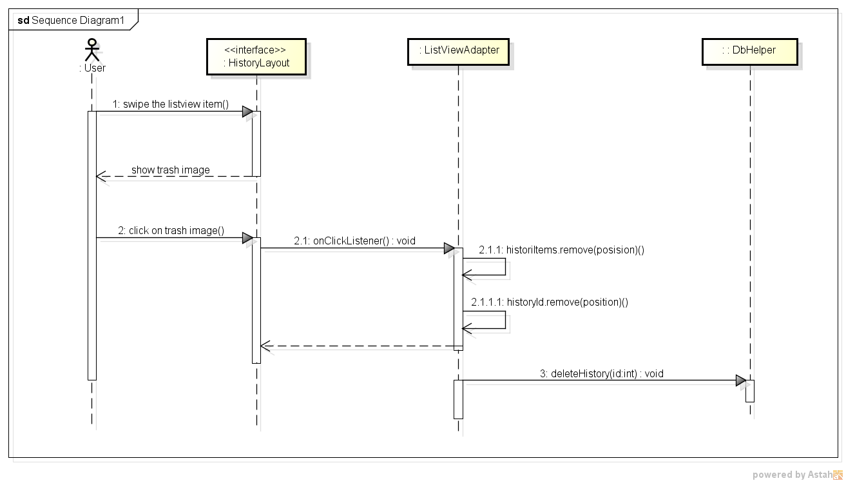

*Figure 82: Sequence diagram of user case Delete a word from history*

**1.7.2.12.3. Activity diagram**

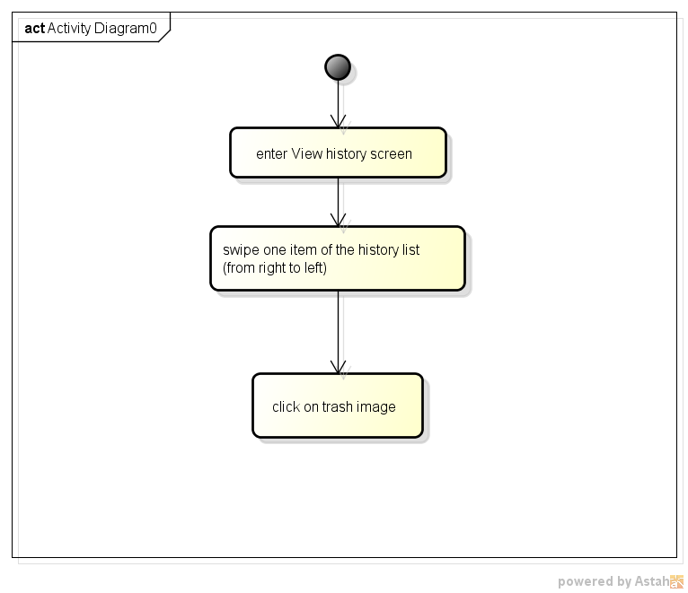

*Figure 83: Activity diagram of user case delete word from history*

#### 1.7.2.14. Clear History

**1.7.2.14.1. User case**

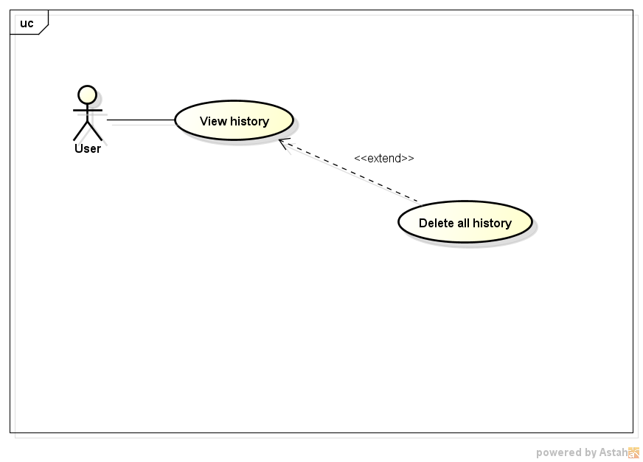

#### 1.7.2.13.1. Logical view

* **Class diagram:**



*Figure 84: Class diagram of user case clear history*

* **Class specification:**

1. **HistoryFragment class**

###### *Attribute:*

|  |  |  |  |
| --- | --- | --- | --- |
| No | Name | Type | Description |
| 1 | lv_result | ListView | display all history items |
| 2 | lv_adapter | ListView Adapter | bind data to every item of ListView (lv_result) |
| 3 | historyItem | History Item | store information (header, footer) to display in each ListView item |
| 4 | historyItems | ArrayList | list of historyItems |
| 5 | historyId | ArrayList | store the id of each history item. |
| 6 | dbHelper | DbHelper | used for accessing database |
| 7 | dialog | Dialog | dialog to confirm deletion |

###### *Method:*

clearHistory

|  |  |  |  |  |
| --- | --- | --- | --- | --- |
| Purpose | clear all history | | | |
| Return | Type | | | Description |
| voi | | | clear all history |
| Parameters | No | Name | Type | Description |
|  |  |  |  |

dialog.create.show

|  |  |  |  |  |
| --- | --- | --- | --- | --- |
| Purpose | confirm the deletion | | | |
| Return | Type | | | Description |
| void | | |  |
| Parameters | No | Name | Type | Description |
|  |  |  |  |

lv_result.setAdapter

|  |  |  |  |  |
| --- | --- | --- | --- | --- |
| Purpose | Create actor’s account after actor logins into system. | | | |
| Return | Type | | | Description |
| void | | |  |
| Parameters | No | Name | Type | Description |
| 1 | mContext | Context | The activity context |
| 2 | historyItems | ArrayList | list of HistoryItem objects to display on layout |
| 3 | historyID | ArrayList | List of history items id |

analyzeCursor

|  |  |  |  |  |
| --- | --- | --- | --- | --- |
| Purpose | analyze the Cursor information to add to listview | | | |
| Return | Type | | | Description |
| void | | |  |
| Parameters | No | Name | Type | Description |
|  |  |  |  |

1. **HistoryItem class**

###### *Attribute:*

|  |  |  |  |
| --- | --- | --- | --- |
| No | Name | Type | Description |
| 1 | header | Spanned | store data of header TextView in the layout |
| 2 | footer | Spanned | store data of footer TextView in the layout |

###### *Method:*

HistoryItem

|  |  |  |  |  |
| --- | --- | --- | --- | --- |
| Purpose | Create a HistoryItem object | | | |
| Return | Type | | | Description |
| void | | | this is a constructor to create a HistoryItem object with null attribute |
| Parameters | No | Name | Type | Description |
|  |  |  |  |

setHeader

|  |  |  |  |  |
| --- | --- | --- | --- | --- |
| Purpose | assign value for header attribute | | | |
| Return | Type | | | Description |
| void | | | assign value for header attribute |
| Parameters | No | Name | Type | Description |
| 1 | header | Spanned | The header attribute of HistoryItem object |

setFooter

|  |  |  |  |  |
| --- | --- | --- | --- | --- |
| Purpose | assign value for footer attribute | | | |
| Return | Type | | | Description |
| void | | | Assign value for footer attribute |
| Parameters | No | Name | Type | Description |
| 1 | footer | Spanned | The footer attribute of HistoryItem object |

1. **DbHelper class**

###### *Method:*

getHistories

|  |  |  |  |  |
| --- | --- | --- | --- | --- |
| Purpose | get all history items | | | |
| Return | Type | | | Description |
| void | | | get all history items |
| Parameters | No | Name | Type | Description |
| 1 | getFavorite | boolean | false: get all items  true: get items that are favorite |

1. **ListViewAdapter class**

###### *Attribute:*

|  |  |  |  |
| --- | --- | --- | --- |
| No | Name | Type | Description |
| 1 | historyItems | ArrayList | list of historyItem. Each element will be bind to one lisview item |
| 2 | historyId | ArrayList | list of history item id (id in the database) |
| 3 | dbHelper | Dbelper | access database |

###### *Method:*

fillValues

|  |  |  |  |  |
| --- | --- | --- | --- | --- |
| Purpose | fill values into listview item | | | |
| Return | Type | | | Description |
| void | | |  |
| Parameters | No | Name | Type | Description |
| 1 | id | int | The id of the listview item |
| 2 | view | view | The listview item |

#### 1.7.2.13.3. Sequence diagram

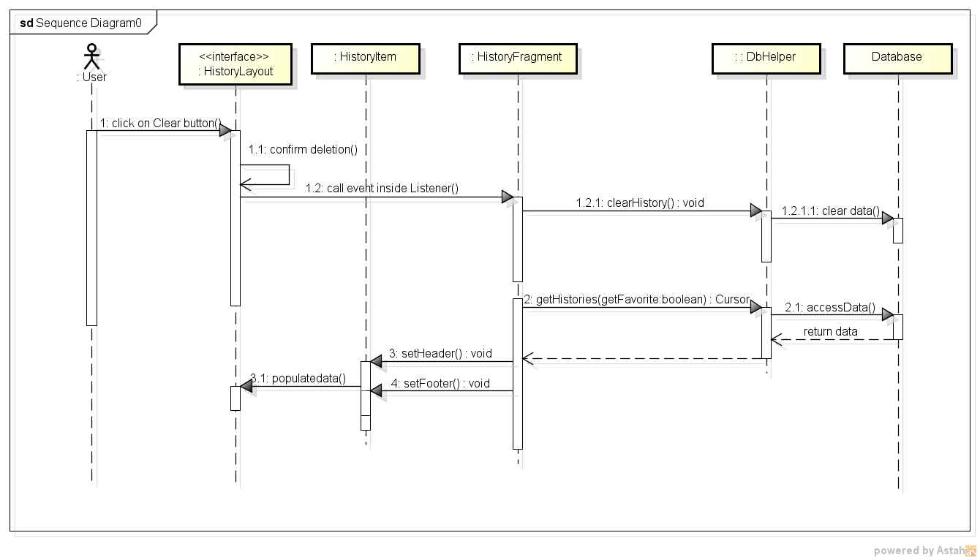

*Figure 85: Sequence diagram of user case clear history*

**1.7.2.13.4. Activity diagram**

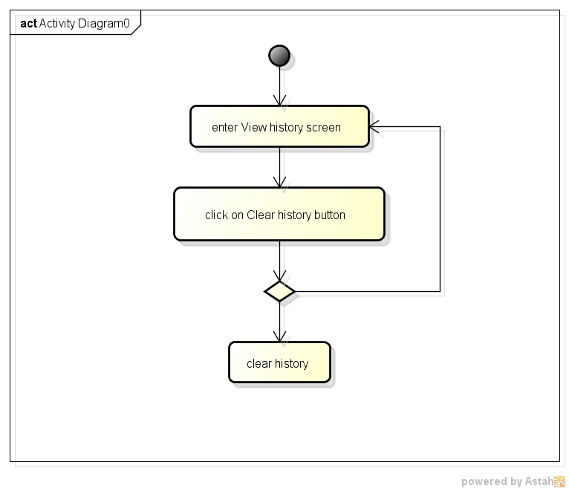

*Figure 86: Activity diagram of user case clear history*

## 1.8. Detail design of Server

### 1.8.1. Overview

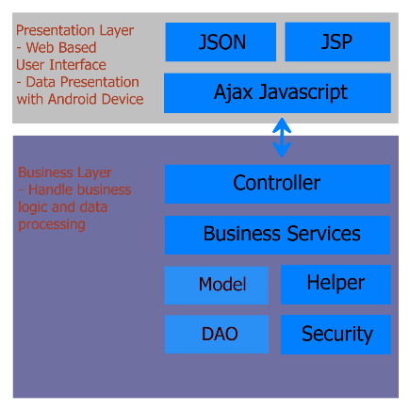

*Figure 87: Overview of server architecture*

### 8.1.2. Detail design

#### 8.1.2.1. Dictionary Management

#### 8.1.2.1.1. Use Case Specification

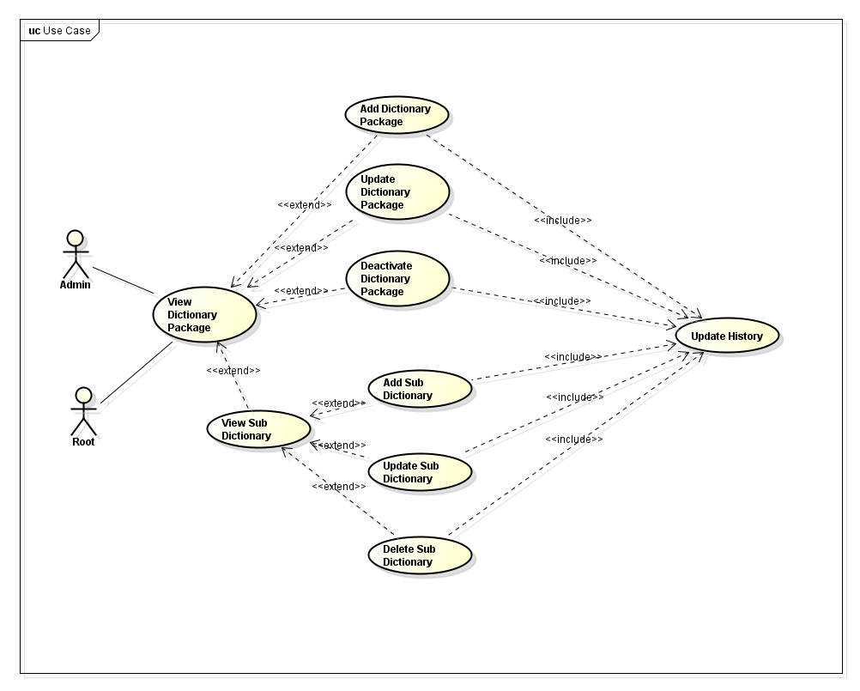

*Figure 88: User cases of Dictionary management*

#### 8.1.2.1.2. Logical view

* **Class diagram**

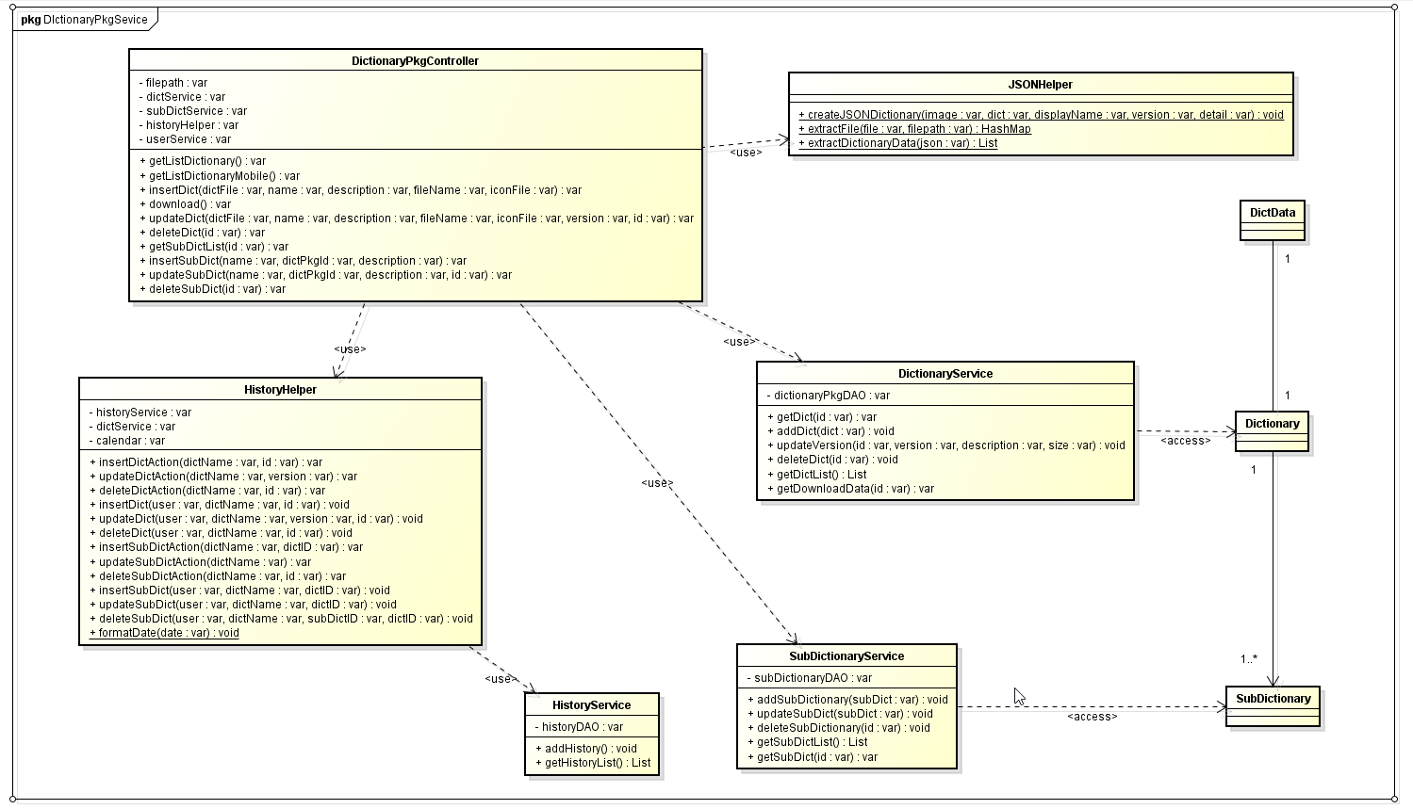

*Figure 89: Dictionary Service Class Diagram*

###### **Class Specification**

###### **DictionaryPkgController**

###### *Attribute:*

|  |  |  |  |
| --- | --- | --- | --- |
| No | Name | Type | Description |
| 1 | filepath | String | This variable contain the current filepath for storing and downloading dictionary json file |
| 2 | dictService | DictionaryPkgService | This variable is the service of dictionary package service |
| 3 | subDictService | SubDictionaryService | This variable is the service of sub dictionary service |
| 4 | historyHelper | HistoryHelper | The helper class of the history service |
| 5 | userService | UserService | The user service, help validate user session |

###### *Method:*

getDictionaryList:

|  |  |  |  |  |
| --- | --- | --- | --- | --- |
| Purpose | Get the list of dictionary package and return the view of that list | | | |
| Return | Type | | | Description |
| String | | | The page view of the dictionary list |
| Parameters | No | Name | Type | Description |
|  |  |  |  |

getDictionaryListMobile:

|  |  |  |  |  |
| --- | --- | --- | --- | --- |
| Purpose | Get the list of dictionary package and return the json string of that list (for Android device’s check for update purpose) | | | |
| Return | Type | | | Description |
| String | | | The json string of the dictionary list |
| Parameters | No | Name | Type | Description |
|  |  |  |  |

getSubDictionaryListMobile:

|  |  |  |  |  |
| --- | --- | --- | --- | --- |
| Purpose | Get the list of sub dictionary package related to a specific sub dictionary and return the json string of that list (for Android device’s data integration purpose) | | | |
| Return | Type | | | Description |
| String | | | The json string of the sub dictionary list |
| Parameters | No | Name | Type | Description |
| 1 | id | String | The id of the dictionary package |

insertDict:

|  |  |  |  |  |
| --- | --- | --- | --- | --- |
| Purpose | Add new dictionary to the database | | | |
| Return | Type | | | Description |
| void | | |  |
| Parameters | No | Name | Type | Description |
| 1 | dictFile | MultipartFile | The dictionary file |
| 2 | name | String | The dictionary name |
| 3 | description | String | The description of the dictionary |
| 4 | fileName | String | The filename of the dictionary which will be stored into the storage |
| 5 | iconFile | MultipartFile | The icon file of the corresponding dictionary |

download:

|  |  |  |  |  |
| --- | --- | --- | --- | --- |
| Purpose | Download the specified dictionary | | | |
| Return | Type | | | Description |
| void | | |  |
| Parameters | No | Name | Type | Description |
|  |  |  |  |

updateDict:

|  |  |  |  |  |
| --- | --- | --- | --- | --- |
| Purpose | Update the specified dictionary by uploading new dictionary file, new icon file, and update the dictionary data | | | |
| Return | Type | | | Description |
| String | | | The view page of the dictionary list |
| Parameters | No | Name | Type | Description |
| 1 | dictFile | MultipartFile | The dictionary file |
| 2 | name | String | The dictionary name |
| 3 | description | String | The description of the dictionary |
| 4 | fileName | String | The filename of the dictionary which will be stored into the storage |
| 5 | iconFile | MultipartFile | The icon file of the corresponding dictionary |
| 6 | version | String | The new version of the dictionary |
| 1 | dictFile | MultipartFile | The dictionary file |

deleteDict:

|  |  |  |  |  |
| --- | --- | --- | --- | --- |
| Purpose | Delete the specified dictionary by setting it into inactive state, allowing the preservation of the history list | | | |
| Return | Type | | | Description |
| String | | | The view page of dictionary list |
| Parameters | No | Name | Type | Description |
| 1 | id | String | The id of the dictionary package |

getSubDictList:

|  |  |  |  |  |
| --- | --- | --- | --- | --- |
| Purpose | Get the list of the sub dictionary and return the view of the sub dictionary list | | | |
| Return | Type | | | Description |
| String | | | The view page of the sub dictionary list |
| Parameters | No | Name | Type | Description |
| 1 | id | String | The dictionary package ID containing the sub dictionary list |

insertSubDict:

|  |  |  |  |  |
| --- | --- | --- | --- | --- |
| Purpose | Add new sub dictionary to the database | | | |
| Return | Type | | | Description |
| String | | | The view page of the sub dictionary list |
| Parameters | No | Name | Type | Description |
| 1 | name | String | The sub dictionary name |
| 2 | dictPkgId | String | The dictionary package ID |
| 3 | description | String | The description of the sub dictionary |

updateSubDict:

|  |  |  |  |  |
| --- | --- | --- | --- | --- |
| Purpose | Update the specific sub dictionary data | | | |
| Return | Type | | | Description |
| String | | | The view page of the sub dictionary list |
| Parameters | No | Name | Type | Description |
| 1 | name | String | The sub dictionary name |
| 2 | dictPkgId | String | The dictionary package ID |
| 3 | description | String | The description of the sub dictionary |
| 4 | id | String | The ID of the sub dictionary |

deleteSubDict:

|  |  |  |  |  |
| --- | --- | --- | --- | --- |
| Purpose | Delete the specific sub dictionary, by remove its data from the database | | | |
| Return | Type | | | Description |
| String | | | The view page of the sub dictionary list |
| Parameters | No | Name | Type | Description |
| 1 | id | String | The sub dictionary id |

###### **DictionaryPkgService**

###### *Attribute:*

|  |  |  |  |
| --- | --- | --- | --- |
| No | Name | Type | Description |
| 1 | dictionaryPkgDAO | DictionaryPkgDAO | This variable contain the dictionary DAO to access to the database |

1. *Methods*

getDict:

|  |  |  |  |  |
| --- | --- | --- | --- | --- |
| Purpose | Get the specific dictionary package | | | |
| Return | Type | | | Description |
| DictionartPackage | | | The specific dictionary package |
| Parameters | No | Name | Type | Description |
| 1 | id | int | The dictionary package id |

addDict:

|  |  |  |  |  |
| --- | --- | --- | --- | --- |
| Purpose | Add new Dictionary into the database | | | |
| Return | Type | | | Description |
| void | | |  |
| Parameters | No | Name | Type | Description |
| 1 | dict | DictionaryPackage | The dictionary package data |

updateVersion:

|  |  |  |  |  |
| --- | --- | --- | --- | --- |
| Purpose | Update the version and dictionary data (Dictionary file is already uploaded in the controller class) | | | |
| Return | Type | | | Description |
| void | | |  |
| Parameters | No | Name | Type | Description |
| 1 | id | int | The id of the dictionary package |
| 2 | version | String | The dictionary new version |
| 3 | size | double | The size of the dictionary file |

deleteDict:

|  |  |  |  |  |
| --- | --- | --- | --- | --- |
| Purpose | Delete the specific dictionary package, by setting its active state to false | | | |
| Return | Type | | | Description |
| void | | |  |
| Parameters | No | Name | Type | Description |
| 1 | id | int | The dictionary packge id |

getDictList:

|  |  |  |  |  |
| --- | --- | --- | --- | --- |
| Purpose | Get the list of dictioney package | | | |
| Return | Type | | | Description |
| List<DictionaryPackage> | | | The list of the dictionary package |
| Parameters | No | Name | Type | Description |
|  |  |  |  |

getDownloadData:

|  |  |  |  |  |
| --- | --- | --- | --- | --- |
| Purpose | Get the download data of the dictionary package | | | |
| Return | Type | | | Description |
| DictData | | | The dictionary data for downloading |
| Parameters | No | Name | Type | Description |
| 1 | id | int | The dictionary package id |

###### **SubDictionaryService**

1. *Attribute:*

|  |  |  |  |
| --- | --- | --- | --- |
| No | Name | Type | Description |
| 1 | subDictionaryDAO | SubDictionaryDAO | This variable contain the sub dictionary DAO to access to the database |

1. *Methods:*

addSubDictionary:

|  |  |  |  |  |
| --- | --- | --- | --- | --- |
| Purpose | Add new sub dictionary to the database | | | |
| Return | Type | | | Description |
| void | | |  |
| Parameters | No | Name | Type | Description |
| 1 | subDict | SubDictionary | The sub dictionary data |

updateSubDict:

|  |  |  |  |  |
| --- | --- | --- | --- | --- |
| Purpose | Update the specific sub dictionary data | | | |
| Return | Type | | | Description |
| void | | |  |
| Parameters | No | Name | Type | Description |
| 1 | subDict | SubDictionary | The sub dictionary data |

deleteSubDictionary:

|  |  |  |  |  |
| --- | --- | --- | --- | --- |
| Purpose | Delete sub dictionary data, by removing its record from the database | | | |
| Return | Type | | | Description |
|  | | |  |
| Parameters | No | Name | Type | Description |
| 1 | id | int | The id of the sub dictionary package |

getSubDictList:

|  |  |  |  |  |
| --- | --- | --- | --- | --- |
| Purpose | Get the list of the sub dictionary | | | |
| Return | Type | | | Description |
| List<SubDictionary> | | | The list of the sub dictionary |
| Parameters | No | Name | Type | Description |
|  |  |  |  |

getSubDict:

|  |  |  |  |  |
| --- | --- | --- | --- | --- |
| Purpose | Get the sub dictionary data | | | |
| Return | Type | | | Description |
| SubDictionary | | | The sub dictionary ata |
| Parameters | No | Name | Type | Description |
| 1 | id | int | The id of the sub dictionary package |

###### **JSONHelper**

###### *Method*

createJSONDictionary:

|  |  |  |  |  |
| --- | --- | --- | --- | --- |
| Purpose | Create a json extension file with the dictionary icon file and the dictionary package file itself. Both the icon file and the dictionary file will be converted into bytes array and put into the json extension file. | | | |
| Return | Type | | | Description |
| void | | |  |
| Parameters | No | Name | Type | Description |
| 1 | image | File | The image file of the dictionary |
| 2 | dict | File | The dictionary file |
| 3 | displayName | String | The display name of the dictionary in Android device |
| 4 | version | String | The current version of the dictionary package |
| 5 | detail | String | The description of the dictionary |

extractFile:

|  |  |  |  |  |
| --- | --- | --- | --- | --- |
| Purpose | Extract the json extension file into dictionary file and icon file, while returning the hash map containing the dictionary data | | | |
| Return | Type | | | Description |
| HashMap<String,String> | | | The hash map of the dictionary data |
| Parameters | No | Name | Type | Description |
| 1 | file | File | The json extension file |
| 2 | filepath | String | The filepath of the dictionary that will be saved into |

extractDictionaryData:

|  |  |  |  |  |
| --- | --- | --- | --- | --- |
| Purpose | Extract a Dictionary json data string into the list of the dictionary data (for Android’s check for update purpose). Using Gson library | | | |
| Return | Type | | | Description |
| List<DictionaryPackage> | | | The list of dictionary package |
| Parameters | No | Name | Type | Description |
| 1 | json | String | The json string of the dictionary list |

#### 8.2.1.3. Sequence Diagram

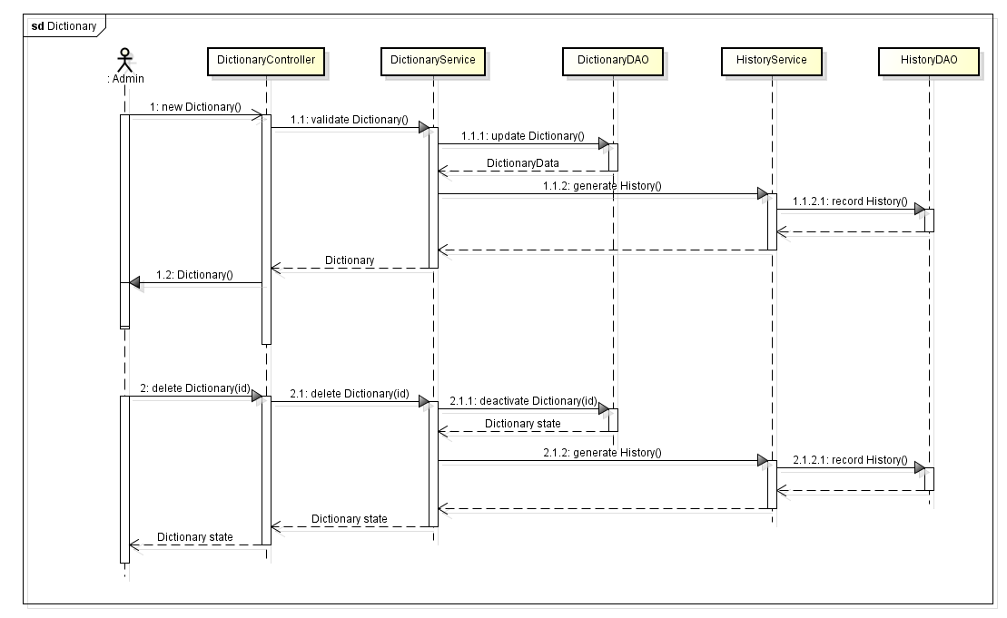

*Figure 90: Dictionary Service Sequence Diagram*

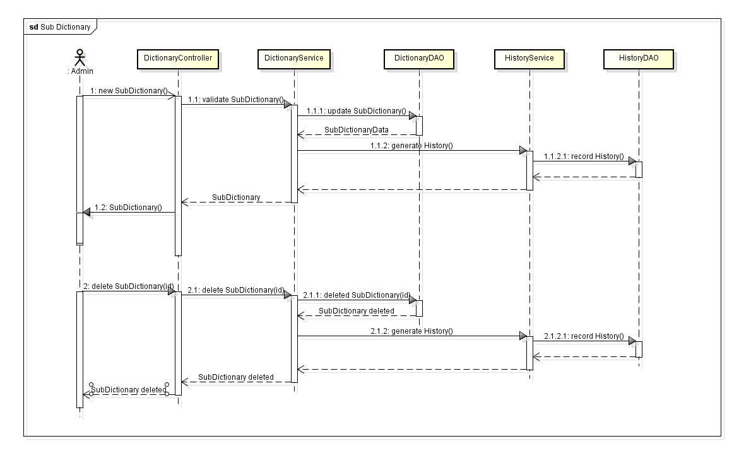

*Figure 91: Sub Dictionary Service Sequence Diagram*

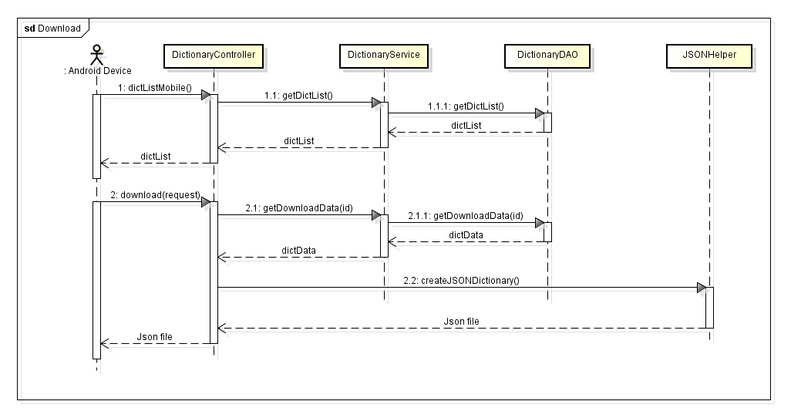

*Figure 92: Download Dictionary Sequence Diagram*

(Reference to 5.4 History Logging for detail design of HistoryService)

#### 1.8.2.1.4. Activity diagram

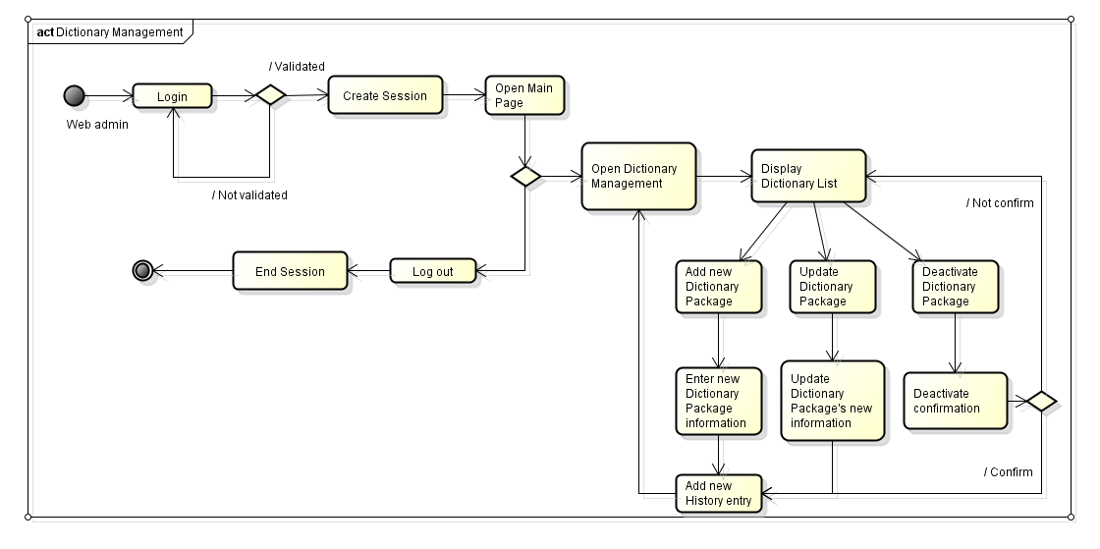

*Figure 93: Dictionary Service Activity Diagram*

After every action evolving dictionary management, the system will always have to log the history data.

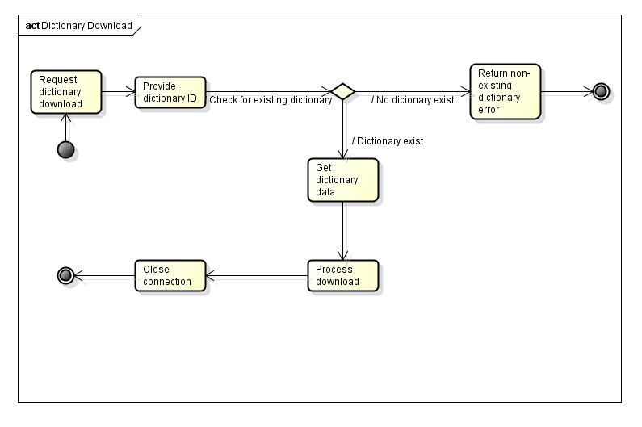

*Figure 94: Download Dictionary Activity Diagram*

#### 1.8.2.2. Account management

#### 1.8.2.2.1. Use Case specification

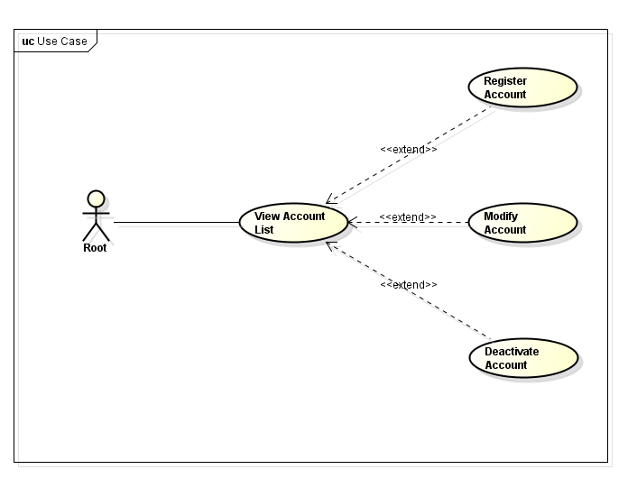

*Figure 95: Account management user cases*

#### 1.8.2.2.2. Logical view

* **Class diagram:**

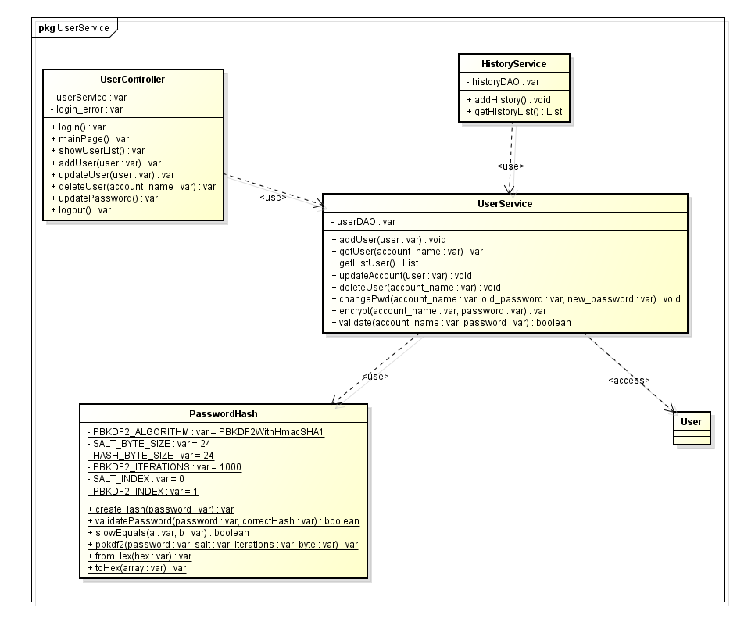

*Figure 96: Account Management Class Diagram*

###### **Class Specification:**

###### **UserController**

###### *Attribute:*

|  |  |  |  |
| --- | --- | --- | --- |
| No | Name | Type | Description |
| 1 | 1 | userService | UserService |
| 2 | 2 | login_error | String |

###### *Method:*

login:

|  |  |  |  |  |
| --- | --- | --- | --- | --- |
| Purpose | Login user into the system, set the session of the user including his account_name and role | | | |
| Return | Type | | | Description |
| String | | | The main page of the system if login successful, otherwise the index login |
| Parameters | No | Name | Type | Description |
|  |  |  |  |

mainPage:

|  |  |  |  |  |
| --- | --- | --- | --- | --- |
| Purpose | Show the main page of the system to the user, while checking for user’s authority | | | |
| Return | Type | | | Description |
| String | | | The main view page |
| Parameters | No | Name | Type | Description |
|  |  |  |  |

showUserList:

|  |  |  |  |  |
| --- | --- | --- | --- | --- |
| Purpose | Get the list of user data (without sensitive information) and display it on the userList page | | | |
| Return | Type | | | Description |
| String | | | The view page of the user list |
| Parameters | No | Name | Type | Description |
|  |  |  |  |

addUser:

|  |  |  |  |  |
| --- | --- | --- | --- | --- |
| Purpose | Add new user into the database, while hashing their password before storing it into the database | | | |
| Return | Type | | | Description |
| String | | | The view page of the user list |
| Parameters | No | Name | Type | Description |
| 1 | user | User | The user data |

updateUser:

|  |  |  |  |  |
| --- | --- | --- | --- | --- |
| Purpose | Update the specific user’s data (without changing their password – at the different method) into the database | | | |
| Return | Type | | | Description |
| String | | | The view page of the user list |
| Parameters | No | Name | Type | Description |
| 1 | user | User | The updated user data (without password) |

deleteUser:

|  |  |  |  |  |
| --- | --- | --- | --- | --- |
| Purpose | Delete the specific user, by deactivated his account in the database. | | | |
| Return | Type | | | Description |
| String | | | the view page of the user list |
| Parameters | No | Name | Type | Description |
| 1 | account_name | String | The account name of the user |

updatePassword:

|  |  |  |  |  |
| --- | --- | --- | --- | --- |
| Purpose | Update user password, by validating it’s old password, then hashing it’s new password and store the new hashed password into the database. Close the windows after changing the password | | | |
| Return | Type | | | Description |
| void | | |  |
| Parameters | No | Name | Type | Description |
|  |  |  |  |

logout:

|  |  |  |  |  |
| --- | --- | --- | --- | --- |
| Purpose | Log out the user from the system | | | |
| Return | Type | | | Description |
| String | | | the index view page |
| Parameters | No | Name | Type | Description |
|  |  |  |  |

###### **UserService**

###### *Attribute:*

|  |  |  |  |
| --- | --- | --- | --- |
| No | Name | Type | Description |
| 1 | userDAO | UserDAO | The user’s DAO, which allow access to the database |

###### *Method*

addUser:

|  |  |  |  |  |
| --- | --- | --- | --- | --- |
| Purpose | Root admin register new admin account for dictionary management | | | |
| Return | Type | | | Description |
| void | | |  |
| Parameters | No | Name | Type | Description |
| 1 | user | User | The user data |

getUser:

|  |  |  |  |  |
| --- | --- | --- | --- | --- |
| Purpose | Get the information of the specific user | | | |
| Return | Type | | | Description |
| User | | | The user data |
| Parameters | No | Name | Type | Description |
| 1 | account_name | String | The accout name of the user |

getListUser:

|  |  |  |  |  |
| --- | --- | --- | --- | --- |
| Purpose | Get the list of all user in the database | | | |
| Return | Type | | | Description |
| List<User> | | | The list of user data |
| Parameters | No | Name | Type | Description |
|  |  |  |  |

updateAccount:

|  |  |  |  |  |
| --- | --- | --- | --- | --- |
| Purpose | Update new information for user data (without password change) | | | |
| Return | Type | | | Description |
| void | | |  |
| Parameters | No | Name | Type | Description |
| 1 | user | User | The user data |

deleteUser:

|  |  |  |  |  |
| --- | --- | --- | --- | --- |
| Purpose | Delete user data, by deactivate it, to prevent that user from accessing into the system | | | |
| Return | Type | | | Description |
| void | | |  |
| Parameters | No | Name | Type | Description |
| 1 | account_name | String | The account name of the user |

changePwd:

|  |  |  |  |  |
| --- | --- | --- | --- | --- |
| Purpose | Allow user to change their password, the old password will be validated, and the new password will be hashed, and update it into the database | | | |
| Return | Type | | | Description |
| void | | |  |
| Parameters | No | Name | Type | Description |
| 1 | account_name | String | The account name of the user |
| 2 | old_password | String | The user’s old password |
| 3 | new_password | String | The user’s new password |

encrypt:

|  |  |  |  |  |
| --- | --- | --- | --- | --- |
| Purpose | Encrypt the the user’s password into the hash string | | | |
| Return | Type | | | Description |
| String | | | The hash of the user password |
| Parameters | No | Name | Type | Description |
| 1 | account_name | String | The account name of the user |
| 2 | password | String | The password of the user |

validate:

|  |  |  |  |  |
| --- | --- | --- | --- | --- |
| Purpose | Validate the current user, return true if the password hash is match the same with the hash in the database, otherwise return false | | | |
| Return | Type | | | Description |
| boolean | | | the validation result of the hash check |
| Parameters | No | Name | Type | Description |
| 1 | account_name | String | The account name of the user |
| 2 | password | String | The password of the user |

**3. PasswordHash**

###### *Attribute*

|  |  |  |  |
| --- | --- | --- | --- |
| No | Name | Type | Description |
| 1 | PBKDF2_ALGORITHM | String | The PBKDF2 with Hmac SHA1 algorithm string declaration, which will be used for password hashing |
| 2 | SALT_BYTE_SIZE | int | The desired byte size of the salt |
| 3 | HASH_BYTE_SIZE | int | The desired hashed string size of the password |
| 4 | PBKDF2_ITERATIONS | int | The iteration number of the algorithm. The larger the number, the more costly to hash a password for the system and also for the attacker |
| 5 | SALT_INDEX | int | The index of the salt in the string got from database |
| 6 | PBKDF2_INDEX | int | The index of the hashed password in the string got from database |

###### *Method*

createHash:

|  |  |  |  |  |
| --- | --- | --- | --- | --- |
| Purpose | Hash the password using the secret random salt | | | |
| Return | Type | | | Description |
| String | | | The hashed password, along with the hashed salt |
| Parameters | No | Name | Type | Description |
| 1 | password | String | The un-hashed password of the user |

validatePassword:

|  |  |  |  |  |
| --- | --- | --- | --- | --- |
| Purpose | Validate the current password with the given pbkdf2 hashed password using salt | | | |
| Return | Type | | | Description |
| boolean | | | the validation result of the hash check |
| Parameters | No | Name | Type | Description |
| 1 | password | String | The password of the user |
| 2 | correctHash | String | The correct hashed password, along with the salt |

slowEquals:

|  |  |  |  |  |
| --- | --- | --- | --- | --- |
| Purpose | Compare the two bytes array in length-constant time. This comparison method is used so that password hashes cannot be extracted from an on-line system using a timing attack then attacked off-line | | | |
| Return | Type | | | Description |
| boolean | | | the validation result of the comparison |
| Parameters | No | Name | Type | Description |
| 1 | a | byte[] | The 1st bytes array |
| 2 | b | byte[] | The 2nd bytes array |

pbkdf2:

|  |  |  |  |  |
| --- | --- | --- | --- | --- |
| Purpose | Compute the PBKDF2 hash of the password | | | |
| Return | Type | | | Description |
| byte[] | | | The PBKDF2 hash of the password |
| Parameters | No | Name | Type | Description |
| 1 | password | char[] | The password of the user |
| 2 | salt | byte[] | The salt for that password |
| 3 | iteration | int | The iteration count (slowness factor) |
| 4 | bytes | int | The length of the hash to compute in bytes |

fromHex:

|  |  |  |  |  |
| --- | --- | --- | --- | --- |
| Purpose | Converts a string of hexadecimal characters into a byte array. | | | |
| Return | Type | | | Description |
| byte[] | | | The hex string decoded into a byte array |
| Parameters | No | Name | Type | Description |
| 1 | hex | String | The string hex |

toHex:

|  |  |  |  |  |
| --- | --- | --- | --- | --- |
| Purpose | Converts a byte array into a hexadecimal string. | | | |
| Return | Type | | | Description |
| byte[] | | | A length*2 character string encoding the byte array |
| Parameters | No | Name | Type | Description |
| 1 | array | byte[] | The byte array to convert |

#### 1.8.2.2.3. Sequence diagram

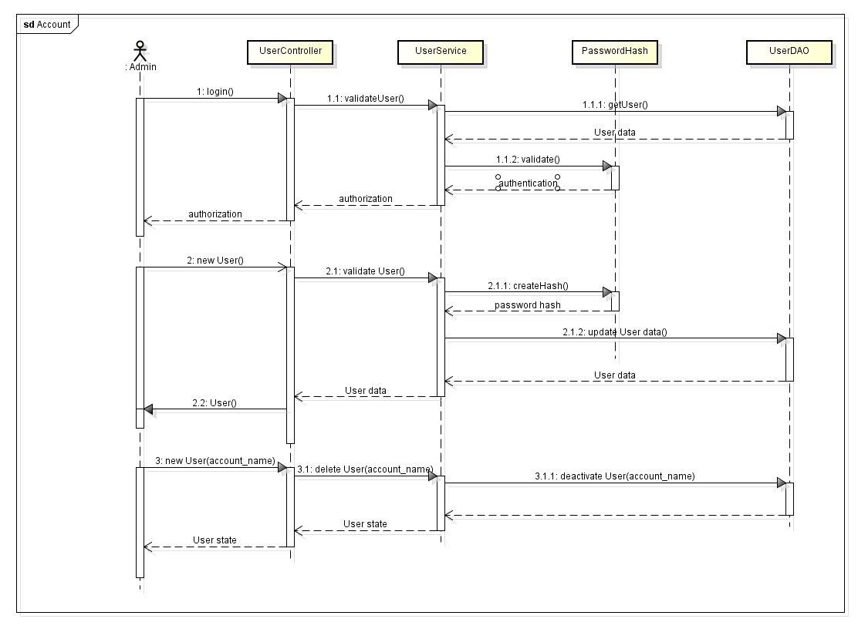

*Figure 97: Account Management Sequence Diagram*

#### 1.8.2.2.4. Activity diagram

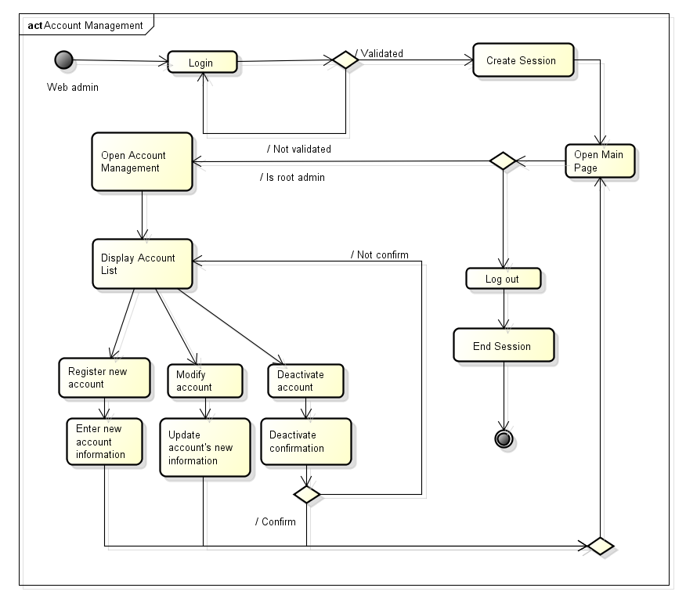

*Figure 98: Account Management Activity Diagram*

#### 1.8.2.3. History Logging

#### 1.8.2.3.1. Use Case diagram

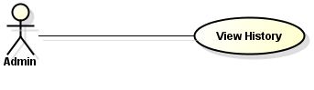

#### 1.8.2.3.2. Logical view

* **Class diagram**

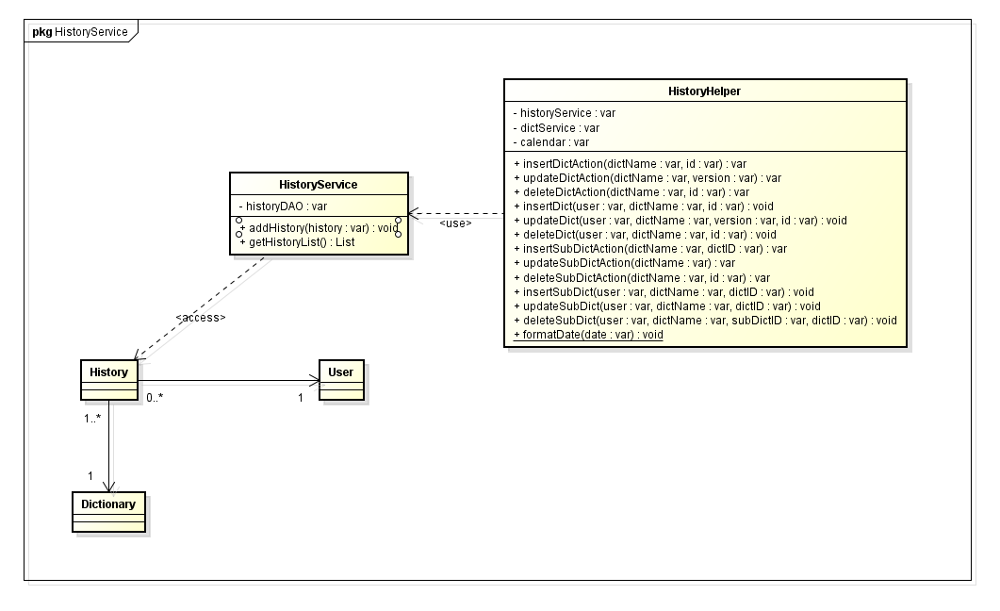

*Figure 99: History Service Class Diagram*

* **Class specification**

###### **HistoryService**

###### *Attribute*

|  |  |  |  |
| --- | --- | --- | --- |
| No | Name | Type | Description |
| 1 | historyDAO | HistoryDAO | The history DAO to access history data in database |

###### *Method*

addHistory:

|  |  |  |  |  |
| --- | --- | --- | --- | --- |
| Purpose | Add new history entry into the database | | | |
| Return | Type | | | Description |
| void | | |  |
| Parameters | No | Name | Type | Description |
| 1 | history | History | The history entry |

getHistoryList:

|  |  |  |  |  |
| --- | --- | --- | --- | --- |
| Purpose | Get the history entry list | | | |
| Return | Type | | | Description |
| List<History> | | | The history entry list |
| Parameters | No | Name | Type | Description |
|  |  |  |  |

###### **HistoryHelper**

###### *Attribute*

|  |  |  |  |
| --- | --- | --- | --- |
| No | Name | Type | Description |
| 1 | historyService | HistoryService | The history service |
| 2 | dictService | DictionaryPkgService | The dictionary package service |
| 3 | calendar | Calendar | The calendar which is used for tracking current time in server |

###### *Method*

insertDictAction:

|  |  |  |  |  |
| --- | --- | --- | --- | --- |
| Purpose | Generate an “add dictionary” string with given dictionary name and dictionary id | | | |
| Return | Type | | | Description |
| String | | | The generated string |
| Parameters | No | Name | Type | Description |
| 1 | dictName | String | The dictionary name |
| 2 | id | int | The dictionary ID |

updateDictAction:

|  |  |  |  |  |
| --- | --- | --- | --- | --- |
| Purpose | Generate an “update dictionary” string with given dictionary name and dictionary version | | | |
| Return | Type | | | Description |
| String | | | The generated string |
| Parameters | No | Name | Type | Description |
| 1 | dictName | String | The dictionary name |
| 2 | version | String | The dictionary new version |

deleteDictAction:

|  |  |  |  |  |
| --- | --- | --- | --- | --- |
| Purpose | Generate an “delete dictionary” string with given dictionary name and dictionary id | | | |
| Return | Type | | | Description |
| String | | | The generated string |
| Parameters | No | Name | Type | Description |
| 1 | dictName | String | The dictionary name |
| 2 | id | int | The dictionary ID |

insertDict:

|  |  |  |  |  |
| --- | --- | --- | --- | --- |
| Purpose | Perform adding new history entry with “add dictionary” message | | | |
| Return | Type | | | Description |
| void | | |  |
| Parameters | No | Name | Type | Description |
| 1 | account name | String | The user that added new dictionary |
| 2 | dictName | String | The dictionary name |
| 3 | id | int | The dictionary ID |

updateDict:

|  |  |  |  |  |
| --- | --- | --- | --- | --- |
| Purpose | Perform adding new history entry with “update dictionary” message | | | |
| Return | Type | | | Description |
| void | | |  |
| Parameters | No | Name | Type | Description |
| 1 | account name | String | The user that updated dictionary |
| 2 | dictName | String | The dictionary name |
| 3 | version | String | The dictionary new version |
| 4 | id | int | The dictionary ID |

deleteDict:

|  |  |  |  |  |
| --- | --- | --- | --- | --- |
| Purpose | Perform adding new history entry with “delete dictionary” message | | | |
| Return | Type | | | Description |
| void | | |  |
| Parameters | No | Name | Type | Description |
| 1 | account name | String | The user that deleted dictionary |
| 2 | dictName | String | The dictionary name |
| 3 | id | int | The dictionary id |

insertSubDictAction:

|  |  |  |  |  |
| --- | --- | --- | --- | --- |
| Purpose | Generate an “add sub dictionary” string with given sub dictionary name and sub dictionary id | | | |
| Return | Type | | | Description |
| String | | | The generated string |
| Parameters | No | Name | Type | Description |
| 1 | dictName | String | The sub dictionary name |
| 2 | dictID | int | The sub dictionary ID |

updateSubDictAction:

|  |  |  |  |  |
| --- | --- | --- | --- | --- |
| Purpose | Generate an “update sub dictionary” string with given sub dictionary name | | | |
| Return | Type | | | Description |
| String | | | The generated string |
| Parameters | No | Name | Type | Description |
| 1 | dictName | String | The dictionary name |

deleteSubDictAction:

|  |  |  |  |  |
| --- | --- | --- | --- | --- |
| Purpose | Generate an “delete sub dictionary” string with given sub dictionary name and sub dictionary id | | | |
| Return | Type | | | Description |
| String | | | The generated string |
| Parameters | No | Name | Type | Description |
| 1 | dictName | String | The sub dictionary name |

insertSubDict:

|  |  |  |  |  |
| --- | --- | --- | --- | --- |
| Purpose | Perform adding new history entry with “add sub dictionary” message | | | |
| Return | Type | | | Description |
| void | | |  |
| Parameters | No | Name | Type | Description |
| 1 | account name | String | The user that added new sub dictionary |
| 2 | dictName | String | The sub dictionary name |
| 3 | dictID | int | The sub dictionary ID |

updateSubDict:

|  |  |  |  |  |
| --- | --- | --- | --- | --- |
| Purpose | Perform adding new history entry with “update sub dictionary” message | | | |
| Return | Type | | | Description |
| void | | |  |
| Parameters | No | Name | Type | Description |
| 1 | account name | String | The user that updated sub dictionary |
| 2 | dictName | String | The sub dictionary name |
| 3 | dictID | int | The sub dictionary ID |

deleteSubDict:

|  |  |  |  |  |
| --- | --- | --- | --- | --- |
| Purpose | Perform adding new history entry with “delete sub dictionary” message | | | |
| Return | Type | | | Description |
| void | | |  |
| Parameters | No | Name | Type | Description |
| 1 | account name | String | The user that deleted sub dictionary |
| 2 | dictName | String | The sub dictionary name |
| 3 | subDictID | int | The sub dictionary id |
| 4 | dictID | int | The dictionary package id containing the deleted sub dictionary |

formatDate:

|  |  |  |  |  |
| --- | --- | --- | --- | --- |
| Purpose | Format a long date into string | | | |
| Return | Type | | | Description |
| String | | | The generated string |
| Parameters | No | Name | Type | Description |
| 1 | account name | String | The user that deleted sub dictionary |
| 2 | dictName | String | The sub dictionary name |
| 3 | subDictID | int | The sub dictionary id |
| 4 | dictID | int | The dictionary package id containing the deleted sub dictionary |

#### 1.8.2.3.3. Sequence diagram

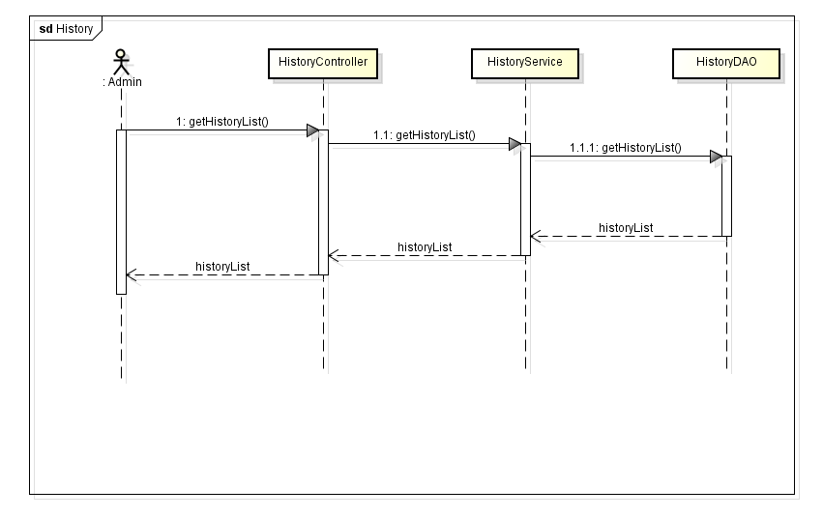

*Figure 100: History Logging Sequence Diagram*

#### 1.8.2.3.4. Activity diagram

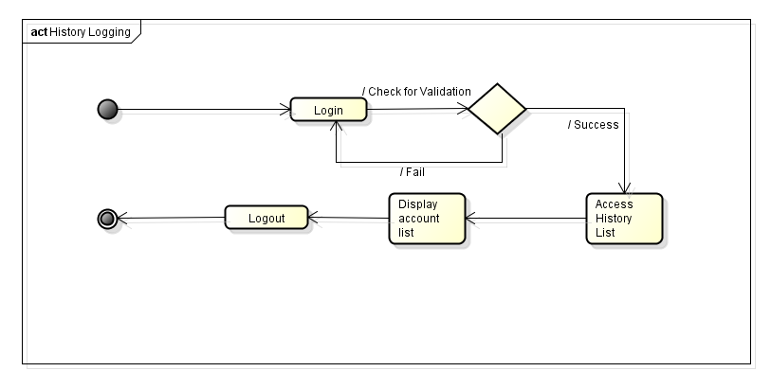

*Figure 101: History Logging Activity Diagram*

(Reference section 5.2.7 for history logging entries)

## 1.9. AKP image processing library

### 1.9.1. Purpose

AKP library is develop to pre-process image before passing to Tesseract to improve text recognition accurary. We use OpenCV library to support in processing image.

The diagram below show sequence of text recognition in Anki Pan application

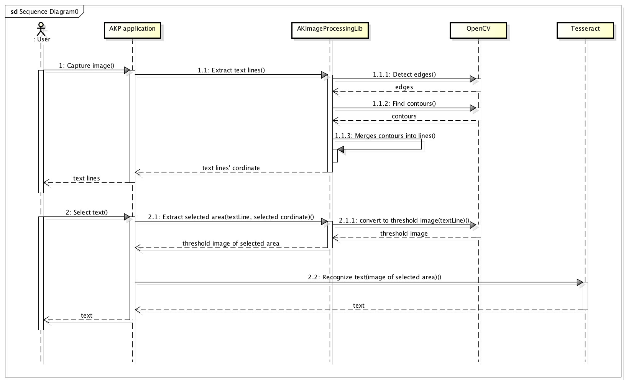

*Figure 102: Text recognition in Anki Pan application*

### 1.9.2. Tesseract’ shortcoming

In fact, Tesseract does various image processing operations, using Leptonica library, before doing the actual OCR. It generally does a good job, but still there are cases where it is not good enough, which leads to significant reduction of accuracy. According to Tesseract wiki on code.google.com[7], Tesseract has some shortcoming, as described below, that cause problem in recognizing characters.

#### 1.9.2.1. Text size

Tesseract can not perform well with unsuitable text size. Characters with x-height less than 8 pixel is considered as noise and will be removed. Characters with x-height of 10 pixel have very little chance of being recognized correctly. Generally, Tesseract performs best with characters that is from 20 pixel in x-height.

#### 1.9.2.2. Binarization

Binarization, in this case, means converting an image to black and white. Tesseract can make mistake in this steps, particularly if the image background is of uneven darkness. As showed in figure below, the bottom left of the image is converted into black, which loses a part of the document.

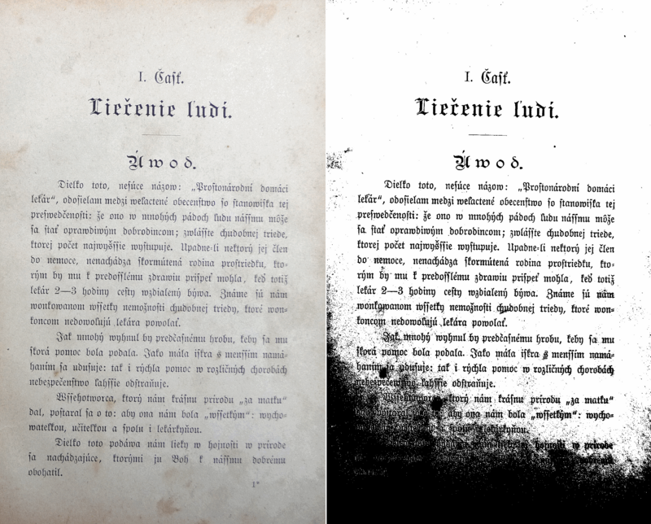

*Figure 103: Sample of image binarized by Tesseract*

#### 1.9.2.3. Noise

Noise is unexpected random variation of brightness or color. Certain type of noise can not be remove by Tesseract, which can cause accuracy to drop.

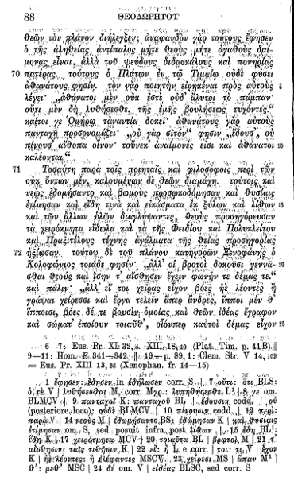

*Figure 104: Sample of image binarized by Tesseract*

#### 1.9.2.4. Orientation / Skew

This is when text in the image is not straight. The quality of Tesseract’s line segmentation reduce significantly if the image is too skew, which severely impact the quality of OCR.

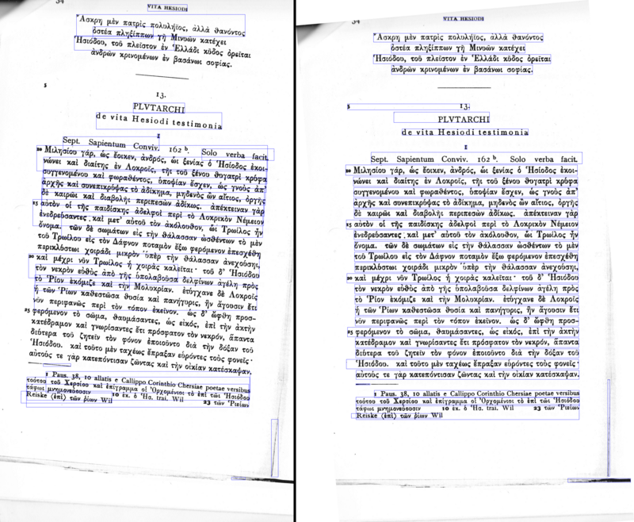

*Figure 105: Tesseract ‘s Text line segmentation performed on skew and straight image*

#### 1.9.2.5. Segmentation

Tesseract is optimized to recognize line of text. If the images are invoice, poster,... that include more than just text in background, it is necessary to extract text area from those image before passing to Tesseract.

### 1.9.3. Tesseract’s recognition of Japanese

We conducted a test for Tesseract’s accuracy of Japanese recognition. First, we developed a tool to create text’s images, and then input these images to Tesseract.

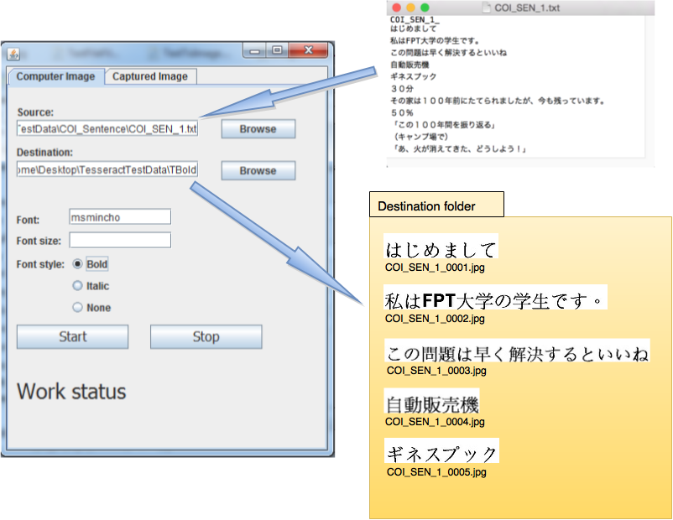

*Figure 106: AKP_CreateImageTool*

We have tested with 3 syllabaries (Hiragana, Katakana, Furigana), numbers, and other character of Japanese writing system. We compared the recognition result of Tesseract with the correct text in each image and summarize in the table below.

|  |  |  |  |  |  |  |
| --- | --- | --- | --- | --- | --- | --- |
| **Image sets** | **Accuracy (%)** | | | | | **SUMMARY** |
| **Bold Text (size 40)** | **Italic text (size 40)** | **Text with size 14** | **Text with size 40\*** | **Text with size 60** |
| **HIRAGANA** | | | | | | |
| Monograph Hiragana （か、き、く、...） | 78.26 | 76.08 | 76.08 | 78.26 | 78.26 |  |
| Diacritic Hiragana （が、ぎ、ぐ、...） | 48.00 | 32.00 | 56.00 | 80.00 | 44.00 |  |
| Digraph Hiragana  （しゃ、しゅ、...） | 0.00 | 0.00 | 17.85 | 0.00 | 4.16 |  |
| **Average:** | **42.09** | **36.03** | **49.98** | **52.75** | **42.14** | **44.60** |
| **KATAKANA** | | | | | | |
| Monograph Katakata （カ、キ、ク、...） | 84.78 | 84.78 | 84.78 | 89.13 | 80.04 |  |
| Diacritic Katakana （ガ、ギ、グ、...） | 56.00 | 56.00 | 28.00 | 40.00 | 44.00 |  |
| Digraph Katakana  （シャ、シュ、...） | 6.54 | 6.54 | 6.54 | 6.54 | 4.16 |  |
| **Average:** | **49.11** | **49.11** | **39.77** | **45.22** | **42.73** | **45.19** |
| **KANJI** | | | | | | |
| Simple Kanji  (立、私、...) | 67.24 | 67.24 | 67.24 | 65.51 | 62.07 |  |
| Complicated Kanji ( 教、葉、...) | 70.00 | 42.50 | 42.50 | 43.75 | 33.75 |  |
| **Average:** | **68.62** | **54.87** | **54.87** | **54.63** | **47.91** | **56.18** |
| **TEXT LINE** | | | | | | |
| 1 text line:  （火が消えてきた...） | **100%** | **18.18** | **9.09** | **18.18** | **9.09** | **11.11** |
| **OTHER CHARACTERS** | | | | | | |
| Special characters （「、！、...」 | 35.71 | 21.42 | 42.85 | 42.86 | 28.57 |  |
| Numbers  (１、２、...) | 80.00 | 80.00 | 60.00 | 80.00 | 80.00 |  |
| **Average:** | **57.86** | **50.71** | **51.43** | **61.43** | **54.29** | **55.14** |

* Text with size 40px equivalent to 20px in x-height

Beside the weak points of Tesseract listed in section 2, analyzing the test result, we realized that:

* When the text size is too big, a kanji which is combined from some single characters will be recognized as those single character. For example休 is a combination of Katakana characters イand Kanji character木will be recognize as イand 木.
* There are some character that Tesseract can not recognize, for example: 」or ・

### 1.9.4. AKP Image Processing Library

This version of AKPImageProcessingLib is able to:

* Extract text lines from simple images which contain black text only. This is to reducing time for Tesseract to processing the whole image, and for better binarization.
* Binarization, in other word convert to threshold image. This is to repair the shortcoming of Tesseract in binarization step.
* Remove noise. This is done in both functions of text line extraction and binarization.
* Extract the exact text area that user selected. When user use finger to select text on screen, they might miss some strokes of the character. AKImageProcessor extracts the text area that cover all the expected characters, with no missed strokes.

Below is class diagram of AKImageProcessingLib

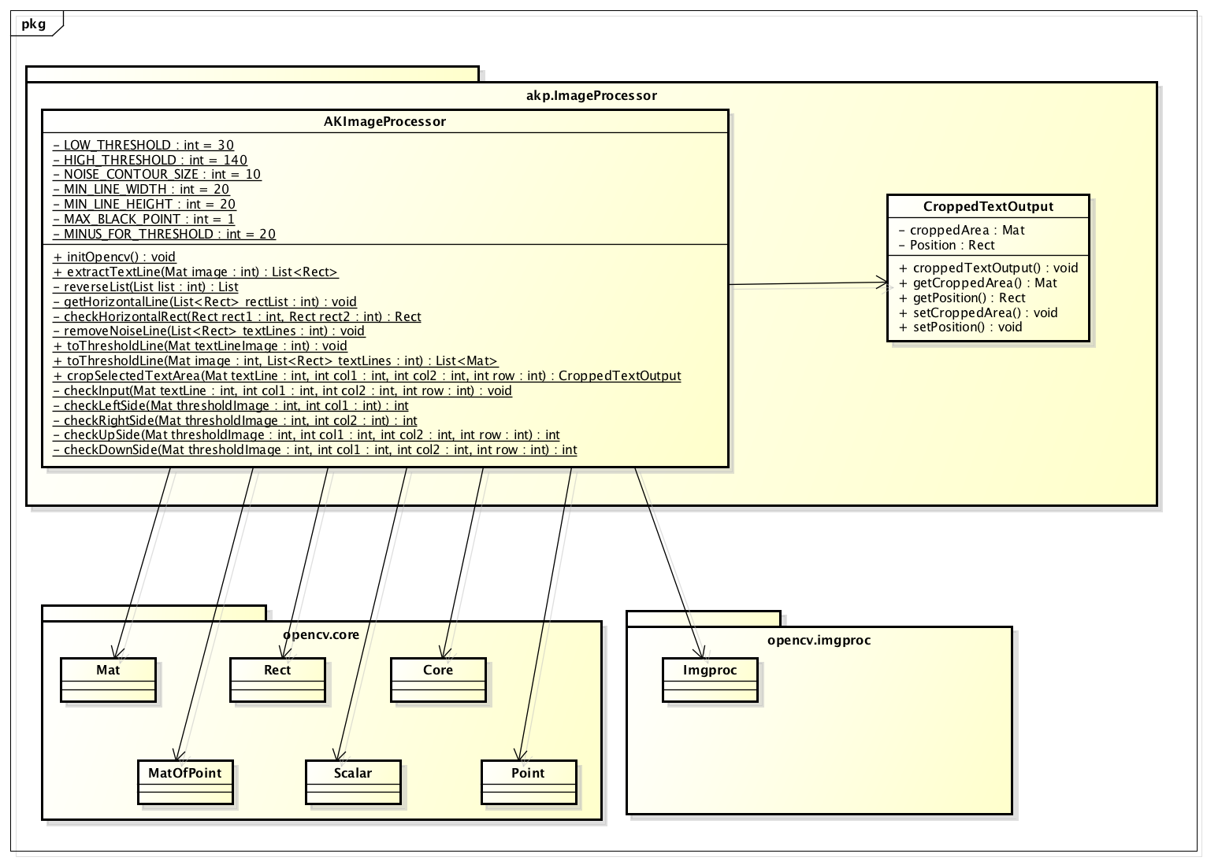

*Figure 107: Class diagram of AKImageProcessingLib*

#### 1.9.4.1. Extract text line

The function of extract text line follow the sequence described below:

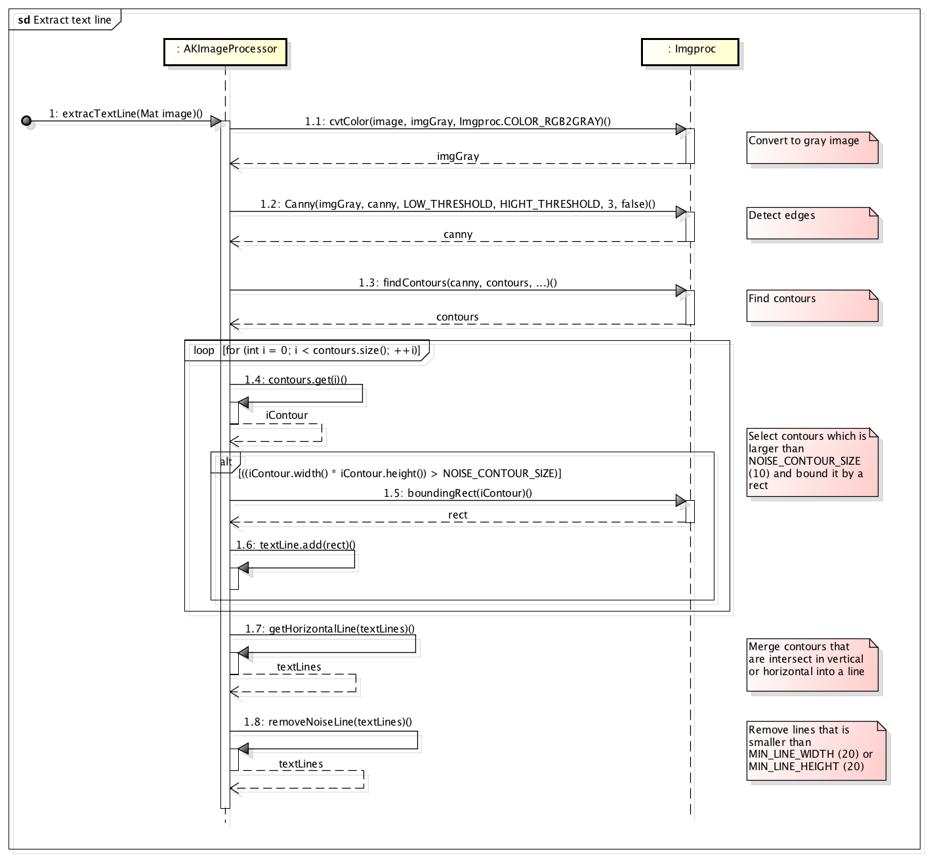

*Figure 108: Sequence diagram of extracting text line*

#### 1.9.4.1.1. Convert to gray image

Function cvtColor() converts color input image to gray image for further process.

#### 1.9.4.1.2. Detect edge by Canny

The method of edge detection is to compute the gradient of pixel intensity find edges[8]. Edge occurs when the gradient is greatest. In text image, there is great gradient between background and text because text is often colored so that they stand out of the background, therefore edges of character strokes will be detected.

Edge detection can be done by Imgproc.Sobel or Imgproc.Canny. In AKImageProcessor, we apply Imgproc.Canny function. Sobel and Canny implement similar algorithm to detect edges. The advantage of Canny over Sobel is that it is better at removing noise and therefore performs better detection[9]. Besides, we tried both Canny and Sobel, and the results showed that Sobel often lose a part of the character strokes (an edge of the stroke).

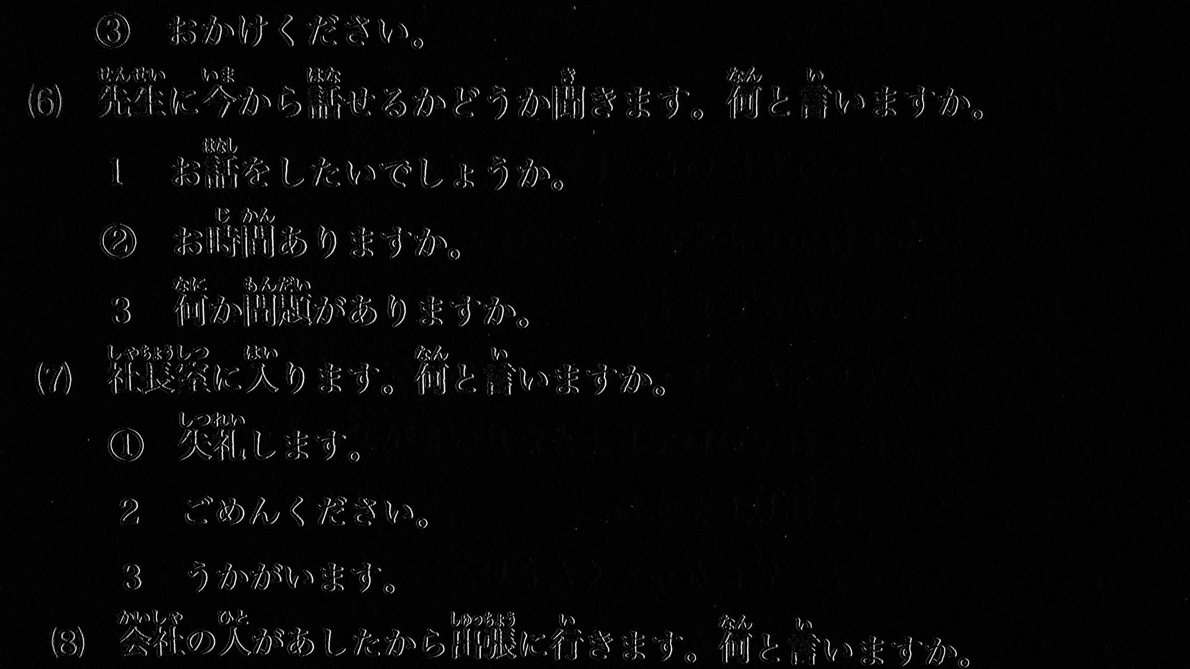

*Figure 109: Result of edge detection by Sobel*

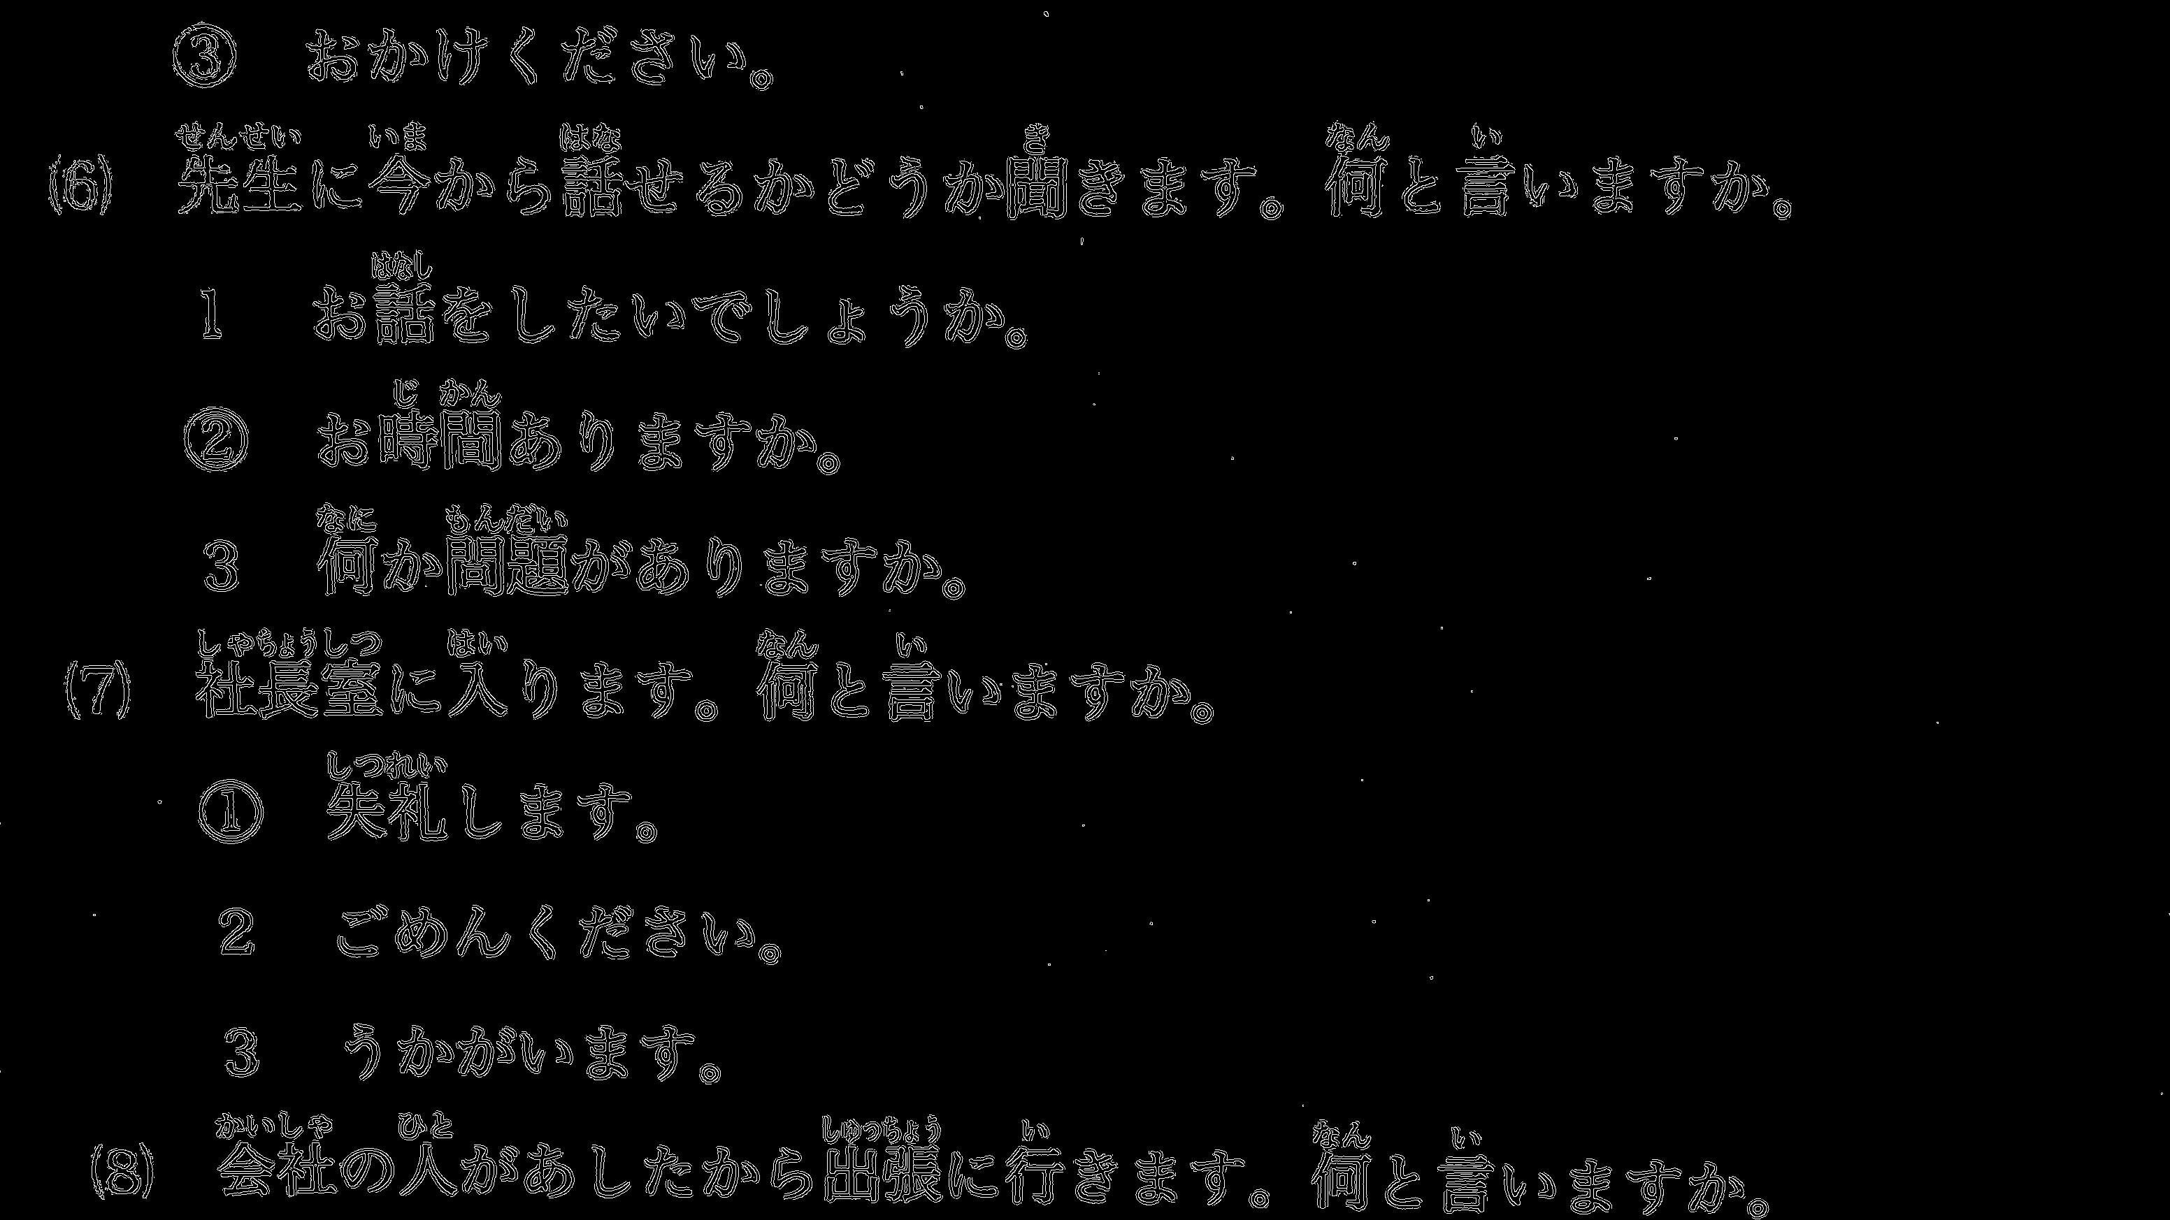

*Figure 110: Result of edge detection by Canny*

#### 1.9.4.1.3. Find contours

Contour is a curve that connect continuous points which have the same color or intensity. We use findContours function to determine contours from edges outputed by Canny. As Canny detect edges of characters, these contours can be considered as parts of character strokes.

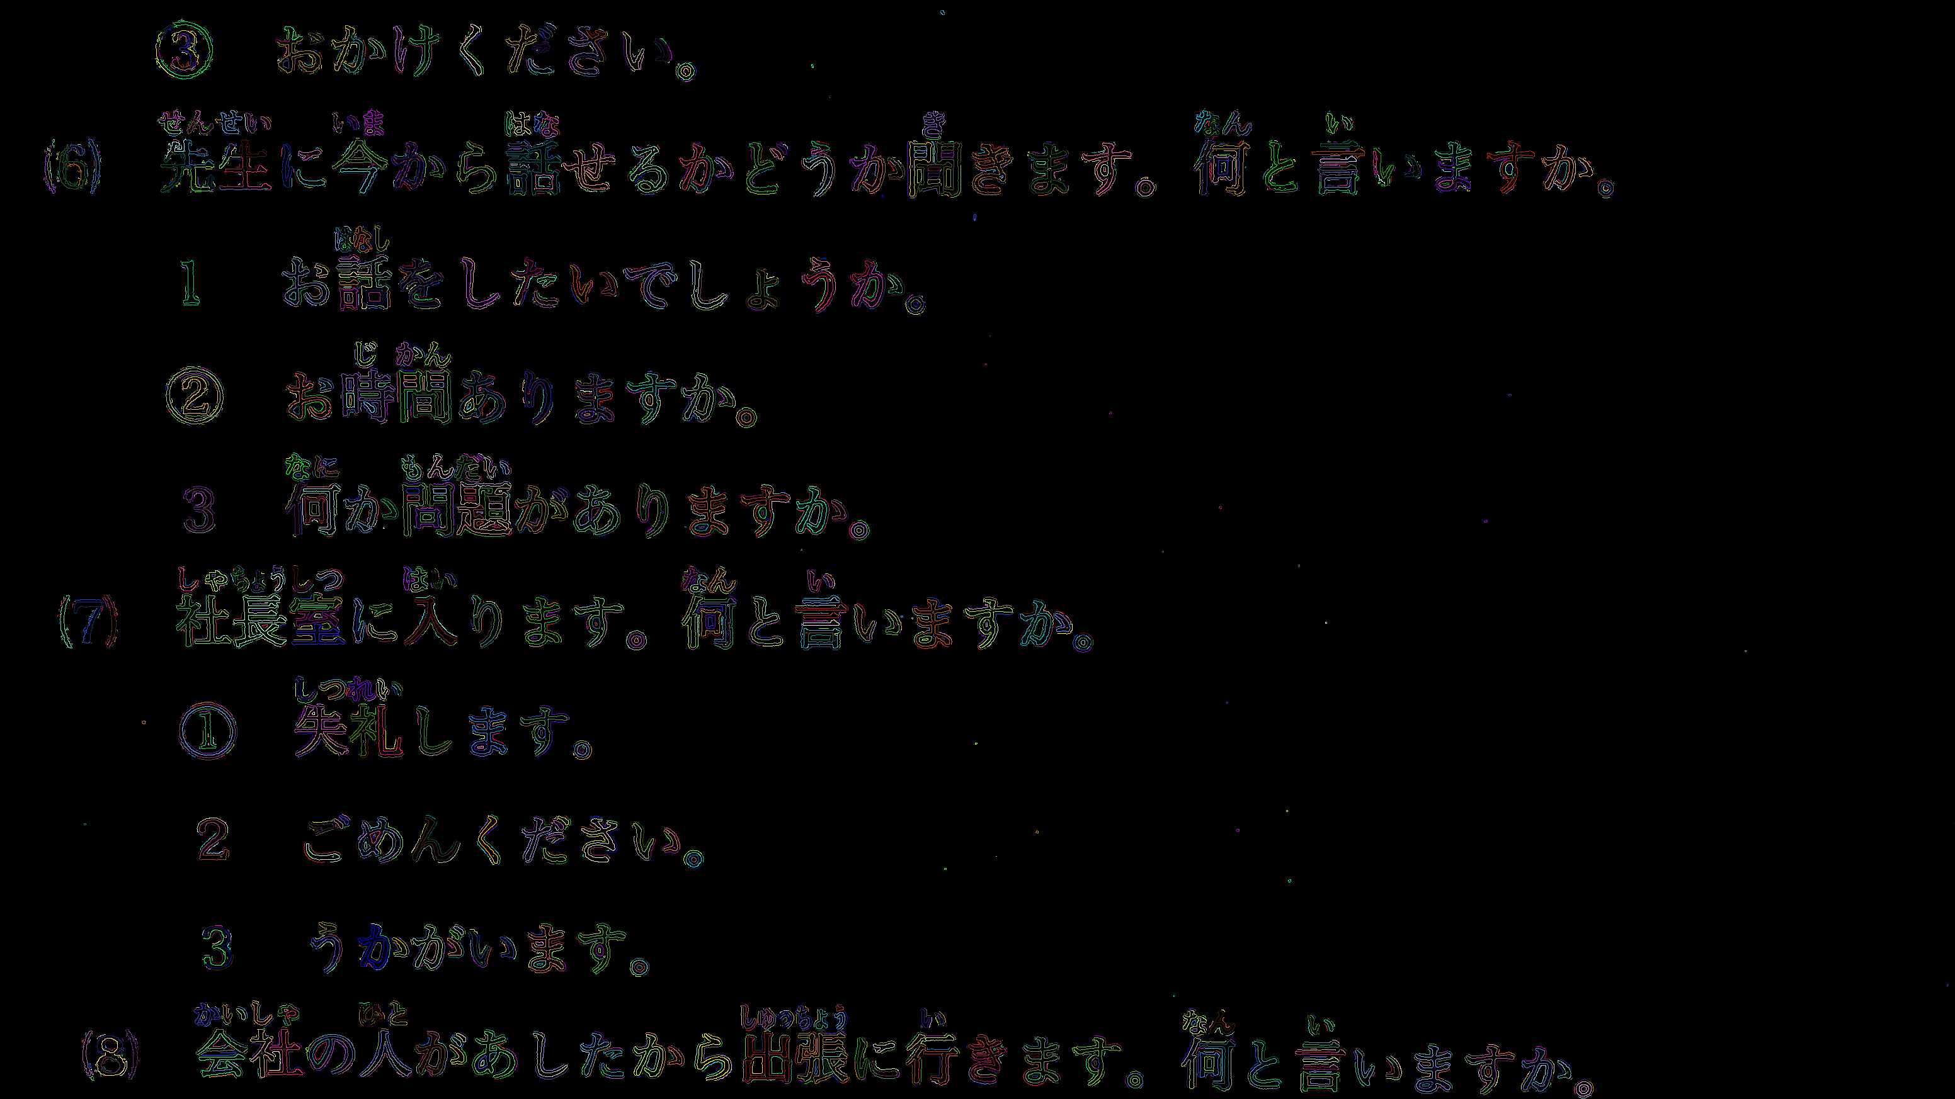

*Figure 111: Detected contours, which is a part of character strokes*

#### 1.9.4.1.4. Get horizontal line

After we got all contours from step 1.3, we bound contours by rectangles, then merge rectangle that in the same text line into 1 line. 2 rectangle are considered as in the same line if they are intersect in vertical.

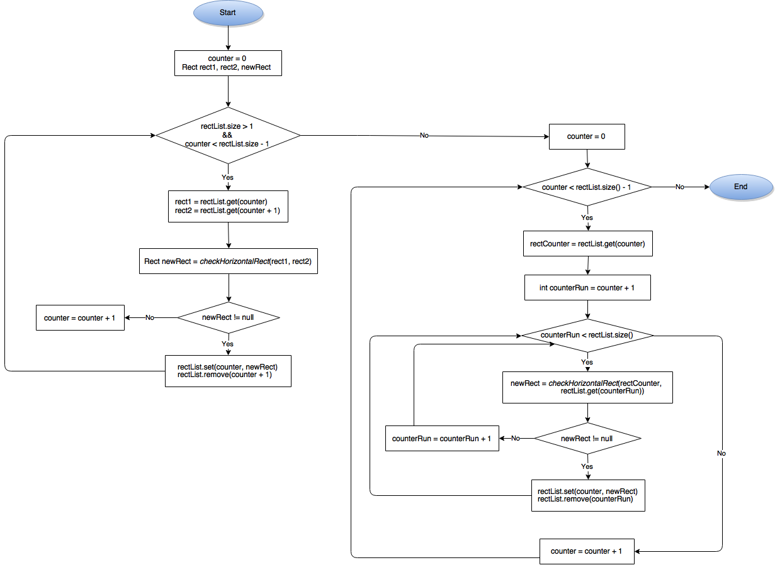

*Figure 112: Flowchart of function getHorizontalLine*

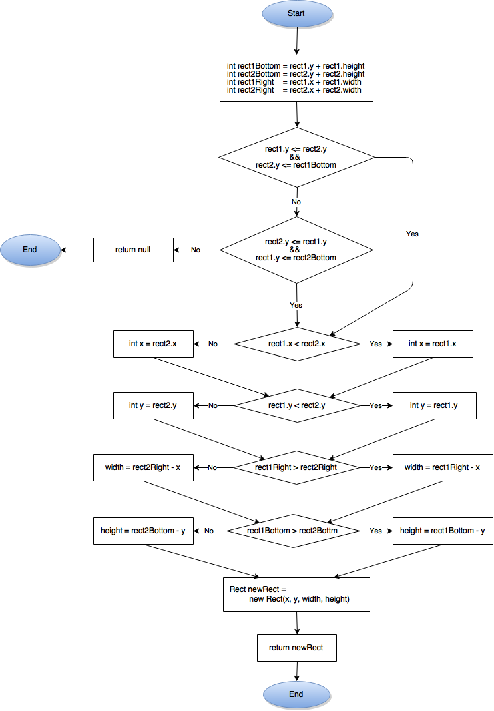

*Figure 113: Flowchart of function checkHorizontalRect*

Image with contours bounded by rectangles:

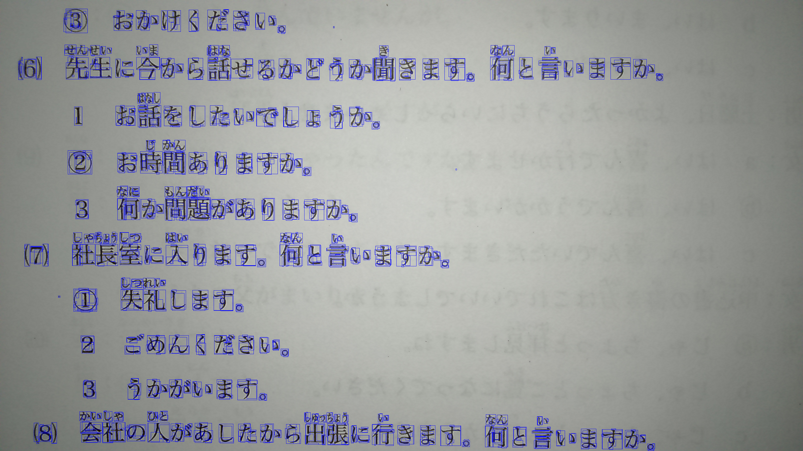

Steps of merging contours is illustrate in figure below:

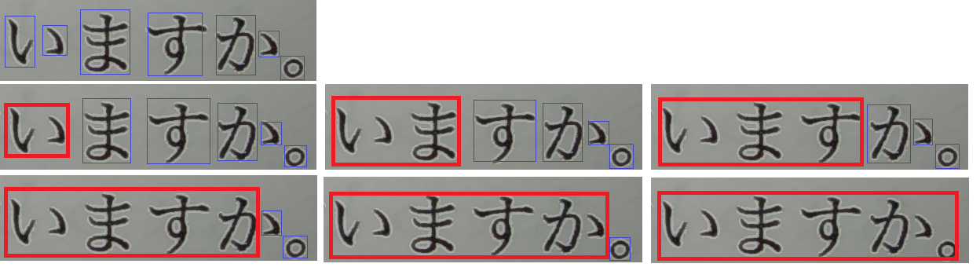

*Figure 114: Example of merging contours into line*

#### 1.9.4.1.5. Remove noise

* In the loop, all the contours whose area are smaller than NOISE_CONTOUR_SIZE ( 10 as defined) will not be consider as a contours of a character stroke and will not be add to textLines list.
* In removeNoiseLine functions, text line with height or width smaller than MIN_LINE_HEIGHT (20 as defined) or MIN_LINE_WIDTH (20 as defined) respectively will be removed. We set the MIN as 20px because Tesseract may not perform well with x-height smaller than 20px, as depicted in section 2.1.

#### 1.9.4.1.6. Result of extractTextLine

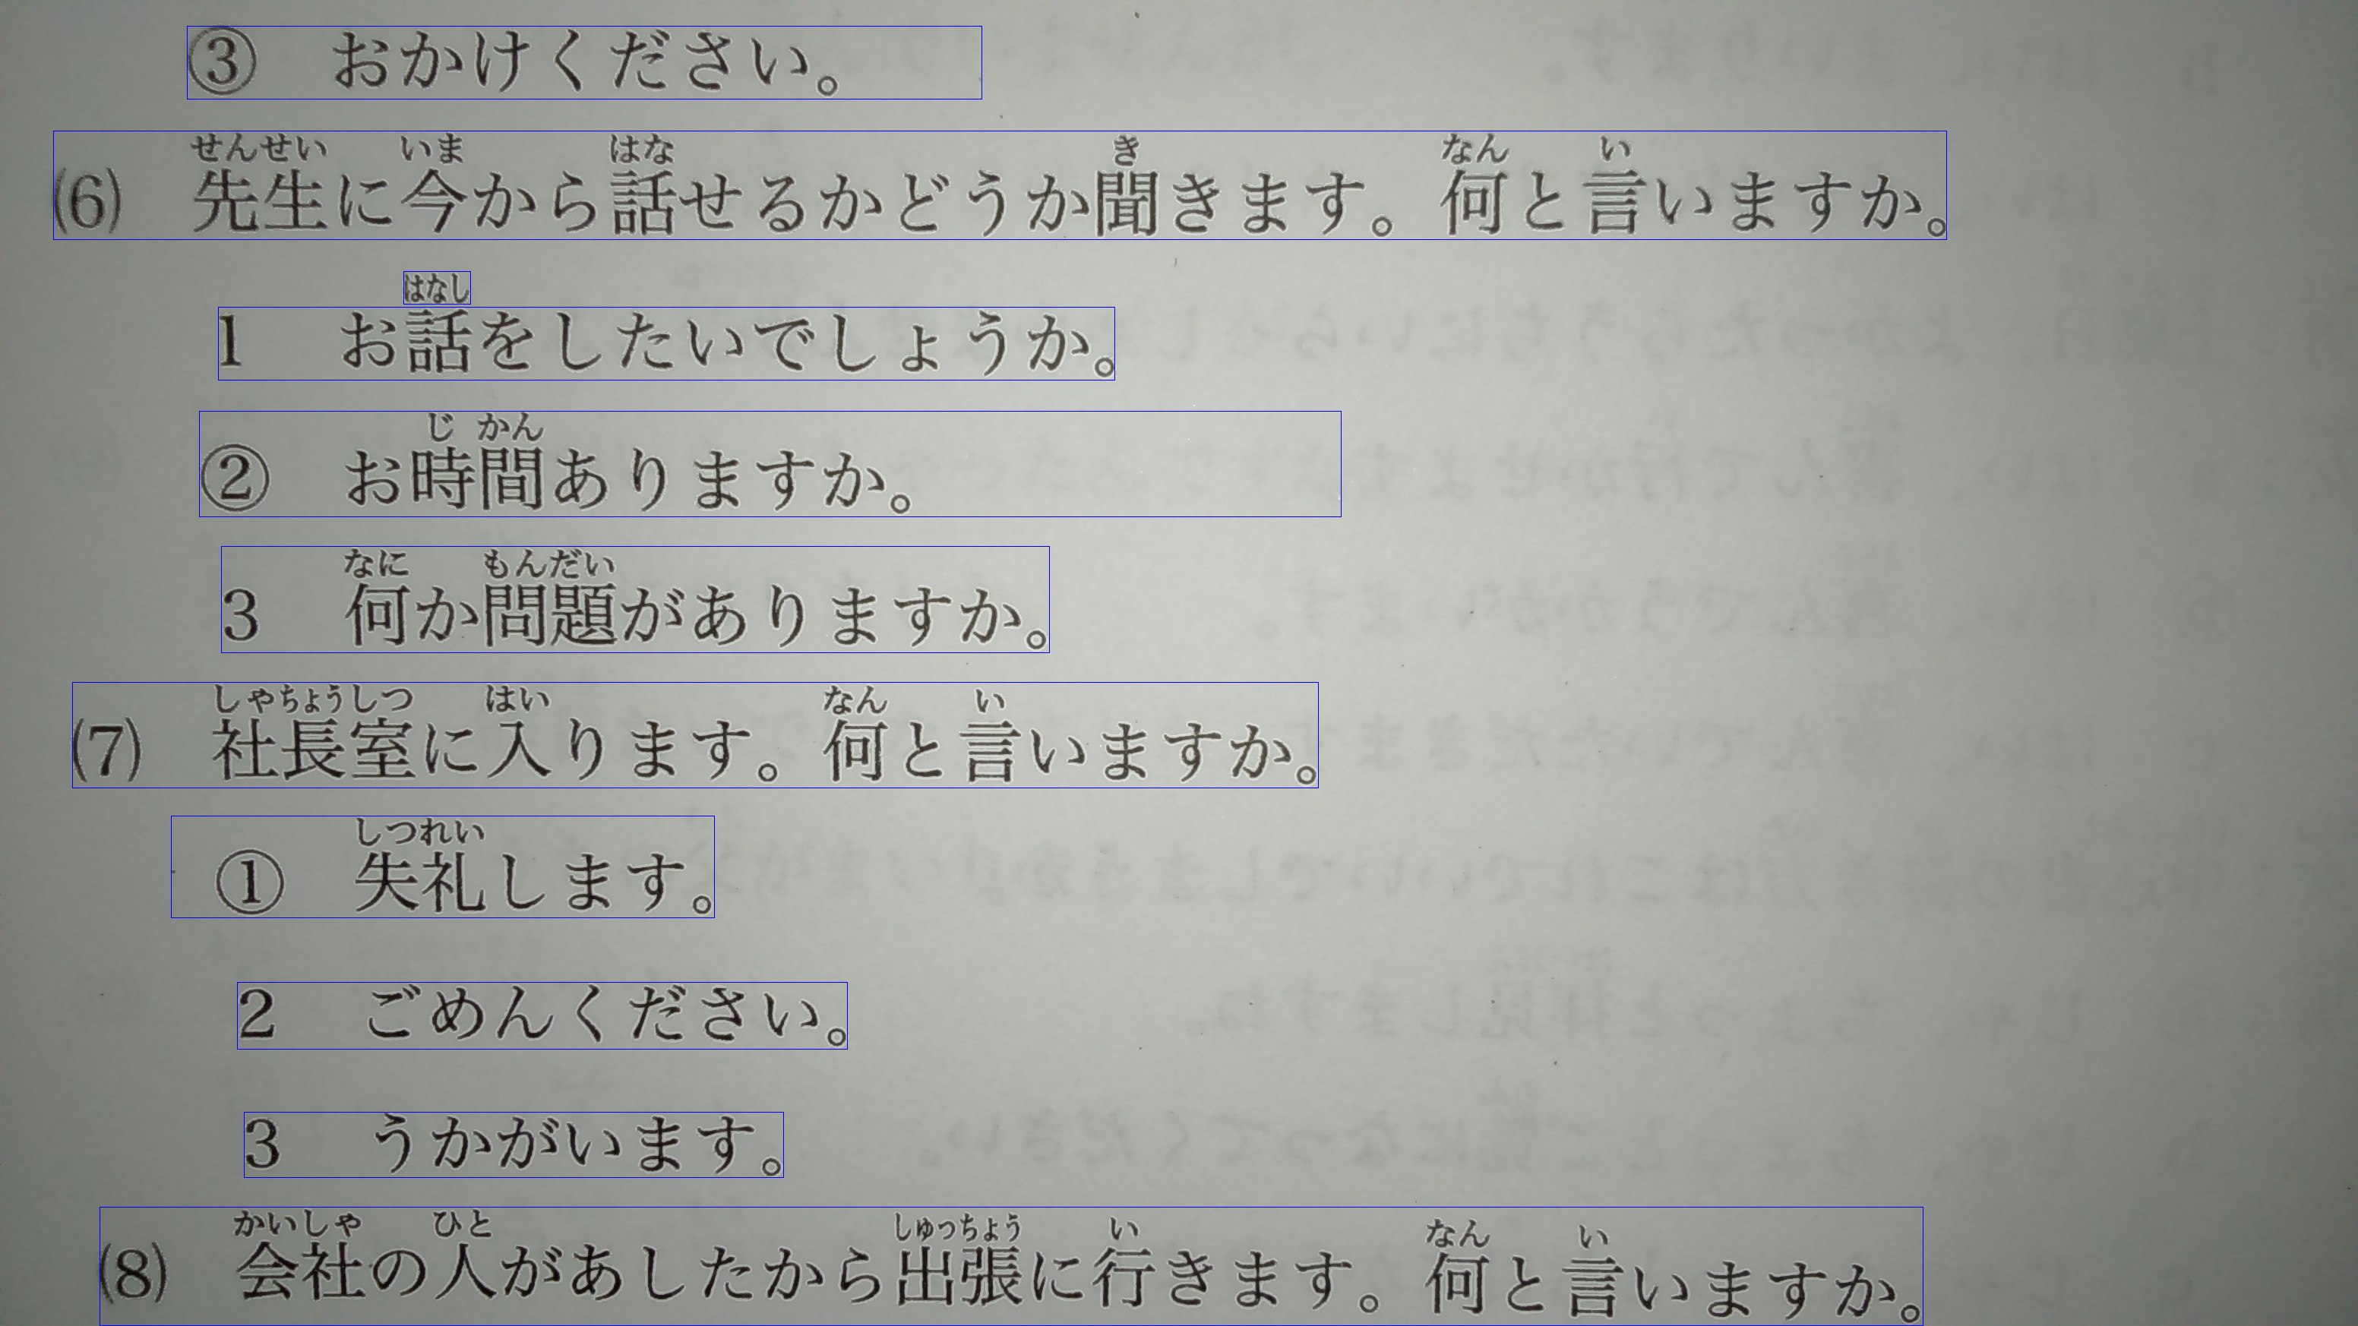

*Figure 115: Final result of extractTextLine()*

#### 1.9.4.2. Binarize image

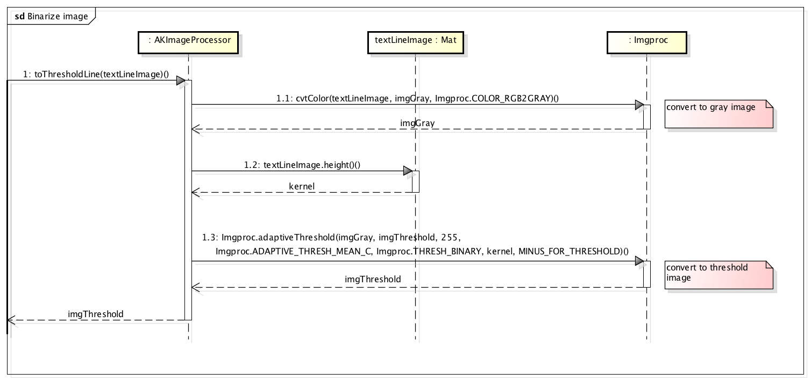

*Figure 116: Sequence diagram of binarizing image*

The method of image binarization is to compare the intensity value of a pixel to a threshold value. If the intensity of the pixel is smaller than the threshold value, then set it to a determined value, otherwise set it to other determined value. By doing this, the image will be segmented into 2 different area.

OpenCV provides 2 kind of bilarization:

* Apply 1 threshold value for all pixel (threshold()). In this, we tried Otsu algorithm, which calculate threshold value base on intensity of all pixel and then apply the threshold value to the whole image. However, the output result was not so good, in case of uneven darkness background.

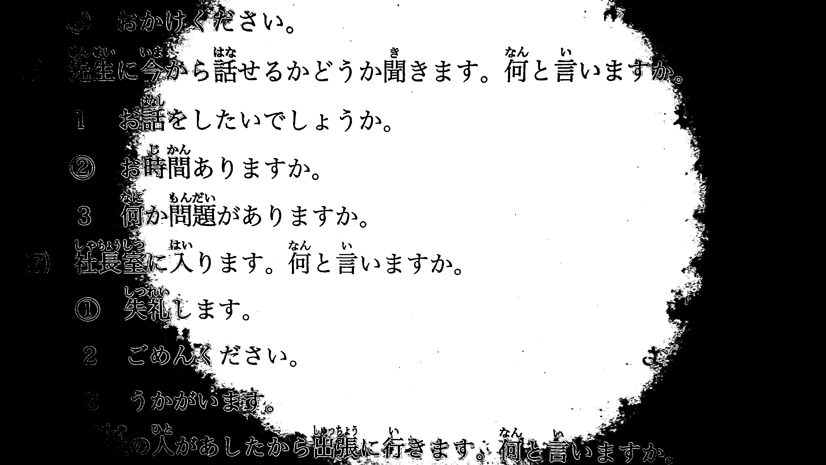

*Figure 117: Image binarized by Otsu algorithm*

* Calculate threshold value for each single pixel base on it neighbors (adaptiveThreshold()). After text lines were extracted from images, we passed the height of each lines to the functions to set as the kernel of comparison. The result was better than using threshold function, so finally we decided to use this one.

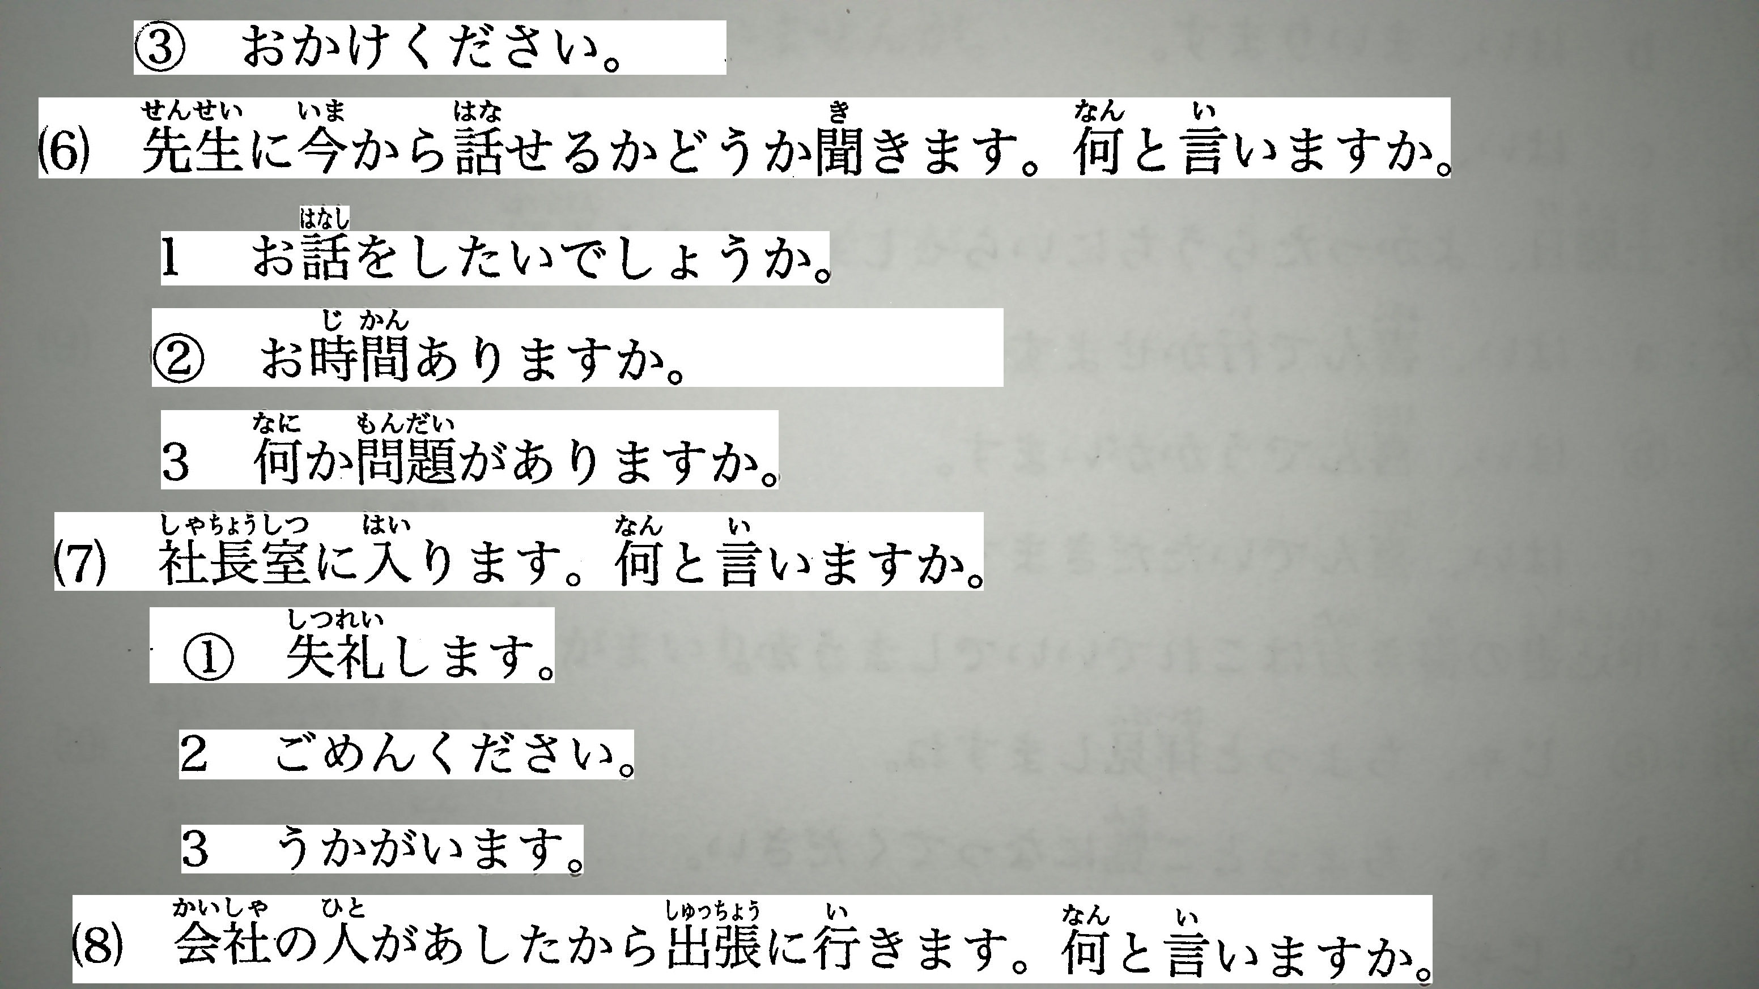

*Figure 118: text lines converted to threshold image by adaptiveThreshold*

In compare to image converted by Tesseract:

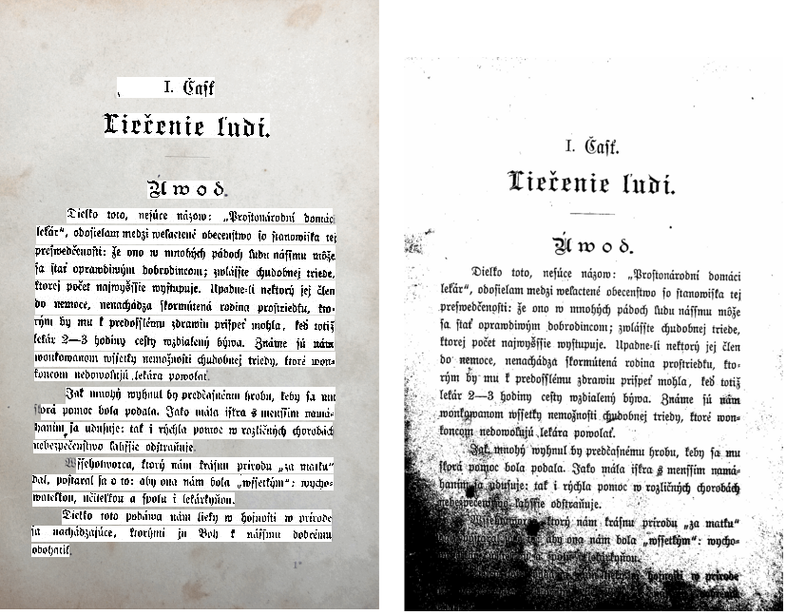

*Figure 119: Image converted to threshold by AKImageProcessingLib (left) and Tessearct (right)*

#### 1.9.4.3. Extract selected text area

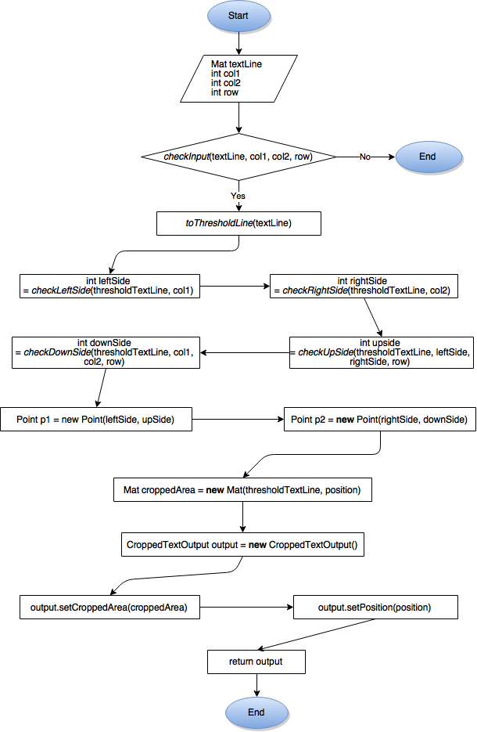

*Figure 120: Flow of text line extraction*

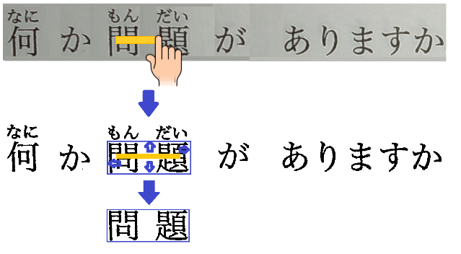

*Figure 121: Illustration of text line selection steps*

### 1.9.5. AKP image processing library’s limitation

This version of AKImageProcessingLib is unable to deskew image. We did try some OpenCV functions but the results for Japanese documents were not as good as English document. In next version we will work more on this issue.

This version does not support document with text printed in vertical direction, which is quite popular format of Japanese document.

## 1.10. Size And Performance

## 1.11. Quality

Anki pan system architecture design aimed at the quality goals as specified below.

### 1.11.1. Scalability:

* **Description:** System’s reaction when user need more than one language.
* **Solution:** Sever can provide more than one dictionary to download, and component design allow developer add more function to application.

### 1.11.2. Reliability / Availability:

* **Description:** Application may require Internet connection. And it may not read image precisely.
* **Solution:** Incased there no Internet connection, application change to offline mode that provide offline function to use. And, application can show tutorial that make user easy to use.

### 1.11.3. Portability:

* **Description:** Ability to be reused in another environment.
* **Solution:** Application was programed in java language, so it can running on any environment that contain JDK (java development kit).

### 1.11.4. Security:

* **Description:** User may leaked their information.
* **Solution:** All data or user’s Information store in user’s device.

# 2. DATABASE DESIGN

## 2.1. Introduction

### 2.1.1. Purpose

This document is created to define the architecture for the entire data structure and business solution.

What is written is this document will make the developer get to know specifically about the database system components. Beside it, the tester implement the unit test base on this design document.

### 2.1.2. Overview

This document is a detail description of the database design of Anki pan system. It depicts all tables to be created, information stored in each tables, and the relationship between tables.

The database data is designed and improved based on the original database of “Jdict” app – made by Le Hoang.

## 2.2. Database

### 2.2.1. Application database

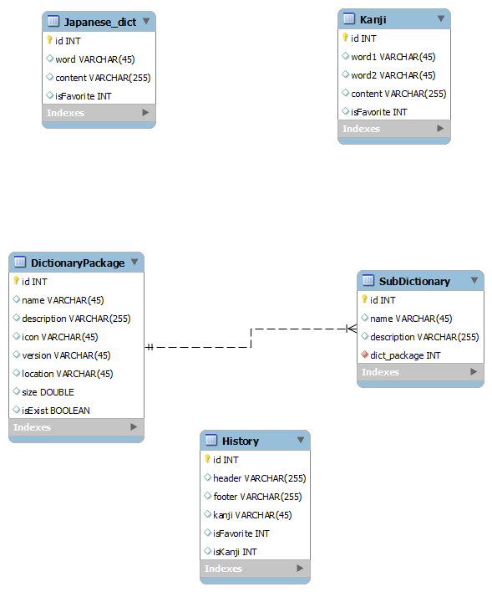

*Figure 122: ERD of Application database*

|  |  |  |
| --- | --- | --- |
| **No** | **Table** | **Description** |
| 1 | DictionaryPackage | List of packages and their detailed information |
| 2 | SubDictionary | List of sub dictionaries and their detailed information |
| 3 | Japanese_dict | List of Japanese words and their meaning, type of word, example, etc. |
| 4 | Kanji | List of Kanji words , “Han – Viet” pronunciation, meaning, etc. |
| 5 | History | Store user’s searching history |

* **DictionaryPackage table**

|  |  |  |  |  |  |  |  |  |  |
| --- | --- | --- | --- | --- | --- | --- | --- | --- | --- |
| **No** | **Field name** | **Type** | **Length** | **Size** | **Null** | **Unique** | **P/F Key** | **Default** | **Description** |
| 1 | id | INT |  |  |  | x | P |  | unique id for each package |
| 2 | name | VARCHAR | 45 |  |  |  |  |  | package name |
| 3 | description | VARCHAR | 255 |  |  |  |  |  | detailed description about the package |
| 4 | icon | VARCHAR | 45 |  |  |  |  |  | path to the location of the package icon |
| 5 | version | VARCHAR | 45 |  |  |  |  |  | package version |
| 6 | location | VARCHAR | 45 |  |  |  |  |  | package’s directory |
| 7 | size | DOUBLE |  |  |  |  |  |  | package size |

* **SubDictionary table**

|  |  |  |  |  |  |  |  |  |  |
| --- | --- | --- | --- | --- | --- | --- | --- | --- | --- |
| **No** | **Field name** | **Type** | **Length** | **Size** | **Null** | **Unique** | **P/F Key** | **Default** | **Description** |
| 1 | id | INT |  |  |  | x | P |  | unique id for each sub_dictionary |
| 2 | name | VARCHAR | 45 |  |  |  |  |  | sub_dictionary name |
| 3 | description | VARCHAR | 255 |  |  |  |  |  | detailed description about sub_dictionary |
| 4 | dict_package | INT |  |  |  |  |  |  | dict_package id that includes the sub_dict |

* **History table**

|  |  |  |  |  |  |  |  |  |  |
| --- | --- | --- | --- | --- | --- | --- | --- | --- | --- |
| **No** | **Field name** | **Type** | **Length** | **Size** | **Null** | **Unique** | **P/F Key** | **Default** | **Description** |
| 1 | id | INTEGER |  |  |  | x | x |  | The unique ID of each history item |
| 2 | header | VARCHAR | 255 |  |  |  |  |  | The header HTML String to be displayed in History |
| 3 | footer | VARCHAR | 255 |  |  |  |  |  | The footer HTML String to be displayed in History |
| 4 | kanji | VARCHAR | 45 |  |  |  |  |  | The single kanji character of the word (if it is kanji) |
| 5 | isFavorite | INTEGER |  |  |  |  |  |  | Favorite status |
| 6 | isKanji | INTEGER |  |  |  |  |  |  | Check if the history item is JWord or Kanji |

* **Japanese_dict table**

|  |  |  |  |  |  |  |  |  |  |
| --- | --- | --- | --- | --- | --- | --- | --- | --- | --- |
| **No** | **Field name** | **Type** | **Length** | **Size** | **Null** | **Unique** | **P/F Key** | **Default** | **Description** |
| 1 | id | INTEGER |  |  |  | x | P |  | Unique id of each word |
| 2 | word | VARCHAR | 32 |  |  | x |  |  | The word text |
| 3 | content | VARCHAR | 256 |  |  |  |  |  | The word’s type, meaning, examples, etc |
| 4 | isFavorite | INTEGER |  |  |  |  |  |  | Values: 0 or 1 to check if the user marks the word as favorite |

* **Kanji table**

|  |  |  |  |  |  |  |  |  |  |
| --- | --- | --- | --- | --- | --- | --- | --- | --- | --- |
| **No** | **Field name** | **Type** | **Length** | **Size** | **Null** | **Unique** | **P/F Key** | **Default** | **Description** |
| 1 | id | INTEGER |  |  |  | x | P |  | Unique id of each word |
| 2 | word1 | VARCHAR | 32 |  |  |  |  |  | The “Han” pronunciation |
| 3 | word2 | VARCHAR | 32 |  |  | x |  |  | The kanji text |
| 4 | content | VARCHAR | 256 |  |  |  |  |  | The “on” pronunciation and the kanji’s meaning |
| 5 | isFavorite | INTEGER |  |  |  |  |  |  | Values: 0 or 1 to check if the user marks the kanji as favorite |

### 2.2.2. Server database

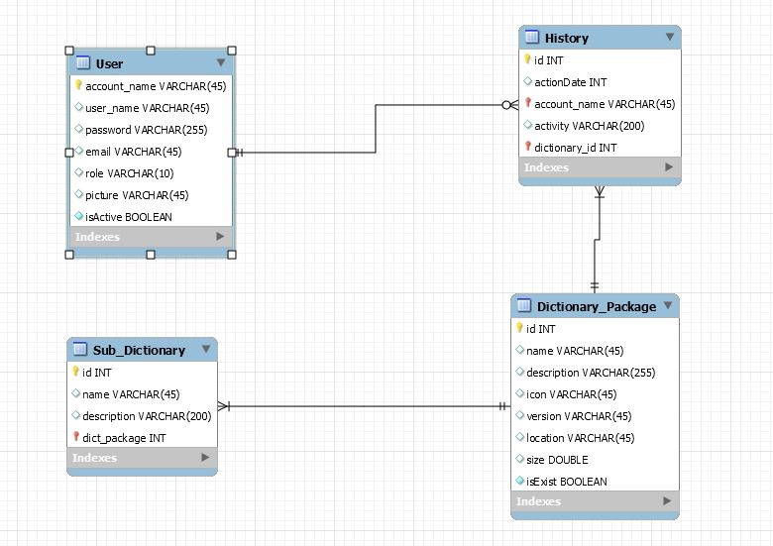

*Figure 123: ERD of server database*

|  |  |  |
| --- | --- | --- |
| **No** | **Table** | **Description** |
| 1 | User | Store all information of Admin and Root admin accounts |
| 2 | History | Store history of updating dictionary database |
| 3 | Dictionary package | Store information of dictionary packages available on server |
| 4 | Sub_Dictionary | Store information of sub dictionaries belong to dictionary packages |

* **User table**

|  |  |  |  |  |  |  |  |  |  |
| --- | --- | --- | --- | --- | --- | --- | --- | --- | --- |
| **No** | **Field name** | **Type** | **Length** | **Size** | **Null** | **Unique** | **P/F Key** | **Default** | **Description** |
| 1 | account_name | VARCHAR | 45 |  |  | x | P |  | unique account name for each user |
| 2 | user_name | VARCHAR | 45 |  |  |  |  |  | the user’s real name |
| 3 | password | VARCHAR | 255 |  |  |  |  |  | the account password |
| 4 | email | VARCHAR | 45 |  |  |  |  |  | user’s email address |
| 5 | role | VARCHAR | 10 |  |  |  |  |  | user’s role: admin/ root |
| 6 | picture | VARCHAR | 45 |  |  |  |  |  | user’s profile picture location |
| 7 | isActive | BOOLEAN |  |  |  |  |  |  | account status:  true: is currently used |

* **Dictionary package table**

|  |  |  |  |  |  |  |  |  |  |
| --- | --- | --- | --- | --- | --- | --- | --- | --- | --- |
| **No** | **Field name** | **Type** | **Length** | **Size** | **Null** | **Unique** | **P/F Key** | **Default** | **Description** |
| 1 | id | INT |  |  |  | x | P |  | unique id for each package |
| 2 | name | VARCHAR | 45 |  |  |  |  |  | package name |
| 3 | description | VARCHAR | 255 |  |  |  |  |  | detailed description about the package |
| 4 | icon | VARCHAR | 45 |  |  |  |  |  | path to the location of the package icon |
| 5 | version | VARCHAR | 45 |  |  |  |  |  | package version |
| 6 | location | VARCHAR | 45 |  |  |  |  |  | package’s directory |
| 7 | size | DOUBLE |  |  |  |  |  |  | package size |
| 8 | isExist | BOOLEAN |  |  |  |  |  |  | package status  true if it currently exists in the database |

* **Sub_Dictionary table**

|  |  |  |  |  |  |  |  |  |  |
| --- | --- | --- | --- | --- | --- | --- | --- | --- | --- |
| **No** | **Field name** | **Type** | **Length** | **Size** | **Null** | **Unique** | **P/F Key** | **Default** | **Description** |
| 1 | id | INT |  |  |  | x | P |  | unique id for each sub_dictionary |
| 2 | name | VARCHAR | 45 |  |  |  |  |  | sub_dictionary name |
| 3 | description | VARCHAR | 200 |  |  |  |  |  | detailed description about sub_dictionary |
| 4 | dict_package | INT |  |  |  |  |  |  | dict_package id that includes the sub_dict |

* **History table**

|  |  |  |  |  |  |  |  |  |  |
| --- | --- | --- | --- | --- | --- | --- | --- | --- | --- |
| **No** | **Field name** | **Type** | **Length** | **Size** | **Null** | **Unique** | **P/F Key** | **Default** | **Description** |
| 1 | id | INT |  |  |  | x | P |  | unique id for each history item |
| 2 | acionDate | INT |  |  |  |  |  |  | the date that the change is made |
| 3 | account_name | VARCHAR | 45 |  |  |  |  |  | the account name that make the change |
| 4 | activity | VARCHAR | 200 |  |  |  |  |  | activity details |
| 5 | dictionary_id | INT |  |  |  |  |  |  | the package id that is affected |

## 2.3. Code Design

|  |  |  |
| --- | --- | --- |
| **No** | **Table** | **Description** |
| 1 | Japanese_dict.content | Contain the word’s type, meaning, examples, etc. |
| 2 | Kanji.content | Contain the on-yomi and the word meaning |
| 3 | User.password | Save account password |

### 2.3.1. Japanese_dict.content

This field contains the word’s other writing, type, meaning, examples. Each attribute starts with a special character (∴/ ☆/ ◆/ ※/:)

* Word’s other writing: The other way of writing the word in Japanese. Start with character ‘∴’
* Word’s type: type of word. Start with ‘☆’
* Word’s meaning: Start with ‘◆’
* Examples: word’s example sentences. There will be one or many examples. Each example starts with ‘※’ character.
* Examples meaning: start with ‘:’

### 2.3.2. Kanji.content

Contain the on-yomi and the kanji meaning, separated by ‘*’ character

### 2.3.3. User.password

Store 2 information to encrypt the password: the password and the salt code. Both fields are stored as hex string.

User's password inputted from web browser will be converted from string to char array while salt will be converted from hex string to byte array. Then we use this 2 values to encrypt password to a byte array, and then convert it to hex string.

The 2 hex string of hashed password and salt will be stored together into the table.

# 3. INTERFACE DESIGN

## 3.1. Introduction

This document describes the User Interface for the AnkiPan Application an Server.

This document is divided into the following sections:

* Structure and layout describes the structure of the application, screen flow
* Screen Descriptions, which comprises the main part of the document, contains a detailed description of each screen and its component parts.

## 3.2. Interface Design of Application

### 3.2.1. Structure and Layout

The overall structure of the application is relatively simple, as shown in the following diagram.

|  |  |  |
| --- | --- | --- |
| **No** | **Screen Name** | **Description** |
| **1** | Capture Screen | Where user can take a photograph . |
| **2** | Result screen. | The Japanese letters will be captured in image . User can select the japanese letters in this image.User uses these letters as a input text for searching in dictionary. |
| **3** | Japanese Dictionary Screen | Where user searchs input word in Japanese dictionary. |
| **4** | Kanji Dictionary Screen | Where user searchs input word in Kanji dictionary. |
| **5** | History Screen | Where displays the history of searched result. |
| **6** | Dictionary Setting Screen | Where user can select dictionary packages to change type of dictionary and delete some dictionary in used package. |
| **7** | Download Dictionary Screen | Where user can download new dictionaries or update new version. |

The content is displayed in the layout that is shown below :

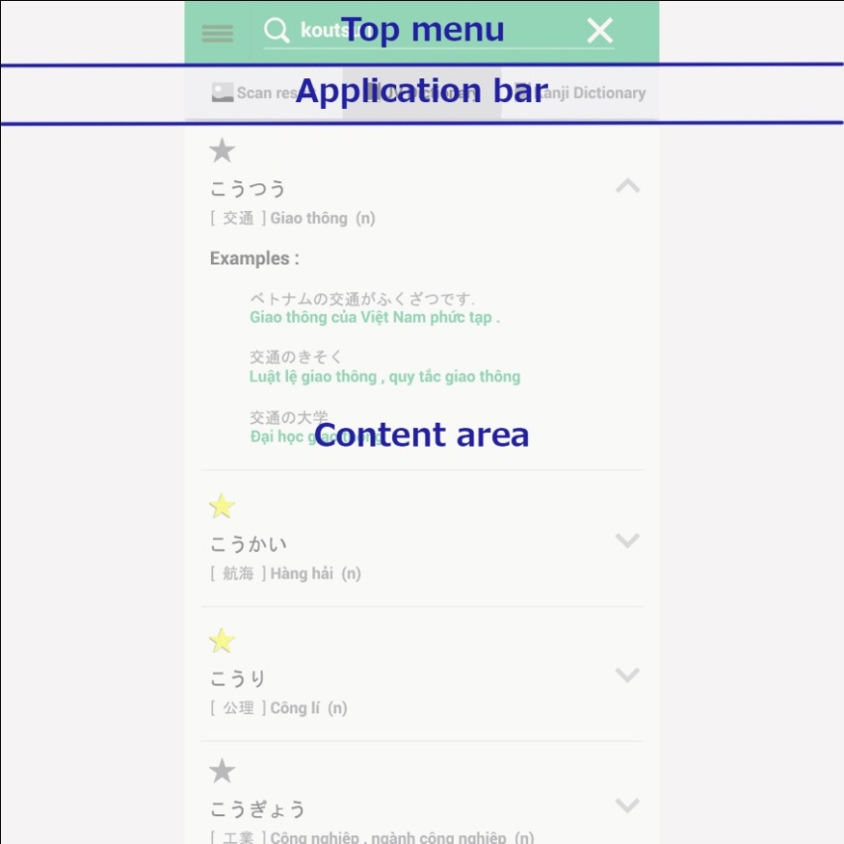

* **Top menu**

Provide a menu button as a navigation , search bar or title

* **Application bar**

Provide option tabs as the features that user can choose

* **Content Area**

Dispay the results

Screen flow :

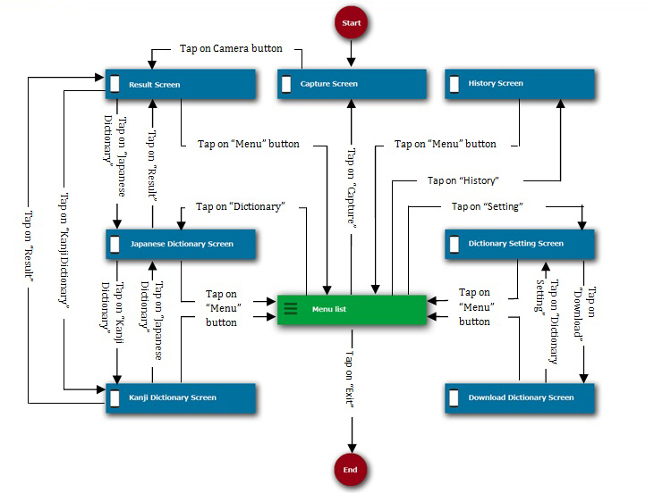

*Figure 124: Screen flow of Anki Pan application*

### 3.2.2. Screen Description

#### 3.2.2.1. Capture screen

This is the first screen after user launched AnkiPan application where user can capture image ans Japanese document.

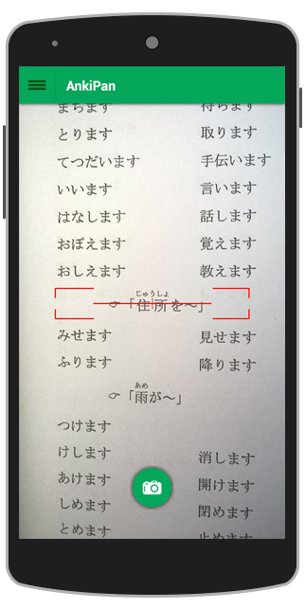 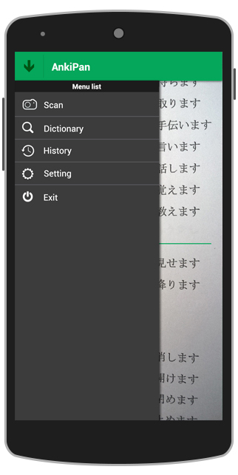

|  |  |  |  |  |
| --- | --- | --- | --- | --- |
| **No** | **Elements** | **Required** | **Type** | **Description** |
| **1** | **Menu** | Touch on | List view | List of the features ( Capture , Dictionary ,History , Setting , Exit )when user taped on it.The menu button like a navigation tool to direct to other screens . |
| **2** | **Title** |  | Label | The title is “AnkiPan” |
| **3** | **Ruler** |  |  | Ruler helps user to adjust the balance for photos . User should setparallel the ruler to the textline before taking the photos. |
| **4** | **Camera button** | Touch on | Button | User taps on capture button to take the photo. |

#### 3.2.2.2. Result screen

When user captures the japanese letter , AnkiPan will display the image. User can touch on the image to select letters. The magnifier will zoom in the selected letter. Application marks the start point and end point of the selected letters.When user finished , the selected words will be ready for searching.

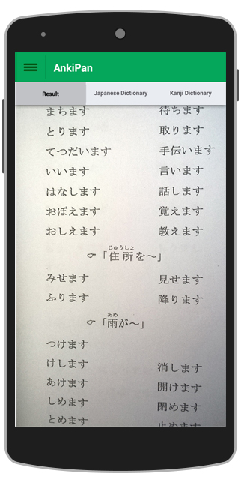 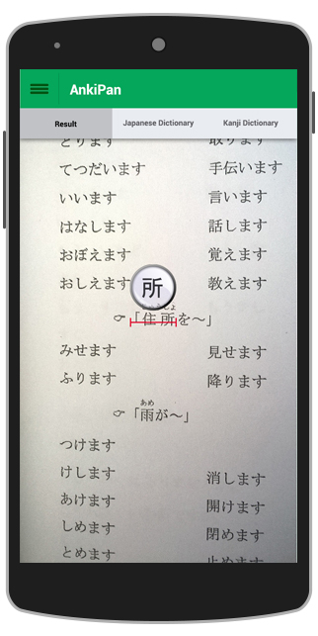 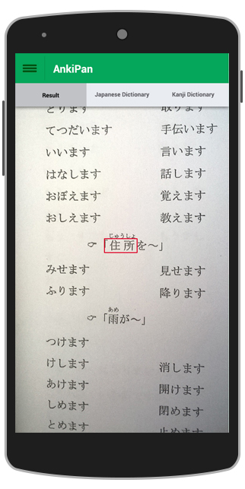

|  |  |  |  |  |  |
| --- | --- | --- | --- | --- | --- |
| **No** | **Elements** | **Required** | **Type** | **Default** | **Description** |
| **1** | **Menu** | Touch on | List view |  | List of the features (Capture ,Dictionary ,History , Setting , Exit )when user taped on it.The menu button like a navigation tool to direct to other screens . |
| **2** | **Title** |  | Label |  | The title is “AnkiPan” |
| **3** | **Tab bar** | Touch on | Sliding tab | [Result] is selected | Tabs make it easily to switch between dictionaries. |
| **4** | **Magnifier** | Touch on |  |  | Zoom in selected letters |
| **5** | **Red line** |  |  |  | Marks start point to end point when user touch on screen. |
| **6** | **Red frame** |  |  |  | Wraps the content that user selected. |

#### 3.2.2.3. Japanese dictionary screen

After selecting letters in image , user can use tab bar to select . AnkiPan provides 2 dictionary Japanese Dictionary and Kanji Dictionary , user inputs text in search bar directly and selects dictinary in tab bar.The result will be displayed below.

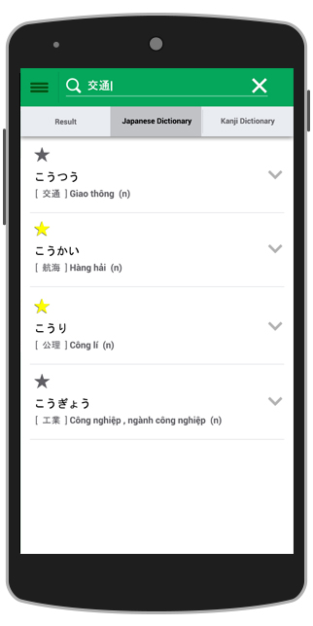 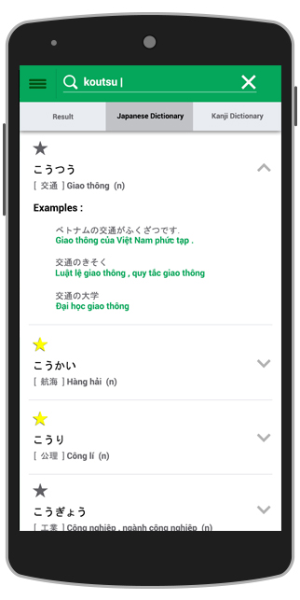

|  |  |  |  |  |  |
| --- | --- | --- | --- | --- | --- |
| **No** | **Elements** | **Required** | **Type** | **Default** | **Description** |
| **1** | **Menu** | Touch on | List view |  | List of the features ( Capture , Dictionary ,History , Setting , Exit )when user taped on it.The menu button like a navigation tool to direct to other screens . |
| **2** | **Search bar** | Touch on | Search bar |  | Input text for translation. The selected letters in captured image also are displayed here |
| **3** | **Tab bar** | Touch on | Sliding tab | [Japanese Dictionary] is selected | Tabs make it easy to switch between dictionaries. |
| **4** | **Star** | Touch on | Button |  | Marks the searched word in history and favorite. Tap again to unmark |
| **5** | **Hiragana** |  | TextView |  | Displays hiragana of searched words. |
| **6** | **Kanji** |  | TextView |  | Displays kanji of searched words if it is possible. |
| **7** | **Meaning** |  | TextView |  | Displays the meaning of search words. |
| **8** | **Type of word** |  | TextView |  | Displays the type of search word |
| **9** | **Examples** |  | TextView |  | Displays some examples |
| **10** | **Expandable Button** | Touch on | Expandable list view |  | Shows more and hides information about searched words. |

#### 3.2.2.4. Kanji dictionary screen

User can select words from captured image or type on search bar directly to search .The result will be displayed as below. When user select two or more words, AnkiPan will return corresponding Sino-Vietnamese words exactly.

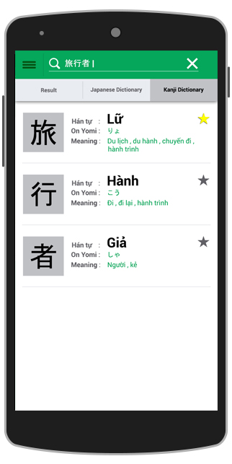

|  |  |  |  |  |  |
| --- | --- | --- | --- | --- | --- |
| **No** | **Elements** | **Required** | **Type** | **Default** | **Description** |
| **1** | **Menu** | Touch on | ListView |  | List of the features ( Capture,Dictionary ,History,Setting,Exit)when user taped on it.The menu button like a navigation tool to direct to other screens . |
| **2** | **Search bar** | Touch on | SearchBar |  | Input text for translation. The selected letters in captured image also are displayed here |
| **3** | **Tab bar** | Touch on | Sliding tab | [Kanji Dictionary] tab is selected. | Tabs make it easy to switch between dictionaries |
| **4** | **Big Kanji** |  | TextView |  | Displays Kanji of searched word in big size. |
| **5** | **Sino-Vietnamese** |  | TextView |  | Displays Sino-Vietnamese of search word in big size. |
| **6** | **On Yomi** |  | TextView |  | Displays on yomi of coresponding kanji |
| **7** | **Meaning** |  | TextView |  | Displays the meaning of coresponding kanji. |
| **8** | **Star** | Touch on | Button |  | Marks the searched word in history and favourite. Taps again to unmark. |

#### 3.2.2.5. History screen

History help user saving searched word so that user can review those words. User can use favourite tab to display all marked words. By touching on star button user can switch between marked and unmarked status. When history is so long with many records , user can clear history to delete all records .

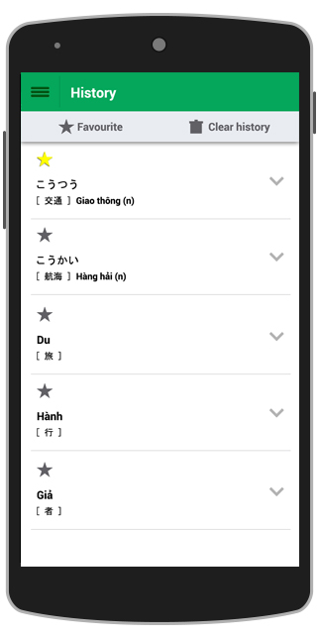 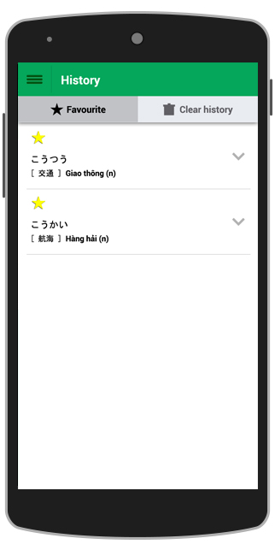

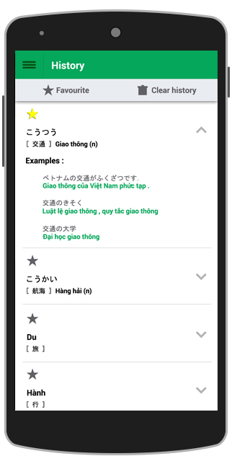 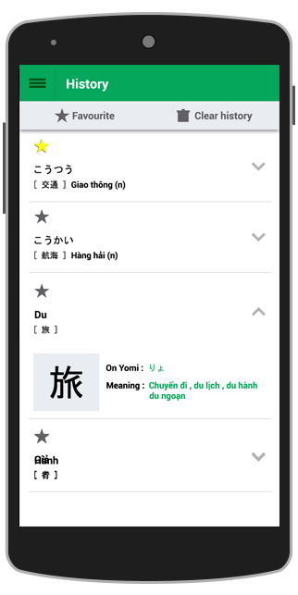

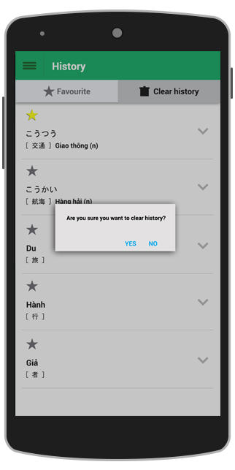 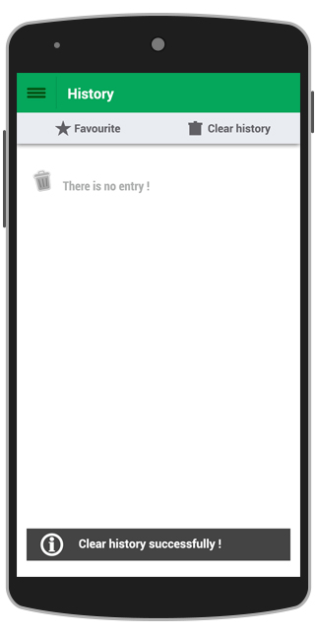

|  |  |  |  |  |
| --- | --- | --- | --- | --- |
| **No** | **Elements** | **Required** | **Type** | **Description** |
| **1** | **Menu** | Touch on | List View | List of the features ( Capture , Dictionary ,History , Setting , Exit )when user taped on it.The menu button like a navigation tool to direct to other screens . |
| **2** | **Title** |  | Label | Title is “History” |
| **3** | **Favorite** | Touch on | Button | Displays the list of marked words. |
| **4** | **Clear history** | Touch on | Button | Deletes all records in history. |
| **5** | **Star** | Touch on | Button | Marks the searched word in history and favorite. Tap again to unmark. |
| **6** | **Hiragana** |  | TextView | Display hiragana of saved words. |
| **7** | **Kanji** |  | TextView | Display kanji of saved words. |
| **8** | **Meaning** |  | TextView | Display the meaning of saved words. |
| **9** | **Sino-Vietnamese** |  | TextView | Display the Sino-Vietnamese of saved words. |
| **10** | **Expandable button** | Touch on | Button | Show or hide more information of saved words. |
| **11** | **Confirmation** |  | ShowDialog | Ask user before do deleting process |
| **12** | **Notice** |  | TextView | Notice “There is no record” when clear history successfully. |

#### 3.2.2.6. Dictionary setting screen

Dictionary setting screen display all dictionarys which user had. The dictionary that user is using will be selected as default .In this screen , user can change dictionary and delete dictionary.

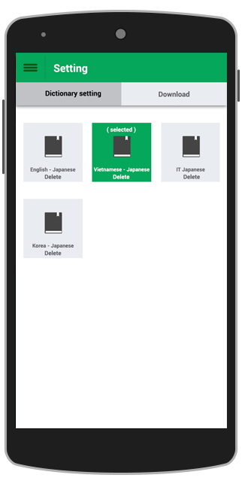 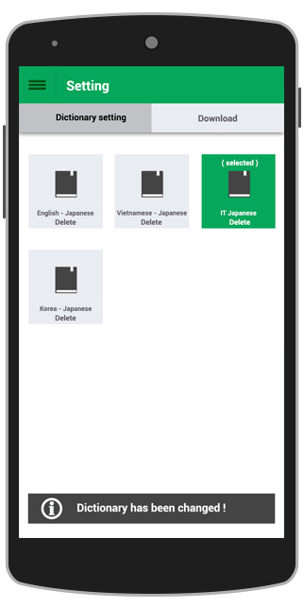

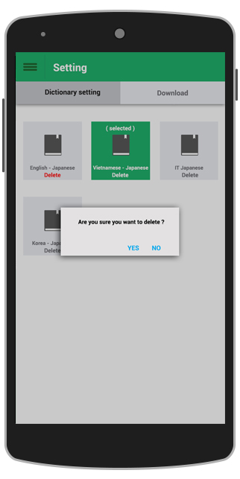 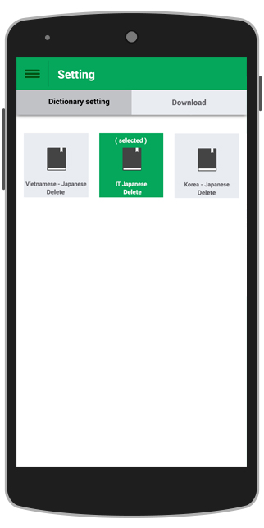

|  |  |  |  |  |  |
| --- | --- | --- | --- | --- | --- |
| **No** | **Elements** | **Required** | **Type** | **Default** | **Description** |
| **1** | **Menu** | Touch on | List View |  | List of the features ( Capture , Dictionary ,History , Setting , Exit )when user taped on it.The menu button like a navigation tool to direct to other screens . |
| **2** | **Title** |  | Label |  | Title is “Setting” |
| **3** | **Tab bar** | Touch on | Sliding tab | [Dictionary setting ] tab is selected | Tabs make it easy to switch between dictionary setting and download. |
| **4** | **Types of Dictionary** | Touch on |  | Dictionary that is using is marked | Display all dictionaries in package . The dictionary that is using will be marked as default. |
| **5** | **Status** |  | Label | [selected] | [selected] status is displayed when a dictionary is selected. |
| **6** | **Delete** | Touch on | Button |  | Delete corresponding dictionary. |
| **7** | **Confirmation** |  | ShowDialog |  | Asks user before deleting dictionary |
| **8** | **Notice** |  | ShowDialog |  | Notice to user when change dictionary or delete dictionary successfully. |

#### 3.2.2.7. Dictionary download screen

Download screen display all dictionary packages. User can download new package or update new version here.

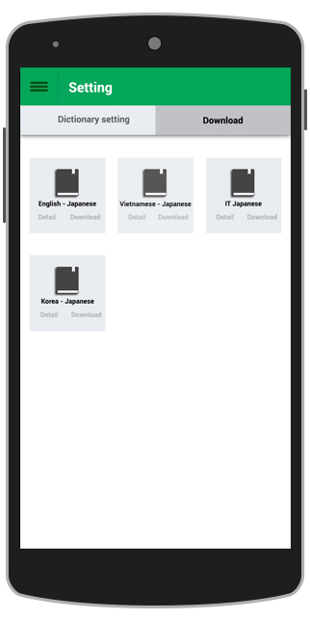 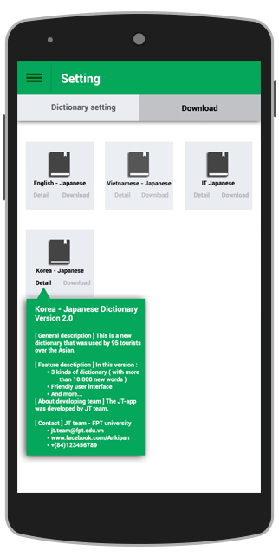

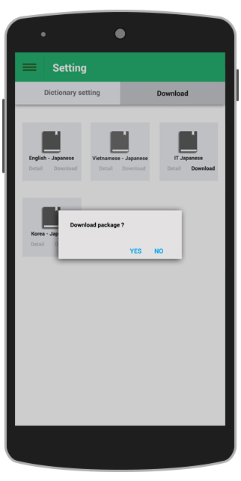 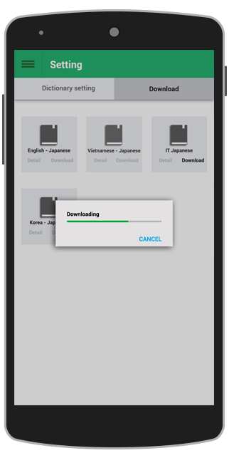

|  |  |  |  |  |  |
| --- | --- | --- | --- | --- | --- |
| **No** | **Elements** | **Required** | **Type** | **Default** | **Description** |
| **1** | **Menu** | Touch on | List View |  | List of the features ( Capture , Dictionary ,History , Setting , Exit )when user taped on it.The menu button like a navigation tool to direct to other screens . |
| **2** | **Title** |  | Label |  | Title is “Setting” |
| **3** | **Tab bar** | Touch on | Sliding tab | [Download ] tab is selected | Tabs make it easy to switch between dictionary setting and download. |
| **4** | **Dictionary packages** |  |  |  | Display all dictionary packages that user can download or update . |
| **5** | **Download** | Touch on | Button |  | Download dictionary. |
| **6** | **Detail** | Touch on | Button |  | Displays information for new version or new packages. |
| **7** | **Confirmation** |  | ShowDialog |  | Asks user before downloading and updating dictionary. |
| **8** | **Progress bar** |  | Progress bar |  | Displays the downloading process and updating process. |

## 3.3. Interface Design of Server

### 3.3.1. Structure and layout

The overall structure of the website is relatively simple, as shown in the following diagram.

|  |  |  |
| --- | --- | --- |
| **No** | **Screen Name** | **Description** |
| **1** | Login page | Where user enters username and password to log in website . |
| **2** | Home page | The first page after loging facilitate navigation to other pages on the site. |
| **3** | Account list page | Where user can see the account list , create new account , edit account , delete account. |
| **4** | Package list page | Where displays all dictionary packages, create new package , edit package , delete package. |
| **5** | Package detail page | Where displays the detail of specific package that include all sub-dictionary in a package. |
| **6** | History page | Where displays the history of actions. |

The content is displayed in the layout that is shown below :

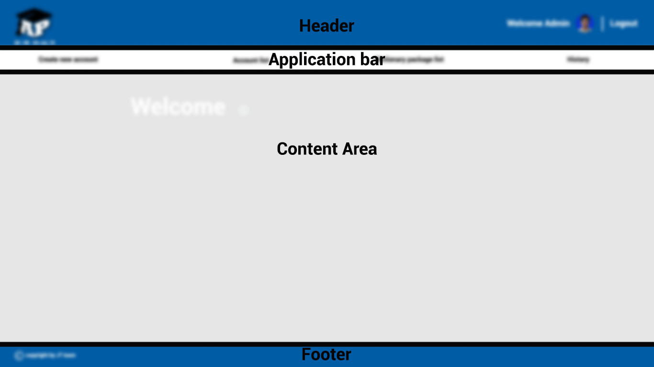

* **Header**



Shows :

_ Ankipan logo

_ Current user

_ Avatar

_ Links to sign out.

* **Application bar**



A tab bar that provides links to other pages :

_ “Create new account” tab ( If user is root admin )

_ ”Account list “ tab

_ “Dictionary package list” tab

**_ “**History” tab

* **Content area**

The content of each pages will be described in topic **3. Page content description**

* **Footer**



Show the privacy

Screen flow:

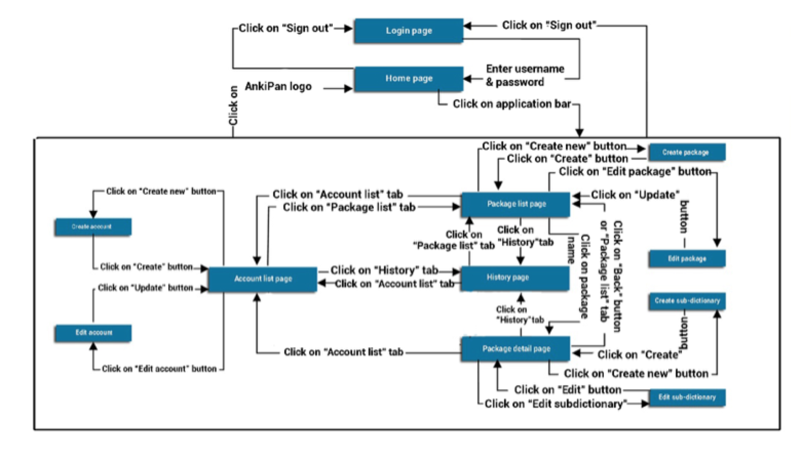

*Figure 102: Secreen flow of server*

### 3.3.2. Page content description

#### 3.3.2.1. Login page

This is the first page where user enters username and password to log in website. In the first page , user can see the AnkiPan logo and login form .User can save username and password in Cookies.



|  |  |  |  |  |
| --- | --- | --- | --- | --- |
| **No** | **Components** | **Elements** | **Type** | **Description** |
| **1** | **AnkiPan logo** | AnkiPan logo | Image | The logo of AnkiPan application. |
| **2** | **Login form** | Username | TextField | Where user enters username . |
| Password | PasswordChar | Where user enters password. |
| Remember password | Check box | Save password to the web browse’s cookies. |
| Login button | Button | Where user click on to submit username and password. |

#### 3.3.2.2. Home page

This is a landing page , where displays all application links to other pages . The greeting will be displayed in the content area .

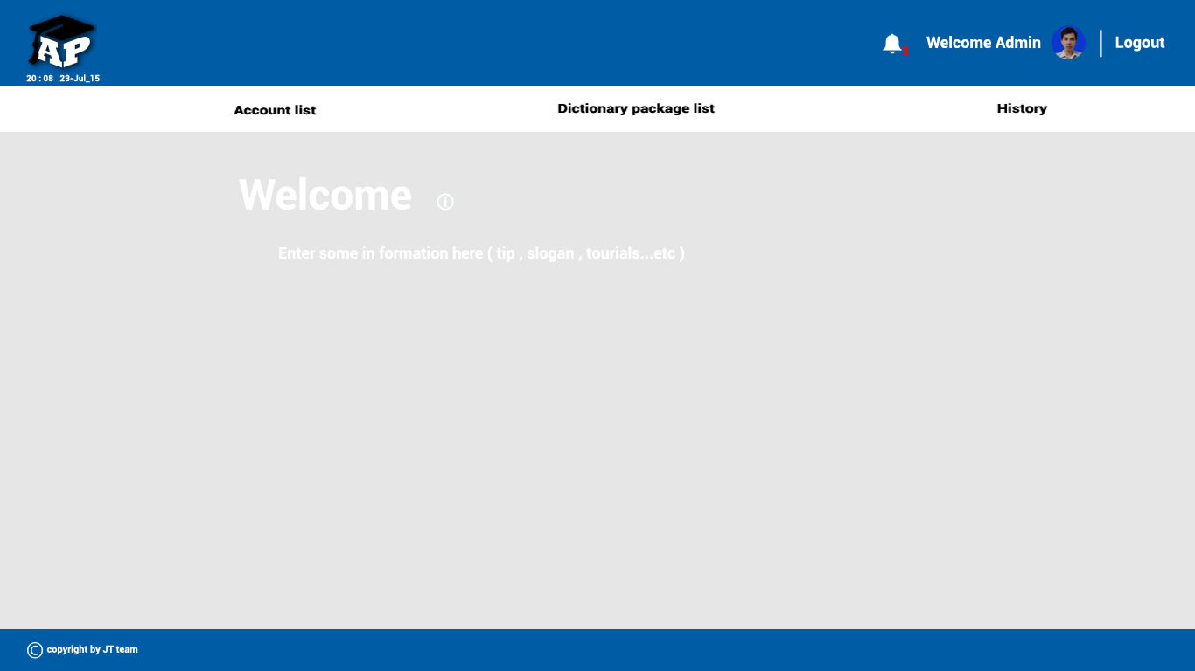

#### 3.3.2.3. Account list page

**3.3.2.3.1. Account list**

User click on account list tab to link to account list page. This page will display the list of accounts as a table.

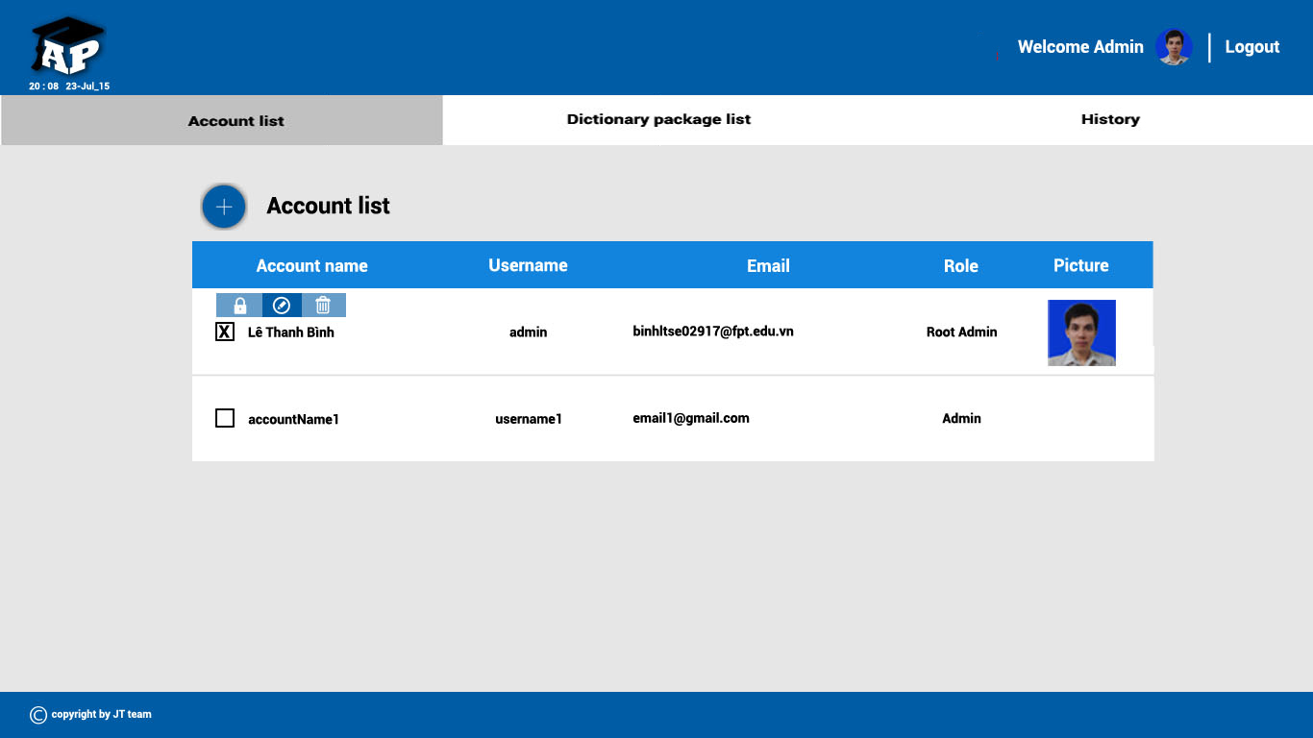

|  |  |  |
| --- | --- | --- |
| **No** | **Column** | **Description** |
| **1** | Account name | Displays all account names.This column is sorted by name. |
| **2** | User name | Displays all user names . This column is sorted by name. |
| **3** | Email | Displays email of accounts. |
| **4** | Role | Displays the role of accounts. |
| **5** | Picture | Displays the picture of account as avatar if it is possible. |

**3.3.2.3.2. Create new account button**

Root Admin click on “Create new account” button to create new account.



**3.3.2.3.3. Create new account form**

In the application bar , Root Admin clicks on create new account tab to link to Create New Account page . In this page , Root Admin can create new accounts.

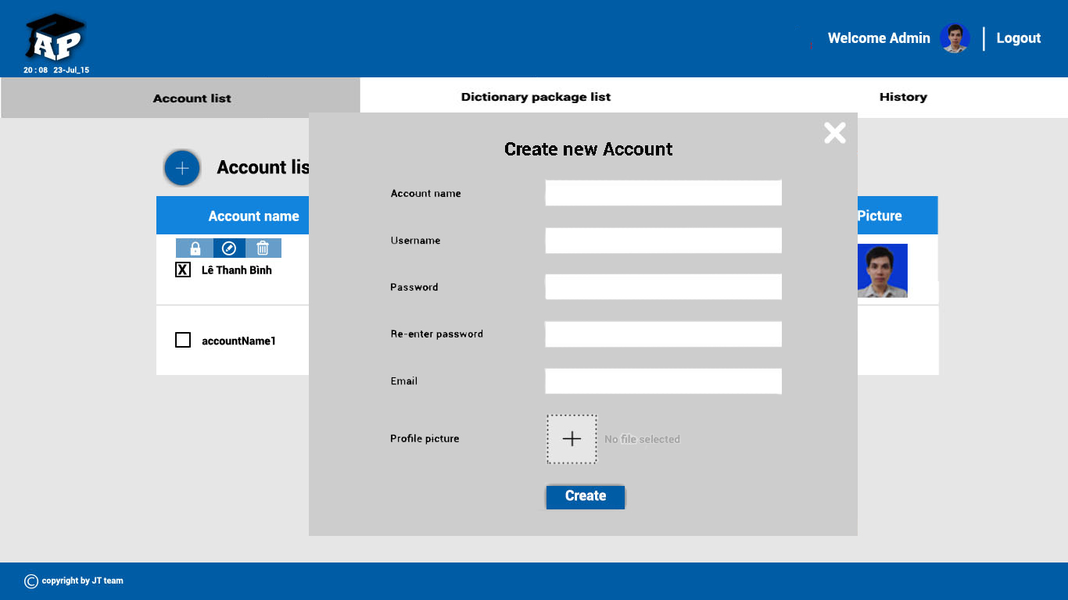

|  |  |  |  |
| --- | --- | --- | --- |
| **No** | **Elements** | **Type** | **Description** |
| **1** | Account name | TextField | Where Root Admin enters the account name. |
| **2** | User name | TextField | Where Root Admin enters the username. |
| **3** | Password | Password Char | Where Root Admin enters the password. |
| **4** | Re-enter Password | Password Char | Where Root Admin re-enters the password. |
| **5** | Email | TextField | Where Root Admin enters the email of user account. |
| **6** | Profile Picture | File Browse | Where Root Admin select picture to set avatar. |
| **7** | Create button | Button | Click on to submit information. |

**3.3.2.3.4. Tool box**

When user selected an account , a Tool box will be displayed .It contain : “Change password” button , “Edit profile” button , “Delete account” button.

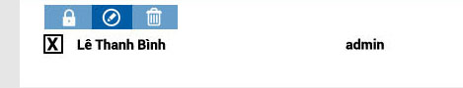

* Change password button , link to “Change passwod” form.
* Edit profile button , link to “Edit profile ” form.
* Delete account button , delete account.

**3.3.2.3.5. Change password form**

In account list page , after selecting an account , root Admin click on “Change Password” button in the tool bar, change password form will be displayed. Root Admin enters new password to change password.

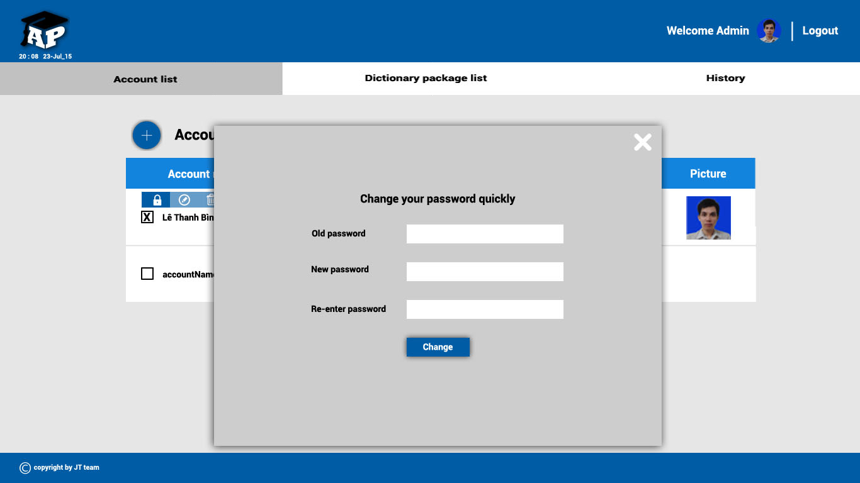

|  |  |  |  |
| --- | --- | --- | --- |
| **No** | **Elements** | **Type** | **Description** |
| **1** | Old password | Password char | Where displays old password |
| **2** | New password | Password char | Where user enters the new password. |
| **3** | Re-enter new password | Password char | Where user re-enters the new password. |
| **4** | Change button | Button | Click on to submit new password, the password will be changed . |

**3.3.2.3.6. Edit profile form**

In account list page , after selecting an account , root Admin click on “Edit profile” button in the Tool box, “Edit profile” form will be displayed. Root Admin enters new information to update profile.

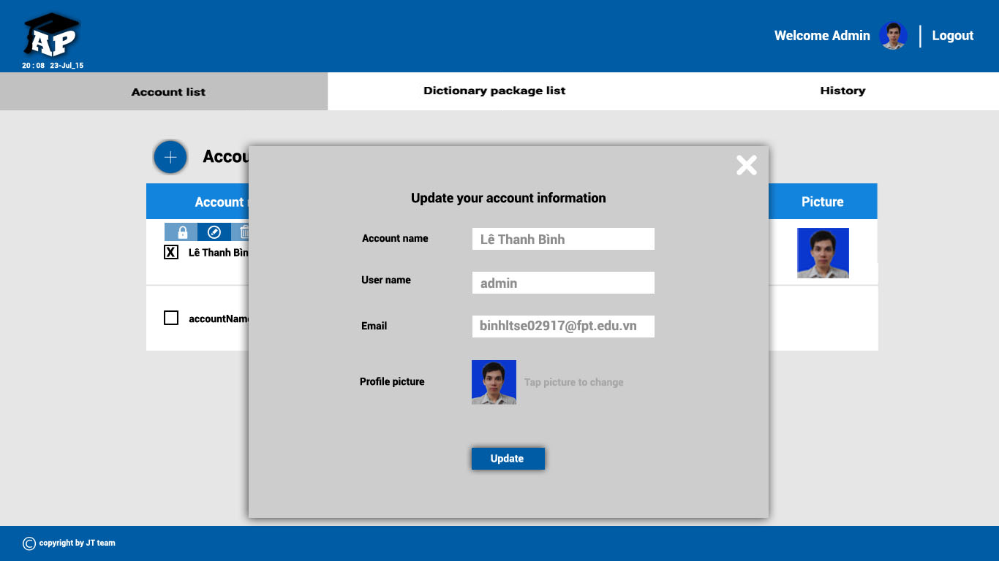

|  |  |  |  |
| --- | --- | --- | --- |
| **No** | **Elements** | **Type** | **Description** |
| **1** | Account name | TextField | Where displays selected account name. |
| **2** | User name | TextField | Where displays user name of account that has been selected |
| **3** | Email | TextField | Where displays email of account that has been selected. |
| **4** | Profile picture | File browse | Displays old picture of account that has been selected . Root admin can change picture. |
| **5** | Update button | Button | Clicks on to update new information. |

#### 3.3.2.4. Package list page

**3.3.2.4.1. Package list**

User click on “Package list” tab to link to package list page. This page will display the list of package as a table.

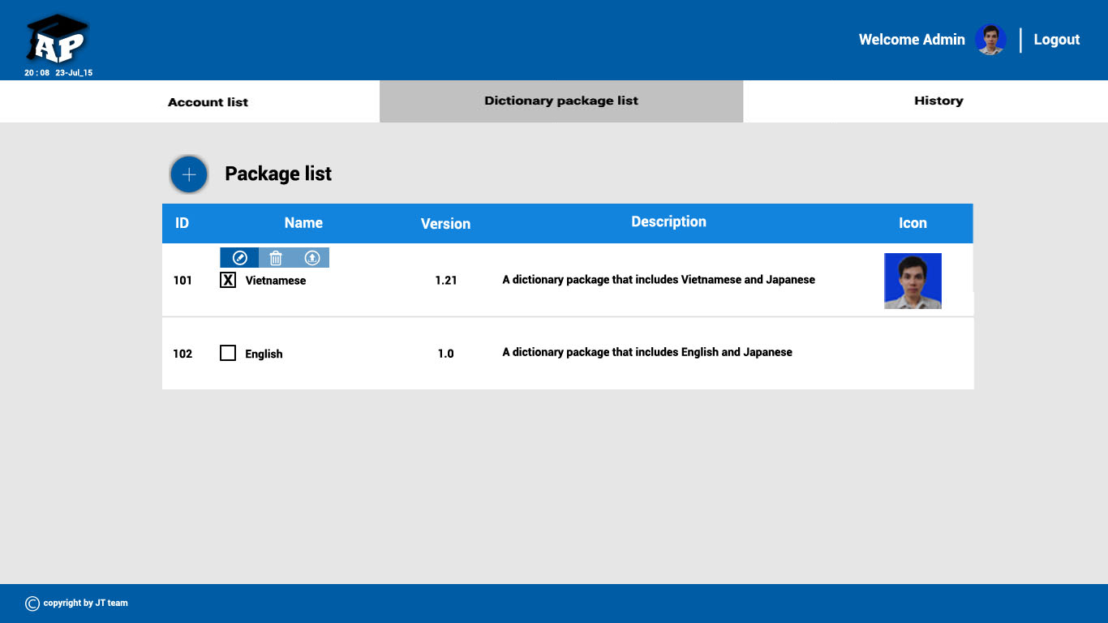

|  |  |  |
| --- | --- | --- |
| **No** | **Column** | **Description** |
| **1** | ID | Displays all package ID. It is also a hyper link that links to “Package detail” page . |
| **2** | Name | Displays the package name. It is also a hyper link that links to “Package detail” page . |
| **3** | Version | Displays the package version. |
| **4** | Description | Describes the package simply and sortly. |
| **5** | Icon | Display the package icon. |

**3.3.2.4.2. Create new package button**

When user click on “Create new package” button , the “Create new package” form will be displayed .



**3.3.2.4.3. Create new package form**

When user click on “Create new package” button , the “Create new package” form will be displayed. User enter the package information , click “Create” button to create new package.

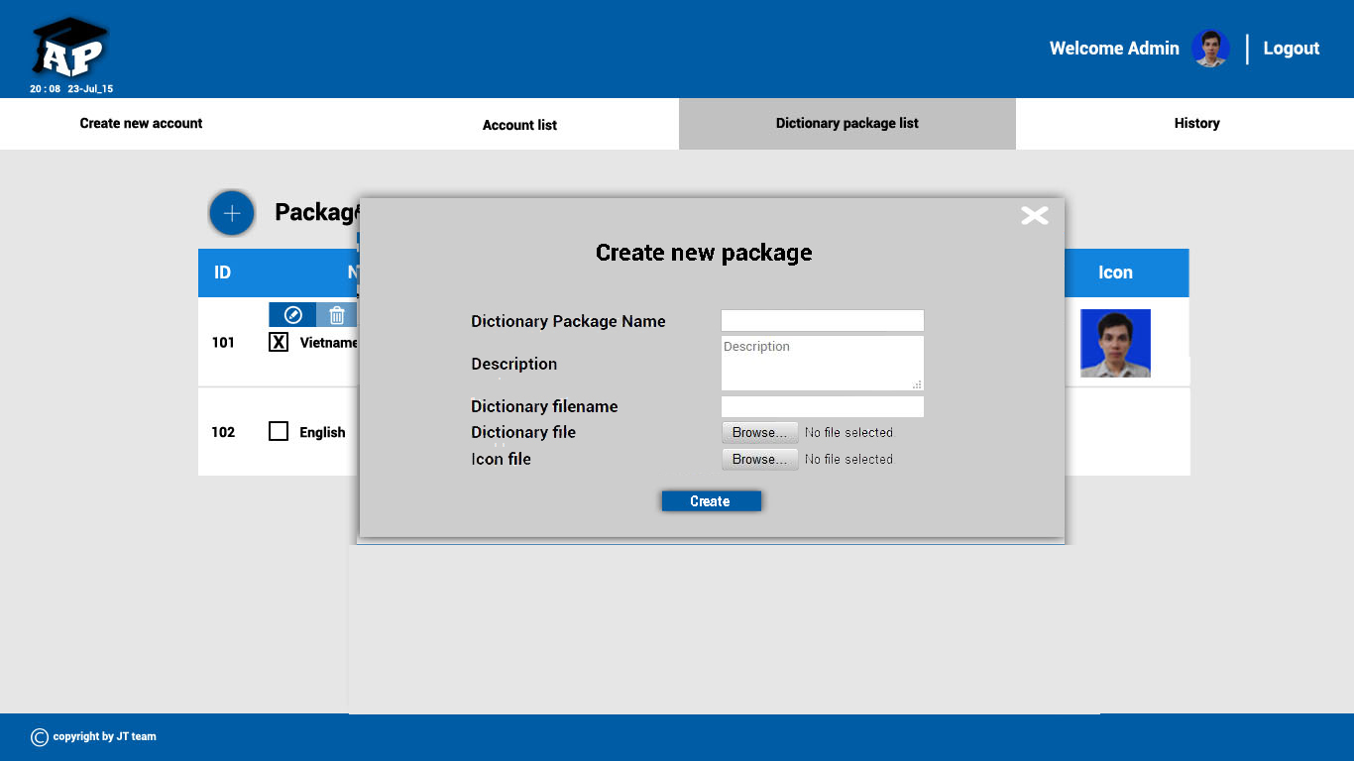

|  |  |  |  |
| --- | --- | --- | --- |
| **No** | **Elements** | **Type** | **Description** |
| **1** | Dictionary Package name | TextField | Where user enter the name of package. |
| **2** | Description | TextArea | Where user describe new package. |
| **3** | Dictionary filename | TextField | Where user enter the filename. |
| **4** | Dictionary file | File Browse | Where user select dictionary file to submit. |
| **5** | Icon file | File Browse | Where user select dictionary icon. |
| **6** | Create button | Button | Click on to create new package. |

**3.3.2.4.4. Tool box**

When user selected an package , a Tool box will be displayed .It contain : “Edit package” button , “Delete package” button , “Download package” button.



* Edit package button , link to “Edit package” form.
* Delete package button , delete package immediately.The package list will be updated immediately.
* Download package button , download packge to your computer.

**3.3.2.4.5. Edit package form**

In package list page , after selecting a package , user click on “Edit package” button in the Tool box, “Edit package” form will be displayed. User enters new information to update package.

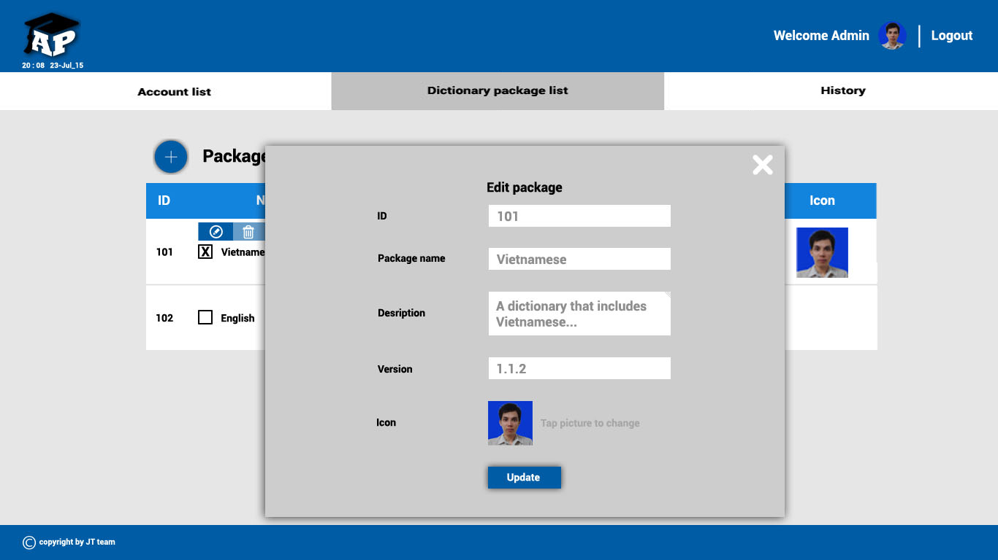

|  |  |  |  |
| --- | --- | --- | --- |
| **No** | **Elements** | **Type** | **Description** |
| **1** | ID | TextField | Where displays selected package’s ID. |
| **2** | Package name | TextField | Where displays the name of package. |
| **3** | Description | TextArea | Where displays sort description of selected package. |
| **4** | Version | TextField | Where displays the version of package. |
| **5** | Icon | Image | Where display package’s icon. |
| **6** | Update button | Button | Clicks on this button to update package. |

#### 3.3.2.5. Package Detail page

**3.3.2.5.1. Package detail**

In the package list page , user click on ID or package name of the package to selected a package . The package detail page will be displayed. The package detail page displays all the sub-dictionary that selected package contains.

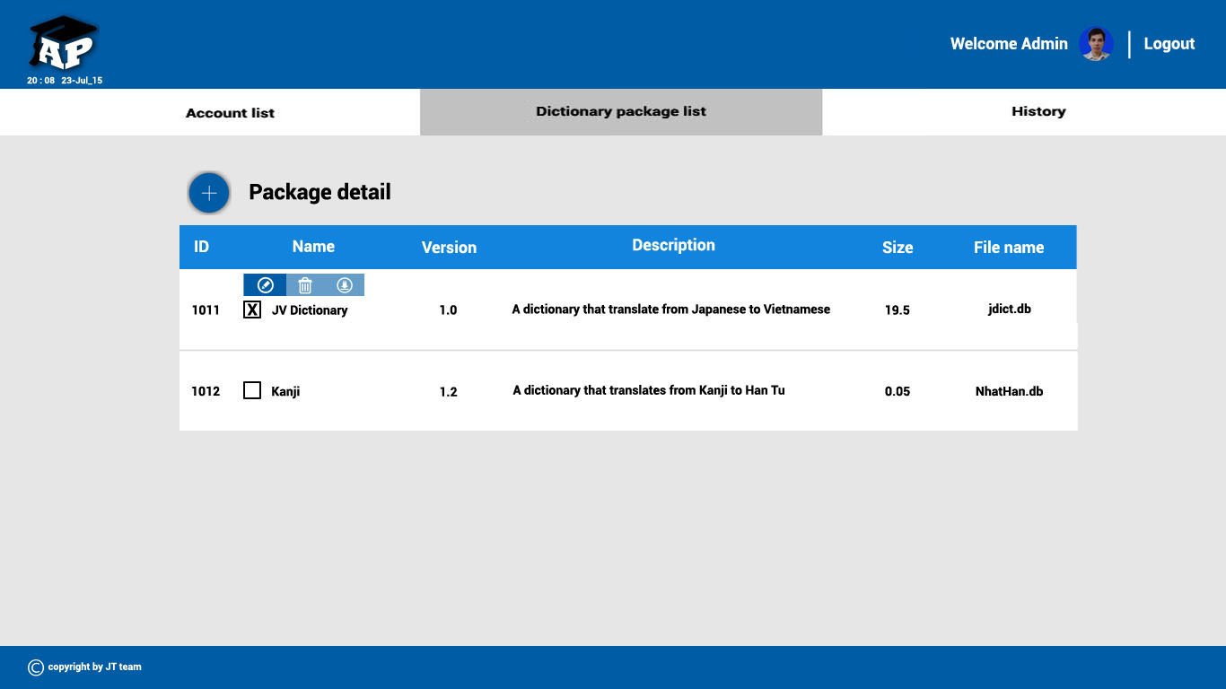

|  |  |  |
| --- | --- | --- |
| **No** | **Column** | **Description** |
| **1** | ID | Displays sub-dictionary ‘s ID. |
| **2** | Name | Displays the sub-dictionary name. |
| **3** | Version | Displays the sub-dictionary version. |
| **4** | Description | Display sort description . |
| **5** | Size | Displays the size of sub-dictionary. |
| **6** | File name | Displays the file name of sub-dictionary. |

**3.3.2.5.2. Create new sub-dictionary button**

In the package detail page , user click on “Create new sub-dictionary” button to create new sub-dictionary.



**3.3.2.5.3. Create new sub-dictionary form**

When user click on “Create new sub-dictionary” button , the create new form will be displayed . User enter the sub-dictionary information to create new subdictionary.

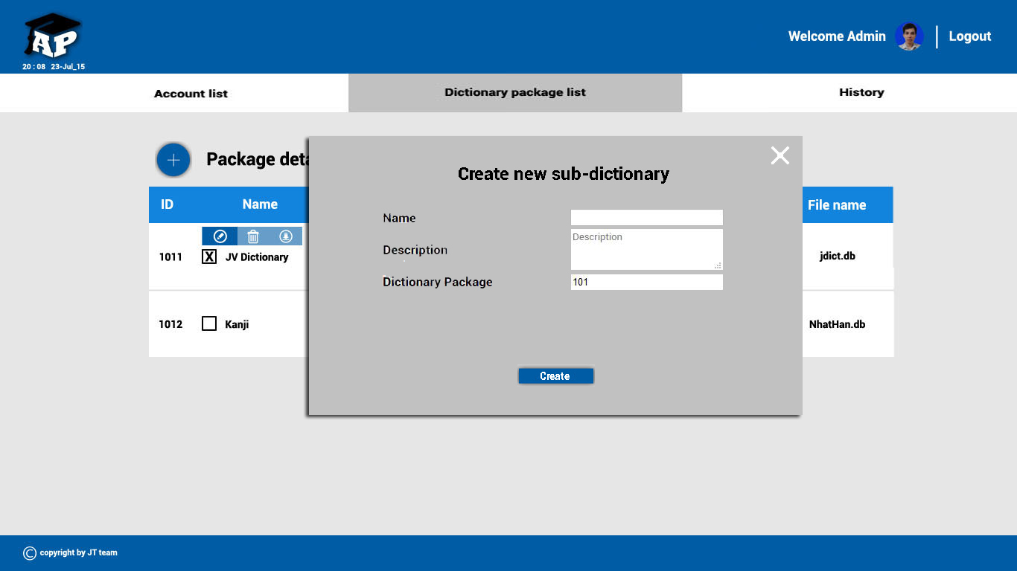

|  |  |  |  |
| --- | --- | --- | --- |
| **No** | **Elements** | **Type** | **Description** |
| **1** | Name | TextField | Where user enter the name of sub-dictionary. |
| **2** | Description | TextArea | Where user describe new sub-dictionary. |
| **3** | Dictionary package | TextField | Where display ID of the selected package. |
| **4** | Create button | Button | Click on to create new sub-dictionary. |

**3.3.2.5.4. Tool box**

When user selected a sub-dictionary, a Tool box will be displayed .It contain : “Edit sub-dictionary” button , “Delete sub-dictionary” button , “Download sub-dictionary” button.



* Edit sub-dictionary button , link to “Edit sub-dictionary” form.
* Delete sub-dictionary button , delete sub-dictionary immediately.The sub-dictionary list will be updated immediately.
* Download sub-dictionary button , download sub-dictionary file to your computer.

**3.3.2.5.5. Edit sub-dictionary form**

In package detail page , after selecting a sub-dictionary , user click on “Edit sub-dictionary” button in the Tool box, “Edit sub-dictionary” form will be displayed. User enters new information to update sub-dictionary.

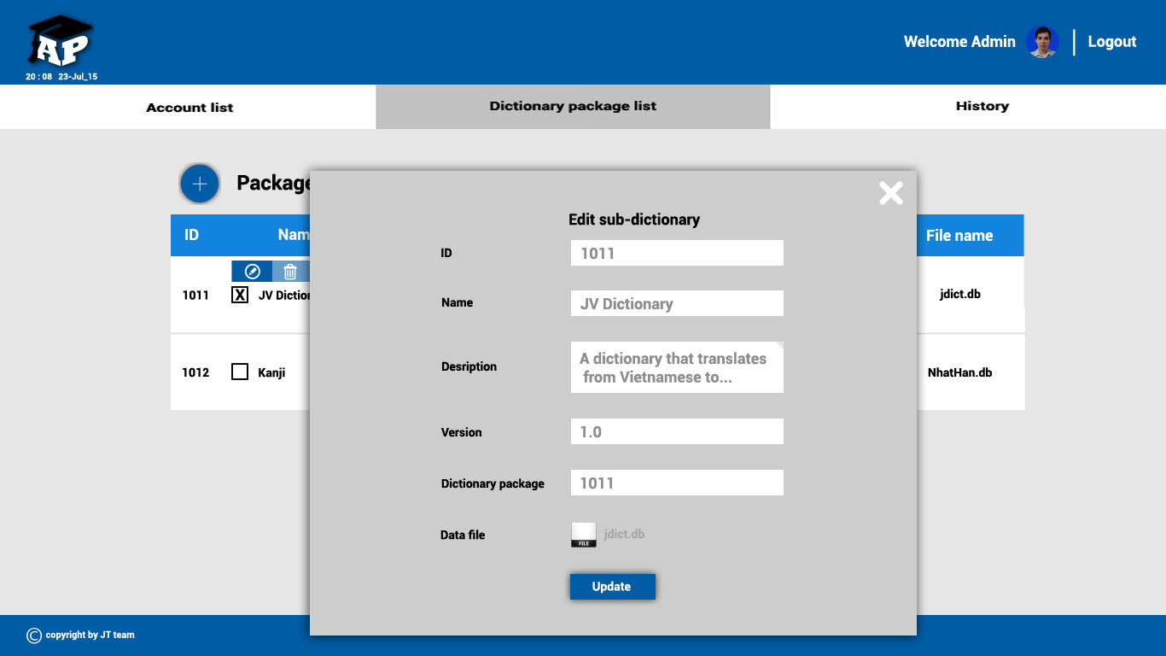

|  |  |  |  |
| --- | --- | --- | --- |
| **No** | **Elements** | **Type** | **Description** |
| **1** | ID | TextField | Where displays the ID of selected sub-dictionary. |
| **2** | Name | TextField | Where displays the name of sub-dictionary. |
| **3** | Description | TextArea | Where displays sort description of selected sub-dictionary. |
| **4** | Version | TextField | Where displays the version of sub-dictionary. |
| **5** | Dictionary package | TextField | Where display the package that contains the selected sub-dictionary. |
| **6** | Data file | File Browse | Where display the current file of selected sub-dictionary . User can change new file. |
| **7** | Update button | Button | Clicks on to update sub-dictionary. |

#### 3.3.2.6. History page

User click on “History” tab to link to history page. This page will display the list of actions as a table.

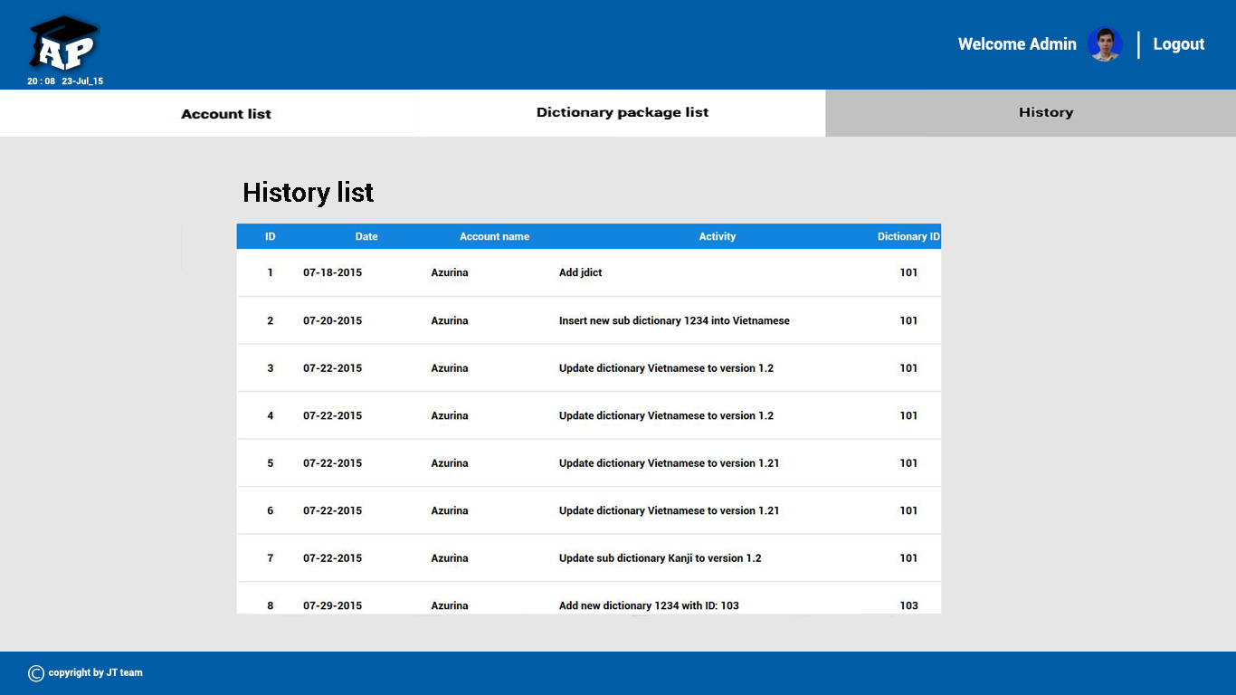

|  |  |  |
| --- | --- | --- |
| **No** | **Column** | **Description** |
| **1** | ID | The ID of action. |
| **2** | Date | The date that action happened in. |
| **3** | Account name | The account name that do the action. |
| **4** | Activity | The name of action. |
| **5** | Dictionary ID | The ID of dictionary that related with action. |

# V. EVALUATION

# 1. TEST PLAN

## 1.1. Introduction

### 1.1.1. Purpose

This document describes the plan for testing the developed software system against the software requirements as defined in the Software Requirements Specification and Detailed Document. The purpose of these tests is to make sure that the software system developed during the Japanese Translator project complies with the requirements. The planning of these test will be done in the Planning phase, they will be designed in the Design phase and finally must be executed in the Coding phase and Testing phase of each cycle in the project.

### 1.1.2. Background information

Japan is one of the most advanced countries in the world. Besides, Japanese culture a spreading very quickly through manga, anime,... Therefore, there are more and more people study Japanese. However, for most of them, reading Japanese is a real challenge because of a lots Chinese-like characters called Kanji. So “Anki Pan” project was kicked off to serve purpose of learning Japanese easier and simpler.

This project will develop an Android application that has following main function:

* Capture image
* Detect Japanese characters in image captured by users
* Select text in captured image
* Search for meaning of Japanese words and Kanji in dictionary
* Download dictionary: allow user to download dictionary package, each package include a Japanese dictionary and a Kanji dictionary.
* Save words to history
* Add to favorite list

A server will also be developed to support users download dictionary database. The server has below main functions:

* Login as admin or root admin
* Logout
* Manage user’ profile (add, delete, edit information)
* Upload dictionary packages, each package includes 2 kind of dictionaries: Japanese dictionary and Kanji dictionary
* Manage dictionary packages (edit, delete)

Project team will develop a library for image processing (AKImageProcessingLib), using OpenCV open library. AKImageProcessingLib is created to:

* Extract all text lines from image captured by user
* Convert image to threshold image

Tesseract open source OCR is used for Japanese recognition. Threshold image converted by AKImageProcessingLib will be passed to Tesseract to detect Japanese characters.

### 1.1.3. Scope of testing

The scope of this test will be limited to testing the application on Android and testing of server.

#### 1.1.3.1. Target of Test

Functional items and Non-functional items will be verified and passed by AKP development team, via test stages, including the requirements of the following functions of Android application:

* Capture image
* Detect Japanese characters in image captured by users
* Select text in captured image
* Search for meaning of Japanese words and Kanji in dictionary
* Download dictionary: download dictionary package, each package include a Japanese dictionary and a Kanji dictionary.
* Save words to history
* Add to favorite list

And the following functions of server:

* Login as admin or root admin
* Logout
* Manage user’ profile (add, delete, edit information)
* Upload dictionary packages, each package includes 2 kind of dictionaries: Japanese dictionary and Kanji dictionary
* Manage dictionary packages (edit, delete)

#### 1.1.3.2. Test stage

|  |  |  |
| --- | --- | --- |
| **No** | **Test Stages** | **Description** |
| 1 | Unit Test | Unit Test will be performed by AKP development team |
| 2 | Integration Test | Integration Test will be performed by AKP tester. After the Unit Test is finished testers will execute the UT Gate based on the UT Gate checklist for each function. Integration Test will only start if the result of UT Gate is passed.  This test stage focuses on specific areas of use cases when all requirements are completed, integration test should be performed to ensure all components incorporate well. |
| 3 | System Test | System test will be execute by AKP testers. Testers will perform complete, end-to-end system testing staged in pre-production environment to validate that functions and system interfaces perform properly in production environment. |
| 4 | Acceptance Test | Acceptance Test will be conducted by users. AKP team’s will fix bugs reported by user in acceptance test phrase. |

### 1.1.4. Constraints

* Working processing must be report Personal weekly report to PM and Supervisor.
* Deadline for testing only can be met if development progress is on time.
* Test execution can be performed when system passes Unit Test Inspection.
* At least one round of testing must be performed for requirements.

### 1.1.5. Risk List

|  |  |  |  |  |  |
| --- | --- | --- | --- | --- | --- |
| **No** | **Description** | **Source** | **Probability** | **Exposure** | **Trigger** |
| 1 | Test phrases is not completed due to testers’ lack of experience | Human | Medium |  |  |

### 1.1.6. Training Needs

|  |  |  |
| --- | --- | --- |
| **No** | **Training items** | **Description** |
| 1 | Testing process | Learn & study by MaiNT:  Understanding: Unit Test, System Test, Acceptance Test, Integration Test  Learn from web: testing.vn |
| 2 | Test tools | Learn & study by BinhLT  Understanding: test tool for server |
| 3 | Test model | Learn & study by developer:  Understanding V-model |

## 1.2. Requirement For Test

### 1.2.1. Test items

Developer will be performed unit test to ensure that all functions are working as expected. Tester will be under taking the responsibility of testing and validating the operation of the part that developed. The functions developed require completing design and execution of function to ensure proper coverage.

The listing below identifies those items that have been identified as targets for testing. This list represents what will be tested.

#### 1.2.1.1. Functional Items

* *Application*

|  |  |
| --- | --- |
| 1. Main menu 2. Capture image 3. Result  * Show text line * Select text from image * Zoom in selecting area  1. Dictionary  * Search Japanese word * Suggest word * Search Kanji * Add to favorite list * Remove from favorite list | 1. History  * Show searched words * Show favorite words (bookmarked words) * Show words’ information * Add to favorite list * Remove from favorite list * Delete a word * Delete all history  1. Setting  * Select dictionary package * Download dictionary package * Delete dictionary package * Show dictionary package’s description  1. Exit |

* *Server*

|  |  |
| --- | --- |
| Root admin & Admin   1. Login 2. Logout 3. Manage profile  * Edit profile (user name, avatar, email) * Change password  1. Upload dictionary package 2. Edit dictionary package 3. Delete dictionary package | Root admin   1. Manage account:  * Add new account * Delete account |

#### 1.2.1.2. Non functional Items

|  |
| --- |
| 1. User interface is clear and easy to understand. User need no more than 10 minutes to learn how to use the application 2. Time for processing image is less than 10s |

### 1.2.2. Acceptance test criteria

(*Reference to FSoft norm 2013 for development project*)

* The criteria for Test team to accept source code after Unit test of Development team:

- Number of UTC/KLOC : 80 - 90 Case/1KLOC

- Weight defects/KLOC : 8-9 bug/1KOLC

- Part coverage : 100%

* The criteria for accept the result of System test:

- Number of UTC/KLOC : 34 - 46 Case/1KLOC

- Weight defect/KLOC : 2 - 4 bug/1KLOC

- Part coverage : 100%

* The criteria for accept the result of Acceptance test:

- Number of UTC/KLOC : 1 – 2 Case/1KLOC

- Weight defect/KLOC : 0 - 1 bug/1KLOC

- Part coverage : 100%

## 1.3. Test strategy

### 1.3.1. Test type

#### 1.3.1.1. Function Testing

Unit testing searches for defects in each function, and verifies the function of Anki Pan application and server.

Application and tests whether its functions are implemented properly as required or not.

|  |  |
| --- | --- |
| **Test Objective** | Ensure proper target-of-test functionality, including navigation, data entry, processing, and retrieval. |
| **Technique** | Execute each use case, use-case flow, or function, using valid and invalid data, to verify the following:  - The expected results occur when valid data is used.  - The appropriate error or warning messages are displayed when invalid data is used. |
| **Completion criteria** | All planned tests have been executed. |
| **Special considerations** | Identify or describe those items or issues (internal or external) that impact the implementation and execution of function test. |

#### 1.3.1.2. User Interface Testing

Integration testing tests interfaces between components (Mobile screen), interactions with different parts of a system, and interfaces between systems.

|  |  |
| --- | --- |
| **Test Objective** | Verify the following:  Navigation through the target-of-test properly reflects business functions and requirements, including window-to-window, field-to-field, and use of access methods (tab keys, mouse movements, accelerator keys) |
| **Technique** | Create or modify tests for each window (server) and each screen (application) to verify proper navigation and object states for each application window and objects |
| **Completion criteria** | Each window(server) and each screen(application) successfully verified to remain consistent with benchmark version or within acceptable standard |
| **Special considerations** | Not all properties for custom and third party objects can be accessed. |

#### 1.3.1.3. Data and Database Integrity Testing

Data and Database Integrity Testing test integrity of data, accuracy of data and save data to the database.

|  |  |
| --- | --- |
| **Test Objective** | Ensure database access methods and processes function properly and without data corruption. |
| **Technique** | * Invoke each database access method and process, seeding each with valid and invalid data or requests for data. * Inspect the database to ensure the data has been populated as intended, all database events occurred properly, or review the returned data to ensure that the correct data was retrieved for the correct reasons |
| **Completion criteria** | All database access methods and processes function as designed and without any data corruption. |
| **Special considerations** | * Testing may require a DBMS development environment or drivers to enter or modify data directly in the databases. * Processes should be invoked manually. * Small or minimally sized databases (limited number of records) should be used to increase the visibility of any non-acceptable events. |

#### 1.3.1.4. Regression Testing

Regression testing is to validate modified parts of the software, to make sure that the modification does not cause errors in other parts.

|  |  |
| --- | --- |
| **Test Objective** | Regression testing is to validate modified parts of the software, to make sure that the modification does not cause errors in other parts. |
| **Technique** | * Reuse the set of test cases from an existing test suite to test a modified module. * Construct a program-analysis infrastructure. We are building an extensible infrastructure to implement and evaluate a program-analysis. Basing on the analysis result, we identify scope of regression test. |
| **Completion criteria** | All selected test cases(cases can cause bugs when changed requirement) are performed and passed. |
| **Special considerations** | N/A |

### 1.3.2 Test stages

|  |  |  |  |  |
| --- | --- | --- | --- | --- |
| Types of Test | Stages of Test | | | |
| Unit | Integration | System | Acceptance |
| Function Test | X | X | X |  |
| User Interface test |  | X | X |  |
| Database Integrity Testing |  | X | X |  |
| Regression test | X | X | X |  |

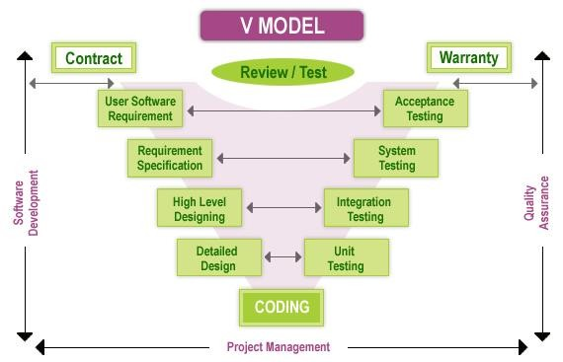

*Figure 125: V-Model*

## 1.4. Resource

### 1.4.1 Human resource

|  |  |  |
| --- | --- | --- |
| **Doer** | **Roles** | **Specific Responsibilities / Comments** |
| MaiNT | Test leader | Manage Test resource and assign test tasks  Create TP ST IT TC Review TC  Execute test |
| NhungBH | PM + Developer | Review test plan  Review test result  Create UT & execute test  Report test result |
| ThaiVH | Technical leader | Create UT & execute test  Report test result |
| NghiaPT | Developer | Create UT & execute test  Report test result |
| HoangND | Developer | Create UT & execute test  Report test result |
| BinhLT | Designer + Tester | Create integration test cases  Execute test cases  Report test result |

### 1.4.2 Environment

|  |  |
| --- | --- |
| **Hardware** | **Version** |
| LG smart phone | Android ver4.4.2 |
| Sony smart phone | Android 5.0.2 |
| Laptop | Window 7 |
|  |  |

|  |  |
| --- | --- |
| **Hardware** | **Version** |
| OpenCV Manager | 2.18 |
| Google Chrome | 44.0.2403.107 |
| Fire fox | 39.0 |
|  |  |

## 1.5. Test Milestones

|  |  |  |  |
| --- | --- | --- | --- |
| **Milestone Task** | **Effort (pd)**  **(pd)** | **Start Date** | **End Date** |
| * **Increment 1** | | | |
| Create test plan |  | 08/06/2015 | 10/06/2015 |
| Submit test plan version 1.0 |  | 11/06/2015 | 11/06/2015 |
| * **Increment 2** | | | |
| Create ST test cases for Dictionary |  | 24/06/2015 | 25/06/2015 |
| Create ST test cases for History |  | 26/06/2015 | 29/06/2015 |
| Create & execute UT test case for image processing library |  | 9/7/2015 | 9/07/2015 |
| Create & execute UT test case for server |  | 10/07/2015 | 10/07/2015 |
| Create & execute UT test case for Dictionary |  | 10/07/2015 | 10/07/2015 |
| Create & execute UT test case for Scan |  | 11/07/2015 | 11/07/2015 |
| Report UT result |  | 11/07/2015 | 11/07/2015 |
| * **Increment 3** | | | |
| Review & update & submit test plan ver2.0 |  | 14/07/2015 | 14/07/2015 |
| Create ST test cases for server |  | 20/07/2015 | 21/07/2015 |
| Execute & report ST for server |  | 22/07/2015 | 23/07/2015 |
| Create & execute UT Result screen's functions |  | 24/07/2015 | 24/07/2015 |
| Create & execute UT History functions |  | 31/07/2015 | 31/07/2015 |
| Create & execute UT Dictionary functions |  | 31/07/2015 | 31/07/2015 |
| Create & execute UT functions of cropping text area |  | 30/07/2015 | 30/07/2015 |
| Create & execute UT Setting functions |  | 1/8/2015 | 1/8/2015 |
| Create & execute IT |  | 30/07/2015 | 1/08/2015 |
| Report UT & IT result |  | 2/08/2015 | 2/08/2015 |
| * **Increment 4** | | | |
| Execute & report ST test cases for Application |  | 5/08/2015 | 7/08/2015 |
| Submit final report of testing |  | 7/08/2015 | 7/08/2015 |

## 1.6. Deliverables

|  |  |  |  |  |
| --- | --- | --- | --- | --- |
| **No** | **Deliverables** | **Delivered Date** | **Delivered by** | **Delivered to** |
| * **Increment 1** | | | | |
| 1 | Test plan ver1.0 | 11/06/2015 | MaiNT | NhungBH |
| * **Increment 2** | | | | |
| 2 | UT test cases and result | 11/07/2015 | ThaiVH | NhungBH |
| 3 | ST test cases ver1.0 | 29/06/2015 | MaiNT | NhungBH |
| * **Increment 3** | | | | |
| 4 | Test plan ver2.0 | 4/07/2015 | MaiNT | NhungBH |
| 5 | UT test cases and result | 2/08/2015 | ThaiVH | NhungBH |
| 6 | ST test case ver2.0 | 23/07/2015 | MaiNT | NhungBH |
| 7 | ST result of server | 23/07/2015 | MaiNT | NhungBH |
| 8 | IT test cases ver1.0 | 2/08/2015 | BinhLT | NhungBH |
| 9 | IT result | 2/08/2015 | BinhLT | NhungBH |
| * **Increment 4**   **31/5/2015**  **MaiNT** | | | | |
| 9 | ST result of application | 7/08/2015 | MaiNT | NhungBH |
| 10 | Final report of testing | 7/08/2015 | NhungBH | Supervisor |

# 2. TEST REPORT

## 2.1. Integration test

## Macintosh HD:Users:Mac:Google Drive:Capstone Project:FinalReport:Images:Screen Shot 2015-08-24 at 9.36.42 AM.png

*Figure 126: Report of Integration test*

## 2.2. System test

* **System test round 1**

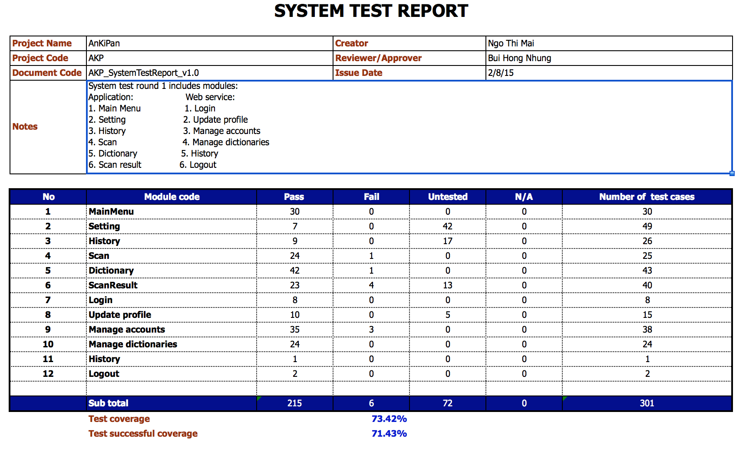

*Figure 127: Report of system test round 1*

* **System test round 2**

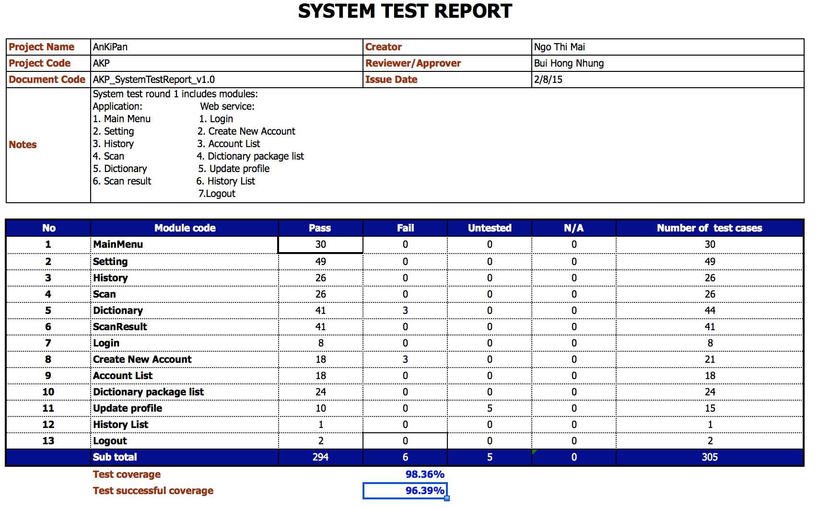

*Figure 128: Report of system test round 1*

# 3. CHECK LIST

Below is a sample of our check list:

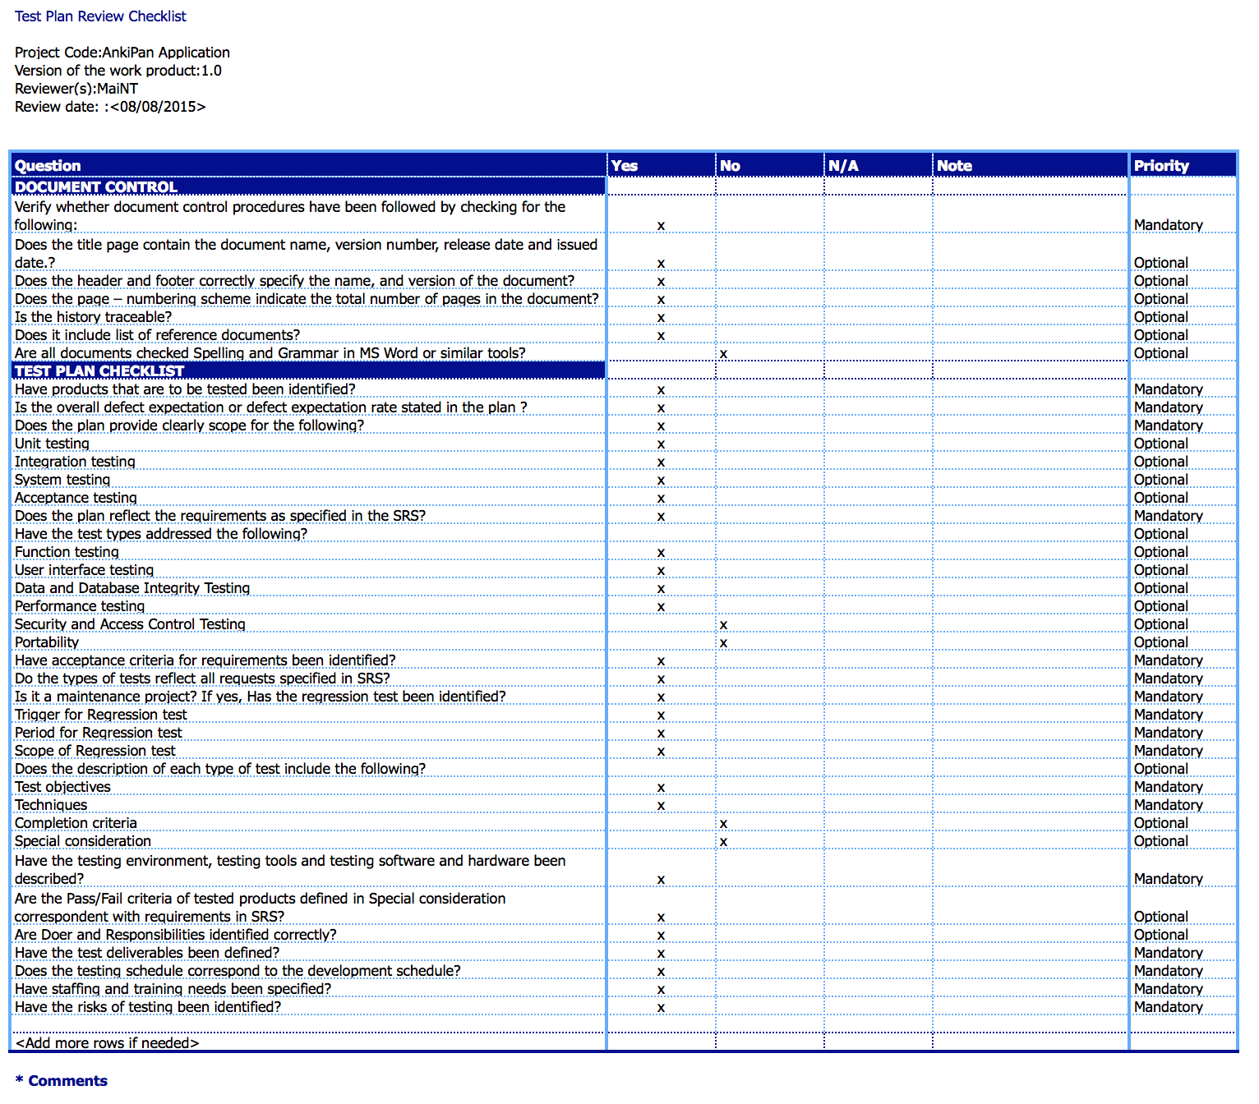

*Figure 129: Check list for test plan*

# VI. IMPLEMENTATION

# 1. DEVELOPMENT

Application and server were developed through 4 Increment as specified in Project Plan. In the end of each Increment, we held a meeting to evaluate the product and defined goals for next Increment.

We have meeting with Supervisor every week to report project progress. All unsolved issues was informed to the Supervisor to get his instruction.

All versions of source code are stored on Google drive.

# 2. PROGRESS REPORT

Project progress reports are delivered to Supervisor every week. Below is the sample of our progress report:

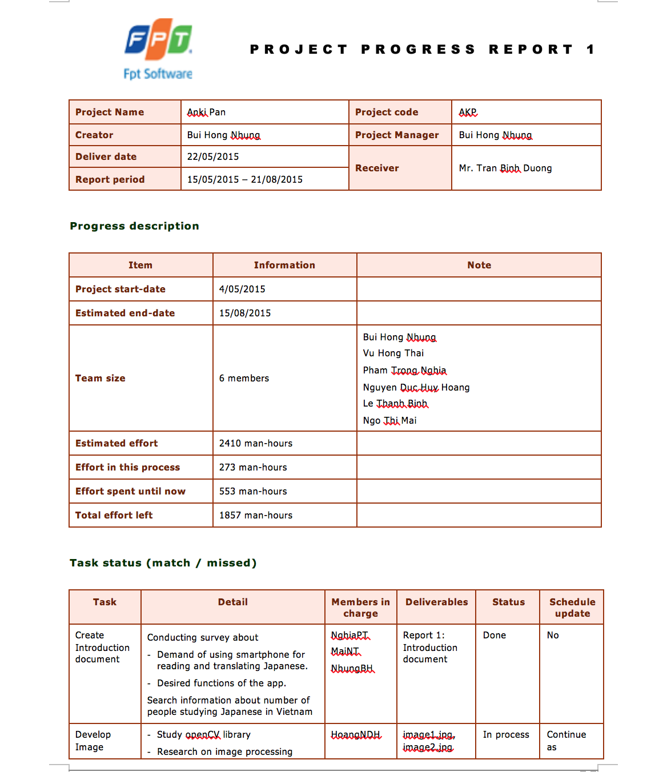

*Figure 130: Sample of progress report (English version)*

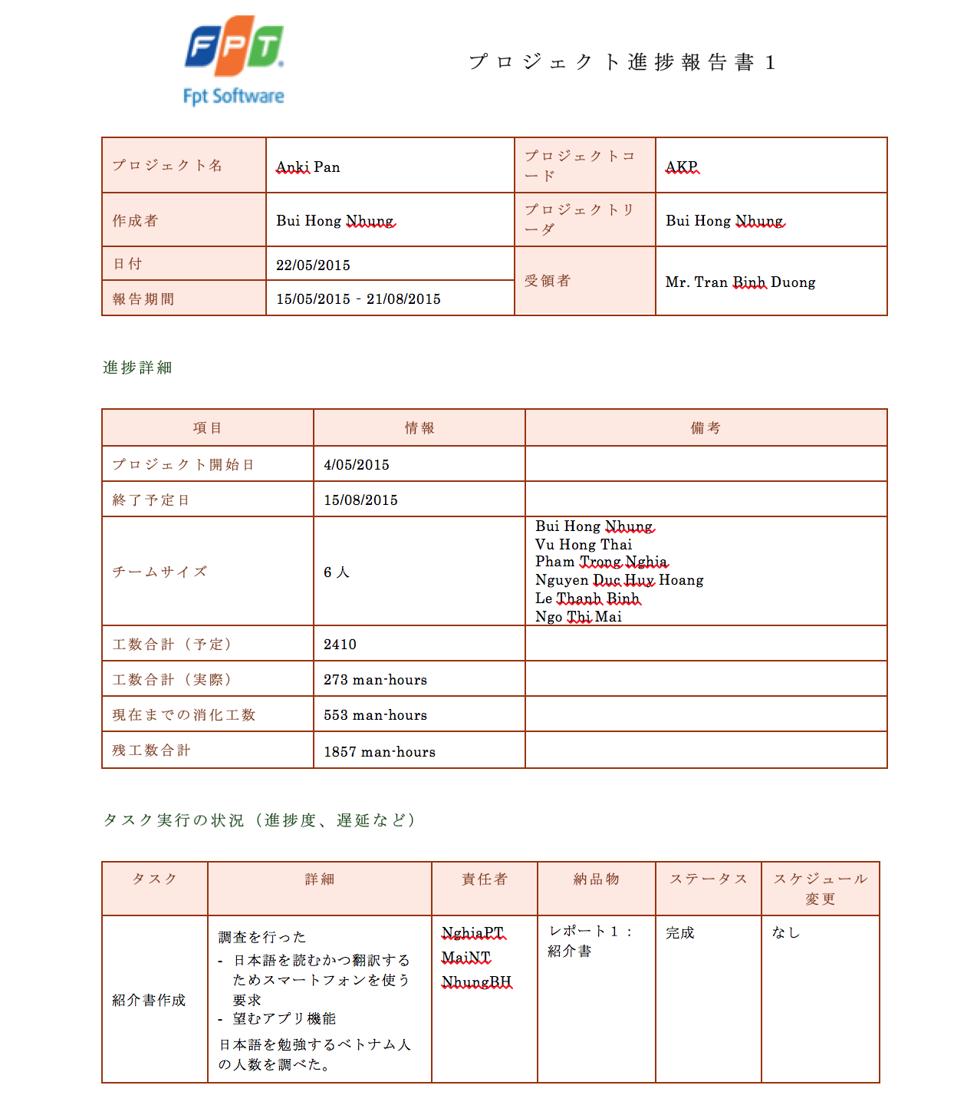

*Figure 131: Sample of progress report (Japanese version)*

# VII. INSTALLATION GUIDE AND USER MANUAL

# 1. INSTALLATION GUIDE

## 1.1. English Version

### 1.1.1. Prerequisites

This section contains the list of prerequisites that must be fulfilled before install.

* A smart phone running on Android ver 4.4.2 or higher
* 50MB free or higher

### 1.1.2. Installation procedures

1. Connect to internet
2. Tap on **Google play** icon on screen
3. Search Anki Pan
4. Tap on **Install** button
5. Tap **Accept** button on confirmation dialog

### 1.1.3. Uninstall procedures

1. Tap **Apps** in the upper right hand corner
2. Tap on **Setting**
3. Tap **Applications** to the left of the screen.
4. Tap **Manage applications** on the right side of the screen.
5. Tap on **Anki Pan**
6. Tap the **Uninstall** button.
7. To confirm you want to uninstall this app tap **OK**.
8. Click **OK** once finished.

## 1.2. Japanese Version

### 1.1.1. 前提条件

このセクションにはアプリをインストールするための前提条件を表します。

* Android バージョン4.4.2以上で動くスマートフォン
* 50MB以上のフリー の容量

### 1.1.2. インストール手順

１．インターネットに接続する

２．画面に現れるグーグルプレアイコンに押す

３．Anki Pan を検索する

４．インストールボタンに押す

５．確認ダイアログのはいボタンに押す

### 1.1.3. アンインストール手順

１．右上コーナーにアプリを押す

２．設定に押す

３．画面の左に現れるアプリケーションに押す

４．画面の右側にあるアプリ管理に押す

５．Anki Pan に押す

６．アンインストールボタンに押す

７．このアプリのアンインストールを確認するためOKに押す

８．アンインストールが終わったらOKに押す

# 2. USER MANUAL

This document guides you how to use Anki pan application. You will need only 10 minutes to learn.

## 2.1. Select a screen

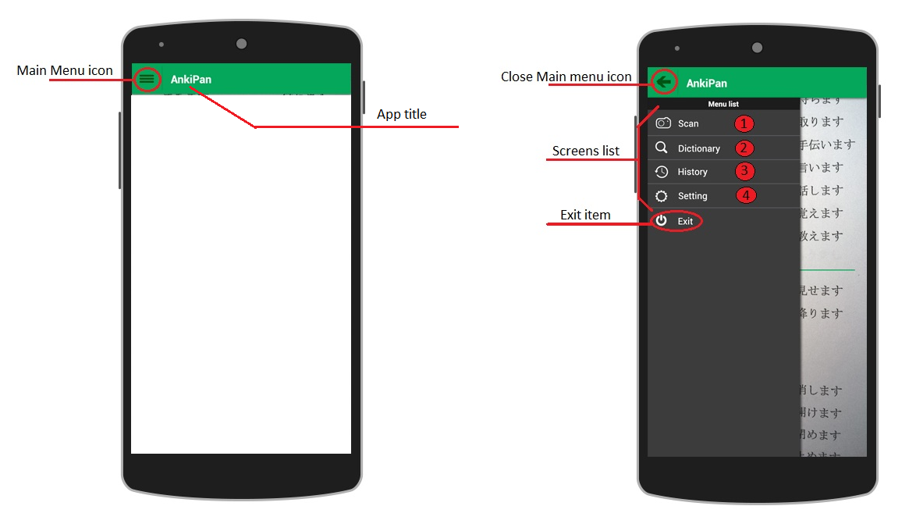

**To select a screen**

1. Tap on Main Menu icon on the upper left corner. The Main Menu will pop out listing all screen of the application.
2. Tap on the screen that you want to use.

* Scan screen: used to capture and scan document
* Dictionary screen: used to show scan result, and to search word in dictionary
* History screen: used to show searched words
* Setting screen: used to select dictionary package or download new dictionary package

If you want to quite the application, tap on Exit.

## 2.2. Scan document

|  |  |
| --- | --- |
| Macintosh HD:Users:Mac:Google Drive:Capstone Project:FinalReport:UserManual:1.png | **To scan a document**   1. Open Scan screen (see 2.1.) 2. Keep your smart phone above the document 3. Adjust your smart phone so that the Ruler is parallel with the text line, and the text is at least equal the height of the Ruler 4. Tap on Camera button   Then you will see Result screen with your document scanned. |

## 2.3. Select text on scanned document

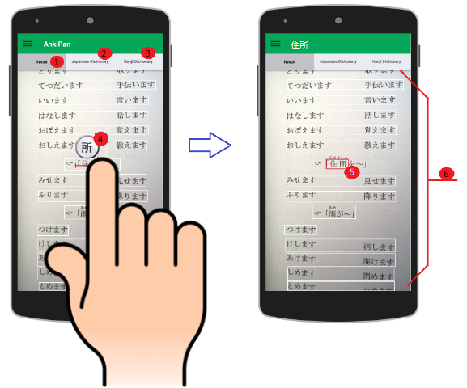

**Screen description**

Result tab: shows scanned document. Text lines are surrounded by white rectangles

Japanese Dictionary tab

Kanji Dictionary tab

Magnifier: zoom in the text area that is being selected

Scanned document

**To select text on scanned document:**

1. Put your finger on the first character of all characters you want to select
2. Swipe your finger to the last character of all character you want to select. While you are moving your finger, the magnifier will zoom in the area that your finger is on, so that you can see the text clear.
3. Lift up your finger. Your selected word will be surrounded by a red rectangle (). Do not worry if you missed stroke of first or last character. The application will process to get all the characters that you might intended to select. The text then will be show in the text field on top of the screen.
4. Now tap on Japanese Dictionary or Kanji Dictionary to look up the selected word.

## 2.4. Search word in Japanese dictionary

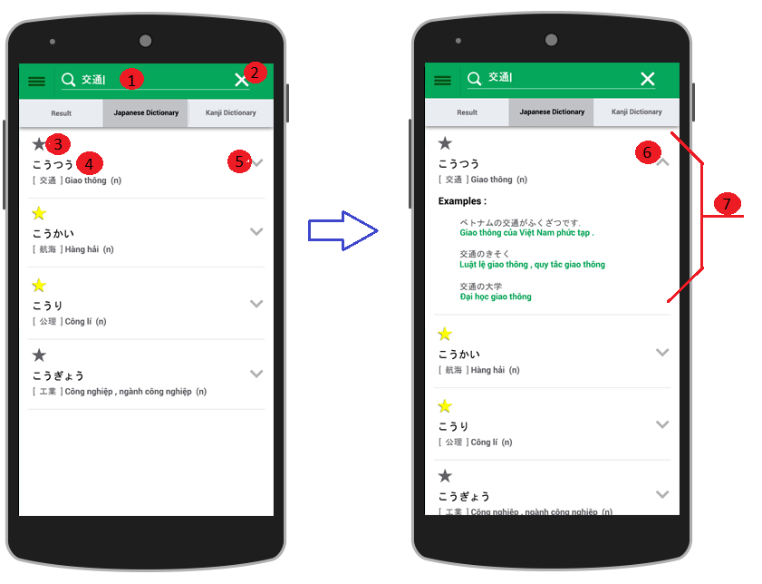

**To search word in Japanese dictionary**

1. Tap on Japanese Dictionary tab in Dictionary screen
2. Type the word to the text field . If you want to clear all the text, tap on Clear icon
3. After you press Search key on keyboard, the words which have the first part the same as the word you typed will be list on the screen. Each word will be show with a Star icon and the word itself
4. If you want to see more about the word, tap the extend icon . Other information of the word, for example meanings, word type,... will be show, as
5. If you want to see the short form, tap the close icon

**To add / remove word from favorite list**

Tap on the Star icon of the word to add / remove it from favorite list. If the star is yellow, it mean that the word is in favorite list. If you tap on a yellow star, the star turns to gray and the word will be removed from favorite list. If you tap on a gray star, the star turns to yellow, and the word will be added to favorite list.

## 2.5. Search kanji in Kanji dictionary

|  |  |
| --- | --- |
| Macintosh HD:Users:Mac:Google Drive:Capstone Project:FinalReport:UserManual:9.png | **To search kanji in Kanji dictionary**   1. Type words in the text field 1. If you want to clear all the text, tap Clear button 2. After you press the Search key on the keyboard, all kanji in you input will be show. You can see the kanji and its On yomi, Kun yomi, meaning... as in 3. To add or remove the kanji from favorite list, tap the Star icon |

## 2.6. View history

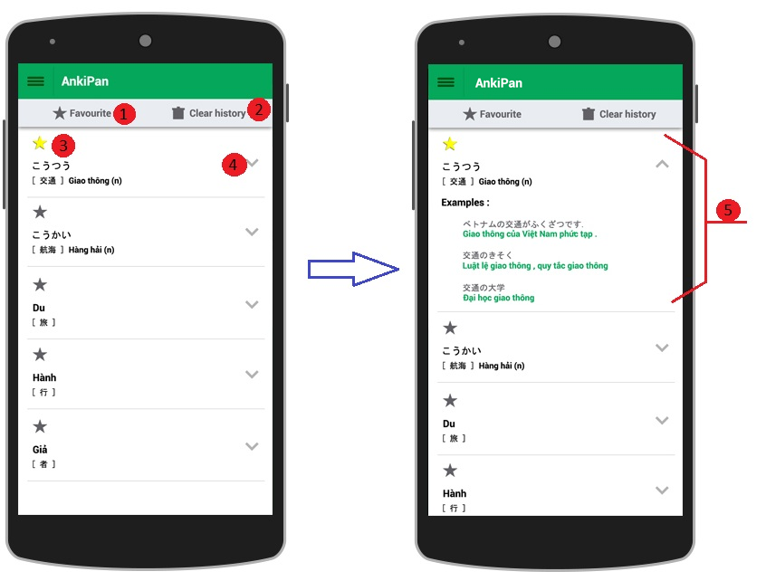

History screen include Favorite button and Clear history button and a list of word that you have searched

To view History screen, select History screen from Main Menu ( see 2.1)

To view full information of the word by tap on the Extend icon

Tap on Star icon to add / remove a word from favorite

## 2.7. View all favorite words

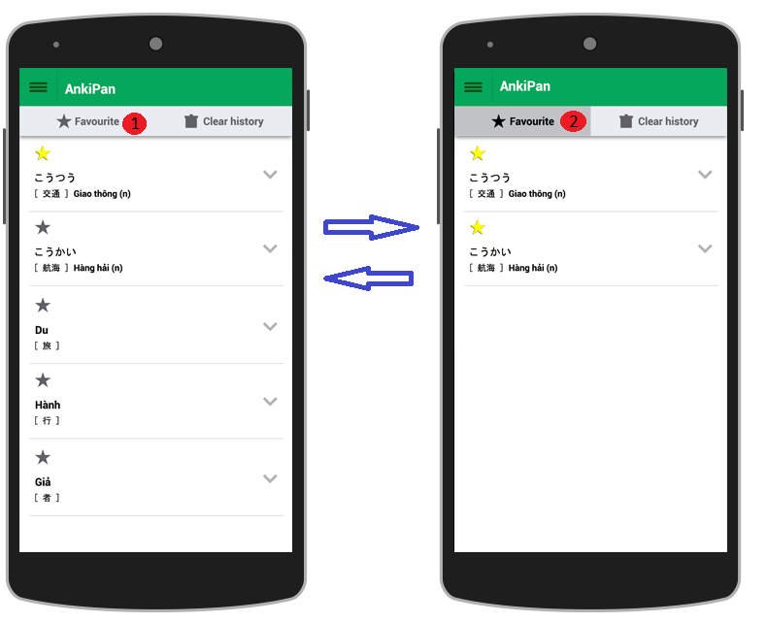

**To view all favorite word**

1. Select History screen from Main Menu (see 2.1)
2. Tap on Favorite button . Then all the words in favorite list will be shown on the screen.
3. If you want to back to History screen, tap the Favorite button again.

## 2.8. Clear history

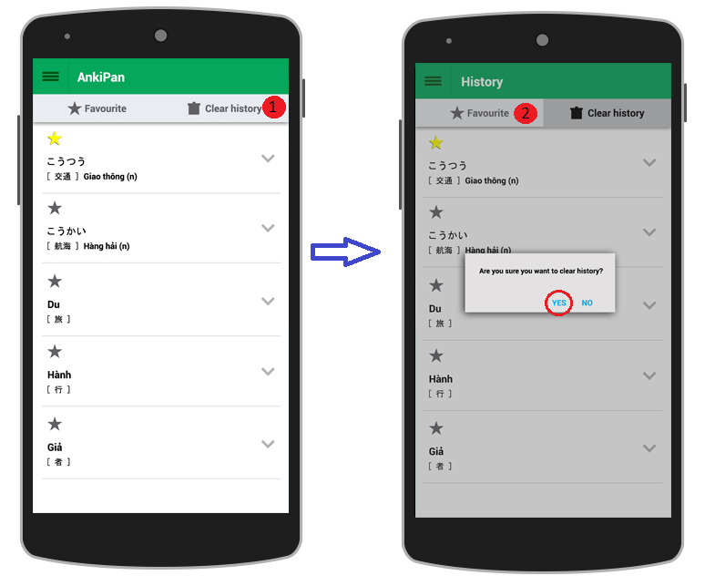

**To Clear all history**

1. Select History screen from Main Menu (see 2.1)
2. Tap on Clear history button
3. To confirm that you want to clear all history, tab on Yes button of confirmation dialog
4. If you want to back to History screen, tap on Favorite button

## 2.10. Select Dictionary package

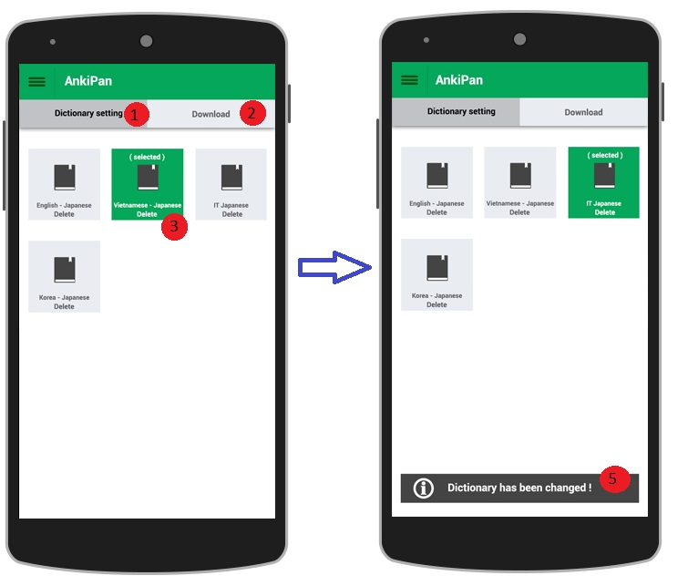

A Dictionary package include a Japanese dictionary and a Kanji dictionary. You can select a Dictionary package to use in Dictionary screen.

**Screen description:**

Dictionary setting tab: used to select or delete Dictionary package

Download tab: used to download new Dictionary package

Dictionary package that is in use is marked by green background

**To select a Dictionary package**

Tap on the Dictionary package that you want to use. The Dictionary package’s background will turn to green and confirm message will be shown on footer of the screen.

## 2.11. Delete Dictionary package

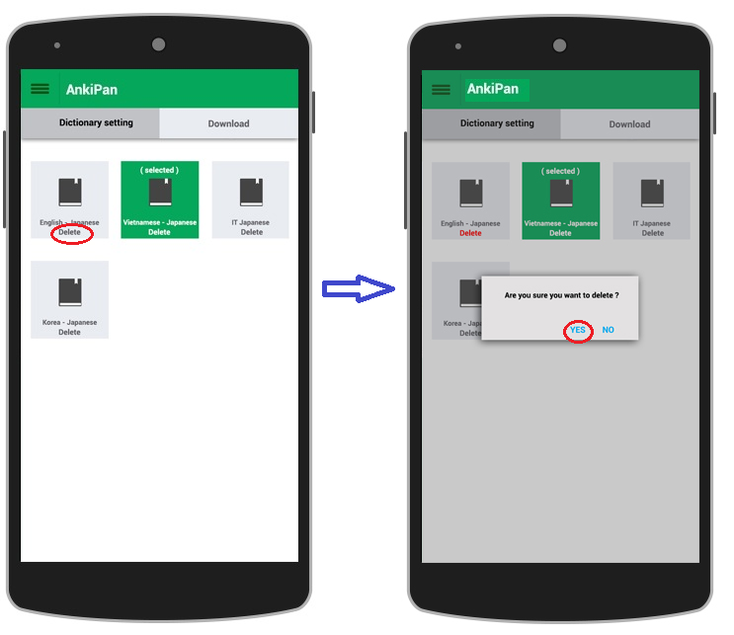

**To delete a Dictionary package:**

1. Tap on the Delete label of the Dictionary package
2. Tap Yes button of the confirmation dialog

## 2.12. Download Dictionary package

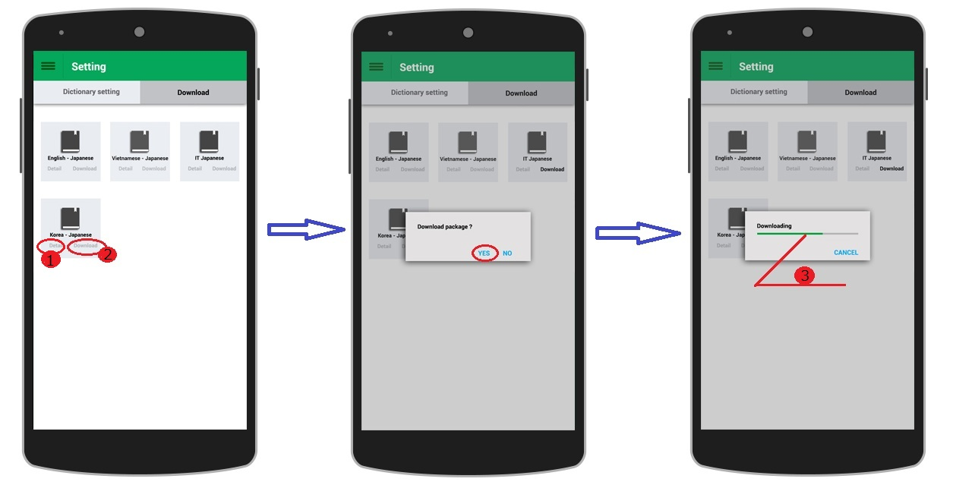

A Dictionary package include a Japanese dictionary and a Kanji dictionary. You can download the Dictionary package that explains words in your own language to use in Dictionary screen.

**To download a Dictionary package:**

1. Select Download screen from Main Menu (see 2.1)
2. Tap on Download tab
3. If you want to see description of a Dictionary package, tap on Detail label
4. Tap on Download label
5. Tap on Yes button of the confirmation dialog. The Dictionary package will be downloaded to the application. Progress bar shows the download progress
6. If you want to stop download, tap Cancel button

# VII. CONCLUSION

# 1. LESSONS LEARN

This project is the last wonderful lectures for us in FPT university. Through this project we learned how to apply all we studied to do the work. We got a lot of experience in document writing, which we did not pay much attention before. We also gained more technical knowledge. Especially, we learned to work which each other in a team. There was pressure and misunderstanding, but we did try to talk and get through that. This is the first time we run a project on our own, and many unexpected problems have occurred, but in the end of the project, we are happy that we did our best and completed the product that we expected.

# 2. FUTURE WORK

We plan to improve AKP image processing library in order to extract text in vertical direction and to work with documents of more complete structure, posters for example.

We also want to provide text recognition and dictionary packages of other languages.

We are in consider of adding translation and text-to-speech functions in next version. In the survey we conducted at the begin of this project, quite many students noted that they want these functions in the application.

# APPENDICES

# 1. SURVEY SUMMARY

SURVEY SUMMARY

*Demands of using smartphone in reading/ translating Japanese*

**Created by:** Pham Trong Nghia

**Create date:** 05/21/2015

* **Total of responses: 78**
* **Do you use your smartphone in studying Japanese?**

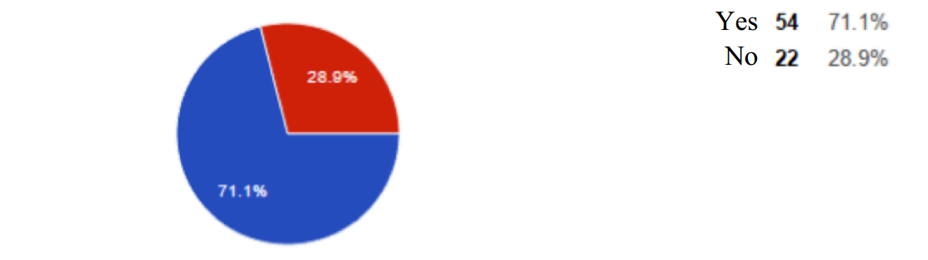

* **Do you usually use Japanese document?**

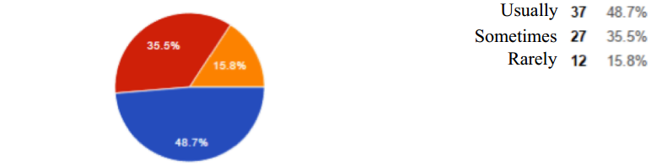

* **Do you have troubles in understanding words when reading/ writing Japanese documents?**

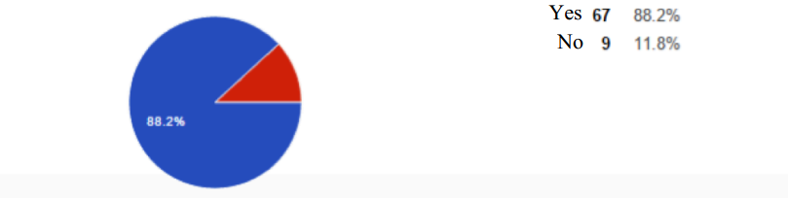

* **Besides, do you have any other troubles in reading Japanese document?**

Answers:

* Reading and translating Kanji.
* Reading and writing Kanji.
* Difficult to translate because one words might has many meanings.
* Do not know how to pronounce the word/ Kanji.
* Having trouble with kanji.
* **Do you find it difficult to read the manual instruction of the consumables made in Japan?**

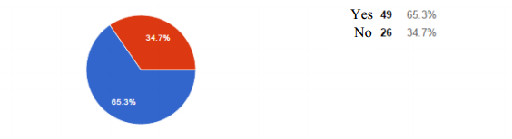

* **What functions do you want a Japanese translating application to have?**

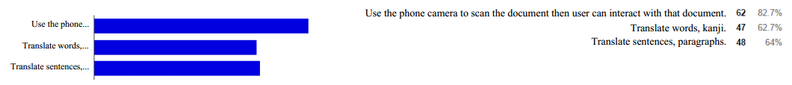

* **Other functions:**

Answers:

* Speech-to-text and translate.
* Quick translate paragraph.
* Auto checking grammar errors in document.
* Small quiz games.
* Display pronunciation, meaning of a word, sentence or each word in a sentence.
* Nice and modern interface, good performance.
* Exactly translate sentences.
* Should divide words into specialized fields. Have paragraphs for users to practice their translating skills. Use images in word definition explaining.
* Have audio for word pronunciation. Add news reading function.
* Add synonyms, antonyms.
* Speech-to-text, translate then read the translated sentence.
* Translate kanji written by user.
* Real-time audio translating.
* Allow user to write note of the words they searched. Audio translating. Capture to translate

# 2. MEETING MINUTES

Below is a sample of our meeting minutes. All meeting minutes is attached in Meeting minutes folder in the CD.

**English version**

|  |  |  |  |  |  |  |  |  |  |
| --- | --- | --- | --- | --- | --- | --- | --- | --- | --- |
| Project Name | | Anki Pan | | | Project code | | AKP | | |
| Project Manager | | Bui Hong Nhung | | | Conductor | | Bui Hong Nhung | | |
| Secretary | | Bui Hong Nhung | | |
| Date | | 20/07/2015 | | | Time | | 12.30 – 13.00 | | |
| Venue | | Room 100, Hoa Lac campus | | | | | | | |
| Meeting topic | | Discuss about problems occurred in last weeks and project progress | | | | | | | |
| **Attendees** | | | | | | | | | |
| **No.** | **Full name** | | | **Unit / Group** | | **Position** | | **Attendance** | |
| 1 | Tran Binh Duong | | | FPT University | | Supervisor | | Present | |
| 2 | Bui Hong Nhung | | | AKP team | | Project Manager | | Present | |
| 3 | Vu Hong Thai | | | AKP team | | Technical leader | | Present | |
| 4 | Nguyen Duc Huy Hoang | | | AKP team | | Developer | | Present | |
| 5 | Le Thanh Binh | | | AKP team | | Designer | | Absent | |
| 6 | Pham Trong Nghia | | | AKP team | | Developer | | Present | |
| 7 | Ngo Thi Mai | | | AKP team | | Tester | | Absent | |
| **Objectives** | | | | | | | | | |
| Find solutions for occurred issues and specify how to write final report | | | | | | | | | |
| **Agenda** | | | | | | | | | |
| * Error in the number of XML file of Application * Error in changing password of server * Report progress of the project * How to write Final report | | | | | | | | | |
| **Contents** | | | | | | | | | |
| 1. **Issues in this week** 2. **Error in the number of XML file of Application**  * Nhung:   + After the 17th XML file is created, the Application can not compile  + We are using 2 open source, OpenCV and Tesseract, but when we import the 3th library, the Application can not compiled either.  + Due to the limit in the number of XML file, we are thinking of combining Result screen and Dictionary screen into 1 and remove Translate screen   * Supervisor   + Project team should try another IDE, Android studio for example. Eclipse still has some errors.  + Using OpenCV version 2.4.9 instead of version 2.4.10. As I searched on the Internet, there are some bugs in version 2.4.10.   1. **Error in editing password of server**  * Nhung: Project team decided to use open source for editing password because we could not fix the error. * Supervisor: What is the error? * Hoang: I have problem in changing charset. The 2 charsets, before and after changing, is not the same * Supervisor: Project team ought to find out cause of the error end fix. I expected project team to do this part.  1. **Project progress**  * Nhung: This week, team members were too busy with studying Japanese, so we did not do much work * Supervisor: Do you have any solution for this? Do project team work together this week? * Hoang: Because each member has different study schedule, so we could not arrange for all team * Nhung: Even if we can arrange for a team work time, it is not suitable for everyone, so 1 or 2 member could not jointed. This period, almost work is of the development team, so I will try to arrange for 3 developer to work to together. * Supervisor:   + All team members should support each other  + A lesson to learn: when manage a project, you should not let a issue of one member affect progress of all other member. You should left the issue on one side, and do other stuff. When you are back to the issue later, you may realize what was the cause.  + Should let Thai to take care more of the technical affair  + About combining screens, project team should evaluate if this solution is OK  + Project team should be united and sociable, go out together sometimes to relax. | | | | | | | | | |
| **Conclusions** | | | | | | | | | |
| **Discussed items** | | | **Decisions** | | | | | | |
| 1. Error in the number of XML file | | | Report to Supervisor result after project team switch to OpenCV version 2.4.9 | | | | | | |
| 2. Error in changing password | | | Find out the root cause of the error and fix. Do not use open source | | | | | | |
| 3. How to write final report | | | - Complete and deliver Final report to University in 15/08  - Write down all process of working in this project  + Testing Tesseract  + All algorithms  + About project idea: what is special point, what issue can it solve | | | | | | |
| **Issues** | | | | | | | | | |
| **No.** |  | | **Resolution** | | | | | | **Target date** |
|  | N/A | |  | | | | | |  |
|  | | | | | | | | | |

**Japanese version**

|  |  |  |  |  |  |  |  |  |  |
| --- | --- | --- | --- | --- | --- | --- | --- | --- | --- |
| プロジェックト名 | | Anki Pan | | | プロジェックトコード | | AKP | | |
| プロジェックト管理者 | | Bui Hong Nhung | | | 指揮者 | | Bui Hong Nhung | | |
| 秘書 | | Bui Hong Nhung | | |
| 日付 | | 20/07/2015 | | | 時間 | | 12.30 – 13.00 | | |
| 会場 | | Room 100, Hoa Lac campus | | | | | | | |
| ミーチングトピック | | 今週に発生した問題の相談と進歩報告 | | | | | | | |
| **出席者** | | | | | | | | | |
| **番** | **氏名** | | | **単位/グループ** | | **担当** | | **出席** | |
| 1 | Tran Binh Duong | | | FPT 大学 | | 監督者 | | 出席 | |
| 2 | Bui Hong Nhung | | | AKP チーム | | 管理者 | | 出席 | |
| 3 | Vu Hong Thai | | | AKP チーム | | 技術リーダー | | 出席 | |
| 4 | Nguyen Duc Huy Hoang | | | AKP チーム | | 開発者 | | 出席 | |
| 5 | Le Thanh Binh | | | AKP チーム | | デザイナー | | 欠席 | |
| 6 | Pham Trong Nghia | | | AKP チーム | | 開発者 | | 出席 | |
| 7 | Ngo Thi Mai | | | AKP チーム | | テスター | | 欠席 | |
| **目標** | | | | | | | | | |
| 問題の解決法を見出すと最後報告の書き方を確認する | | | | | | | | | |
| **議題** | | | | | | | | | |
| * XMLファイル数のエーラ　（アプリ） * パスワード変更のエーラ　（ウェーブサービス） * 進歩報告 * 最後報告の書き方 | | | | | | | | | |
| **内容** | | | | | | | | | |
| ア．今週の問題  ア１．XMLファイル数のエーラ（アプリ）   * Nhung:   ＋　１７番名のXMLファイルを追加すると、アプリがコンパイルできない  ＋　二つのライブラリー、OpenCV とTesseractを使っているが、３番名のライブラリーをインポートすると、アプリもコンパイルできない  ＋　XMLファイル数限で、結果画面と辞書画面を一緒にしたり、翻訳画面を無しにしたりする解決法を考えている   * 監督者   ＋　プロジェックトチームが他のIDE、例えばAndroid studio、を試したほうたいいと思う。Eclipseはいつかのエーラがあるらしい  ＋　OpenCV 2.4.10の代わりにOpenCV 2.4.9にしてください。インタネットで調べた結果、バージョン2.4.10はまだブッグがあるということ  ア２．パスワード変更のエーラ（ウェブサービス）   * Nhung: 私たちはパスワード変更の機能にオープンソースを使うに決めた。エーラは直せなかったから * 監督者：エーラはどのようだ？ * Hoang: チャセット変更に問題がある。チャセットは変更するあとは元のチャセット違う。 * 監督者：皆さんはこのエーラと原因を見出して、直しなさい。プロジェックトチームはこの機能を自力で開発と思ってきた。   イ．プロジェックト進歩   * Nhung：今週、チームメンバーは日本語の勉強で忙しかったので、あまり仕事は進歩していない * 監督者：解決法は考えたか？ * Hoang：メンバーは違う大学スケジュールがあるので、全員に手配できない * Nhung：チームワークの時間が決まっても、全員に適用できないので、１、２人が参加できない。この期間、ほとんどのタスクは開発チームのタスクだから、開発者の３人がチームワークできるように手配する。 * 監督者：   ＋　チームメンバーがお互いにサポートすれば良い  ＋　得られた経験：プロジェックト管理には、一人の問題を全員に影響させてはいけない。解決できない問題を一時中止して、他のタスクをする。後で振り返って考えるとこの問題の原因が分かるかもしれない  ＋　Thaiさんに技術問題をもっと任せてください  ＋　画面を一緒にするについては、皆さんがそれで良いかどうか判断してください  ＋　チームは共同で社交的で、たまにも一緒に遊びに行ってリラックスすれば良い | | | | | | | | | |
| **結論** | | | | | | | | | |
| **相談項目** | | | **決定** | | | | | | |
| ア．XMLファイル数のエーラ | | | OpenCV 2.4.9に変わった後で結果はどうか報告しなさい | | | | | | |
| イ．パスワード変更のエーラ | | | 原因を見出して、直す。オープンソースは使わない | | | | | | |
| ウ．最後報告の書き方 | | | * ８月１５日までに完成して、大学に渡す * プロジェックトの過程を全部記述する   ＋　Tesseract テストと結果  ＋　アルゴリズム  ＋　プロジェックトアイディア：特別は点、解決できる問題 | | | | | | |
| **問題** | | | | | | | | | |
| **番** | **詳細** | | **解決法** | | | | | | **目標期日** |
|  | N/A | |  | | | | | |  |
|  | | | | | | | | | |

# 3. CONFIGURATION MANAGEMENT

## 3.1. CI Identification and Naming Convention

|  |  |  |
| --- | --- | --- |
| **No** | **Configuration items** | **Naming convention** |
| * Project Management | | |
| 1 | Project plan | AKP_ProjectManagementPlan_ver[version number]  For example: AKP_ProjectManagementPlan_ver1.0 |
| * Requirement | | |
| 2 | Software requirement specification | AKP_ SoftwareRequirementSpecification_ver[version number]  For example:  AKP_SoftwareRequirementSpecification_ver1.0 |
| * Design | | |
| 3 | Architecture design | AKP_ArchitectureDesign_ver[version number]  For example: AKP_ArchitectureDesign_ver1.0 |
| 4 | Database design | AKP_DatabaseDesign_ver[version number]  For example: AKP_DatabaseDesign_ver1.0 |
| 5 | Interface design | AKP_InterfaceDesign_ver[version number]  For example: AKP_InterfaceDesign_ver1.0 |
|  | Source code |  |
| 6 | Source code | AKP_SourceCode_ver[version number][Tested/Untested]  For example: AKP_SourceCode_ver1.0Tested |
| * Support Document | | |
| 7 | User manual | AKP_UserManula_ver[version number]  For example: AKP_UserManula_ver1.0 |
| * Test | | |
| 8 | Test plan | AKP_TestPlan_ver[version number]  For example: AKP_TestPlan_ver1.0 |
| 9 | Unit Test Case | AKP_UnitTestCase_ver[version number]  For example: AKP_UnitTestCase_ver1.0 |
| 10 | Integration test case | AKP_IntegrationTestCase_ver[version number]  For example: AKP_UnitTestCase_ver1.0 |
| 11 | System test case | AKP_SystemTestCase_ver[version number]  For example: AKP_SystemTestCase_ver1.0 |
| 12 | Test data | AKP_TestData_ver[version number]  For example: AKP_TestData_ver1.0 |
| 13 | Test result | AKP_TestReport_ver[version number]  For example: AKP_TestReport_ver1.0 |
| * Report | | |
| 14 | Personal weekly report | [Name]_WeeklyReport_W[week No]_[Send Date(ddmmyyyy)]  For example: NhungBH_WeeklyReport_W4_04062015 |
| 15 | Team weeky report | AKP_WeeklyReport_W[week No]_[Send Date(ddmmyyyy)]_[EN/JP]  For example: AKP_WeeklyReport_W4_04062015_EN |
| * Date format | | |
| 16 | Date wrote in files | DD/MM/YYYY  For example: 20/07/2015 |
| * File type | | |
| 17 | MS Word | *.doc, *.docx |
| 28 | MS Excel | *.xls |
| 29 | MS Power Point | *.ptt |
| 20 | MS Project Plan | *.mpp |
| 21 | Astah | *.asta |
| 22 | Images | *.png, *.jpg, *.jpeg, *.bmp, *.gif |

## 3.2. Version Numbering Rules[6]

* **For documents:**

Each file has a version number as part of its identity. This version number is physically represented as a 2-part string with the following format:

<version>.<revision>

For example, version 1.0 indicates 1 as the version, and 0 as the revision number.

The first version will be numbered 1.0

* **Version number:** appears to the left of the decimal. It is changed only when the core content of the item is significance changed. For example: when an item is completely overhauled, with substantial internal changes, the version 1.0 would become version 2.0.
* **Revision number**: appears to the right of the decimal. It is changed when the existing content is changed, but the main (or core) content is remained. The normal sequence of revision is 1.1, 1.2, and so on.
* **For Software source files:**

Software executable and support files are generally identified by name and version number.

The version number is physically represented as a 3-part string with the following format: <version>.<revision><update>

For example, version 1.1a indicates 1 as the version, 0 as the revision number, and a as the update level.

* **Version number:** appears to the left of the decimal. It is changed only when the core content of the item is significance changed, as when moving from one are of the development tool to another, when an Application is completely overhauled, or the user interface changes fundamentally. In this case, version 1.1a would become version 2.0.
* **Revision number:** appears to the right of the decimal. It is changed when new features, functionality or other content are added or significantly changed. In normal case, the core architecture or user interface have been extended or limited in some manner. The most common reason for changing the revision number is adding a new module or other functionality to the software. The normal sequence of revision is 1.0, 1.1 and 1.2 and so on.
* **Update level:** is appended or incremented when the only change to the software item is to correct one or more defects, without the addition of any new function. Version 1.1 would become v1.1a, 1.1b and so on. This updating is overridden when a combination revision, involving bug fixes and new feature additions, is performed. In such a case, the software revision number is incremented and any update indicator is dropped, as in v1.1b to 1.2.

## 3.3. Directory Structure

A folder used to store all project documents is created on Google driver. This folder includes of some main folders as viewed in the following table.

|  |  |  |
| --- | --- | --- |
| **Main folder** | **Sub-folder** | **Purpose** |
| Download |  | Store documents, material downloaded from Internet or other sources |
| Meeting minutes |  | Store project meeting minutes |
| Weekly report | W1_15052015 | Store weekly report of week 1 (end at 15/05/2015) |
| W2_22052015 | Store weekly report of week 2 |
| W3_29052015 | Store weekly report of week 3 |
| .... |  |
| Project report | Report1_Introduction | Store Introduction document |
| Report2_ManagementPlan | Store PMP and related files |
| Report3_SoftwarDetailDesign | Store SDD and related files |
| Report4_SoftwareRequirement | Store SRS and related files |
| Report5_SoftwareImplementatioAndTest | Store SIT and related files |
| Report6_UserManual | Store SUM |
| Source code | Increment 1 | Store source code completed in Increment 1 |
| Increment 2 | Store source code completed in Increment 2 |
| Increment 3 | Store source code completed in Increment 3 |
| Test Tesseract |  | Store tool, data used to test Tesseract library and Test result. |
| Templates |  | Store templates of documents |
| Training |  | Store training documents of team members |
| Others |  | Store other document of project team |

# 4. CODING CONVENTION

## 4.1. Coding Convention

* Naming class: Use the uppercase letter for the first character of each word. For example: ImageProcessor
* Naming variables:
* Start the name with a lowercase letter and follow Camel Case. For example: inputImage
* Name of a variable must describe itself
* Catch exception
* Catch all exceptions that may happened
* Throw all exceptions that may occur

## 4.2. Comment Convention

* Write comment for all functions, include what the functions do, what they returns
* Write comment for all important logic.
* Explain all parameters of each function

# REFERENCES:

[1] **４００万人に迫る！ 世界で日本語を学んでいるのはどんな人？**

<http://www.wochikochi.jp/topstory/2013/12/learning-japanese.php>

[2] Google Translate application on Google play store

<https://play.google.com/store/apps/details?id=com.google.android.apps.translate&hl=en>

[3] CamDictionary application on Google play store

<https://play.google.com/store/apps/details?id=com.intsig.camdict&hl=en>

[4] Jidict application on Google play store

<https://play.google.com/store/apps/details?id=info.hoang8f.jdict>

[5] Risk management template

<http://www.projectmanagementdocs.com/project-planning-templates/risk-management-plan.html>

[6] Version numbering rules

EC_FinalReport_v1.0.pdf

Author: Easy Chemistry team

[7] Tesseract

<https://en.wikipedia.org/wiki/Tesseract_(software>)

[8] Canny edge detection

<http://docs.opencv.org/doc/tutorials/imgproc/imgtrans/canny_detector/canny_detector.html>

[9] Sobel detector and Canny detector

<http://www.egr.msu.edu/classes/ece480/capstone/fall13/group04/docs/danapp.pdf>

Tips to write user manual

http://online-learning.com/five-tips-writing-user-manual/

StudentGuide_CapstoneProject_JS_v1.0.doc

Author: FPT university

FPT University The_Student_Guide_Summer2013.pdf

Autory: FPT university